What does the  
Children’s Rights  
Report 2017 say?

for children and young people

© Australian Human Rights Commission 2018.

The Australian Human Rights Commission encourages the dissemination and exchange of information presented in this publication and endorses the use of the [Australian Governments Open Access and Licensing Framework](http://www.ausgoal.gov.au/) (AusGOAL).

cid:image003.jpg@01CE1A65.17DB2520

All material presented in this publication is licensed under the [Creative Commons Attribution 4.0 International Licence](http://creativecommons.org/licenses/by/4.0/legalcode), with the exception of:

* photographs and images
* the Commission’s logo, any branding or trademarks
* where otherwise indicated.

To view a copy of this licence, visit <http://creativecommons.org/licenses/by/4.0/legalcode>.

In essence, you are free to copy, communicate and adapt the publication, as long as you attribute the Australian Human Rights Commission and abide by the other licence terms.

**Please give attribution to:**

© Australian Human Rights Commission 2018.

**What does the Children’s Rights Report 2017 say? Child-friendly version**

ISSN 2203-0948 (Print)  
ISSN 2204-1176 (Online)

**Electronic Format**

This publication can be found in electronic format on the Australian Human Rights Commission’s website at [www.humanrights.gov.au/about/publications/](http://www.humanrights.gov.au/about/publications/).

**Contact details**

For further information about the Australian Human Rights Commission or copyright in this publication, please contact:

Communications Unit  
Australian Human Rights Commission  
GPO Box 5218  
SYDNEY NSW 2001

Telephone: (02) 9284 9600  
Email: [communications@humanrights.gov.au](mailto:communications%40humanrights.gov.au?subject=)

# Hi!

I’m Megan Mitchell, the National Children’s Commissioner.

My job is to protect the rights of all children and young people in Australia and make sure you get the help you need to be safe and healthy.

Every year I write a report to the Australian Government telling it how I think we can better look out for all children and young people. This is my fifth report.

I am going to talk about the main things I said in my report.

# Did you know that we all have human rights?

We have these rights because we are human beings. Our human rights are the things that we all need to have a good life.

Children and young people have special rights that are written in a document called the **United Nations Convention on the Rights of the Child**.

Children and young people have special rights because their needs are different from adults.

As a child or young person, you have the right to:

* be treated fairly
* have a say about decisions affecting you
* live and grow up healthy
* get information that is important to your wellbeing
* be safe, no matter where you are
* be cared for and have a home
* privacy
* get an education
* know who you are and where you come from.

These are just some of the rights you have. The Australian Government has promised to make sure that all children and young people get these rights.

There is also a special group of people called the **United Nations Committee on the Rights of the Child**. This Committee watches out for children all over the world and tells governments how they can better protect children’s rights.

In 2012, the Committee looked at what life is like for children in Australia and told the Australian Government what it could do to make things better. They said that Australia does a lot of good things for children and young people, but that the Government can still do more. They were worried that some children:

* are being treated unfairly
* are being bullied and hurt
* are not getting the education they need
* can’t live with their parents
* are not as happy or as healthy as they could be
* do not have homes
* are in trouble with the law and need help
* are locked up
* are exposed to violence.

**Australia needs to listen to children and young people and work harder to help them.**

# In my first year as the National Children’s Commissioner, I went around Australia listening to children and young people.

I asked them what was important to them and what would make life better.

I heard stories from adults who work with children and young people too.

After I had listened to all the great things that children, young people and adults had to say, I came up with five main ideas. These ideas are helping me to do my work.

**1. The right to be heard**

We need to make sure adults listen to children and young people and take their views seriously.

**2. Freedom from violence, abuse and neglect**

We need to make sure all children and young people are safe.

**3. The opportunity to thrive**

All children and young people have a right to grow up strong, healthy and happy. We need to help children and young people who are having a hard time right from the start, instead of waiting until problems get really bad.

**4. Engaged citizenship**

We should help children and young people get involved in their schools and communities – to be citizens! They need to know about their rights!

**5. Action and accountability**

We need to know all about how children and young people are doing in Australia. Then we need to make sure the Government makes  
laws, rules and programs that help all children and young people.

# This year, I paid special attention to the rights of young people who are parents or who are expecting a baby.

I want to make sure young parents and their children have all the opportunities they need to be healthy, get a good education and do well in life.

**To find out more about the problems and issues young parents face, I collected information from 166 young or expecting parents about their experiences.**

I learnt that:

* many young parents and their children live in unstable or unsafe housing
* some young parents are helped to stay at school, but many are not helped
* many young parents experience stigma and discrimination. Many said that they aren’t taken seriously or respected by health and other professionals
* some young parents find it hard to get a driver’s licence and need help with this. Many don’t have access to good transport
* young parents find it very hard to make ends meet financially and generally can’t afford to put their children in pre-school. This makes it harder for them to study or get a job
* young parents benefit from information and help about sexual and mental health, relationships, parenting and their child’s development, both before and after the birth of their baby, but many don’t receive it or don’t know where to get it
* young fathers get very little support or recognition
* some young parents are worried about child protection agencies taking their children away, and want these agencies to do more to support them as parents.

**Did you know that in 2015 there were around 8,500 babies born to mothers aged 19 or under?**

Overall, young parents are very motivated to be good parents, get an education, a job and a home, and to make sure their children are safe, healthy and have every opportunity.

They said that they really need services to work together to help them make their way in all these areas.

They also said that they like to be in programs with other young parents because they can understand what they are going through.

Many young people said that becoming a parent changed their life for the better. They said that governments should do more to help young parents and their children be the best they can.

In my report to the Australian Government, I recommended that:

* we find out more about the experiences and needs of young parents and their children, including young fathers
* more education, employment and training programs be developed for young parents
* we make sure all young parents can access their right to education and health services
* we make sure young parents are not unfairly discriminated against
* young parents receive support to help them in their parenting role.

# Messages to government

* I should be able to consent as a parent, not just for my child but for myself as well.
* Free Childcare for single parents, more Healthcare benefits for children.
* Everyone know what services are available. A lot of services that were available for me I didn’t find out about till after I really needed them.
* The punitive and harsh cuts to welfare and support to young parents will only contribute to the same cycle of deprivation I was born into. Policies such as the work for the dole and the basics card show only contempt for future vulnerable children. “a society is judged by how it treats it’s most vulnerable”.
* Dear Government, I think you should be more aware of the young mums out there who are suffering and struggling. More support is needed financially, support networks, case managers, more needed for housing not just refuges.
* It’s hard to get your licence and gain 100 hours supervised training when you have no money/no one to help.
* Do your job!
* Housing needs to be more affordable or attainable for mothers on low income, A stable home is the first step to a child’s future.

# Advice to other young parents

* Gain as much knowledge as you can. As hard as some days may seem try and find the right support to get what your entitled to!!! The support is there. Just seems very hidden.
* This world is so judgemental. If someone wants to judge you, it doesn’t matter. They don’t know [what] you’ve been through.
* Try and attend as much parents groups as possible. Make sure you have a circle you belong to.
* 1. Patience  
  2. Enjoy every moment they get older quickly  
  3. You can’t love them enough.
* Going to school is important.
* Run your own race, take all the advice with a grain of salt.
* Don’t count the days, make the days count.
* You’re not silly, ask’s all the question are not dumb its okay to asks for help.
* Things will be easier with education.
* Be there for your kid, pull your head in.

# All children and young people have a right to be safe and cared for, no matter where they are or who they are with.

Most children and young people feel happy, safe and protected – at home, in their neighbourhood, at school, in church, at the doctor’s, or at the local sports club or youth group.

**But some children and young people don’t feel safe.**

Children and young people who don’t feel safe can be afraid, uncomfortable, anxious or confused. They may not feel they will be believed or listened to by the people running things.

People who work with children and young people should understand children and young people’s rights and needs. They need to treat children and young people fairly and with respect, and always make sure children and young people can have a say. Physical and online spaces also need to be safe, so that children and young people can’t be hurt or bullied.

It is really important that children and young people are able to speak up if they are feeling unsafe or worried.

**If you feel unsafe or worried, it is important to speak up and ask for help.**

You can talk to someone you trust, like a family member, a friend or a teacher.

You can talk to Kids Helpline:

You can talk to **Kids Helpline:**

* on the phone on **1800 55 1800**
* online at [**www.kidshelpline.com.au**](http://www.kidshelpline.com.au).

You can also talk to **headspace:**

* face-to-face at a headspace centre
* online at [**www.eheadspace.org.au**](http://www.eheadspace.org.au)
* on the phone on **1800 650 890**.

If you think you are in immediate danger, you can call the **police** by dialling **000**.

**All children and young people have the right to be safe.**

I am working with the Australian Government to make sure children and young people are safe and protected in all the spaces and places they go.

This will make sure all organisations, no matter how big or small, follow **ten main rules** to protect children’s safety and wellbeing:

1. The people in organisations care about children and young people’s safety and wellbeing.

2. Children and young people are told about their rights, have a say in decisions about them and are taken seriously.

3. Families and communities are included in child safety and wellbeing plans.

4. Everyone is treated with dignity, respect and fairness.

5. People working with children and young people are supported in how to be safe for children.

6. Children, young people, families, staff and volunteers are listened to and can share problems and concerns.

7. Staff and volunteers keep learning so they know how to keep children and young people safe.

8. Children and young people can be safe online and in the ‘real world’.

9. Organisations check to make their safety and wellbeing policies and procedures better.

10. Organisations write down how they are safe for children and young people, and make sure everyone sees it.

**It is really important that children and young people are able to speak up if they are feeling unsafe or worried.**

# What will I do now?

Each year I make a report like this telling the Australian Government what it can do to make life better for children and young people.

As well, I will let everyone know about the five main ideas to make things better for children and young people: the right to be heard; freedom from violence, abuse and neglect; the opportunity to thrive; engaged citizenship; and action and accountability.

Every few years, Australia reports to the United Nations on how it is treating children and young people and meeting its promises under the **Convention on the Rights of the Child**. Australia last reported in 2011, and is reporting again in 2018.

I will also report to the United Nations about the good things Australia is doing for children and young people, and the things we should be doing a whole lot better. To do this properly, I want to talk to children and young people across Australia to find out what they think, and make sure their voices are heard by the United Nations and the Australian Government.

I will be travelling across Australia to talk to some of you and get your ideas for how life could be better for children and young people.

# What can you do now?

You can have your say about your rights, any time!

If you want to talk to me about something, you can:

* email me at [kids@humanrights.gov.au](mailto:kids@humanrights.gov.au)
* find me on Facebook at [www.facebook.com/MeganM4Kids](http://www.facebook.com/MeganM4Kids)
* find me on Twitter [@MeganM4Kids](https://twitter.com/MeganM4Kids)

Or you can follow my pup, Scout, on Instagram, @Scout4Kids

# Know your rights word scramble!

All children and young people in Australia – and the world – have human rights. Unscramble the words by looking for clues in your rights below.

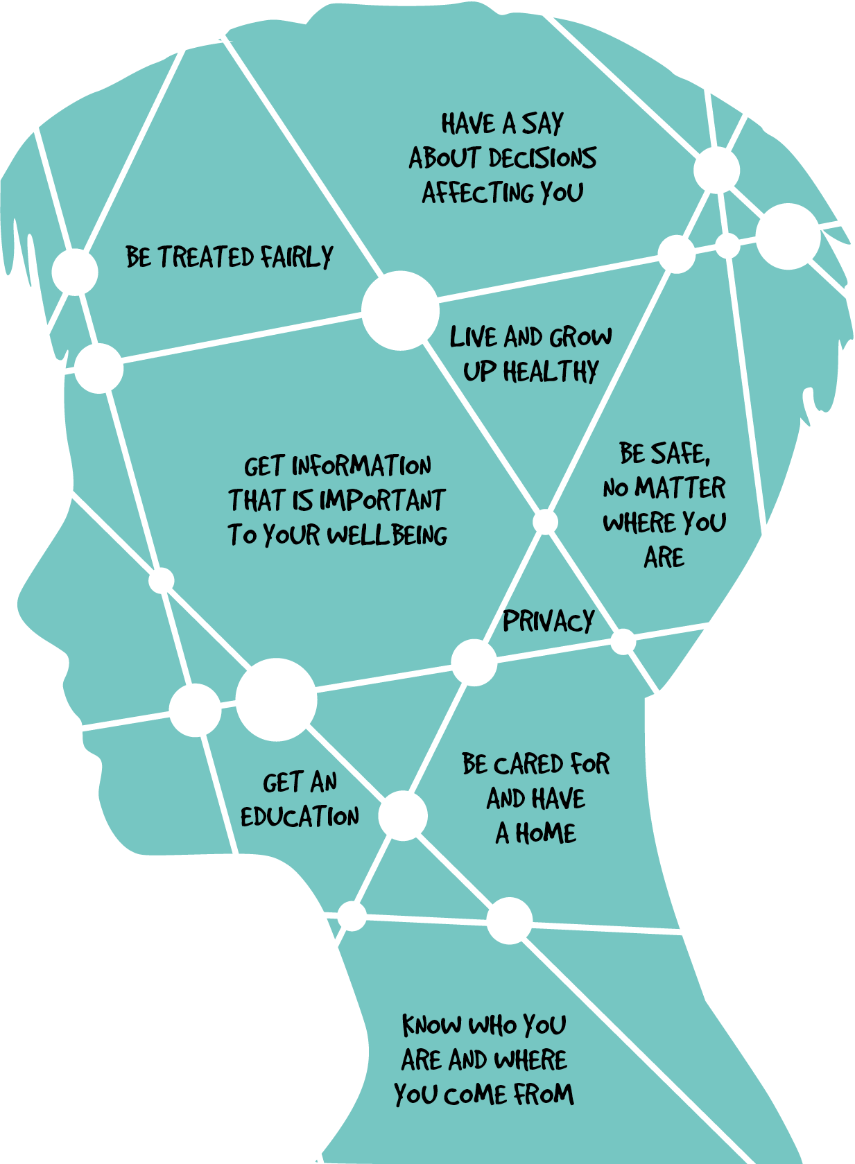

**MYAILF ICVEO**

**UNOATICED FTEAYS**

**DEERTTA LAFYRI TALEHH**

**EHMO RTAOINONFMI**

**TTNYIEDI**