© Australian Human Rights Commission 2021.
The Australian Human Rights Commission encourages the dissemination and exchange of information presented in this publication.
All material presented in this publication is licensed under the Creative Commons Attribution 4.0 International Licence, with the exception of:
- photographs and images;
- the Commission’s logo, any branding or trademarks;
- content or material provided by third parties; and
- where otherwise indicated.
To view a copy of this licence, visit http://creativecommons.org/licenses/by/4.0/legalcode.
In essence, you are free to copy, communicate and adapt the publication, as long as you attribute the Australian Human Rights Commission and abide by the other licence terms.
Please give attribution to: © Australian Human Rights Commission 2020.
Disability Action Plan Guide • 2021
ISBN 978-1-925917-61-1
Acknowledgements
The Australian Human Rights Commission would like to thank the following individuals and organisations:
IncludeAbility Employer Network Members: Australia Post, Westpac and the University of Queensland
IncludeAbility Ambassadors: Dr Dinesh Palipana OAM and Associate Professor Paul Harper
This publication can be found in electronic format on the Australian Human Rights Commission’s website at https://www.humanrights.gov.au/our-work/publications.
For further information about the Australian Human Rights Commission or copyright in this publication, please contact:
Australian Human Rights Commission
GPO Box 5218
SYDNEY NSW 2001
Telephone: (02) 9284 9600
Email: communications@humanrights.gov.au
Design and layout Dancingirl Designs
Photography iStock
Cover iStock

Contents

Foreword 5
1 Introduction 6
1.1 Disability in Australia 7
1.2 The role of the Australian Human Rights Commission 8
1.3 Disability discrimination 9
2 What is the role of a Disability Action Plan? 10
2.1 The importance of language 12
2.2 The role of a Disability Action Plan in determining unjustifiable hardship 14
3 What are the benefits of a Disability Action Plan? 15
3.1 Benefits for individuals 15
3.2 Benefits for the workplace 17
3.3 Benefits for the community 17
4 Who can develop a Disability Action Plan? 19
5 Stages of developing a Disability Action Plan 20
6 How to develop a Disability Action Plan 22
6.1 Review business practice 22
6.2 Devise policies and programs 24
(a) Define the problem 24
(b) Brainstorm solutions 24
(c) Consult with people with disability 25
(d) Prioritise your policies and programs 26
(e) Allocate budget and resources 27
(f) Align your DAP with other planning and reporting documents 28
6.3 Establish goals and targets 30
6.4 Develop evaluation strategies 32
6.5 Allocate responsibility 34
6.6 Communicate your Disability Action Plan 35
(a) The accessibility of your DAP 35
(b) Communicating your DAP internally 37
(c) Establishing feedback channels 37
Appendix A: Resources 38
Appendix B: Relevant Legislation 40
Appendix C: Disability policy in Australia 42
Appendix D: International human rights instruments 44

Foreword
The Disability Discrimination Act 1992 (Cth) (DDA) was passed nearly 30 years ago. Although the DDA has had many positive effects on Australian society, its impact has been limited due to a lack of understanding of the benefit of the widespread inclusion of people with disability.
The objects of the DDA include to eliminate, as far as possible, discrimination against persons on the ground of disability in areas such as work, education, the provisions of goods and services and the administration of government programs. The objects extend to seeking to ensure people with disability have the same rights to equality before the law as the rest of the community and to promote that people with disability have the same rights as other individuals.
Although a considerable amount of focus in the community has been given to highlighting what are discriminatory practices towards people with disability, less focus has been given by organisations, businesses and providers of goods and services as to how to promote equal opportunities for people with disability. This has meant the inclusion of people with disability has suffered.
Organisations, businesses and providers of goods and services entering into action plans under the DDA—what is commonly referred to as a “Disability Action Plan” (DAP)— presents a compelling message to the community that they view people with disability as equals. At present, not all companies listed on the Australian Securities Exchange have a DAP. This needs to change.
Having a well-publicised and thoroughly prepared DAP reduces the likelihood of discrimination and ensures people with disability are treated as equals.
I look forward to the Commission receiving a copy of your DAP in the near future.
Dr Ben Gauntlett
Disability Discrimination Commissioner

Introduction
We all have a role to play in reducing discrimination against people with disability and promoting a more inclusive community.
Inclusion goes beyond physical accessibility and considers the attitudes, behaviours and systems in our workplaces and communities which may be discriminatory. It challenges us to listen and reflect on how we can improve. Inclusion requires us to commit to change and to continuous improvement, and to embedding accessibility in all areas of life.
Organisations and businesses have an important role in creating more inclusive workplaces and businesses for employees and customers. The economic and social benefits of increased accessibility are extensive and allow an organisation to increase revenue, boost productivity and improve community attitudes.
A DAP provides a blueprint for how your organisation can review current practices, plan strategically and implement change. A DAP will support your organisation to recognise and promote the rights of people with disability and provide a public commitment to inclusion.
This Guide has been developed to assist your organisation to develop and implement a DAP in accordance with the provisions in section 61 of the Disability Discrimination Act 1992 (Cth) (DDA).

Disability in Australia
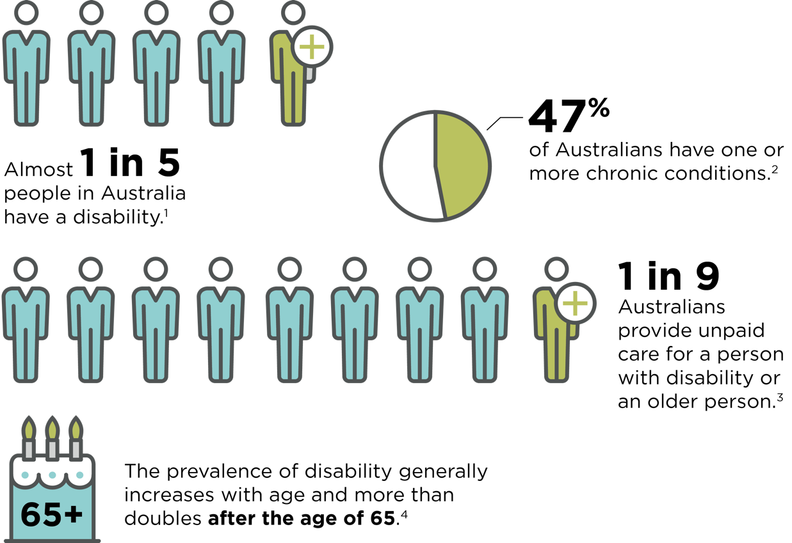

1 Australian Bureau of Statistics, Survey of Disability, Ageing and Carers, Summary of Findings 2018 (Catalogue No 4430.0, 24 October 2019).
2 Australian Institute of Health and Welfare (AIHW) 2020, Chronic conditions and multimorbidity, viewed 27 October 2021, https://www.aihw.gov.au/reports/australias-health/chronic-conditions-and-multimorbidity.
3 Australian Bureau of Statistics, Survey of Disability, Ageing and Carers, Summary of Findings 2018 (Catalogue No 4430.0, 24 October 2019).
4 Australian Bureau of Statistics, Survey of Disability, Ageing and Carers, Summary of Findings 2018 (Catalogue No 4430.0, 24 October 2019).

Disability is part of life for millions of Australians. People with disability, their friends and families are part of your workforce, customer base and community.
It is important to recognise that disability is diverse and that not all disability is visible. The definition of disability under the DDA is wide ranging and includes the presence of disease and illness as being a disability. This encompasses people with chronic diseases which have long-lasting conditions with persistent effects.
Creating an accessible and inclusive environment enables all people with disability to fully enjoy their human rights and participate in the community.

The role of the Australian Human Rights Commission
The Australian Human Rights Commission (the Commission) is Australia’s national human rights institution.
It is an independent statutory organisation with responsibility for leading the promotion and protection of human rights in Australia.
Under the DDA and the Australian Human Rights Commission Act 1986 (Cth), the Commission has specific functions in upholding the rights of people with disability. This is led by the Disability Discrimination Commissioner who is appointed under section 113 of the DDA.
One of the Commission’s functions is to investigate and conciliate complaints about discrimination and breaches of human rights. This includes complaints relating to disability discrimination under the DDA. In 2019-20, the Commission received 1,006 complaints under the DDA, amounting to 44% of all complaints received. Of these, the highest complaints areas were goods, services and facilities (39%), employment (20%) and complaints relating to the Disability Standards (12.5%).
In 2019-20:
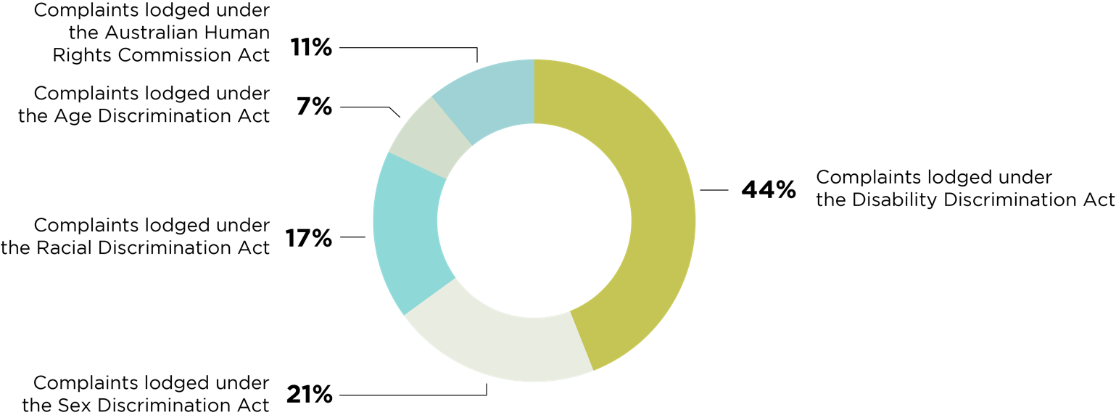
Reference: Australian Human Rights Commission 2020, Australian Human Rights Commission 2019-20 Complaint statistics, available at https://humanrights.gov.au/sites/default/files/2020-10/AHRC_AR_2019-20_Complaint_Stats_FINAL.pdf.
The Commission is responsible for promoting understanding and acceptance of the DDA, including undertaking research and educational programs to increase community understanding. Additionally, the Commission has the power to develop and publish guidelines to help individuals and businesses avoid discrimination on the basis of disability.

Disability discrimination
Discrimination occurs when someone is disadvantaged or treated unfavourably because of their own disability, or because of the disability of someone they’re associated with. This includes disability that a person currently has, once had, may have in future, or is assumed to have. This protection is also extended to friends, family and carers of a person with disability.
There are two types of unlawful discrimination.
‘Direct’ discrimination happens if a person is treated less favourably because of their disability. For example, if an employee was excluded from a team social activity because they have a vision impairment.
‘Indirect’ discrimination occurs when there is an unreasonable rule or policy that is the same for everyone but has an unfair effect on people with disability. For example, if the only way to enter a government building is through a set of stairs which prevents people with a physical disability from accessing the building.
Under the DDA, discrimination may occur at work, in education, in accessing premises, in providing, goods, services and facilities, in providing accommodation, in dealing with land, in participating in clubs and incorporated associations, in participating in sport, or in the administration of Commonwealth laws and programs.
Exceptions to a claim of discrimination under the DDA include when avoiding the discrimination would impose an unjustifiable hardship on the discriminator or when a person is unable to perform the inherent requirements of particular work even when reasonable adjustments had been made.
Disability Standards may be made under the DDA. There are Disability Standards in the areas of public transport, education and access to premises. It is a breach of the DDA to contravene a Disability Standard.

What is the role of a Disability
Action Plan?
To help employers and other organisations eliminate discrimination against people with disability and to increase awareness of the rights of people with disability, the DDA encourages organisations to develop “action plans” or what is commonly referred to as a DAP (Disability Action Plan). The purpose of a DAP is to encourage, recognise and promote an active commitment to eliminating disability discrimination and to promote the recognition of the rights of people with disability.
A DAP is a document which sets out your organisation’s strategy for identifying and addressing practices which might result in discrimination against people with disability and to promote the recognition of the rights of people with disability. It details how an organisation is making its workplace, products and services accessible and inclusive to people with disability, and informs the public how it is approaching diversity and inclusion. A DAP is similar to a business plan, as it sets out a blueprint for change that is short, action-oriented, time-sensitive and measurable.
Part 3 of the DDA relates to the development and use of DAPs, and sets out the provisions for a plan to be compliant with the DDA.

Disability Discrimination Act Part 3 – Action plans
59 Scope
This Part applies in relation to a person (the action planner) who, under Part 2, is prohibited from discriminating against another person on the ground of a disability of the other person.
60 Action plans
The action planner may prepare and implement an action plan.
61 Provisions of action plans
The action plan must include provisions relating to:
(a) the devising of policies and programs to achieve the objects of this Act; and
(b) the communication of these policies and programs to persons within the action planner; and
(c) the review of practices within the action planner with a view to the identification of any discriminatory practices; and
(d) the setting of goals and targets, where these may reasonably be determined against which the success of the plan in achieving the objects of the Act may be assessed; and
(e) the means, other than those referred to in paragraph (d), of evaluating the policies and programs referred to in paragraph (a); and
(f) the appointment of persons within the action planner to implement the provisions referred to in paragraphs (a) to (e) (inclusive).
62 Action plans may have other provisions
The action plan may include provisions, other than those referred to in section 61, that are not inconsistent with the objects of this Act.
63 Amendment of action plans
The action planner may, at any time, amend the action plan.
64 Action plans may be given to Commission
(1) The action planner may give a copy of the action plan, or of any amendments to the action plan, to the Commission. (2) If the action planner does so, the Commission must make the copy available to the public.

2.1 The importance of language
Language has a powerful impact on behaviours and community attitudes. Historically, the term ‘disability’ has been used to isolate and exclude people with disability by associating disability with deficit or illness—a ‘medical’ model of disability. During the disability rights movement of the 1960s, advocates sought to reframe the term while claiming their civil, political and economic rights as citizens.
The DDA refers to the development and use of action plans and does not specifically require the term ‘disability’ to be used in the title. The Commission has chosen to refer to “Disability Action Plans” (or DAPs) to recognise the experiences of people with disability and the need for specific action to address the ongoing barriers to inclusion and accessibility.
If your organisation includes disability as part of your broader diversity strategy rather than a separate action plan, it is still important to highlight the specific actions that you are taking to support people with disability. Not every person with disability has an accessibility requirement. An organisation’s ability to normalise the conversation concerning disability is a critical aspect of inclusion of people with disability.

Examples of provisions of action plans
Here are some examples of ways that you can achieve the provisions of action plans under the DDA
Provision | Example
Policies and programs to achieve the objects of the Act | An employment program to increase the number of employees with disability
Communication of these policies and programs to people identified in the plan | Providing a resource hub on the staff intranet
A review of practices to identify discriminatory practices | An access review of your premises
Goals and targets which can be assessed to determine the success of the plan | A target to decrease the number of complaints related to accessibility
Any other evaluation processes | A regular staff survey
Allocation of responsibility for each of the provisions | An implementation plan with clearly allocated responsibility for a team or individual

What is the Disability Action Plan Register?
Under section 64 of the DDA, organisations may provide a copy of their DAP and any amendments to the Commission. When the Commission receives a copy of a DAP, it will be published on the Disability Action Plan Register (the Register).
DAPs are made available on the Register so that organisations developing an action plan can benefit from other organisations’ work and experience. The Register also allows people with disability to see what an organisation has committed itself to achieving and contribute their views on how action plans and their implementation could be improved.
The DAP Register is available at https://humanrights.gov.au/our-work/disability-rights/register-disability-discrimination-act-action-plans. Registration of a DAP on the Register does not imply that it is endorsed by the Commission.

The role of a Disability Action Plan in determining unjustifiable hardship
Under the DDA, employers and businesses are required to make changes which reduce barriers for people with disability. These are known as ‘reasonable adjustments’ and may include changes such as making the premises more accessible, modifying equipment or changing work schedules.
In some circumstances, it may be unreasonable for these adjustments to be made if the cost or difficulty of providing access will place an ‘unjustifiable hardship’ on a person or organisation. Unjustifiable hardship is based on an assessment of what is fair and reasonable in the circumstances. If the proposed adjustments are likely to cause hardship, it is up to the person or organisation to show that they are unjustified.
If a complaint is made to the Commission regarding alleged disability discrimination, the Commission is obliged to consider any DAP which has been lodged on the Register when considering unjustifiable hardship.

What are the benefits of
a Disability Action Plan?

Benefits for individuals
A DAP provides employees and customers with a comprehensive understanding of what actions a business is taking to create a more inclusive and accessible environment. It demonstrates that your organisation is aware of the needs of people with disability and is committed to reducing direct and indirect discrimination. It also allows people with disability to make an informed choice when deciding on a business, service provider or employer by considering their understanding of disability and their role in creating a more inclusive community.
  - Benefits for organisations
One in five potential customers have a disability. This reflects a significant number of active participants in Australia’s economy. Ensuring that your organisation is accessible and inclusive can increase your customer base and potential earnings.
Research in the United Kingdom has demonstrated the economic value of the ‘Purple Pound’ which refers to the spending power of households with disability. In the UK, it was estimated that businesses lose approximately £2 billion per month by ignoring the needs of people with disability. This includes loss of income due to poor accessibility (both physical and digital) and poor customer service.
Digital accessibility continues to be a significant contributor to lost income, with 73% of potential customers experiencing barriers on more than a quarter of the websites they visited.

Missing out: The case for customer diversity
In 2017, the Australian Human Rights Commission launched the report, Missing out: The business case for customer diversity, in partnership with Deloitte Australia. This report found that paying attention to the needs and preferences of diverse customer groups improves customer experiences and significantly influences buying decisions.

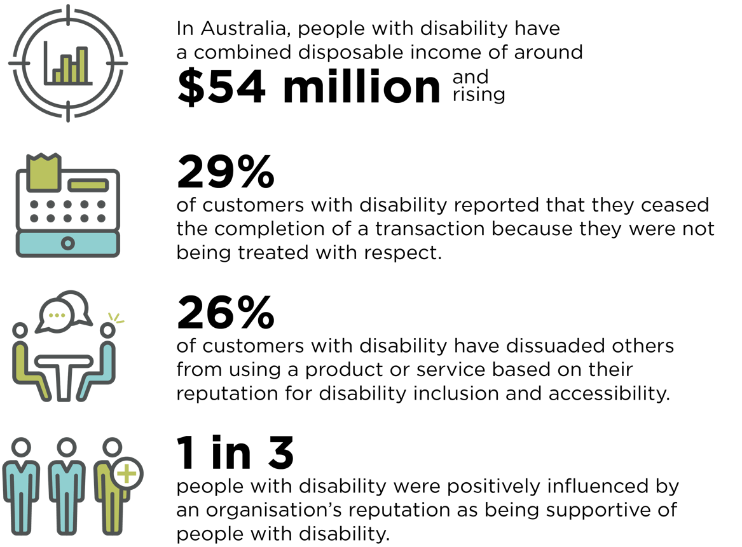

Reference: Australian Human Rights Commission 2017, Missing out: The business case for customer diversity, https://humanrights.gov.au/our-work/rights-and-freedoms/publications/missing-out-business-case-customer-diversity-2017.

Benefits for the workplace
Increasing the employment rate of people with disability in your organisation can have economic and social benefits which boost productivity and profit. A DAP can support your organisation to develop a strategy which promotes the recruitment and career progression of employees with disability.
Employees with disability consistently demonstrate punctuality, loyalty and high attendance rates. This creates a competitive advantage for businesses as a result of increased employee productivity and positive work ethos and reduced turn-over and absenteeism.
There are also benefits for the broader economy. In Australia, the labour force participation rate for people with disability aged 15–64 years is 53.4%, compared to 84.1% of people the same age without disability.
For more information, see the IncludeAbility factsheet The economic and business benefits of employing people with disability at https://includeability.gov.au/.

Benefits for the community
Research shows that to be successful in changing negative attitudes towards people with disability, policy initiatives must be directed at a personal, organisational and government level. Organisations and businesses can deliver change on both a personal and organisational level through strategic policies and programs. By committing to a DAP, your organisation can create meaningful change, extending beyond your workplace and business and into the broader community.
The process of developing and implementing a DAP can also support your organisation to increase community engagement. By establishing ongoing consultation processes, your organisation can hear directly from customers and better understand their needs.

Diversity includes disability
The ASX Corporate Governance Council Principles and Recommendations on Diversity Report (2015) highlighted that in Australia understanding of diversity goes beyond gender and includes age, disability, ethnicity, marital or family status, religious or cultural background, sexual orientation and gender identity.
Diversity policies may only focus on one or more of these characteristics, which limits the potential of an organisation to build a truly inclusive workplace and business. By recognising the intersectionality between different diversity characteristics, your organisation can better understand your employees, customers and community.

Who can develop a Disability Action Plan?
Any person or party who may be found to discriminate under the DDA can create a DAP. For example, employers, education providers, sporting organisations and organisations that provide goods, services and facilities.
In some states and territories, government agencies and bodies are required to develop a DAP or Disability Inclusion Action Plan (DIAP).
For example, in NSW all government agencies and local councils are required to develop a DIAP under the Disability Inclusion Act 2014 (NSW). This plan must set out the measures that the agency or council will undertake to support people with disability to access general supports and services available in the community and participate fully in community life.
A full list of relevant legislation is available in Appendix B.

Stages of developing a
Disability Action Plan
Your DAP will be specific to the needs of your organisation, regardless of size, type or where you are on your diversity and inclusion journey. It can be helpful to assess what stage you are at in your inclusion journey to inform your goals and strategies. Each DAP developed and implemented by your organisation helps achieve the broader goals of inclusion and diversity.

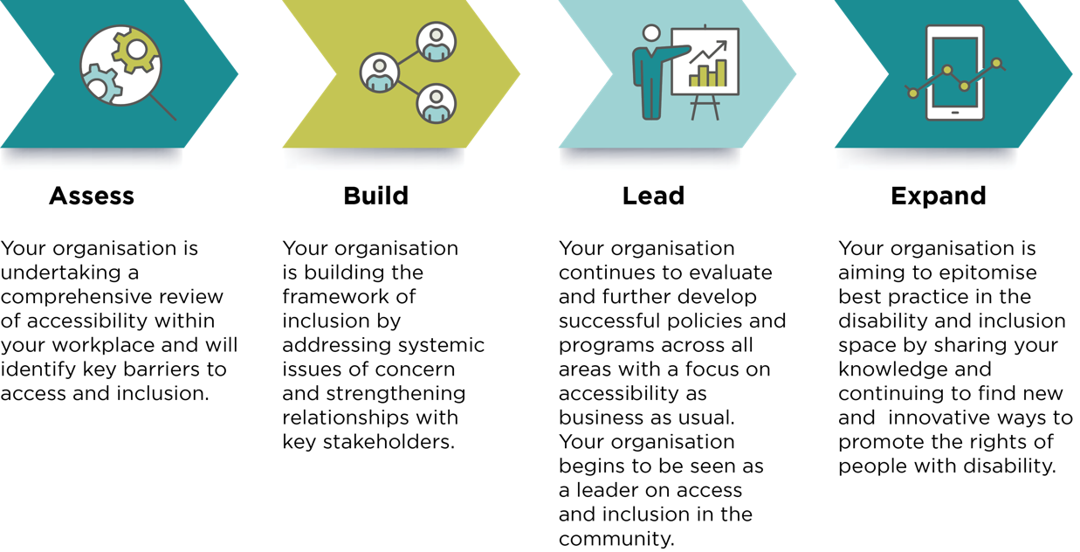

IncludeAbility Employer Network Spotlight – Westpac
At Westpac Group, accessibility is about giving equal access, inclusion and dignity to customers, employees, and the community, enabling them to access our products and services independently. We’re building it into the very core of what we do as part of our business purpose, Helping Australians and New Zealanders Succeed.
Having Access and Inclusion Plans helps bring our purpose to life in a practical and meaningful way. It outlines our renewed initiatives to helping those living with impairments or chronic health conditions succeed. Refreshing our Access and Inclusion strategic plan every few years allows us to focus efforts on innovation for more accessible banking products and services, as well as inclusive workplace practices and workspaces. Westpac Access and Inclusion Plans build on the solid foundation we’ve laid over the past two decades, while also seeking to address gaps through continued innovation and investment in accessibility.
Delivery of our initiatives are managed and tracked through the Access and Inclusion Committee, which is chaired by senior leaders in our business, reiterating top-down support for accessibility at Westpac Group. Measuring and tracking progress through an established governance process also helps us ask “what more we can do for people with disabilities”, whilst considering how we integrate accessibility into the way we view and manage our business.
To learn more about Westpac’s Access and Inclusion Plan, visit https://www.westpac.com.au/web-accessibility/accessibility-action-plan/.

How to develop a Disability Action Plan

Review business practice
The first step is to conduct a review or audit of the ways in which your organisation’s practices might result in unfavourable or disadvantageous treatment of people with disability.
Your review might find that your organisation directly or indirectly discriminates against people with disability. Although this can be confronting to realise, this step is crucial. Without identifying opportunities for improvement, it’s difficult to develop an effective plan for change. The information you gather from this review will be essential for evaluating progress towards the goals that you set in your DAP.
A successful review requires old practices to be considered from a new perspective. Because of their unique experiences, people with disability will often have expertise in quickly identifying those barriers which discourage people with disability from becoming customers or clients of your organisation. That said, your employees with disability should not be expected to lead the review unless they have expressed an interest in doing so. For this reason, it may be useful to have the review conducted independently by consultants or organisations which offer the expertise of people with disability.

Case Study
Abdul is the Disability and Inclusion lead at a local council. He wants to ensure that people with disability are consulted during the development of the new DAP.
His team have developed a consultation paper which is available in Easy Read, as a video with Auslan translation, and in several languages. Additionally, people with disability, their friends and family are able to contribute to the development of the DAP in the following ways:
- completing a survey which is available on the council website
- attending an online workshop or in-person town hall meeting
- nominating for the council Disability Advisory Panel to contribute to the development and implementation of the DAP
- emailing or posting a written submission in response to the consultation paper
- speaking with a member of the Disability and Inclusion team either at a council office or on the phone.
Through this consultation process, Abdul aims to ensure that the new DAP reflects the experiences of people with disability in the community and identifies key areas for improvement.

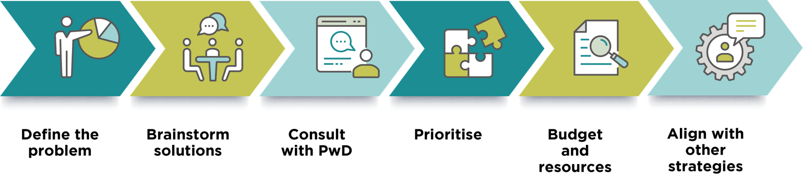

Devise policies and programs
Undertaking a business review and consulting with people with disability will have provided you with an understanding of where your organisation can improve. You will now be able to enhance existing policies and procedures, and develop new ones where needed to address these areas of concern.
It is important to remember that your DAP should be specific to the needs of your organisation, employees and customers, and reflect your stage of the inclusion journey.

Define the problem
The purpose of your DAP is to respond to the issues of concern identified in your business review and think strategically about how these can be minimised or resolved. Therefore, the first step in designing solutions should be clearly identifying and defining the problem.
Your policies and programs should also consider why the issue has occurred and what can be done to prevent or reduce the likelihood of it occurring again in the future. This helps ensure that your DAP has a long-term impact and creates lasting change.

Brainstorm solutions
When brainstorming solutions, it can be helpful to bring together a range of stakeholders from across your organisation.
This may involve consulting with the teams who have responsibility for a particular area which has been identified as inaccessible or creating a working group with representatives from across the organisation. By bringing together a diverse range of people, you can harness the experience and talent that already exists in your workplace.
Your organisation may also benefit from research and learning from other organisations. The Commission’s Disability Action Plan Register is a useful resource which allows you to learn from the experiences and successes from others in your industry.

Your DAP should also include consideration of how your organisation can increase the employment of people with disability through both recruitment and retention. For more information about attracting and recruiting people with disability and creating a more accessible and inclusive workplace, visit the IncludeAbility website: https://includeability.gov.au.

Consult with people with disability
The lived experience of people with disability should guide the development of policies and programs in your DAP.
When you have developed ideas to address the barriers to inclusion in your workplace, you should seek the feedback of people with disability and their formal and informal supports.
This may include providing a draft document for public consultation, establishing an advisory group or requesting feedback from key stakeholders such as peak disability organisations.

IncludeAbility Ambassador Reflection
Disability Action Plans (DAPs) can contribute a powerful foundation to an organisation’s value of inclusion. It creates a message for team members that says, ‘this is what we believe in and here is how we want to do it’.
To make a DAP powerful, input from people with lived experience is critical. This is because in all areas of life, we simply don’t know what we don’t know. Therefore, people with lived experience can provide important, sometimes hidden, insights into developing a meaningful DAP. Additionally, all people of the organisation should be invited to collaborate on a DAP. When a collaborative plan is developed in this way, the entire organisation becomes invested in deploying meaningful action.
Dinesh Palipana
IncludeAbility Ambassador
2021 Queensland Australian of the Year
International Day of People with Disability Ambassador

Prioritise your policies and programs
To be successful, your DAP should include a mixture of short, medium and long-term objectives which will be achieved over the life of your plan. Creating a priority list can assist you to develop a plan for how they will be implemented.
Consider using an ‘action priority matrix’ to prioritise. The ‘quick wins’ and ‘big projects’ will create the greatest impact for people with disability, so these should be prioritised first. The ‘filler tasks’ and ‘hard slogs’ are less impactful (but still important), so they can be considered as less of a priority.

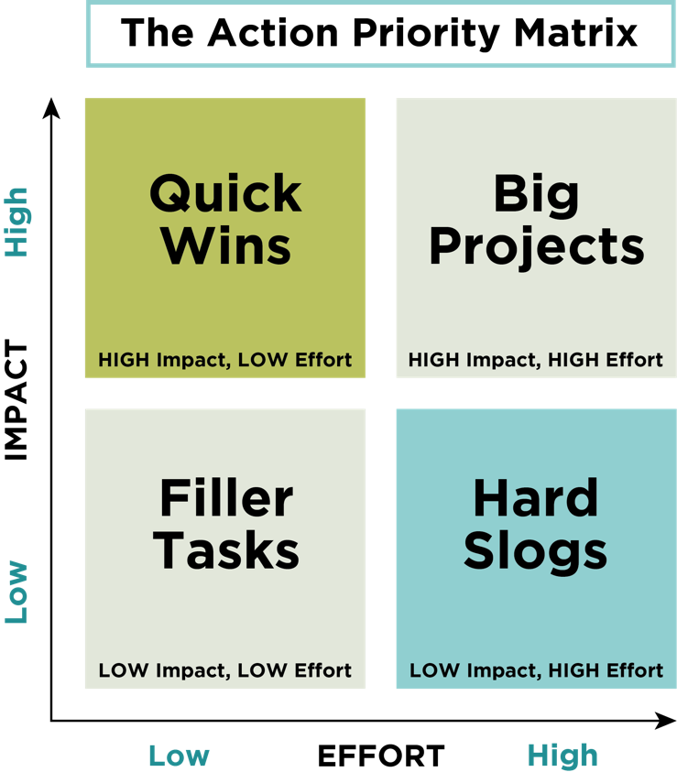

Description – an Action Priority Matrix with a square divided into four quarters. The top left is Quick Wins (high impact, low effort), the top right is Big Projects (high impact, high effort), the bottom left is Filler Tasks (low impact, low effort) and the bottom right is Hard Slogs (low impact, high effort).

Allocate budget and resources
Each of your policies and programs will require commitment from your organisation to ensure that they are implemented successfully. When planning your policies and programs, you should consider what resources will be required including:
- the time that people in your organisation need to scope, build and evaluate each new initiative
- the people who will be responsible for implementing the new policies and programs
- the cost of implementing these initiatives.
Allocating resources and budget for your DAP is an investment in a more inclusive and successful organisation. The costs of your policies and programs should be incorporated into current and future budgets.

Align your DAP with other planning and reporting documents
Your DAP should form part of your organisation’s broader strategic plans. This ensures that disability and inclusion is integrated in all planning processes.
How this is achieved will look different depending on the size of your organisation. You may consider:
- providing information about the progress of your DAP in your annual report
- including your DAP as a standing agenda item at planning and strategy meetings
- incorporating policies and programs from your DAP in business plans and key performance indicators.
Some organisations choose to incorporate their DAP into a broader Diversity and Inclusion Plan which also includes strategies to reduce discrimination for other groups – such as women, Aboriginal and Torres Strait Islander peoples, culturally and linguistically diverse and LGBTQI+ groups. This can assist in developing a holistic approach to inclusion and support interconnectivity between diversity initiatives. However, be mindful that this combined approach to a Diversity and Inclusion Plan can also risk solutions becoming too generalised and not effective in addressing the specific challenges facing people with disability. Consider the pros and cons of each approach and what will be most effective for your organisation.
If your organisation chooses to include disability as part of a broader Diversity and Inclusion Plan, you should ensure that it addresses the provisions of section 61 of the DDA.

Case Study
Cassie is leading the development of the DAP at the homewares company where she works.
As part of the business review, customers were invited to provide feedback through an online survey which was promoted through email and social media. In the survey, customers reported that the company’s advertising campaigns did not include people with disability.
Cassie recognised that increasing the representation of people with disability in the company’s marketing materials would promote inclusion and better represent their customer base. She found that the problem was occurring because the company did not have images of people with disability in the internal photo and video library and people with disability were not recruited as talent for campaigns.
After consulting with the marketing team, Cassie identified a mix of quick wins and bigger projects to address this issue:
- The marketing team will be provided with a budget to procure a range of images of people with disability for future publications.
- The brand guidelines will be updated to include a requirement that any marketing strategy or material will also include representation of people with disability.
- The marketing team will be required to report on how many marketing campaigns included a person with disability as a key performance indicator.

IncludeAbility Employer Network Spotlight
– Australia Post
Australia Post has developed their Accessibility and Inclusion Plan (2020–2022) including a whole-of-business approach with the aim of providing accessible and inclusive employment, products, services and places for everyone.
The Plan has five key commitments and goals which are specific to Australia Post, their customers and employees.
- Our Commitment – To actively listen to and consult with people with disability in the delivery of commitments in this plan.
- Our People – To drive employment and engagement of people with disability and continue to build a disability confident workplace.
- Our Customer – To provide accessible products, services and a dignified customer experience.
- Our Place – To make Australia Post an accessible place for everyone.
- Our Community – To strengthen community and supplier partnerships by promoting greater accessibility, disability awareness and community cohesion.
You can read more about Australia Post’s Accessibility and Inclusion Plan at https://auspost.com.au/about-us/corporate-responsibility/our-people/diversity-and-inclusion.

Establish goals and targets
To translate your DAP from planning to action, it is important to identify goals and targets which provide direction on how you will implement your policies and programs. These also provide the basis for your evaluation and assessment framework to measure the success of your DAP.

Consider using the ‘SMART goal’ framework to set goals that are:
 | Good example | Poor example
Specific  Be precise about what, where and how your goal will be achieved. | Ensure all external access points to the Brisbane office comply with physical accessibility standards. | Ensure all doors are accessible.
Measurable  Set goals that can use data, statistics and reporting to measure their success. | Increase employment of people with disability by 10% before July next year (compared with July last year) and retain them for at least 12 months. | Attract and retain more employees with disability.
Achievable  Be realistic and honest about your goals and their timeframes. | Ensure all employees in Victorian stores receive training on disability inclusion before the end of the year. | Ensure all employees in Victorian stores are disability experts before the end of next month.
Relevant  Ensure the goals actually help you implement the policies and programs you have devised. | Survey all employees by the end of this year to gather data on discriminatory attitudes to disability, to inform what training will be required. | Survey all employees by the end of this year to find out if their family members or friends have disability.
Time-bound  Provide realistic time limits. | By 31 August this year, update the website so that it complies with web accessibility standards. | Update the website so that it complies with web accessibility standards.

Develop evaluation strategies
The goals and targets that you have developed will inform your evaluation processes. Each policy and program should already include a timeline for completion and a measurable objective.
Evaluation should be an ongoing aspect of your disability strategy and should not be left until the end of the timeframe set up by your DAP. This enables your organisation to adapt, refine or expand a policy or program as needed.
Your DAP should include a governance structure which outlines how your DAP will be evaluated, who is responsible for undertaking the evaluation and how often this occurs.
For a small to medium business, this may be a quarterly meeting between senior leaders to review the progress of each policy and program. For a larger organisation, this may require a separate body with responsibility for assessing progress against defined criteria.
Data collection
Data collection should be central to your evaluation strategy. In addition to collecting data which is specific to each initiative, your organisation should undertake regular surveys to understand the experiences of employees and customers.
This may include an annual employee survey, a feedback form provided to customers after a transaction or focus groups with people with disability.
Employees and customers should have the opportunity to provide their feedback anonymously. Fear of identification or adverse consequences may prevent a person from providing honest insight into their experience with your organisation.
By collecting data on a regular basis, your organisation can identify trends and opportunities for improvement. This also provides an evidence base to inform future planning decisions.

IncludeAbility Ambassador and Employer Network Reflection
My name is Associate Professor Paul Harpur, I am the 2022 Blind of Australian of the Year, and I have the privilege of being a IncludeAbility Ambassador and chair of the University of Queensland (UQ) Disability Inclusion Group. The fact the CEO, the Vice Chancellor, commits the University to implementing our Disability Action Plan (DAP) provides this initiative gravitas, however implementing the plan is complex. Universities are highly fragmented organizations, with various organizational units training students, researching for and on, and engaging with every sector, industry, profession, and issue confronting the globe. Recognising the complexity of implementing the DAP, our leadership team appointed a senior executive, Professor Tim Dunne, as the Disability Champion. Professor Dunne has been committed to disability empowerment and supported my suggestion for me to lead a university-wide group to monitor and report on the DAP.
In 2019 the UQ Disability Inclusion Group received a University Excellence Award and I received an individual citation for my work chairing the group. The citation reads:
“Formed in 2017, UQ's Disability Inclusion Group (DIG) provides outstanding leadership and advocacy for students/staff with disability. The Group has delivered numerous programs and actions to dismantle physical, technological and cultural barriers impacting students and staff with disability, to enable full access to UQ life. The DIG is a unique operating model within Higher Education, in that it brings stakeholders, staff and students with disability together in a cohesive way, to champion and progress disability inclusion outcomes. The Disability Action Plan developed by DIG members in 2018 is considered 'industry leading', and is receiving considerable external interest. The DIG works across a range of area in support of inclusion, including law, academia, information technology, student and staff support, governance, property and facilities and library services.”
Persons with disabilities have the expertise to support disability inclusion, and when strongly supported by senior leadership, they also have the authority to realize change. The UQ DAP not only gives persons with disabilities a voice in governance, it also empowers them to have something to say.
UQ has recognised the importance of involving persons with disabilities in governance structures. The University is governed by a University Senate which operates in the same way that a board of directors operates corporations. At the suggestion of Dr Dee Gibbon, and with the support of Vice Chancellor Professor Debbie Terry, from 2020 the chairs of all equity and diversity groups joined the UQ Senate Sub-Committee on Equity, Diversity and Inclusion. This committee has Senators, the Vice Chancellor, Provost and some other senior executives participating. Our next DAP aims to reinforce and expand the inclusion of persons with disabilities in governance structures to help advance ability equality.
While advancing inclusion is the right thing, the UQ DAP helps align inclusion with core business. Universities train the leaders of tomorrow, employ the leaders of today, and produce research and innovation which transforms society. The UQ DAP commits the university to support research that will help it become a disability champion of change. This has led to UQ funding researchers to analyse the heightened financial impact on staff that travel for work. This has resulted in academic publications and the university adopting a staff disability travel fund to cover disability related costs when staff travel on university business. It has also led to research on digital access and the library developing a tool to enable to prefer suppliers who are more disability inclusive. Inclusion is now core university strategy and the University of Queensland’s enthusiastic involvement in the Australian Human Rights Commission’s IncludeAbility Employer Network is one signal of our commitment.
To learn more about the University of Queensland Disability Action Plan, visit https://staff.uq.edu.au/information-and-services/human-resources/diversity/commitment/strategies#0.

Allocate responsibility
Developing your DAP is an important step towards accessibility and inclusion however its success will depend on having clear lines of responsibility. This may best lie with an individual, a working group, or a committee, depending on the size and structure of your organisation.
Consider appointing a leader or leaders to oversee the implementation of the DAP, and delegate tasks to other members of the organisation. It is important to ensure these people have the authority and respect within the organisation to carry out this role.
Each policy and program should have an allocated lead or team responsible for implementation and reporting. This may already have been established through your goal setting and evaluation planning.
It can be helpful to present the responsibility of each stakeholder in a table. For example:
Action | Responsible stakeholder | Timeline | Measure of success
Include disability awareness training as part of onboarding for new employees. | Director of People and Culture | June 2022 | 100% of new staff complete disability awareness training within 3 months of commencing employment.
Undertake a review of ICT systems and processes and develop a strategy for remediation. | Director of Information and Technology | December 2022 | A proposal and budget for ICT remediation is presented to the Executive Leadership Team for consideration.

Communicate your Disability Action Plan

The accessibility of your DAP
It is important that your DAP is accessible for all employees, customers and stakeholders. This means that your DAP should be compliant with best practice for accessibility and available in multiple formats including:
- Word and PDF
- Easy Read
- Large print
- Braille
- Languages other than English.
For more information about how to make your document accessible, refer to the IncludeAbility Guide on Creating accessible and inclusive communications.
Easy Read
Easy Read is language that is presented in a way that is easy to understand and aims to remove barriers to accessible information. Easy Read encompasses accessible language, easy to understand illustrations, colours and layout. Incorporating an Easy Read DAP will allow people with intellectual disability, cultural and linguistically diverse communities, and people with lower literacy rates to access your plan. With 44% of Australians having literacy rates below the level of early high school, having an accessible DAP will not only reach this group but will also reflect your commitment to inclusion.

NSW Department of Communities and Justice
The NSW Department of Communities and Justice has adopted a web-based approach to publishing their Disability Inclusion Action Plan (DIAP). This creates an accessible and user-friendly version of the DIAP which is easy to understand.
This approach allows the department to update the public on the progress of each policy and program throughout the life of the DIAP, increasing transparency and accountability.
To learn more visit https://www.dcj.nsw.gov.au/about-us/disability-inclusion-action-plan.
© State of New South Wales (Department of Communities and Justice)
Copyright notice and disclaimer available at https://www.dcj.nsw.gov.au/copyright-and-disclaimer

Communicating your DAP internally
The success of your DAP relies on individuals making gradual, measurable changes to their behaviour and practices. To make this happen, your organisation’s employees need to understand their obligations under the DAP.
Some ways you can help set expectations include:
- regularly reporting on your DAP’s evaluation metrics, identifying and thanking the people who are responsible for achieving the DAP’s goals
- updating existing practices (for example, codes of conduct, performance management processes, and employee inductions) to reflect the goals and changes in your DAP
- taking a zero-tolerance stance on disability discrimination, harassment and bullying
- organising regular all-staff updates to be given directly by the CEO or other executives to reinforce the commitment of your senior leadership.

Establishing feedback channels
Your DAP should form part of an ongoing discussion regarding accessibility and inclusion. Encouraging and facilitating feedback from employees, customers and key stakeholders helps to improve your evaluation processes and inform the future direction of your DAP.
To achieve this, your DAP should be accompanied by information about how employees or customers can provide feedback on their experiences with your organisation and any comments they have regarding your DAP. This may include a feedback page on your website, dedicated email address or phone number.

Appendix A: Resources

IncludeAbility Health Check
The IncludeAbility Health Check will enable your organization to identify how it is performing across key areas in accessibility and inclusion. By undertaking this exercise annually your organisation will have a benchmark to reflect upon and celebrate its successes. It will also identify areas requiring further attention.
To learn more about the IncludeAbility Health Check visit https://includeability.gov.au/

International Labour Organization Global Business and Disability Network
The International Labour Organization Global Business and Disability Network (ILO Network) aims to create a global workforce culture that is respectful and welcoming of people with disabilities.
The ILO Network provides a blueprint for how this can be achieved through the Charter of principles including:
- respect and promotion of human rights
- non-discrimination
- equality of treatment and opportunities
- accessibility
- job retention
- confidentiality
- attention to all types of disabilities
- collaboration
- evaluation
- knowledge sharing.
The ILO Network is a useful resource for peer-to-peer learning and contains publications, resources and tools to support organisations to build workplace diversity. This includes the Charter self-assessment tool to support organisations to identify areas of improvement and provide recommendations for increasing inclusion.
To learn more about the ILO Network, visit http://www.businessanddisability.org/.

WeThe15
WeThe15 is the sporting world’s biggest ever human rights movement to end discrimination and was launched in 2021 during the Tokyo Paralympics. The campaign is a global movement of sport, human rights, policy, communications, business, arts and entertainment organisations which aims to transform the lives of the world’s 1.2 billion persons with disabilities.
WeThe15 will work with governments, businesses and the public over the next decade to initiate change, create more opportunities for persons with disabilities and improve mobility and accessibility.
To learn more about WeThe15 visit https://www.wethe15.org/.

South Australian Government Online Accessibility Toolkit
The Online Accessibility Toolkit provides information and guidance for embedding digital best practice into all aspects of development. This includes developing both digital platforms and content which is accessibility for the whole community.
To learn more about the Online Accessibility Toolkit visit https://www.accessibility.sa.gov.au/.

Paul Harpur TEDxUQ
Paul is an associate professor at the University of Queensland Law School, an Academic Fellow at the Harvard Law School Project on Disability, an international distinguished fellow with the Burton Blatt Institute, and non-executive director at Help Enterprises.
In his talk, Paul builds on his experiences chairing the UQ Disability Inclusion Group and his work at Harvard Law School Project on Disability as a Fulbrighter and sets out a vision for aligning disability inclusion with university strategy.
To learn more about integrating disability into broader strategy documents, this TED talk is available at https://youtu.be/ehHVY95snO4.

Appendix B: Relevant Legislation

Federal legislation
In Australia, the Disability Discrimination Act 1992 (Cth) (DDA) provides protection from discrimination on the basis of disability. This includes people with disability, people who are assumed to have disability and people who are relatives, friends, carers, co-workers or associates of a person with a disability.
The DDA protects people with disability from both direct and indirect discrimination in the following areas:
- work, accommodation, education, access to premises, clubs and sport
- the provision of goods, facilities, services and land
- existing laws
- the administration of Commonwealth laws and programs.
The development of Disability Action Plans is guided by section 61 of the DDA. This section includes the provisions which should be considered in the preparation of a DAP.
The DDA is supported by Disability Standards which provide more detail on rights and responsibilities about equal access and opportunity for people with a disability. Disability Standards are legally binding. These include:
- Disability (Access to Premises – Building) Standards 2010
- Disability Standards for Education 2005
- Disability Standards for Accessible Public Transport 2002
Guidelines (or ‘Advisory Notes’) are issued by the Commission to help people and organisations understand their rights and comply with their responsibilities under the DDA and accompanying Standards. This includes World Wide Web Access: Disability Discrimination Act Advisory Notes (2014).

State legislation
States and territories have also enacted legislation relating to disability discrimination. This legislation may include a requirement for state or territory government agencies or councils to develop and implement a DAP or similar document.
It is important for government agencies and bodies to understand their obligations under the relevant state legislation. Other organisations may benefit from understanding the framework for DAPs in their state or territory.

State or Territory | Anti-Discrimination Legislation | Legislation relating to Disability Action Plans
Australian Capital Territory | Equality Act 2010
New South Wales | Anti-Discrimination Act 1977 | Disability Inclusion Act 2014
Northern Territory | Anti-Discrimination Act 1992
Queensland | Anti-Discrimination Act 1991
South Australia | Equal Opportunity Act 1984 | Disability Inclusion Act 2018
Tasmania | Anti-Discrimination Act 1998
Victoria | Equal Opportunity Act 2010  Charter of Human Rights and Responsibilities Act 2006 | Disability Act 2006
Western Australia | Equal Opportunity Act 1984 | Disability Services Act 1993

Appendix C: Disability policy in Australia

Australia’s Disability Strategy
Australia’s Disability Strategy 2021–2031 (the Strategy) is Australia’s national disability policy framework. It provides a plan for how all levels of government will work together to improve outcomes for people with disability.
The vision of the Strategy is for an inclusive Australian society that ensures people with disability can fulfil their potential, as equal members of the community. The Strategy provides the framework for how Australia will ensure the rights of people with disability under the CRPD by identifying practical changes which remove barriers to inclusion.
The Strategy has seven Outcome Areas which will enable people with disability to participate in society on an equal basis to others.
- Employment and Financial Security
- Inclusive Homes and Communities
- Safety, Rights and Justice
- Personal and Community Support
- Education and Learning
- Health and Wellbeing
- Community Attitudes
The Strategy is built on the interconnectedness of the Outcome Areas, recognising that success in one area will contribute to the progress for another. For example, when community attitudes support equality, inclusion and participation, people with disability are able to achieve their full potential in education and employment.
The implementation of the Strategy will also be supported by Targeted Action Plans and Associated Plans.
Targeted Action Plans (TAPs) are short plans which outline how federal, state and territory governments will achieve outcomes in specific areas. Each TAP is focused on improving a particular Outcome Area by focusing on evidence-based actions and initiatives. TAPs are intended to run for between one and three years with new TAPs commissioned throughout the life of the Strategy.
Associated Plans (APs) are strategies, plans, roadmaps and frameworks which provide a longer-term approach for achieving the Outcome Areas. An AP may be sector specific (for example, the arts sector) or for a specific segment of the community (e.g. people with intellectual disability). They last for between three to ten years and provide a cohesive plan for how different government initiatives will work together to support the vision of the Strategy.
To learn more about Australia’s Disability Strategy visit https://www.disabilitygateway.gov.au/ads.

The National Disability Insurance Scheme
The National Disability Insurance Scheme (NDIS) provides support to people with disability to achieve their goals, build skills and participate in the community. To be eligible to receive funding through the NDIS, a person must be aged under 65 with a permanent and significant disability and be either an Australian citizen or resident.
The NDIS provides individual funding for reasonable and necessary supports and services to help a participant achieve their goals. This is based on a participant’s NDIS plan which outlines their goals, needs and funding. Participants have the choice and control to decide who they would like to deliver their supports and how they will be provided. At 30 September 2021, 484,700 participants had an NDIS plan. This represents only 10-15% of people with disability in Australia.
The NDIS also provides people with disability who are not eligible for funding with information and connections to services in their communities as well as information about what support is provided by each state and territory government.

Appendix D: International
human rights instruments

The Convention on the Rights of Persons with Disabilities
The Convention on the Rights of Persons with Disabilities (CRPD) is the international human rights convention which sets out the fundamental human rights of people with disability. It recognises the universal and indivisible rights of all people with disability, including the right to live free from discrimination and fully participate in all aspects of life.
The CRPD contains the main human rights provisions expressed as a series of Articles. These include the right to equal recognition before the law, access to justice, freedom from exploitation, violence and abuse, and the right to live independently and be included in the community.
Under the CRPD, people with disability have the right to dignity, independence, full participation and inclusion in society. This right is universal and extends to all aspects of life including the physical, social, economic and cultural environment.
The CRPD is accompanied by the Optional Protocol. The Optional Protocol to the CRPD enables people with disability to make individual complaints to the Committee on the Rights of Persons with Disabilities if they believe that their rights have been violated by a state party or government.
The CRPD and its Optional Protocol opened for signature on 30 March 2007 and Australia became one of the original signatories. The CRPD entered into force for Australia on 16 August 2008, and the Optional Protocol in 2009.

International Covenant on Civil and Political Rights
The International Covenant on Civil and Political Rights (ICCPR) recognises that every person has the right to self-determination as well as physical integrity, liberty, security of the person and equality before the law.
The ICCPR opened for signature on 19 December 1966 and was signed by Australia on 18 December 1972. Australia ratified the ICCPR on 13 August 1980.

International Covenant on Economic, Social and Cultural Rights
The International Covenant on Economic, Social and Cultural Rights (ICESCR) protects the right to work, social security, family life, health, education and participation in cultural life.
The ICESCR was opened for signature on 19 December 1966 and was signed by Australia on 18 December 1972. Australia ratified the ICESCR on 10 December 1975.

Sustainable Development Goals
Organisations have a corporate responsibility to reduce discrimination and create a more equitable and inclusive society. This can only be achieved with the full participation of all people, including people with disability.
Built on the principle of ‘leaving no one behind’, the 2023 Sustainable Development Goals emphasise the need to actively promote the rights of people with disability, not only as a moral imperative but as a practical necessity. With more than one billion people with disability around the world, disability-inclusive practices are essential to achieving sustainable development for all.

United Nations Disability Inclusion Strategy
The United Nations Disability Inclusion Strategy provides the foundation for sustainable and transformative progress on disability inclusion through all pillars of the work of the United Nations.
Through the Strategy, the organizations of the United Nations system reaffirm that the full and complete realization of the human rights of all persons with disabilities is an inalienable, integral and indivisible part of all human rights and fundamental freedoms.

Endnotes

Australian Institute of Health and Welfare (AIHW) 2020, Chronic conditions and multimorbidity, viewed 27 October 2021, https://www.aihw.gov.au/reports/australias-health/chronic-conditions-and-multimorbidity.
Australian Human Rights Commission 2020, Australian Human Rights Commission 2019-20 Complaints Statistics, https://humanrights.gov.au/sites/default/files/2020-10/AHRC_AR_2019-20_Complaint_Stats_FINAL.pdf.
Disability Discrimination Act 1992 (Cth) s 67(1)(g)(h).
Disability Discrimination Act 1992 (Cth) s 67(1)(k).
Disability Discrimination Act 1992 (Cth) s 61.
Royal Commission into Violence, Abuse, Neglect and Exploitation of People with Disability 2021, Disability in Australia: Shadows, struggles and successes, https://disability.royalcommission.gov.au/node/6718.
Royal Commission into Violence, Abuse, Neglect and Exploitation of People with Disability 2021, Disability in Australia: Shadows, struggles and successes, p 46, https://disability.royalcommission.gov.au/node/6718. Australian Law Reform Commission 2014, Equality, capacity and disability in Commonwealth Laws, p 49 https://www.alrc.gov.au/publication/equality-capacity-and-disability-in-commonwealth-laws-alrc-report-124/.
Disability Discrimination Act 1992 (Cth) s 11(1)(e).
Australian Chamber of Commerce and Industry, Employ Outside the Box: The Business Case for Employing People with Disability (2014).
Purple, The purple pound, Accessed 8 October 2021, https://wearepurple.org.uk/the-purple-pound-infographic/.
Purple, The purple pound, Accessed 8 October 2021, https://wearepurple.org.uk/the-purple-pound-infographic/.
Australian Human Rights Commission, 2017, Missing out: The business case for customer diversity, p 12 https://humanrights.gov.au/our-work/rights-and-freedoms/publications/missing-out-business-case-customer-diversity-2017.
Lindsay S, Cagliostro E, Albarico M, Mortaji N and Karon L, ‘A systematic review of the benefits of hiring people with disabilities’ (2018) 28 Journal of Occupational Rehabilitation 634-655.
The labour force participation rate is the sum of working-age (aged 15-64) people who are employed or unemployed and looking for work as a percentage of the working-age population. See: Australian Institute of Health and Welfare, People with Disability in Australia (Cat no DIS 72, 2 October 2020).
Australian Bureau of Statistics, Disability, Ageing and Carers, Australia: Summary of Findings, 2018 (Catalogue No. 4430.0, 24 October 2019).
Fisher, KR and Purcal, C, 2017. Policies to change attitudes to people with disabilities. Scandinavian Journal of Disability Research, 19(2), pp 161–174 DOI: http://doi.org/10.1080/15017419.2016.1222303.
KPMG 2015, ASX Corporate Governance Council Principles and Recommendations on Diversity, https://www.asx.com.au/documents/asx-compliance/asx-corp-governance-kpmg-diversity-report.pdf.
Disability Discrimination Act 1992 (Cth) s 59.
Disability Inclusion Act 2014 (NSW) s 13(1).
Australian Bureau of statics (ABS) 2013, Programme for the International Assessment of Adult Competencies, Australia, Viewed 5 November 2021, https://www.abs.gov.au/statistics/people/education/programme-international-assessment-adult-competencies-australia/latest-release.
Disability Discrimination Act 1992 (Cth) s 3(a).
United Nations, 2018 Disability and development report: Realizing the Sustainable Development Goals by, for and with persons with disabilities, https://www.un.org/development/desa/disabilities/about-us/sustainable-development-goals-sdgs-and-disability.html.

