

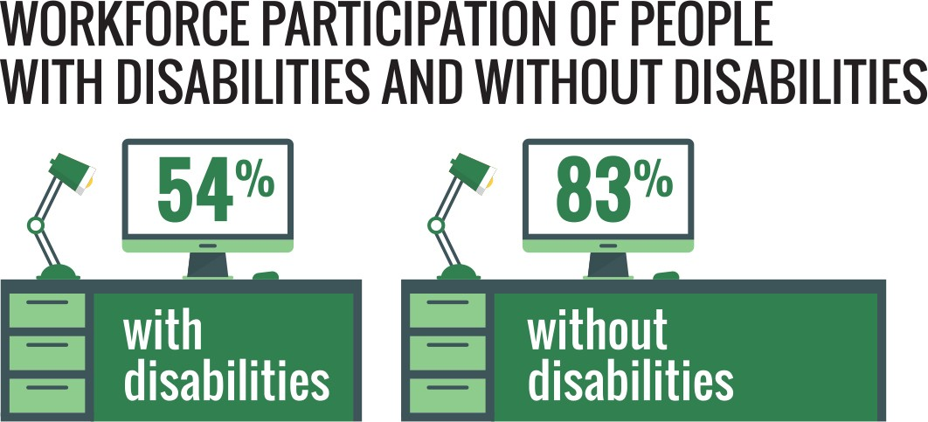

**Face the facts:**

DISABILITY RIGHTS • **2014**

The Australian Human Rights Commission encourages the dissemination and exchange of information provided in this publication. All material presented in this publication is provided under Creative Commons Attribution 3.0 Australia, with the exception of:

* the Australian Human Rights Commission Logo
* photographs and images
* any content or material provided by third parties.

The details of the relevant licence conditions are available on the Creative Commons website, as is the full legal code for the CC BY 3.0 AU licence.

**Attribution**

Material obtained from this publication is to be attributed to the Australian Human Rights Commission with the following copyright notice:

© Australian Human Rights Commission 2014.

**Face the Facts:** Disability rights • **2014 ISBN** 978-1-921449-67-3

**Design and layout** Dancingirl Designs

**Infographic Design** Firefly Interactive

**Content** James Iliffe, Black and White Media Australia

**Electronic format**

This publication can be found in electronic format on the website of the Australian Human Rights Commission:

[**http://www.humanrights.gov.au/publications**](http://www.humanrights.gov.au/publications/sex-discrimination)

**Contact details**

For further information about the Australian Human Rights Commission, please visit

[**www.humanrights.gov.au**](http://www.humanrights.gov.au/)or email [**communications@humanrights.gov.au**.](mailto:communications@humanrights.gov.au) You can also write to:

Communications Team

Australian Human Rights Commission GPO Box 5218

Sydney NSW 2001

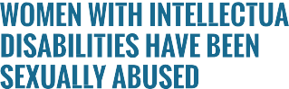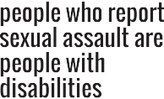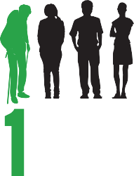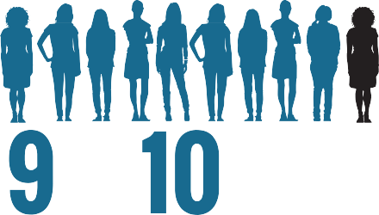

## 

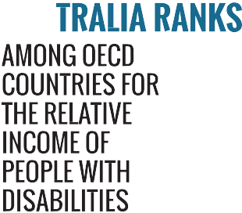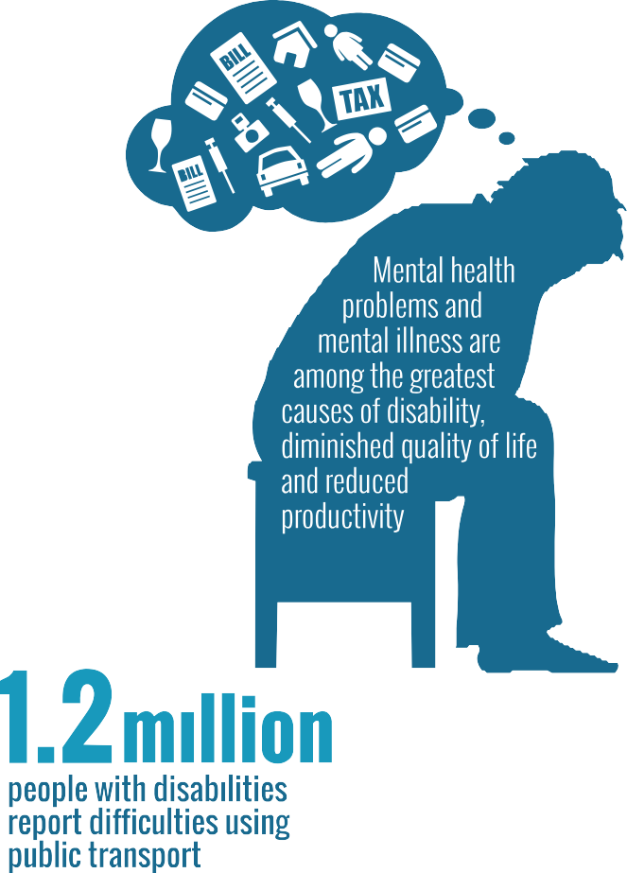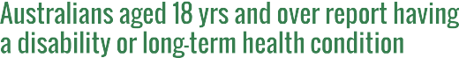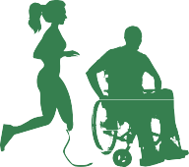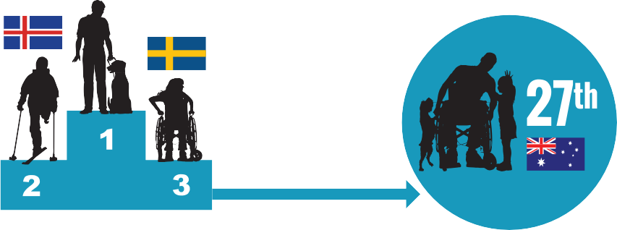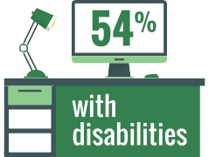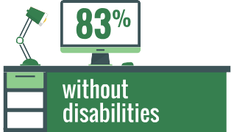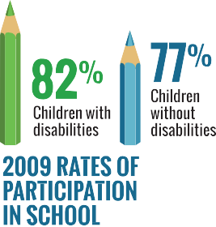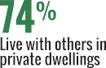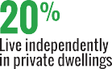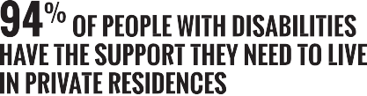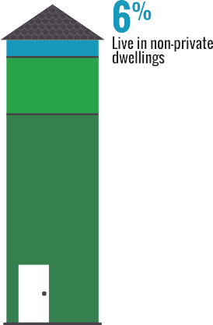

 



[**www.humanrights.gov.au/face-facts**](http://www.humanrights.gov.au/face-facts)



Disability rights

Many people will have a disability at some stage in their lives. For some, the disability will be temporary. Others may be affected for a lifetime.

Whatever the type or impact of a disability, everyone has the right to be an active member of their community and to have a say in the decisions that affect their lives.

The United Nations [Convention on the Rights of Persons with](https://www.humanrights.gov.au/our-work/disability-rights/international/disability-rights-international-convention-human-rights-and) [Disabilities](https://www.humanrights.gov.au/our-work/disability-rights/international/disability-rights-international-convention-human-rights-and), which Australia ratified in 2008, sets out the role of governments to make this a reality.

However, negative attitudes, physical barriers and difficulties accessing necessary supports still limit the opportunities of people with disabilities to find work, study, socialise and be included in community life.

In Australia, the [Disability Discrimination Act](http://www.humanrights.gov.au/about/legislation/index.html#dda) protects people across Australia from unfair treatment in many areas of public life. It also promotes equal rights, equal opportunity and equal access for people with disabilities.

# About

* + Around 6.8 million Australians (40 per cent) aged 18 years and over report having a disability or long-

term health condition.1 Most (87 per cent) are restricted in carrying out at least one everyday activity, such as self-care, mobility or communication.2

* + The likelihood of having a disability increases as people age. For example, seven per cent of children aged under 15 years, 15 per cent of people aged

15 to 64 years and over half (53 per cent) of people aged 65 years and over report having some form of disability.3

* + In 2009, 290,000 children aged 0 to 14 years reported having a disability. Over half (57 per cent) had a profound or severe disability and almost one in five (18 per cent) had a moderate or mild disability.4

# Key issues for people with disabilities

* People with disabilities are more likely to experience poverty, live in poor quality or insecure housing and have low levels of education. They are often socially isolated, with fewer opportunities to take part in community life.5
* Mental health problems and mental illness are among the greatest causes of disability, diminished quality of life and reduced productivity.6
* Australia ranks lowest among OECD countries for the relative income of people with disabilities.7 Overall employment rates for people with disabilities remain low, with workforce participation at around 54 per cent compared to 83 per cent for people without a disability.8
* In NSW, young people with mental health disorders and/or cognitive impairment are at least six times more likely to be in prison compared with young people without a disability.9
* Despite progress towards making all public transport in Australia fully accessible by 2022, 1.2 million people with disabilities report difficulties using public transport.10
* More than a quarter of people who report sexual assault have a disability.11 Ninety per cent of women with intellectual disabilities have been sexually abused.12

# Positive developments

* + In 2009, children with disabilities had significantly higher rates of participation in school compared to children without disability (82 per cent and 77 per cent respectively). This reflects a growing number of children with disabilities staying in school for longer.13
  + Most people with disabilities (94 per cent) have the support they need to live in private residences; 74 per cent live with others and 20 per cent live alone. People with disabilities are also more likely to own their own home outright (24 per cent) compared with people who do not have disabilities (16 per cent).14
  + In July 2013, the [National Disability Insurance](http://www.ndis.gov.au/) [Scheme](http://www.ndis.gov.au/) was rolled out in Tasmania, South Australia, Victoria (Barwon area) and NSW (Hunter area). From July 2014, it will commence across the ACT and in the Northern Territory (Barkly region) and Western Australia (Perth Hills area). The full national scheme will commence progressively from July 2016.

# Did you know?

The life expectancy of Australians born with Down Syndrome has more than tripled in the four decades to 2002, increasing from 18 years to 60 years. A contributing factor to this positive outcome is the shift in public attitudes regarding Down Syndrome.15

# Find out more

* Australian Human Rights Commission, [*Twenty Years,*](http://www.humanrights.gov.au/twenty-years-twenty-stories)[*Twenty Stories; Celebrating 20 years of the Disability*](http://www.humanrights.gov.au/twenty-years-twenty-stories)[*Discrimination Act*](http://www.humanrights.gov.au/twenty-years-twenty-stories)(2013)
* Council of Australian Governments (COAG), [*Disability*](https://www.coagreformcouncil.gov.au/reports/disability/disability-2011-12-comparing-performance-across-australia)[*2011-12: Comparing performance across Australia*](https://www.coagreformcouncil.gov.au/reports/disability/disability-2011-12-comparing-performance-across-australia)(2013)
* Department of Social Services, [*National Disability*](http://www.dss.gov.au/our-responsibilities/disability-and-carers/program-services/government-international/national-disability-strategy#1)[*Strategy 2010-2020*](http://www.dss.gov.au/our-responsibilities/disability-and-carers/program-services/government-international/national-disability-strategy#1)(2011)
* National People with Disabilities and Carer Council, [*Shut Out: The Experience of People with Disabilities*](http://www.dss.gov.au/our-responsibilities/disability-and-carers/program-services/government-international/national-disability-strategy-shut-out-report)[*and their Families in Australia*](http://www.dss.gov.au/our-responsibilities/disability-and-carers/program-services/government-international/national-disability-strategy-shut-out-report)(2012)

# Our role

The Commission helps people resolve complaints of unfair treatment under the [Disability Discrimination Act](http://www.humanrights.gov.au/about/legislation/index.html#dda). We also assess applications for temporary [exemptions](http://www.humanrights.gov.au/disability_rights/exemptions/exemptions.html) under the Act and provide advice on laws, policies and programs that affect people with disabilities.

The [Disability Discrimination Commissioner](http://www.humanrights.gov.au/about/president_commissioners/innes.html) works in partnership with others to help all Australians understand their rights and meet their legal responsibilities by conducting

[public inquiries](http://www.humanrights.gov.au/disability_rights/inquiries/inquiries.html), negotiating disability [standards and guidelines](http://www.humanrights.gov.au/disability_rights/standards/standards.html) and assisting organisations to develop [Disability Action Plans](http://www.humanrights.gov.au/disability_rights/action_plans/index.html).

Find out more about [our work](https://www.humanrights.gov.au/our-work/disability-rights) in this area.

Endnotes

1. Australian Bureau of Statistics, [*4159.0-General Social Survey: Summary*](http://www.abs.gov.au/ausstats/abs%40.nsf/Products/7CF609FE3B72F353CA25791A0082C3EB?opendocument)[*Results, Australia, 2010*](http://www.abs.gov.au/ausstats/abs%40.nsf/Products/7CF609FE3B72F353CA25791A0082C3EB?opendocument)(September 2011).
2. Australian Bureau of Statistics, [*4429.0-Profiles of Disability, Australia,*](http://www.abs.gov.au/ausstats/abs%40.nsf/Lookup/by%20Subject/4429.0%7E2009%7EMain%20Features%7EHome%20Page%7E1)[*2009*](http://www.abs.gov.au/ausstats/abs%40.nsf/Lookup/by%20Subject/4429.0%7E2009%7EMain%20Features%7EHome%20Page%7E1)(June 2012).
3. Victorian Health Promotion Foundation (VicHealth), [*Disability and health*](http://www.vichealth.vic.gov.au/Publications/Health-Inequalities/Disability-and-health-inequalities-in-Australia.aspx)[*inequalities in Australia*](http://www.vichealth.vic.gov.au/Publications/Health-Inequalities/Disability-and-health-inequalities-in-Australia.aspx)(2012). This prevalence data is based on a VicHealth analyses of the [*Survey of Disability, Ageing and Carers 2009*](http://www.abs.gov.au/AUSSTATS/abs%40.nsf/DetailsPage/4430.02009)and the current ABS disability classification system.
4. Australian Bureau of Statistics, [*4102.0-Australian Social Trends, June*](http://www.abs.gov.au/AUSSTATS/abs%40.nsf/Lookup/4102.0Main%2BFeatures30Jun%2B2012)[*2012*](http://www.abs.gov.au/AUSSTATS/abs%40.nsf/Lookup/4102.0Main%2BFeatures30Jun%2B2012)(June 2012).
5. World Health Organization and World Bank Group, [*World report on*](http://www.who.int/disabilities/world_report/2011/en/)[*disability*](http://www.who.int/disabilities/world_report/2011/en/)(2011), p 263.
6. Australian Bureau of Statistics, *4446.0-Disability, Australia, 2009*

(May 2011).

1. Organisation for Economic Co-operation and Development, [*Sickness,*](http://www.oecd.org/employment/emp/42699911.pdf)[*disability and work: Keeping on track in the economic downturn –*](http://www.oecd.org/employment/emp/42699911.pdf)[*Background paper*](http://www.oecd.org/employment/emp/42699911.pdf)(2009), p 34.
2. Australian Human Rights Commission, [*Submission to the United Nations*](https://www.humanrights.gov.au/submissions/information-concerning-australia-and-convention-rights-persons-disabilities)[*Committee on the Rights of Persons with Disabilities: Information*](https://www.humanrights.gov.au/submissions/information-concerning-australia-and-convention-rights-persons-disabilities)[*concerning Australia and the Convention on the Rights of Persons with*](https://www.humanrights.gov.au/submissions/information-concerning-australia-and-convention-rights-persons-disabilities)[*Disabilities*](https://www.humanrights.gov.au/submissions/information-concerning-australia-and-convention-rights-persons-disabilities)(11 March 2013); Australian Bureau of Statistics, note 6.
3. University of New South Wales and PwC, [*People with mental health*](https://www.humanrights.gov.au/publications/justice-reinvestment-people-disability-could-save-millions)[*disorders and cognitive impairment in the criminal justice system: Cost-*](https://www.humanrights.gov.au/publications/justice-reinvestment-people-disability-could-save-millions)[*benefit analysis of early support and diversion*](https://www.humanrights.gov.au/publications/justice-reinvestment-people-disability-could-save-millions)(2013).
4. Australian Bureau of Statistics, note 6, [Transport](http://www.abs.gov.au/ausstats/abs%40.nsf/Latestproducts/4446.0Main%20Features122009?opendocument&amp;tabname=Summary&amp;prodno=4446.0&amp;issue=2009&amp;num&amp;view) (2011).
5. Statewide Steering Committee to Reduce Sexual Assault, Office of Women’s Policy, Department for Victorian Communities, [*Study of*](http://mams.rmit.edu.au/igzd08ddxtpwz.pdf)[*Reported Rapes in Victoria 2000–2003: Summary Research Report*](http://mams.rmit.edu.au/igzd08ddxtpwz.pdf)(2006), p 16.
6. C Frohmader, Women with Disabilities Australia, [*There is no justice –*](http://find.lib.uts.edu.au/search.do%3Bjsessionid%3D418D49B976CF8AE8B80A2BDC1C293C58?R=OPAC_b1880778)[*there’s just us: The status of women with disabilities in Australia*](http://find.lib.uts.edu.au/search.do%3Bjsessionid%3D418D49B976CF8AE8B80A2BDC1C293C58?R=OPAC_b1880778)(2002); as cited in VicHealth, [*Disability and health inequalities in Australia*](http://www.vichealth.vic.gov.au/Publications/Health-Inequalities/Disability-and-health-inequalities-in-Australia.aspx)(2012).
7. Australian Bureau of Statistics, note 2.
8. Australian Bureau of Statistics, note 6.
9. A Bittles and E Glasson 2004, [*‘*Clinical, social, and ethical implications of](http://onlinelibrary.wiley.com/doi/10.1111/j.1469-8749.2004.tb00483.x/abstract) [changing life expectancy in Down syndrome’](http://onlinelibrary.wiley.com/doi/10.1111/j.1469-8749.2004.tb00483.x/abstract), *Developmental Medicine & Child Neurology*, vol 46, no 4 (2004) p 282.