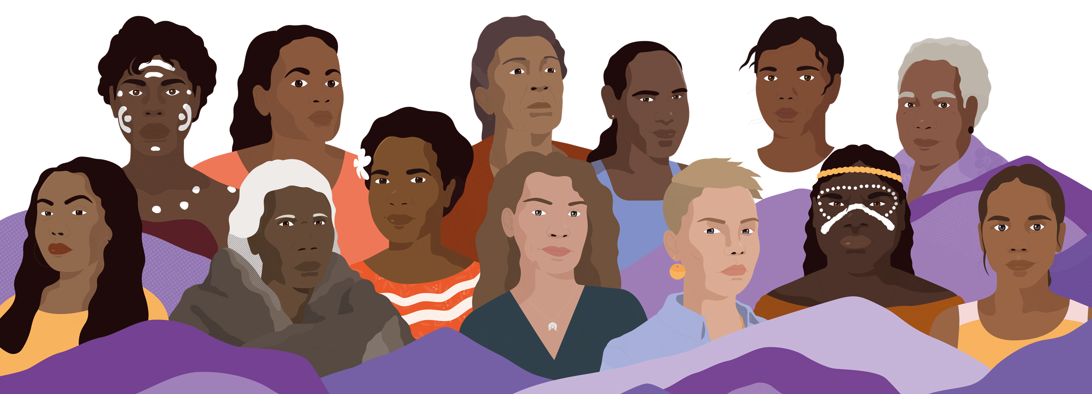
WIYI YANI U THANGANI YOUTH STATEMENT 2023

At the historic Wiyi Yani U Thangani, Women’s Voices Summit, we the Aboriginal & Torres Strait Islander Youth Forum representatives share with you Our Youth Statement – Strength from the past and our vision for the future.
To our First Nations Matriarchs we say thank you. It is your hands that have held us, nurtured us and empowered us. You have paved the way for the opportunities that we have today. As First Nations young people, we see the power and strength of your advocacy.
As young people standing in their power, we gathered ready to embrace change. From the desert, the saltwater and freshwater, the islands north and south, the top of the mountain ranges and the deep valleys, we have traveled to share our truth.
As first nations young people present, we are a small representation of the many more back home in our communities and across our vast country. As a collective we are diverse in our viewpoints and in our lived experience. This is what makes us strong. We can debate and challenge each other with love, care and respect. These are demonstrations of our readiness to exercise our self-directing freedom, our moral independence, our autonomy of our own bodies, our lives, our families and our
communities. It is our birth-right to be able to exercise our autonomy over our culture and our future.
We have demonstrated over thousands of years how we govern ourselves. We live as part of the ecosystem in balance with our lands, waters and skies. Our people educated our young ones and cared for our elders. We have managed our affairs and had international trade with our neighbours. Our first nations worldview prepares us for modern challenges.

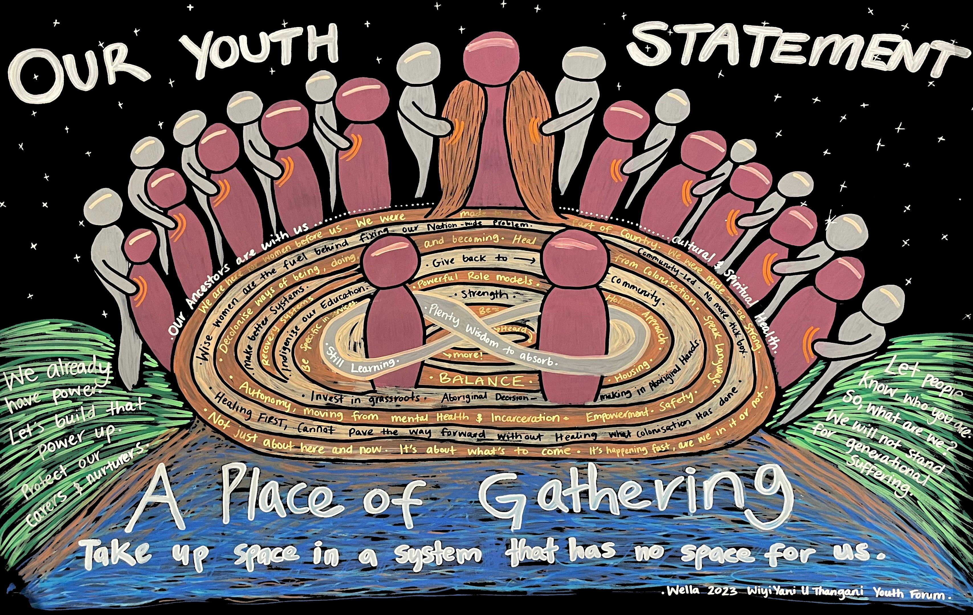
Our shared history teaches us that this country has built and continues to build systems that were not made for our empowerment. They were void of our ancestors’ voices. Void of our solutions and our priorities. Yet, our elders and our ancestors continued to show up and challenge those systems. As young people in the 21st century, we inherit the legacy of these systems that continue to fail us.
The future holds more challenges, some old and some new. Challenges that we have never seen before. Some of our pressing concerns are first nations gender justice, climate justice, our self-determination and our cultural integrity in the digital world. As our nation’s future leaders,
academics, policy makers, professionals, partners, carers and mothers. We make this commitment to you all, we will continue to show up. We will continue to be a part of the solution. We will continue to take back our space and have our voices heard.
The First Nations Gender Justice Institute provides us with this space to have a say on the policies and systems that impact our lives. We must have an independent voice, that amplifies our truths. As the future leaders that will continue to drive forward the work of the institute, the work of our matriarchs, we call for your trust in our contributions. We seek not one seat but many seats at your table.
The voices and seats must extend beyond the First Nations gender Justice Institute, we call upon our community leaders and elders to continue to make space in our own communities' decision making for young people to listen, learn and contribute.

2 |

As the largest demographic of First Nations people, young people deserve the right to speak and be heard. There are so many other youth voices that have not been heard or valued. We want to come together with young women, men, trans and non-binary mob, neurodiverse mob and mob with disabilities. We deserve more time to connect across our diverse experiences. We deserve a national space to build meaningful relationships that enable us to create systemic change. We seek your support to host the FIRST Aboriginal & Torres Strait Islander National Youth Summit that is led, designed and hosted by First Nations young people.
As we step up to drink water from the well, we will not forget who dug the well. Together we will raise our families and our communities in a new future.

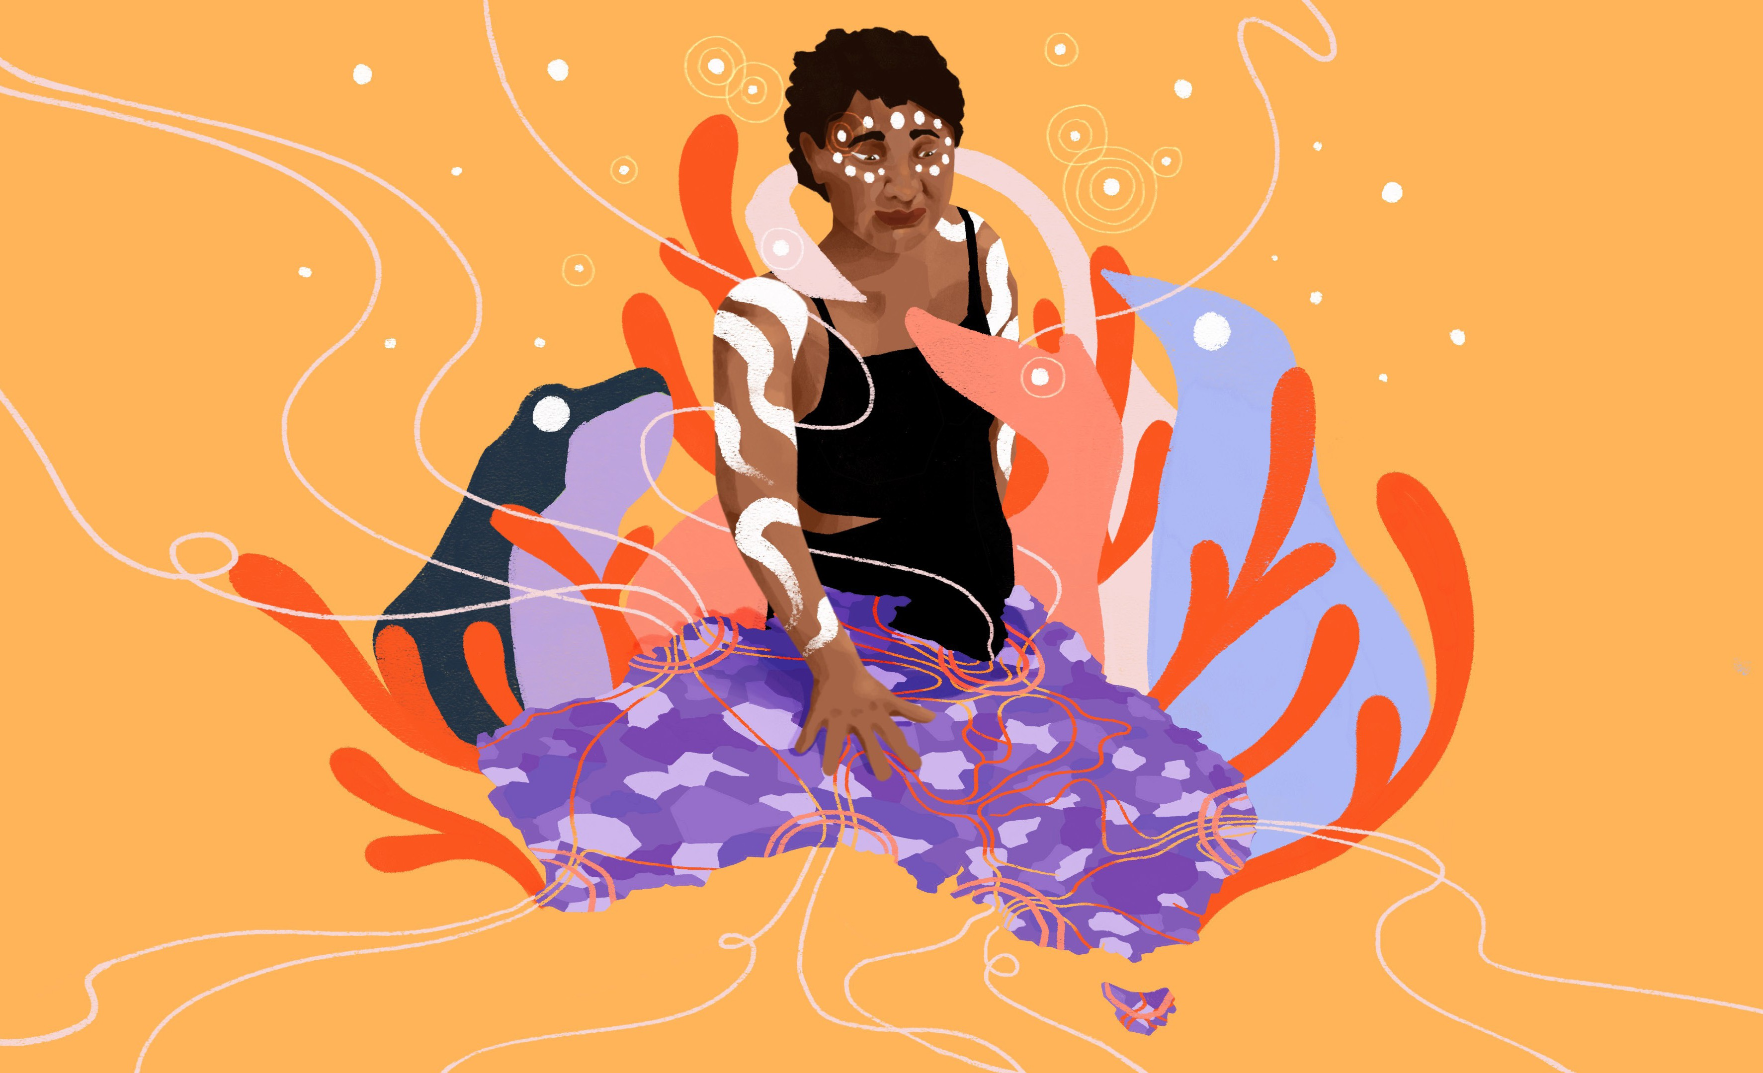
Wiyi Yani U Thangani (Women’s Voices) • National Summit Statement • 2023 | 3

