Operating environment
Each year we examine our forward operating environment to assess the factors (constraints, dependencies, risks, challenges, strengths and opportunities) that may have an impact on our work in the coming year, and in our four-year outlook.

1.1 Overview
We work in a complex social and political context with multiple factors that can affect how, and how well, we achieve our purpose. The figure below shows the key factors identified in the assessment for the 2022–23 (to 2026) environment.

Figure 1: Key factors in our operating environment
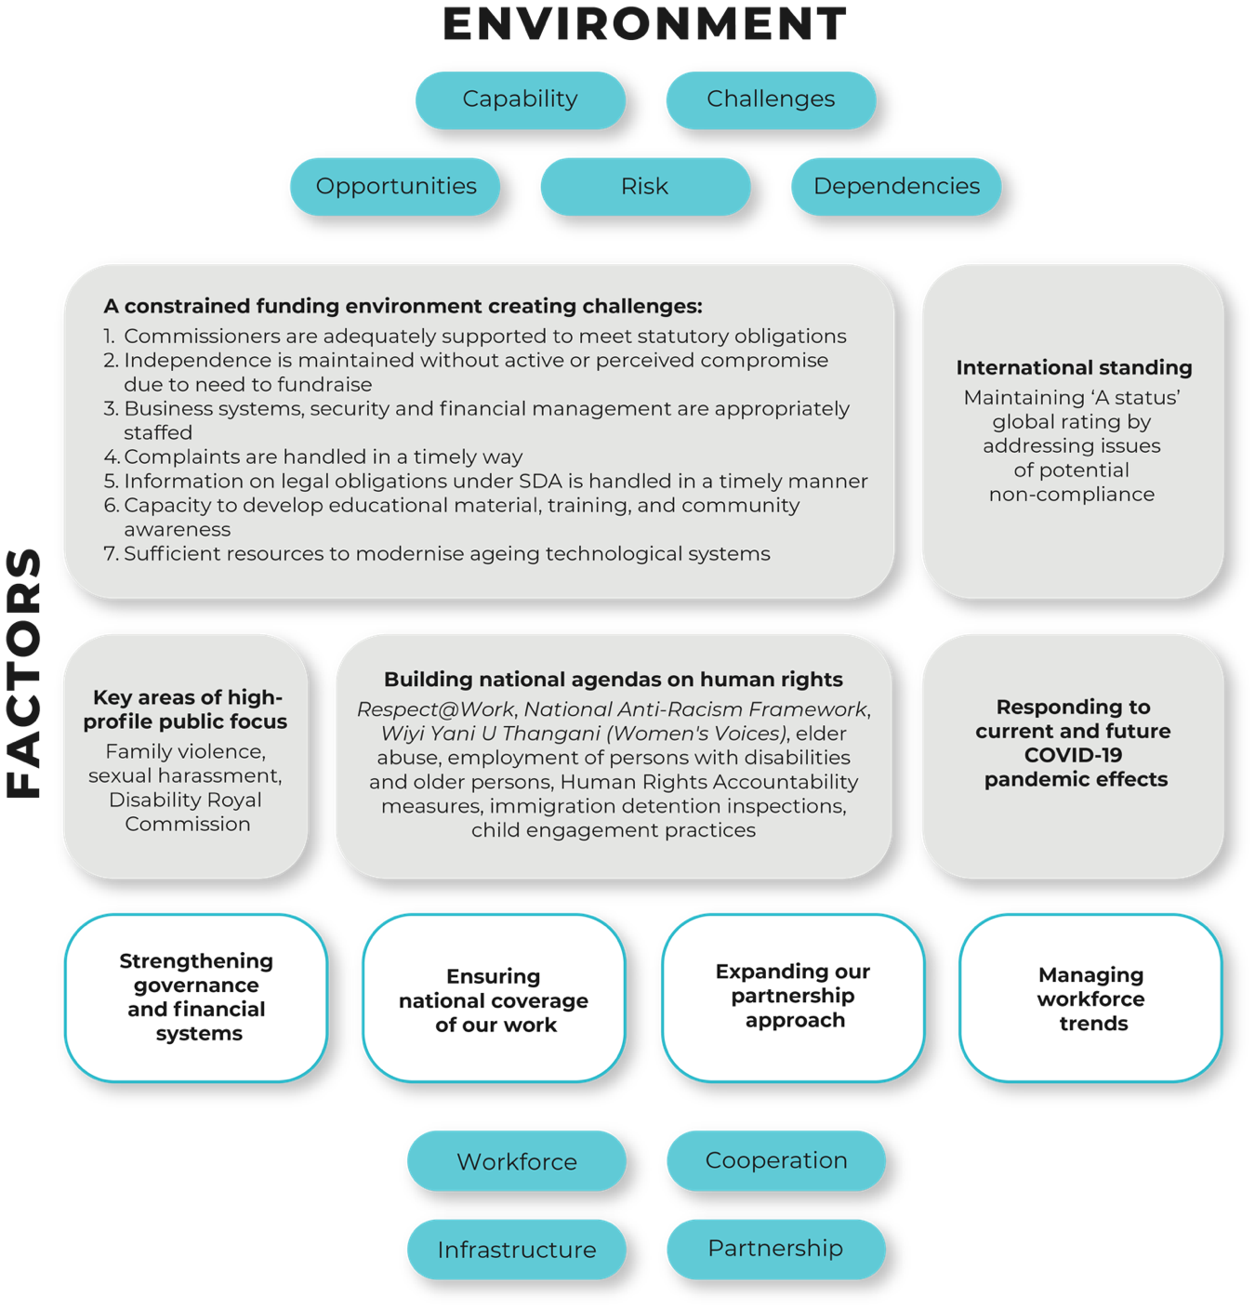
Our work involves a mixture of forward-looking, agenda-setting programs that seek to strengthen Australia’s human rights framework, as well as reactive support where we provide human rights expertise and input to government priorities, parliamentary processes, relevant court proceedings and through the operation of our national information service and complaint-handling functions.
We are most effective in our impact where our knowledge and expertise align with the external processes in which we engage.
Our work on gender and cultural reform will continue with Set the Standard: Report on the Independent Review into Commonwealth Parliamentary Workplaces, the National Sexual Harassment Council and implementation of recommendations form the Respect@Work report, continuation of a partnership with the Australian Federal Police, the cultural reform partnership with the Australian Defence Force and Australian Border Force, and partnerships with other industry and sector bodies.
We continue to operate in in the context of the global COVID-19 pandemic. Our Commissioners have a leadership role to provide robust, independent human rights expertise during the pandemic to ensure that no-one is left behind during and in the aftermath.
Our national information service and investigation and conciliation service will continue to provide information and assistance to people making and responding to complaints about discrimination and human rights breaches including those arising from responses to the pandemic.
In 2022–23 the Commission will release its Free and Equal Position Paper on a federal human rights act model, and related measures to build a human rights culture throughout government. This will constitute the second major set of Free and Equal reform recommendations, following the 2021 Position Paper setting out an agenda for national discrimination law reform.
The Commission will continue to focus on the implementation of the findings of our significant and novel research and consultation processes which provide guidance on key human rights challenges in our community. This includes: the findings of the Human Rights and Technology Final Report; Wiyi Yanu U Thangani report on the voices of Aboriginal and Torres Strait Islander women and children; What’s age got to do with it? research report; Sharing the stories of Australian Muslims research report; and our report on forced surgical procedures on people with variations in sex characteristics, Ensuring Heath and Bodily Integrity.
We will report the findings of the scoping phase of the National Anti-Racism Framework including delivering a process solution to progress this initiative.
During 2022–23 the IncludeAbility project will focus on increased Ambassador engagement. The Employer Pilot Projects will be delivered, aiming to increase the confidence and capacity of employers to recruit, retain and advance employees with disability. Resource development will focus on comprehensive disability employment guides, and Swinburne University Centre for Social Impact will work closely with IncludeAbility to provide advice, monitoring, and program evaluation.
We anticipate that all our work will take place in a constrained resourcing environment, and with significant economic pressures facing the entire community.
We will look to embed further changes to working practices that have arisen during the COVID-19 pandemic, such as increased workplace flexibility through a hybrid work model and digital engagement tools.

1.2 Capability through digital infrastructure and investment
Information and communications technology (ICT) has a crucial role in supporting the organisation’s communication and sharing of information, both internally and externally. Investing in this aspect of our capability has been challenging, given our long-standing fiscal constraints and as a small Commonwealth agency.
However, over recent years, our ICT team has led the Commission through a range of significant ICT infrastructure projects. Partnerships have been established within resource constraints to deliver innovative, high value and low-cost ICT capabilities to service our organisational needs. This has led to the Commission being the first Commonwealth entity to deliver services wholly through cloud-based infrastructure, as well as implementing an industry-leading artificial intelligence centred document management system.
In response to the outbreak of COVID-19, the ICT team delivered significant capability to enable all Commission staff to undertake their work remotely. They were able to transition the entire workforce to remote working arrangements within a week, supported by new digital tools for internal and external engagement, as well as providing full access to the financial management and human resources functions remotely while maintaining appropriate security.
Microsoft Teams continues to provide the platform to enable hybrid working and ICT Services staff are participating in the Hybrid Working Committee to ensure that the best possible platforms and systems are implemented to support ongoing hybrid working.
The Commission continues to seek capital investment to improve and bring coherence and efficiency across our various systems.

1.3 Capability and our workforce
High performing and resilient people are critical to the Commission’s success. We value a workforce that is reflective of the broad community we serve, and we seek to enhance our diversity at every employment opportunity.
We are proud of our staff and their commitment to maintaining a strong organisation, especially in times of adversity.
Over the past two years, Commission staff have shown their extraordinary flexibility and creative problem solving. They are supportive, cohesive, strategic and highly productive. They have faced unique challenges with grace and positivity.
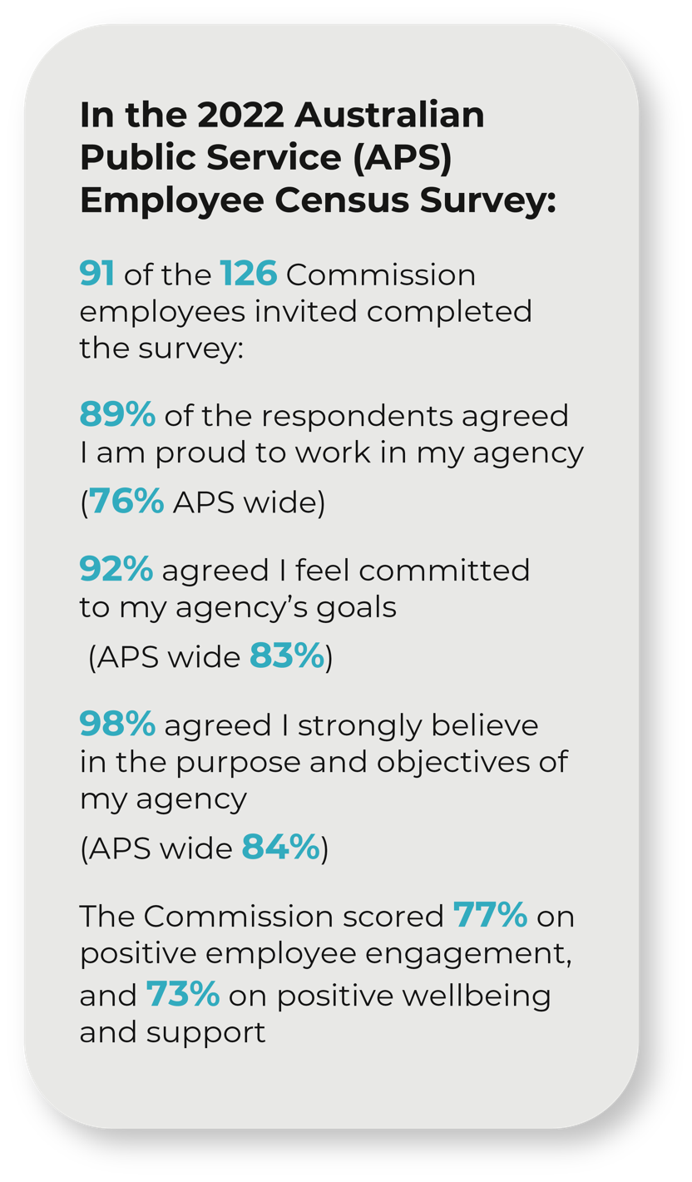
In 2022, Commission staff responses to the State of the Service employee survey scored 73% on our wellbeing engagement score and 77% on our engagement score. The scores are lower compared to previous years reflecting internal and external challenges. As experienced throughout the 2020–21 and 2021–22 financial years staff were subject to lockdowns and limitations on access to the workplace. This was of particular significance for new staff who faced the added challenge of establishing themselves in a new workplace whilst not being able to meet colleagues face to face. Internally, The Commission has recently been through a major restructure, necessitated by financial constraints leading to a reduction in the existing staff profile.
Managers and teams have responded to the challenges in a professional and productive manner and our focus is now on ensuring that sufficient resources are available to enable the Commission to continue to meet its statutory obligations while promoting and supporting staff wellbeing.
Our challenges are now to retain exceptional staff whilst we are undergoing structural change and to ensure that we continue to focus on quality outcomes and sustainable workloads. Our reputation for the quality of our work can only be enhanced as we continue to be a partner of choice for significant human rights and cultural reform projects.
After an extensive consultation process of employee feedback, we have formalised and initiated our hybrid work policy. The flexibility entrenched in this policy promotes employee work-life balance and provides options to employees to enable them to make decisions around their work practices that meet the needs of the team, individuals and Commission. An additional benefit from the formalised hybrid work arrangement is access to a broader talent pool and the ability to engage and encourage diversity by employing staff located in different geographical areas of Australia.
The Commission continues to attract candidates of high calibre whenever we have had employment opportunities, and this is consistent with recruitment for significant projects as well as ongoing roles.
In managing our complaint-handling function, we ensure regular capacity building of our staff to handle complex interactions, build resilience and consistent skills upgrading in alternative dispute resolution to ensure swift resolution and satisfaction for all parties.

1.4 Cooperation and capability through our partnerships
The Commission regularly operates through partnerships and collaborations with government, business, the non-government sector and internationally.
We have built a reputation for expertise in human rights research, consultation, and implementation design. Our operation as an independent agency is critical to our capability in this regard: it means we are a trusted neutral interlocutor that can bring diverse and often competing interests together to address difficult human rights challenges.
Partnerships increase our capability through shared skills and resources and create a collective ability to achieve outcomes greater than the individuals or organisations acting alone. It is a central feature of how we work.
Working together to solve problems in multi-year arrangements also builds the impetus and capacity of our partners to implement positive changes which improve workplace culture and increase the capacity of personnel to contribute their best. We have learned that medium to long-term collaboration delivers real reform. Partnerships ensure that the Commission can work on responses to identified issues with stakeholders across multiple years. This approach is in line with institutional reform learnings, which recognise that real improvements come from thoughtful and sustained response.
Governments and entities from all sectors consistently invite us to work with them to share our human rights expertise and to enter collaborations on specific human rights projects and advocacy activities. In doing so, we have become accomplished in collaborating with professionalism and integrity and delivering impact.
Our partnerships are diverse and take many forms, including agreements for in-kind support, pro bono and financial support. We also enter a range of ‘fee for service’ partnerships on a cost-recovery basis where we can provide our technical expertise to third parties.
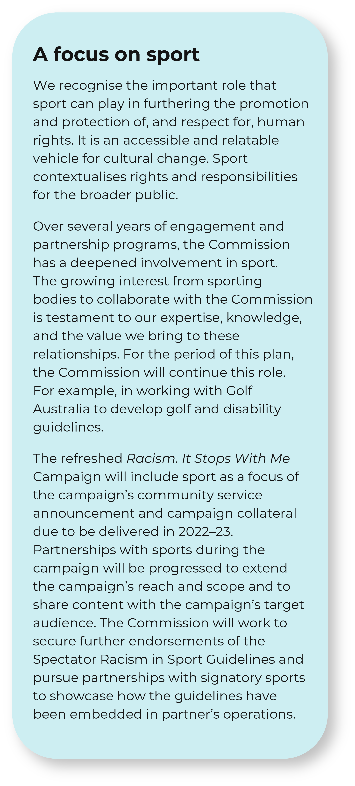
Our partnerships can be informal or formalised by a letter, MOU or legal contract and they may be short-to-long-term.
In 2022 we established an internal Project Delivery Committee to ensure that our approach to partnerships is aligned with the Commission’s strategic goals and that delivery is timely and to budget.
Each year our planning process captures data on our partner organisations, figure 4 shows the range of partner categories in our forward workplan.
Figure 2: Partnership categories
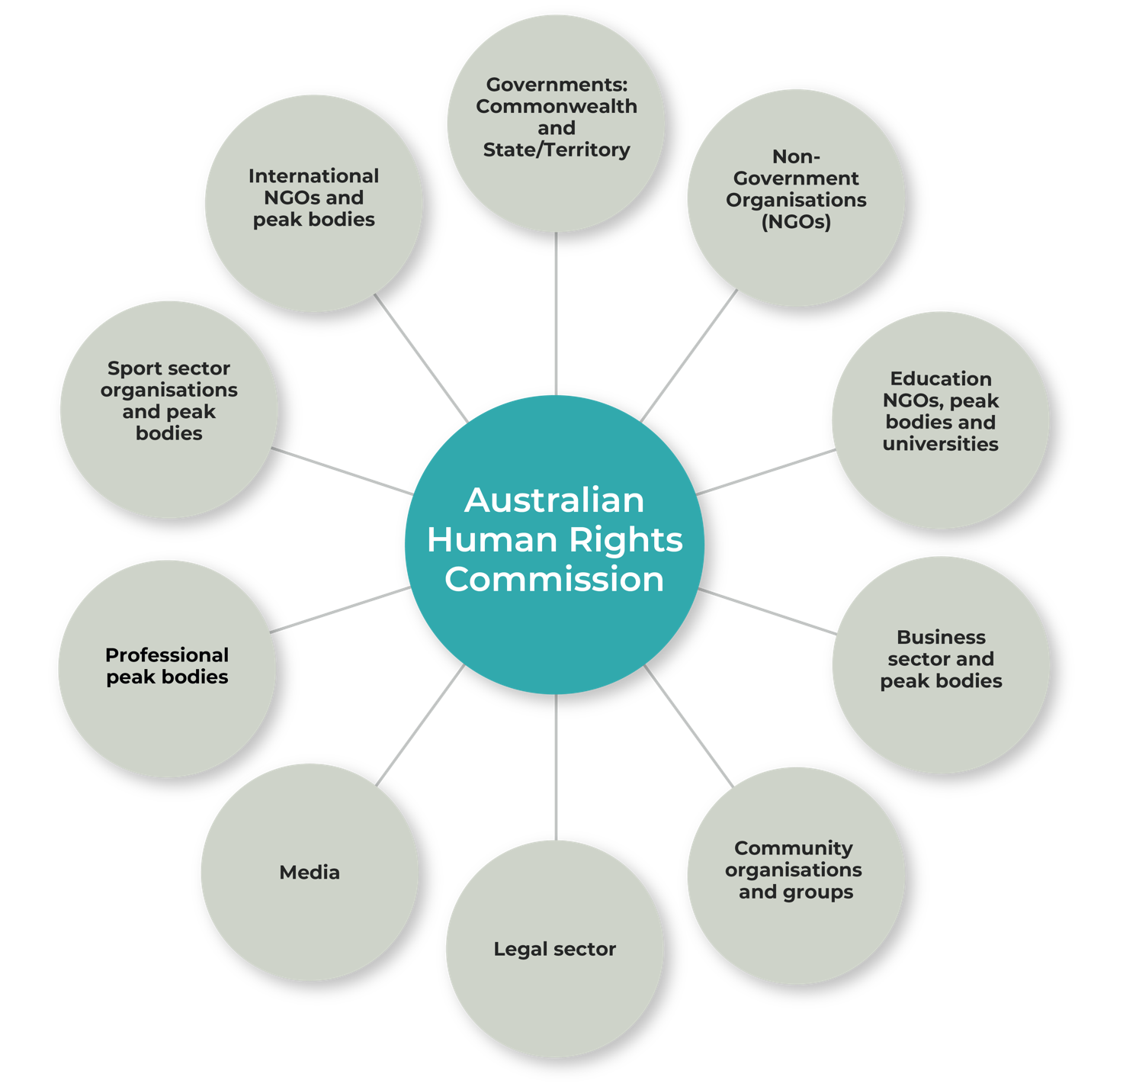

1.5 Risk oversight and management
We adopt a positive risk management culture that promotes an open and proactive approach to managing risk.
Our existing risk management framework provides a mechanism for proactively identifying and mitigating risks across the organisation, and for monitoring the operating environment. The risk management framework is tailored to meet the needs of the Commission, and covers three main areas:
- Key strategic risks: including a constrained funding environment, damage to the Commission’s independence and reputation, not managing relationships with key government stakeholders and other external parties, and not responding quickly and effectively to a changing political landscape.
- Core business risks: including policy activities that are not aligned to the Commission’s strategic objectives, failing to provide an accessible and effective complaint-handling service that complies with all relevant laws, and community engagement activities that fail to achieve the objective of increased public awareness of human rights.
- Corporate support risks: including failure to recruit and retain appropriately skilled and diverse staff, the misuse of assets or resources, business continuity processes not in place, IT interruption, outage or information compromise, and an unsafe work environment.
We have the following mitigation strategies and controls in place to manage these key risks: a risk owner has been allocated for each risk that has been identified; and the risk owner has responsibility for managing the particular risk.
We undertake regular reviews of the Commission’s risk management framework and the risks being managed, to ensure new risks are identified and existing risks remain appropriately managed. Our most recent review was undertaken by senior executive staff and the Accountable Authority in November 2021.
We have embedded risk management into our decision-making and key business processes. For example, risk evaluations are conducted during procurement processes and in program planning processes. Simple templates have been developed to ensure these risk assessments are accessible to all staff.
We have specialist policies and processes for particular risk categories including: business continuity; pandemic planning; fraud control; work health and safety; privacy; child safety and wellbeing; and modern slavery in our supply chains.
The Pandemic Planning Team (PPT) was established in response to the COVID-19 pandemic. The PPT has met regularly to reassess the Commission’s response to COVID-19 and to ensure business continuity.
We have conducted a major review of the Accountable Authority Authorisations and Accountable Authority Instructions, which includes ascertaining whether any further authorisations are required, particularly in the areas of risk management and performance accountability. In association with this, the Commission is reviewing and revising relevant policies and associated documentation.
In 2021, a Senior Compliance Officer commenced to manage the Commission’s compliance function to ensure relevant laws, government policies and internal guidelines are followed, with a focus on governance and risk management.
We have appointed new internal auditors to conduct our regular audit reviews and other assurance activities for our strategic planning and core business processes.
The Commission’s Audit and Risk Committee also has a role in overseeing risk management practices. The Audit and Risk Committee provides independent assurance to the Accountable Authority on the Commission’s financial and performance reporting responsibilities, risk oversight and management, and system of internal control and assurance. In 2021, the Commission appointed an independent Chair of the Audit and Risk Committee to comply with the new requirement for all government agencies. All members of the Audit and Risk Committee are now external to the Commission.

Table: Key factors, challenges, opportunities, outlook, and management
This table summarises the key environmental, capability, cooperation and risk factors that may affect our operations in the four-year outlook of this year’s work plan. It outlines the associated challenges, opportunities, our level of control over them and management strategies.
Factor | Assessment |  | Level of Control
 | Challenges, risks, opportunities and outlook | Management | A lot | Some | None
Responding to the current and future COVID-19 pandemic effects | Our President and Commissioners have focused on identifying the human rights impacts of the COVID-19 pandemic on an ongoing basis.  Current Commission priorities include:  - continuing to assess a high volume of complaints under federal discrimination law and the Australian Human Rights Commission Act relating to vaccine mandates, mask wearing and international travel  - mental health impacts on vulnerable groups, including children | To respond to the challenges presented by the pandemic, we will:  - proactively address emerging trends, including through our complaints and information services, to prevent human rights abuses and discrimination  - liaise with our state and territory human rights and discrimination partners to ensure consistent and informed advice across all jurisdictions.
 | Before the pandemic, much of our work was anchored in face-to-face program components and advocacy. We swiftly ensured staff could work remotely (maintaining our business) and had the tools to conduct activities through digital engagement. This has minimised disruption to our work activities and ensured that we have greater digital engagement capabilities moving forward. | In this four-year period, assuming capital resources are available, we will continue to strategically build our technical and program digital capabilities, including through our learning management system, web-based submissions and engagement hub, and enhancing skills in web seminars and consultations.  We will continue to focus on partnerships as well as community engagement that ensures our activities and services are accessible to vulnerable and marginalised people and communities, to ensure that the increased reliance on digital technologies does not impact negatively.
A constrained funding environment | Fiscal restraint across government appropriations is expected. The impact of this on small agencies will continue to drive tight internal budgeting.  Financial pressures and structural underfunding over many years have left the Commission under-resourced and forced to reduce staff. Without a rebasing of its ongoing core budget the Commission cannot be functionally sustainable.  The Commission is currently reliant upon external partnerships and fund-raising to support achievement of the Commission’s overall workplan and each individual Commissioner’s term goals.  While we have been successful in attracting funding for specific projects, in an unstable economic environment this support may be at risk over several of the reporting periods.  Building partnerships and work needs agility, guidance, coordination and recognition that not all Commission functions or priority work areas can attract such funding. | We need to:  - ensure our program of work is flexible to respond to changing government priorities that have key human rights impacts  - ensure support through core budget for such activities to ensure that the Commission maintains a balanced and independent work program across all Commissioners and areas of responsibility  - build the case for a more sustainable level of funding for the organisation, commensurate to the broad-ranging functions of our Commissioners and the organisation  - continue to build our partnership and engagement capability using agreed principles and a strategic decision-making process to seek and implement partnership opportunities  - ensure we can demonstrate our value prospect in achieving common goals and human rights benefits  - ensure we can demonstrate strong governance and financial management.
Long term reform agendas to improve human rights outcomes | The Commission announced the ‘Free and Equal: An Australian conversation on human rights’ project in December 2018 as a flagship multi-year initiative to set out the main priorities for human rights reform over the next decade.  The key challenge is to deliver a persuasive national reform agenda for human rights that can garner support from government and Parliament to drive the human rights priorities over the next decade at the federal level.  The realisation of the reform agenda will provide a long-term stage for this work, increasing the reach and relevance of our education and awareness programs to the broader community.  This work will be supplemented by a focus on implementation of the recommendations of key national reports: Human Rights and Technology Final Report, Wiyi Yani U Thangani (Women’s Voices), Set the Standard and the Respect@Work: Sexual Harassment National Inquiry Report. | - In the coming year, the Free and Equal project will conclude with the publication of a second of two Position Papers and a Report setting out a long-term national reform agenda for human rights.  - Having conducted thorough and innovative research and consultation phases, the Commission will focus on building buy-in and consensus on achieving national reforms in relation to human rights and technology, Indigenous women, and addressing sexual harassment.  - New national consultations and research projects will commence to establish the required elements of a more comprehensive and effective approach to combatting racism and more effective protection of children in vulnerable situations.
High profile focus on violence and harassment issues | A significant focus on violence, harassment and abuse against women, will likely ensure high public interest in the Commission’s research, consultation and reform proposals in these areas.  The cultural review of the Australian Parliament as a workplace and implementation of the recommendations of the Respect@work report will likely receive greater focus.  The Royal Commission into institutional abuse of persons with disabilities and the now finalised Royal Commission into aged care, provide a spotlight to advance human rights protections and a safeguarding focus for vulnerable groups and people. | The Commission will play a leading national role in identifying pathways to address sexual harassment, violence and abuse against women through a series of cultural reform projects (Defence, Australian Federal Police, Australian Border Force and sporting codes.  The Commission will also conduct and finalise activities targeted at addressing violence, harassment and abuse faced by others in the community, including by:  - research and public engagement on elder abuse  - publishing the outcomes of national consultations and surveys with Muslim communities  - leading national consultations with vulnerable children and families to inform the development of the 3rd national framework on protecting Australia’s children  - conducting Australia’s 5th national workplace sexual harassment prevalence survey in 2022.
Paris Principles compliance | The Paris Principles (Principles Relating to the Status of National Human Rights Institutions) provide an internationally agreed basis for assessing the independence and effectiveness of national human rights institutions. At our most recent accreditation review in March 2022, consideration of our ‘A Status’ was deferred to October 2023 on the basis of issues of potential non‑compliance in the recruitment and appointment of Commissioners. | The Sub-Committee on Accreditation of the Global Alliance of National Human Rights Institutions will next consider this issue in October 2023. The Commission is working with the Government to ensure that legislative protections are introduced to ensure public trust in the process for the appointment of Commissioners into the future.
Ensuring national coverage of our work | The single base of our organisation in Sydney, with some Commissioners located inter-state, and our constrained resourcing creates challenges for ensuring engagement with regional, rural and remote Australia.  The COVID-19 pandemic has significant implications for the foreseeable future for engagement strategies, with limits on the ability to conduct face to face consultations and travel nationally. | The COVID-19 pandemic has resulted in significant changes to external outreach strategies, due to the lack of ability to travel or conduct face to face consultation and meetings. Over the coming year, we shall look to embed these new practices and build our technical capability to conduct online and remote consultation.
Managing workforce trends | The Commission has recently been through a major restructure, necessitated by financial constraints leading to a reduction in the existing staff profile. Our focus is now on ensuring that sufficient resources are available to enable the Commission to continue to meet its statutory obligations while promoting and supporting staff wellbeing.  Underlying the staffing challenges of the future is an appreciation of a stronger mobility mindset among our newest cohorts and the need to harness this talent quickly and effectively rather than building for a longer-term return on investment.  The breadth of work that the Commission engages in vs how much we can do within limited budget and resources continues to challenge our capacity.  There is a need to recognise the opportunities in effective home-based work (HBW) practices, virtual team environments and opening roles to geographically remote personnel as appropriate. | In managing a more mobile workforce our strategy includes investing in our more senior tiers to build the capacity of managers to work with this cohort and to develop internal systems to manage the retention of corporate knowledge.  Robust planning processes will be important in reality-checking ambitious workplans with the aim to:  - ensure that our workload remains achievable against resourcing  - that staff and internal support systems are productive, but not overwhelmed.  We will build on our stronger digital capability to harness the productivity, attraction, retention and reputational benefits that could flow from greater flexible arrangements as outlined in our Hybrid Work and Workplace Flexibility Policy and Procedure Guidelines July 2022.
Strengthening our digital capability | Investment in our digital technology infrastructure in 2020 has delivered benefits including streamlined information management with 24/7/365 access to systems and data, increased security, more workforce flexibility and versatility and efficiencies in our program activities.  These benefits and our agility in this area were demonstrated in our swift response to remote working and our creation of a virtual ‘business as usual’ culture during the COVID-19 lockdown period. | Our focus is on:  - increased use of centralised web outreach through our new ‘Have your say’ portal  - increased use of digital engagement tools  - more strategic and coordinated communications outreach through digital channels.

