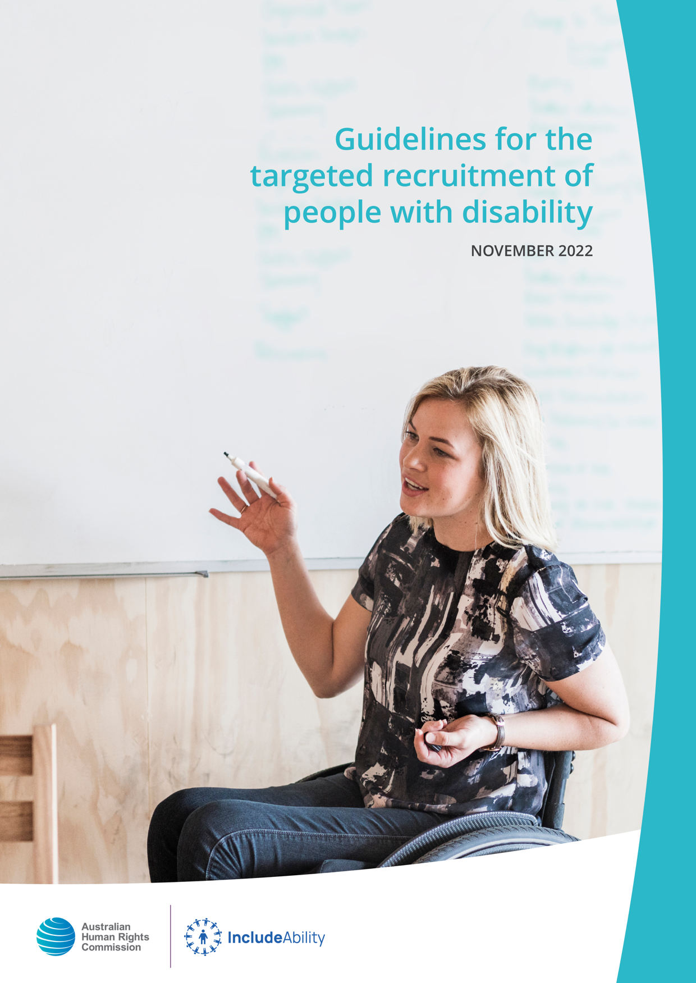

© Australian Human Rights Commission 2022.
The Australian Human Rights Commission encourages the dissemination and exchange of information presented in this publication.
All material presented in this publication is licensed under the Creative Commons Attribution 4.0 International Licence, with the exception of:
- photographs and images;
- the Commission’s logo, any branding or trademarks;
- content or material provided by third parties; and
- where otherwise indicated.
To view a copy of this licence, visit http://creativecommons.org/licenses/by/4.0/legalcode.
In essence, you are free to copy, communicate and adapt the publication, as long as you attribute the Australian Human Rights Commission and abide by the other licence terms.
Please give attribution to:© Australian Human Rights Commission 2022.
Guidelines for the targeted recruitment of people with disability • 2022
ISBN 978-1-925917-70-3
Acknowledgements
The Australian Human Rights Commission would like to thank the following individuals and organisations:
IncludeAbility Employer Network Members: Herbert Smith Freehills, NSW Public Service Commission, Australian Public Service Commission, ABC and PwC
IncludeAbility Ambassador: Sam Drummond
This publication can be found in electronic format on the Australian Human Rights Commission’s website at https://www.humanrights.gov.au/our-work/publications.
For further information about the Australian Human Rights Commission or copyright in this publication, please contact:
Australian Human Rights Commission
GPO Box 5218
SYDNEY NSW 2001
Telephone: (02) 9284 9600
Email: communications@humanrights.gov.au
Design and layout Herbert Smith Freehills and dancingirldesigns
Photography iStock, Design Pics Inc.
Cover Getty Images

Guidelines for the targeted recruitment of people with disability

November 2022

Australian Human Rights Commission

Contents
Foreword 6
Executive summary 8
What is a targeted recruitment strategy? 10
What is a special measure? 10
Purpose of the Guidelines 10
Genuine occupational requirements 11
1. About the Guidelines 12
1.1 Nature of the Guidelines 12
2. Targeted recruitment of people with disability 13
2.1 What is a targeted recruitment strategy? 13
2.2 Why consider targeted recruitment strategies? 15
3. What the law says 18
3.1 Overview of anti-discrimination laws 18
3.2 Exemptions/exceptions under anti-discrimination legislation 19
(a) Special measures 20
(b) Key elements of a special measure – federal law 21
(c) Key elements of a special measure – other jurisdictions 21
(d) Could a targeted recruitment strategy be a special measure? 21
(e) Genuine occupational requirements 22
3.3 Overview of relevant anti-discrimination law provisions 22

4. Special measure requirements for implementing targeted recruitment
strategies for people with disability 24
4.1 Explain the inequality or the special needs required to be met amongst
the targeted group 26
(a) Inequality or lack of equal opportunity 26
(b) Special needs 26
4.2 Explain how the strategy is reasonably intended, and is necessary, to ensure
equal opportunity or meet the special needs identified 27
4.3 Demonstrate that the strategy is otherwise reasonable and proportionate in
its intention and effect 28
4.4 Plan for the strategy to be regularly reviewed to ensure that it remains necessary 28
5. Practical guidance on designing and implementing a targeted recruitment strategy 29
5.1 Document a clear intention 29
5.2 Establish the legal basis for targeted recruitment 29
5.3 Communicate the intention of the recruitment strategy 30
5.4 Seek the participation and inclusion of persons with disability in the strategy’s
design and implementation 30
5.5 Ensure inclusive communication 31
5.6 Establish accessible and inclusive recruitment practices 31
5.7 Create an accessible and inclusive workplace 32
6. Applying for statutory exemptions 34
6.1 New South Wales 34
6.2 Tasmania 36
6.3 Other jurisdictions 37
7. More information and contact details – Federal, state and territory bodies 38
Appendix – Template for documenting a targeted recruitment strategy addressing special measure criteria 39

Foreword
The employment of people with disability is a critical issue for all Australians.
However, the rate of employment of people with disability in Australia has remained stagnant for decades. As a country, we need to do more. We know employment and economic participation are good for an individual’s self-esteem, health and financial independence. These benefits are magnified for people with disability.
The justification that is often forgotten when discussing the employment of people with disability is the long-term benefit to the employer. People with disability are hard-working and diligent employees who enable organisations to better understand and cater for a significant group of people in the community.
We need to explore novel and unique methods to ensure people with disability obtain not just a job, but a good job.
One method an employer can use to increase its number of employees with disability is to undertake a targeted recruitment strategy, which is a recruitment campaign that solely targets people with disability. This is potentially a form of ’special measure’ that makes such a targeted campaign lawful under the Disability Discrimination Act 1992 (Cth) (Disability Discrimination Act) and state and territory equal opportunity or anti-discrimination legislation.
There are many misconceptions concerning targeted recruitment campaigns, and the Guidelines for the Targeted Recruitment of People with Disability (the Guidelines) seek to ameliorate some of those concerns. In short, aside from New South Wales (and noting the particular view adopted in Tasmania), there is no need to get any form of authorisation before undertaking a targeted recruitment campaign provided that it can be considered a ’special measure’.

The Guidelines are produced as part of the Australian Human Rights Commission’s IncludeAbility Project (www.includeability.gov.au). The Project is designed to support employers to create meaningful employment opportunities for people with disability. It is funded by the Paul Ramsay Foundation and the Australian Department of Social Services.
We would like to thank Herbert Smith Freehills, an IncludeAbility Employer Network Member, for its pro bono assistance in completing the Guidelines.
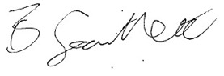
Dr Ben Gauntlett
Disability Discrimination Commissioner

Executive summary
More than 4 million people in Australia have a disability, yet this significant part of the population is being left behind in the labour market. Currently, the employment rate for people with disability who are of working age is just 48%, compared with 80% of people without disability.
These numbers reinforce that employers can do far more to tap into the talents and expertise of this diverse group. If we work together to address the employment gap, everybody benefits.
The benefits of improving employment opportunities for people with disability are clear with individuals, businesses, society and the economy all benefiting.

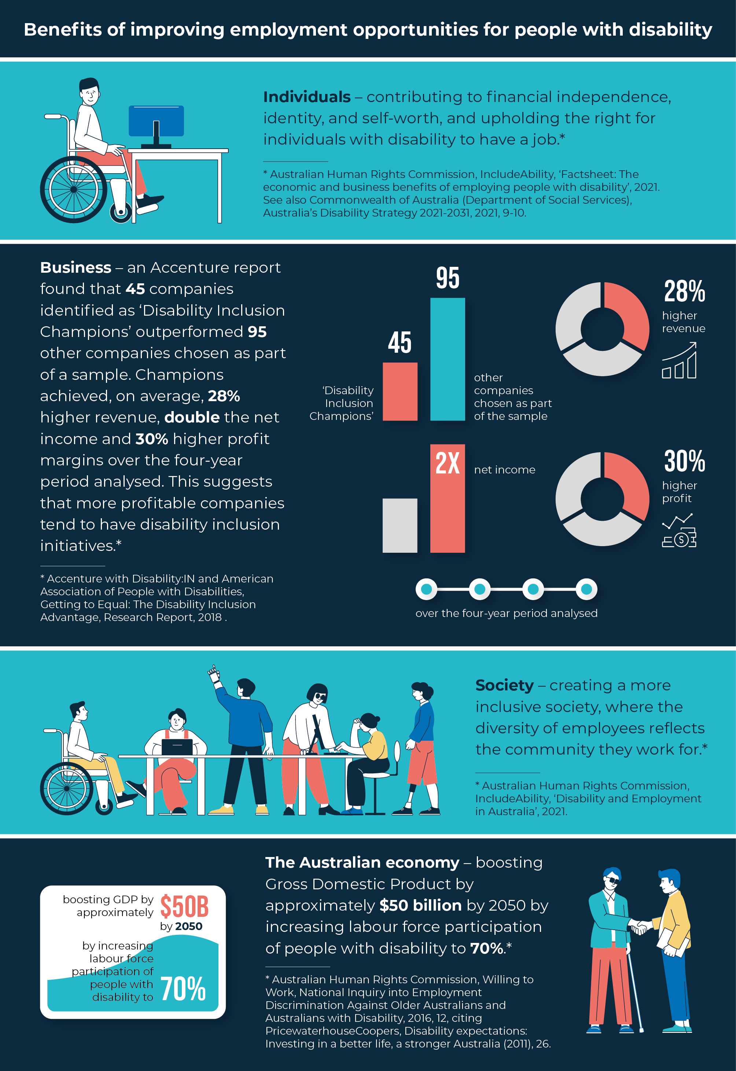
To achieve the full benefits, a multi-faceted focus on the recruitment, retention and advancement of employees with disability is critical to achieving strong employment outcomes for individuals, employers and the community as a whole.
As part of broader comprehensive employer strategies to achieve greater workforce diversity, targeted recruitment strategies are crucial to addressing the discrimination and attitudinal, systemic, and structural barriers faced by people with disability in securing work opportunities. They are also key to achieving inclusive workplaces and communities.

What is a targeted recruitment strategy?
Under a targeted recruitment strategy, employers target their recruitment of roles towards people with disability (or a particular disability), for example to increase equality, or for roles which are themselves directed to meeting the special needs of people with disability (or a particular disability).

What is a special measure?
A ‘special measure’ is a positive action taken to promote equality for a group of people with a protected attribute, such as disability, in order to overcome the entrenched disadvantage that the people in that group face. It may be an act that is intended to ensure equality of opportunity for the group or to meet their special needs. Special measures are sometimes described as acts of ‘positive discrimination’ or ‘affirmative action’.
A targeted recruitment strategy can be an example of a special measure, provided that it meets the legislative requirements of a ‘special measure’ under the Disability Discrimination Act and applicable state or territory anti-discrimination law provisions.
If a program like a targeted recruitment strategy is a special measure, then it does not amount to unlawful discrimination under federal, state or territory anti-discrimination law. However, there is no ‘special measure’ provision in the relevant New South Wales (NSW) law. In some circumstances, employers may have to apply for a statutory exemption to comply with NSW law.

Purpose of the Guidelines
The Guidelines provide general guidance to employers on designing and documenting targeted recruitment strategies. The Guidelines also provide general guidance about meeting the requirements of a ‘special measure’ under federal, state and territory anti-discrimination laws, including on the practical steps employers can take to implement a targeted recruitment strategy as a ‘special measure’. The documentation gathered in accordance with the Guidelines will help employers to establish that their strategy is a special measure and is consistent with anti-discrimination laws.
The Guidelines also provide an outline of how to apply to regulators in NSW and Tasmania for a statutory exemption, where necessary, to undertake a targeted recruitment strategy.

Genuine occupational requirements
The Guidelines note that in several state and territory jurisdictions, targeted recruitment strategies may also fall within ‘genuine occupational requirements’ exceptions under relevant laws. Where engaged and if their elements are met, the strategies are lawful, and there is no need for an employer to apply for a general statutory exemption.

About the Guidelines

Nature of the Guidelines
The Australian Human Rights Commission (the Commission) has prepared the Guidelines in the exercise of its function under section 67(1)(k) of the Disability Discrimination Act. The Guidelines have been prepared in consultation with the Commission’s state and territory counterpart bodies.
The Guidelines are not legally binding and should be read in conjunction with the whole of the Disability Discrimination Act, and state and territory anti-discrimination laws. An organisation or individual may not be protected from a finding of unlawful discrimination if they claim that they conformed with, or relied on, the Guidelines. Organisations or individuals should seek their own independent legal advice if they have concerns regarding their compliance with the Disability Discrimination Act or with relevant state or territory anti-discrimination legislation.
However, in the view of the Commission and its state and territory counterpart bodies, detailed documentation gathered in accordance with the Guidelines will help employers establish that their targeted recruitment strategy is a special measure, and consistent with the Disability Discrimination Act, and state and territory anti-discrimination laws (other than in NSW – see Part 6.1 below).
It should also be noted that it is rare for the Commission or its state and territory counterpart bodies to receive complaints about targeted recruitment strategies for people with disability. At the federal level, few complaints about targeted recruitment strategies for people with disability have been received and, at the time of publication of the Guidelines, none have proceeded to court.

Targeted recruitment of people with disability

What is a targeted recruitment strategy?
Under a targeted recruitment strategy, employers target recruitment campaigns towards people with disability, or with a particular disability. There are a range of reasons why an employer may reasonably choose to target its recruitment in this way, for example:
- to increase equality and diversity within their organisation and ensure that opportunities are made available to the targeted group within the broader community
- to ensure that the special needs of service recipients are better recognised and met for a role which involves developing or implementing policies, programs or services which are themselves directed towards people with disability.

Case Study
Department of Regional NSW
The Department of Regional NSW recently announced its Assistant Project Officer disability targeted talent pool recruitment process. For successful candidates, being placed in the pool provides the opportunity to be ‘placed in the front of the queue’ for many roles with the Department, as they become available. These roles will provide project and operational support for the development and delivery of projects across the Department and the state of NSW.
The advertisement is clearly linked to the NSW Government’s ‘Age of Inclusion’ strategy which champions and advocates for the inclusion of people with disability across its workplaces. It simultaneously reinforces the Department’s own commitment to diversity and inclusion as core values, and the community benefits of this approach:
The Department of Regional NSW is a workplace where everyone is able to contribute and participate to their full potential, and we are proud to have a team that reflects the richness and complexity of the regional NSW communities we serve.
The strategy further reinforces that:
- Flexible working arrangements are supported (including through hybrid working environments being available, and full-time, part-time and job share applications all being considered). Flexibility in interviewing arrangements is also available.
- If adjustments are required in completing applications, interviewing, completing any pre-employment testing, or otherwise participating in the recruitment selection process, a Departmental Disability Recruitment Specialist is available to help (contact details provided).
- The Department will soon be launching a Reasonable Adjustments Passport which will make it easier for its staff to request workplace adjustments.
- The Department partners closely with several organisations including the Australian Network on Disability.
Applicants with disability are encouraged to consider more generally working with the Department as part of the strategy, with other disability targeted processes (for example, recruitment for assistant policy officers) being clearly visible on the site.

Why consider targeted recruitment strategies?
Increased employment of people with disability will benefit individuals, organisations, and our community as a whole.
The Commission’s IncludeAbility project undertook a systematic review of 39 international studies and found four key improvements to business which flowed from increased employment of people with disability:
- Improvements in profitability related to both employee performance and increased customer satisfaction. Employees with disability consistently demonstrated punctuality, loyalty and high attendance rates leading to improved customer experience and a competitive advantage for the business.
- Inclusive and diverse workplace culture which benefited all employees and increased workplace motivation and engagement.
- Increased ability awareness, including challenging stereotypes and misperceptions of disability and recognition of the benefits of hiring people with disability.
- Secondary benefits for employees with disability, who reported improved quality of life, enhanced self-confidence and a sense of community.
Within a broader disability employment action framework, targeted employment recruitment is one of many strategies that can play an essential role in achieving these outcomes.

Case Study
Australian Public Service
The Australian Government’s Australian Public Service Disability Employment Strategy 2020–25 sets out a comprehensive plan to improve the representation of people with disability at all levels in the Australian Public Service (APS). To achieve the Australian Government’s target of a 7% employment rate of people with disability by 2025, it requires all public service agencies to take an active approach to recruitment, promotion and retention.
The strategy clearly recognises why this change is needed across APS workforces:
An APS workforce that better reflects the diversity of the Australian community will help produce programs, policies and services that meet the community’s diverse needs. People with disability bring lived experiences and expertise to the workplace and want to make a positive difference.
The strategy specifically encourages the use of affirmative measures to expand the range of employment pathways into the APS across entry level, middle management and senior roles. The strategy highlights that:
Affirmative measures for people with disability and targeted pathways can act as strong attractors for prospective employees, and demonstrate employer commitment. Agencies must actively identify opportunities to use affirmative measures across all levels, entry points and roles within their organisation.
The strategy also recognises that the success of targeted pathways increases when there is significant attention paid to supporting job-readiness and the readiness of the workplace. To encourage and assist applicants with disability to apply for APS jobs, the Australian Public Service Commission has created a guide about affirmative employment measures.

Case Study
ABC Regional Storyteller Scholarship
The ABC’s Regional Storyteller Scholarship recognises the early career value of supporting emerging content makers with disability who live outside capital cities, helping them to challenge perceptions they face within the broader community, as well as to break down unnecessary barriers.
Scholarship winners work with various ABC teams over three months to develop their skills, produce content and gain valuable employment experience.
The ABC’s 2022 Regional Storyteller Scholarship has been awarded to two content makers with disability from regional NSW and Queensland: Jessica Horner from Wagga Wagga, NSW, and Raven Cook from Cairns, Queensland.
Beyond the value to scholarship recipients themselves, ABC Regional & Local Director, Judith Whelan, has particularly highlighted the broader value to public broadcasting of this scholarship:
Each year we have seen some exceptional talent emerge and some exceptional storytelling produced, all of which have resonated strongly with our audiences.

3

What the law says

Overview of anti-discrimination laws
Anti-discrimination laws in all Australian federal, state and territory jurisdictions prohibit discrimination on the basis of disability across many areas of public life, including employment. With respect to the federal Disability Discrimination Act, for example, the prohibition on unlawful discrimination in the area of employment extends to recruitment processes, the terms and conditions on which employment is offered or provided, access to promotion, transfer, training or other benefits associated with employment, dismissal, or subjecting an employee to any other detriment.
The Disability Discrimination Act covers people who have temporary and permanent disabilities; physical, intellectual, sensory, neurological, learning and psychosocial disabilities, diseases or illnesses, physical disfigurement, medical conditions, and work-related injuries. It extends to disabilities that people have had in the past and potential future disabilities, as well as disabilities that people are assumed to have.
Generally, discrimination falls into two categories:
- Direct discrimination occurs where a person is treated less favourably because of their protected attribute – for example, refusing to employ a person because of their disability.
- Indirect discrimination occurs where an unreasonable condition or requirement is imposed on a person who, because of their protected attribute, cannot comply with the condition or requirement, which has the effect of disadvantaging that person. For example, imposing a requirement that all employees attend a work conference at a building which is only accessible by stairs may indirectly discriminate against an employee who uses a wheelchair, if that requirement is unreasonable in the circumstances.
In addition, under the Disability Discrimination Act a failure to provide ‘reasonable adjustments’ to a person with a disability may amount to direct or indirect disability discrimination. Victorian anti-discrimination law contains a positive duty to make reasonable adjustments for people with disability, and the concept of needing to make adjustments is also recognised across other jurisdictions. For example, it may be a reasonable adjustment to provide an employee who has low vision with a larger computer monitor. Employers that fail to make reasonable adjustments to facilitate the employee performing their role may have discriminated against them.
However, employers are not required to make adjustments where this would amount to an ‘unjustifiable hardship’ for the employer (for example, because making the adjustment would be too expensive, difficult, time-consuming or would cause some other hardship).

Exemptions/exceptions under anti-discrimination legislation
As outlined above, relevant anti-discrimination legislation in Australia is generally directed towards eliminating discrimination against persons on the ground of disability in key areas of public life, ensuring that persons with disability have the same rights to equality before the law, and promoting acceptance and recognition that they have the same fundamental rights as the rest of the community.
Relevant laws contain two key ‘exemptions’ or ‘exceptions’ to this general premise, which are highly relevant to the targeted recruitment of people with disability:
- ‘special measures’ provisions
- ‘genuine occupational requirement’ provisions.

Special measures
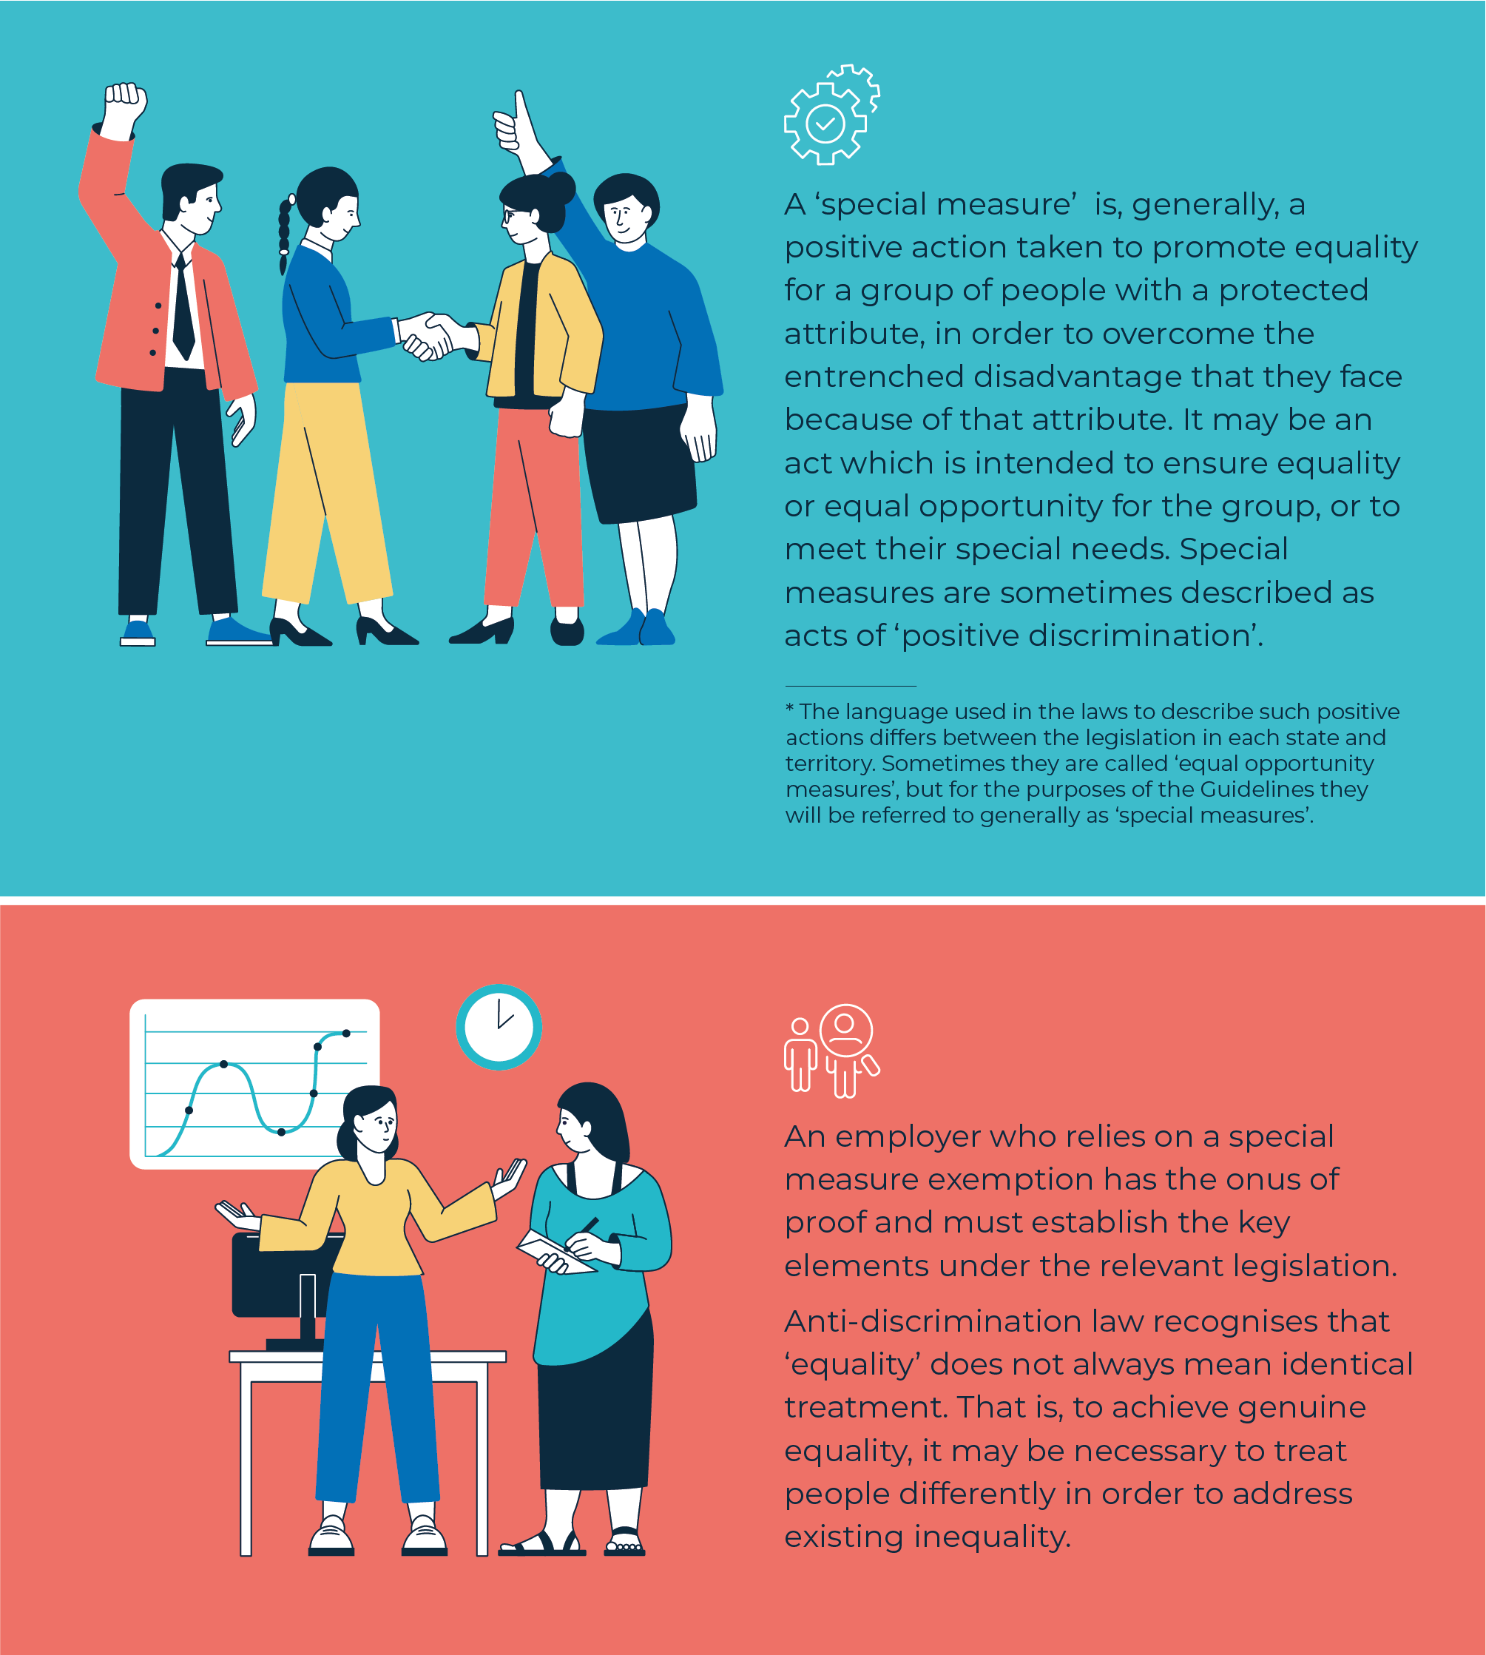

Key elements of a special measure – federal law
Under the Disability Discrimination Act, the elements of a special measure are:
- the measure must be reasonably intended to
- ensure that persons who have a disability have equal opportunities with other persons in areas of public life covered by the Disability Discrimination Act (in this case, employment), or
- afford persons with disability, or a particular disability, goods or access to facilities, services or opportunities (or grants, benefits or programs) to meet their special needs in relation to:
- employment, education, accommodation, clubs, or sport, or
- the provision of goods, services, facilities or land, or
- the making available of facilities, or
- the administration of Commonwealth laws and programs, or
- their capacity to live independently.
- However
- any discriminatory effect of the measure must be necessary for implementing the special measure, and
- the exemption for special measures does not apply in relation to the rates of salary or wages paid to persons with disability (which are dealt with elsewhere in the Disability Discrimination Act).

Key elements of a special measure – other jurisdictions
The core elements of a special measure are essentially the same under all federal, state and territory anti-discrimination laws except NSW. However, the wording of the criteria in the legislation of each jurisdiction differs slightly.
Importantly, there is no relevant ‘special measures’ exception under the Anti-Discrimination Act 1977 (NSW) (the NSW Act). In some circumstances, employers wanting to conduct targeted recruitment for people with disability in NSW may have to apply for a statutory exemption from the NSW Act.
In addition, in Tasmania, the Anti-Discrimination Commissioner encourages employers to seek a statutory exemption for a targeted short-term recruitment strategy. The NSW and Tasmanian requirements are discussed in Parts 6.1 and 6.2 below.

Could a targeted recruitment strategy be a special measure?
A targeted recruitment strategy can be an example of a ‘special measure’, provided that it meets the legislative requirements of a ‘special measure’ under the federal Disability Discrimination Act and applicable state or territory anti-discrimination law provisions.
If a program like a targeted recruitment strategy is a ‘special measure’, then it does not amount to unlawful discrimination under federal, state or territory anti-discrimination law (noting that there is no ‘special measure’ provision in the relevant New South Wales law).

Genuine occupational requirements
Certain state and territory anti-discrimination laws also contain separate provisions which apply if having a disability is a genuine occupational qualification or requirement for a particular job. In general, the concept of ‘genuine occupational qualification’ permits discrimination when employing someone because of an overriding consideration in the performance of the job. It identifies what the character of the work is such that it is better or preferably done by someone with a particular attribute, including for reasons of empathy or authenticity.
For example, this may include roles that provide persons with a particular disability with services for the purpose of promoting their welfare, where those services are most effectively provided by a person with the same disability. A company may create the position to be performed by a person with disability to provide support and information to service users who are themselves people with disability.
The wording and scope of the genuine occupational requirement provisions vary across each state and territory. Employers will need to check the wording of the law in the state and/or territory in which they operate to see if the jobs they intend to advertise would fall within the provision (see Table 1 at Part 3.3 below).
If the genuine occupational requirement provision does apply to the particular position, it is recommended that in advertisements for the position, the employer include prominent wording to the effect that:
‘[Name of employer] considers that having a disability is a genuine occupational requirement for this position under [insert relevant provisions]’.
Note, however, that the federal Disability Discrimination Act does not include an exception for genuine occupational requirements. This means that even if having a disability is a genuine occupational requirement for a position, an employer will still need to satisfy itself, and be prepared to demonstrate that recruitment for this position also meets the criteria for a special measure (set out in Part 4 of the Guidelines) in order to comply with the Disability Discrimination Act.

Overview of relevant anti-discrimination law provisions
As outlined above, anti-discrimination legislation exists at a federal level as well as in each state and territory in Australia. The relevant legislative provisions in each state and territory are summarised in the table below.

Jurisdiction | Legislation | Exemption or exception for ‘special measures’ which includes recruitment | Exception for genuine occupational requirements | Comment
Commonwealth | Disability Discrimination Act 1992 (Cth) | Yes – s 45 | No
Australian Capital Territory | Discrimination Act 1991 (ACT) | Yes – s 27 | Yes – s 48
New South Wales | Anti-Discrimination Act 1977 (NSW) | No | No | A statutory exemption may need to be sought under s 126
Northern Territory | Anti-Discrimination Act 1992 (NT) | Yes – s 57 | Yes – s 35(1)(b)(i)
Queensland | Anti-Discrimination Act 1991 (Qld) | Yes – s 105 | Yes – s 25(1)
South Australia | Equal Opportunity Act 1984 (SA) | Yes – s 82 | No
Tasmania | Anti-Discrimination Act 1998 (Tas) | Yes – ss 25 and 26 | Yes – s 45(b)
Victoria | Equal Opportunity Act 2010 (Vic) | Yes – s 12 | Yes – ss 26(3) and 28
Western Australia | Equal Opportunity Act 1984 (WA) | Yes – s 66R | Yes – s 66S

Special measure requirements for implementing targeted recruitment strategies for people with disability
The purpose of this section is to describe a nationally consistent set of requirements for a targeted recruitment strategy for people with disability to be considered a ‘special measure’.
The requirements listed in the infographic below consolidate the various requirements under the Disability Discrimination Act and state and territory anti-discrimination laws.
The strictest requirements across jurisdictions are reflected, so if an employer can demonstrate that its recruitment strategy meets all the criteria, it can have confidence that it would meet the test in every jurisdiction. Employers can use the template provided in the Appendix to the Guidelines to record how their strategy meets these criteria.

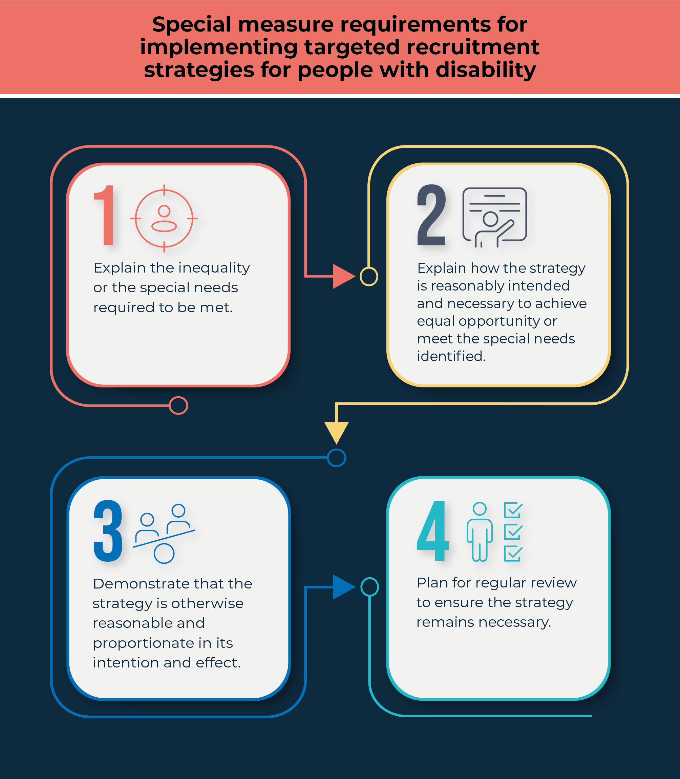

Explain the inequality or the special needs required to be met amongst the targeted group

Inequality or lack of equal opportunity
To demonstrate that a targeted recruitment strategy is necessary to ensure equality or equal opportunity amongst the targeted group (in this instance, people with disability or a particular disability) in employment, an employer will require evidence which clearly demonstrates that group’s disadvantage in the workforce by providing recent and reliable data.
For example, according to the Australian Institute of Health and Welfare, in 2018, working age people with psychosocial disability or intellectual disability had particularly high rates of unemployment (24% and 18%, respectively). In comparison, the unemployment rate of working age people with disability was 10%, while for working age people without disability, the rate was far lower at 4.6%.
Data on the percentage of an employer’s workforce from the target group and/or the levels of employment of the target group within the industry in which it operates, would also be relevant (assuming it shows low rates of employment).

Special needs
The question of how best to afford people with disability, or a particular disability, goods or access to facilities, services or opportunities – or grants, benefits or programs – to meet their special needs may arise in relation to employment, and specifically the recruitment for roles.
For example, an employer may be focused on providing services or facilities to people with a particular disability to meet their special needs, even though their benefits are not available to other persons. This would require the creation of roles requiring skills and attributes to ensure that these special needs are recognised and met. A targeted recruitment strategy may provide a valuable tool in this regard.
The special needs of the target group should be clearly explained. For example, with respect to government online service design and delivery, service recipients who are blind or have low vision have special needs which must be met, such as through accessible and adaptive technology. Evidence outlining these special needs by reference to the absence of currently accessible or inclusive online services for this group would provide a valuable starting point.

Explain how the strategy is reasonably intended, and is necessary, to ensure equal opportunity or meet the special needs identified
The targeted recruitment strategy must be ‘reasonably intended’ and necessary to achieve the purpose of:
- ensuring equal opportunity by providing a benefit to the group of people with a particular disability, so that they have the same employment opportunities as people without that disability. A targeted recruitment strategy aimed at increasing the employment of a group of people with that disability, who typically face difficulties with gaining employment, is a clear example of a benefit which ensures equal opportunity, or
- meeting the special needs of the target group. This might involve, in the example above, addressing particular barriers to employment faced by people who are blind or have low vision. Identifying relevant barriers may require consultation with individuals with lived experience of disability and relevant peak bodies to understand their needs and the appropriate responses. A targeted recruitment strategy that seeks to address these needs may, in turn, drive the uptake of more accessible and adaptive technology in service design, procurement and delivery more generally.
Objectively, the suitability of the targeted recruitment strategy adopted to achieve the specified purpose must be evident so that it meets the standard of ‘reasonably intended’. It must also be undertaken in good faith for the stated purpose. The necessity of the strategy, including any discriminatory effects, should be clear by reference to that purpose – the strategy must be justified because the members of the identified group have a particular need for advancement or assistance.
Accordingly, employers need to document their intention in conducting targeted recruitment strategies for people with a particular disability. Employers can do so by using the template attached at the Appendix to the Guidelines. The documentation should refer to the evidence which demonstrates why the measure is necessary, as mentioned above. A detailed record of the planning and rationale behind the measure will serve both as evidence of its purpose, and of the good faith of the employer undertaking it.
While any recruitment strategy will need to take into account the salary or wages paid to prospective employees, section 45(2)(b) of the Disability Discrimination Act provides that discriminatory rates of pay cannot be justified as a special measure. Rates of pay should be set at a non-discriminatory level or otherwise in accordance with sections 47(1)(c) or (d) of the Disability Discrimination Act.

Demonstrate that the strategy is otherwise reasonable and proportionate in its intention and effect
A targeted recruitment strategy must be designed to effectively address the actual disadvantage of the targeted group (in this case, people with disability, or a particular disability). That is, it must be ‘appropriate and adapted’ to its purpose.
At a high level, an employer needs to show there is a rational connection between the planned strategy and its stated objective in such a way that it is reasonably likely that the strategy will be successful.
A special measure must also be proportionate to the degree of disadvantage experienced by the target population. The principle of proportionality requires that the means adopted to address the disadvantage must not go beyond what is necessary to do so.
To demonstrate that a targeted recruitment strategy meets these requirements, an employer should:
- refer to the evidence of the disadvantage or special need which needs to be addressed – for example, the statistics which show that people with the particular disability are under-employed.
- consider why a targeted recruitment campaign is an appropriate way of increasing employment of people with disability – for example, by explaining previous unsuccessful attempts to
- employ this group in the past without implementing a targeted program, or pointing to the low number of people with disability employed by the organisation.
The test for proportionality will be the same whether the targeted recruitment strategy includes individual or bulk recruitment. Due to the inequality in employment outcomes for people with disability, a bulk recruitment strategy targeting people with a particular disability is likely to be proportionate.

Plan for the strategy to be regularly reviewed to ensure that it remains necessary
The targeted recruitment strategy must be ‘necessary’ to achieve the stated purpose. Should the purpose later be achieved (for example, substantive equality has been achieved and rates of employment of the target group are equal to or better than rates of employment outside the target group), then the strategy will no longer be necessary, and it will not be a special measure.
This means that employers should review any regularly conducted targeted recruitment strategy periodically to ensure that it:
- continues to address workforce disadvantage, or meets a special need
- is effective in doing so.
Employers should cease pursuing strategies that are no longer necessary.

Practical guidance on designing and implementing a targeted recruitment strategy
This section sets out practical steps an employer can take to make it clear that a targeted recruitment strategy for people with disability is a special measure, as well as ensuring that targeted recruitment programs are truly accessible to people with disability.
Taking these steps will minimise the risk of complaints that such measures are unlawfully discriminatory and provide evidence to dispute such a claim in the unlikely event a complaint is made. Following these steps will also enhance the success of any targeted recruitment strategy by ensuring accessibility for people with disability.

Document a clear intention
It is important for an employer to document why and how a targeted recruitment strategy will be a special measure to benefit people with disability. This documentation should address all the requirements mentioned in Part 4 above. The template attached as the Appendix to the Guidelines can be used for this documentation.
The recruitment should be consistently documented as a targeted employment strategy to address the under-representation of persons with disability in employment in the employer’s staff/industry/local area, or to meet the special needs of persons with disability.
A written record of the intent and evidence for the special measure will not only be important to demonstrate that the recruitment strategy is a special measure, but also will be useful in gaining executive support for the strategy within the organisation.
An employer can also use this information to measure the success of the strategy, to determine whether and when its objective has been achieved.

Establish the legal basis for targeted recruitment
It is good practice for an employer to clearly identify that its decision to target candidates with a particular disability for a certain position (or group of positions) has a legal basis by making reference to the ‘special measure’ provisions in the relevant legislation. This will minimise the risk of other applicants challenging the employment as a possible breach of anti-discrimination laws.

The Commission and its state and territory counterpart bodies recommend that all advertisements and selection documentation for the special measures position(s) contain the wording:
‘The filling of this position is intended to constitute a special measure under section 45 of the Disability Discrimination Act 1992 (Cth), and [insert relevant provisions of state/territory acts]. The position/s is/are therefore only open to applicants with disability/ applicants with [insert particular disability].’

Communicate the intention of the recruitment strategy
Communicating the intention of a targeted recruitment strategy throughout its development and implementation is crucial to ensuring that it is well understood. The employer’s intention, including the legal provisions relied upon, should be reflected in the internal documentation prepared in planning the measure, the job description, advertisements for the position/s, the information provided at a formal interview, and any recruitment documentation provided to the successful applicant/s.
If applicable, the employer can include links to relevant disability employment strategies, Disability Action Plans, diversity and inclusion plans, or other relevant documentation in any online advertisements for the position/s.
Employers can also consider the involvement and value of a diversity inclusion officer or trained human resources representative for any targeted positions. This person will be able to ensure a recruitment process that is accessible and inclusive and explain the concept of, and justification for, special measures if required.

Seek the participation and inclusion of persons with disability in the strategy’s design and implementation
The Commission supports the full and effective participation and inclusion of persons with disability in identifying and responding to matters that affect them, including employment. It strongly encourages employers to seek the expertise and participation of their existing employees with disability, disability support network groups, and disability representative groups when considering and implementing a targeted recruitment strategy. This would include seeking views on the merits and design of such a strategy, having regard to alternative approaches, to ensure that it is well-supported and fit for purpose.

Ensure inclusive communication
When developing a targeted recruitment strategy, an employer should be mindful to ensure that all forms of workplace communication are accessible and inclusive. This is an integral part of facilitating access and inclusion in the workplace. Accessible and inclusive communication means that messaging and information meets the communication needs of everyone within the community and that the target audience can access, understand and engage with the information being shared. Depending on the needs of the target audience, this may involve:
- providing job advertisements in alternative formats, including hard copy, audio, large print and Easy Read
- ensuring job advertisements can be easily read by screen readers
- avoiding platforms requiring people to download additional software
- including contact details for the National Relay Service to assist candidates who are deaf or have a hearing impairment.
It also means using inclusive and respectful language, and developing accessible and inclusive written communications.
For more information, see the Commission’s IncludeAbility – Creating Accessible and Inclusive Communications Guide. The People with Disability Australia – Language Guide also contains useful guidance in relation to the use of inclusive language.

Establish accessible and inclusive recruitment practices
When looking to recruit people with disability, an employer should be mindful to ensure that it establishes accessible and inclusive recruitment practices. An employer can proactively connect with candidates with disability by:
- engaging with a Disability Employment Services provider or disability organisations that support people with disability
- advertising on job search sites dedicated to people with disability, including toozly.com.au.
An employer can also take steps to ensure that its job advertisements are accessible, including by:
- encouraging applicants to request any reasonable adjustments needed to assist them through the application and recruitment process
- indicating a willingness to customise the role for the right candidate
- avoiding including any non-essential requirements in the position description (for example, having a driver’s licence if this relates to sporadic travel).
At the interview stage, an employer should ask candidates if they require reasonable adjustments and facilitate these, and ensure that the physical location or online platforms being used for interviews are accessible.
The Commission’s IncludeAbility Attracting and Recruiting People with Disability to your Organisation Guide provides more information and advice to employers on these areas.

Create an accessible and inclusive workplace
Recruitment should form only one aspect of an employer’s approach with respect to employing persons with disability. An employer should implement measures to create an accessible and inclusive workplace, not only to facilitate successful recruitment outcomes, but to actively foster the retention and advancement of talented employees with disability. For example, employers should:
- create accessible and inclusive induction programs, to establish a long-lasting relationship built on mutual respect
- ensure the physical accessibility of their workplace, including its overall accessibility, internal accessibility, signage and waiting and reception areas
- ensure equitable access to workplace technology
- foster workplace attitudes that support people with disability to feel welcome, safe and included at work, including
- through all-staff training on diversity, inclusion disability and accessibility ensure that reasonable adjustments are made to work processes, practices or environments, to ensure employees with disability can perform their job, free from barriers
- consider having a Disability Employee Network and a diversity inclusion officer role
- consider implementing a Disability Action Plan.
For more information about measures that can be implemented to create inclusive and accessible workplaces, including for people with disability, please refer to:
- the Commission’s IncludeAbility Creating an Accessible and Inclusive Workplace Guide
- the Commission’s IncludeAbility Creating an Accessible and Inclusive Induction Guide
- the Commission’s Disability Action Plan Guide.

Case Study
PwC Australia
Under its recently revised access and inclusion plan, one of PwC Australia’s goals is to become an employer of choice for candidates with disability. It aims to do this by:
- running targeted recruitment campaigns and connecting with universities through disability support services on campus
- participating in external disability employment campaigns, media and speaking opportunities
- increasing accessibility at all stages of recruitment and on-boarding including mandatory disability confidence training for recruiters
- continuing to provide support and training for people conducting interviews with candidates with a disability, for example disability confidence training and unconscious bias training
- encouraging people with disability to disclose their disability and any reasonable adjustments during the recruitment process and throughout their employment.

Applying for statutory exemptions
If a targeted recruitment strategy is a special measure under the federal Disability Discrimination Act, it is not necessary to apply to the Commission for a statutory exemption. This is because special measures are lawful under the Disability Discrimination Act and the statutory exemption process is concerned with potentially unlawful conduct.
Statutory exemptions under section 55 of the Disability Discrimination Act are temporary in nature and are generally only granted where an applicant is currently not fully compliant with its requirements under the Disability Discrimination Act but can demonstrate that it is actively taking steps towards full compliance (for example steps to ensure the accessibility of buildings or public transport). Temporary exemptions are not granted for conduct that is ongoing and potentially indefinite. The Commission’s practice is not to grant temporary exemptions for conduct that is or could be a special measure.
In most states and territories, seeking a statutory exemption is also unnecessary for a targeted recruitment strategy that constitutes a special measure. The situation is, however, different in NSW, where there are no special measures exceptions, and in Tasmania where, even though special measures exceptions exist, seeking a statutory exemption is nevertheless recommended. This is explained below.

New South Wales
The Anti-Discrimination Act 1977 (NSW) (the NSW Act) does not contain special measures provisions. In NSW, an employer wanting to conduct a targeted recruitment strategy for people with disability may need to apply for a statutory exemption under the NSW Act, however there are some exceptions that may apply.
Anti-Discrimination NSW has information on its website about how to apply for an exemption to the NSW Act. Generally, an employer does not require an exemption from the NSW Act for undertaking targeted recruitment for all people with disabilities, but only if an employer wants to specify a particular type of disability. For example, if an employer wants to recruit for a person with lived experience of an intellectual disability, an exemption should be sought.
Anti-Discrimination NSW’s website explains:
An exemption is an approval that is granted by us under section 126 of the Act, giving permission to favour a particular group of people relating to specific jobs, programs or services. Exemptions generally relate to employment and recruitment; however, you can apply for an exemption in relation to any area covered by the Act.
Anti-Discrimination NSW lists the information an employer must provide to the President as part of its application, and the six criteria that the employer must address in its application to the President.
Much of the information mentioned in the Guidelines regarding how to establish special measure will be relevant to an application for an exemption under section 126 of the NSW Act.
For example, to be granted an application the employer must address:
- information about its organisation and what the organisation does, including information in relation to the organisational structure and the particular position that is being recruited
- how long the employer would like the exemption for and the reasons for that length of time
- the scope and terms of the exemption (for example, details of the positions being recruited, and/or a copy of the relevant position description)
- an outline of how the proposed exemption meets the criteria in the regulation.
In addition, the President must take into account the following six factors when assessing an exemption application, all of which should be addressed by the employer in its application:
- whether the proposed exemption is appropriate or reasonable
- whether the proposed exemption is necessary
- whether there are any non-discriminatory ways of achieving the objects or purposes for which the proposed exemption is sought
- whether the proponent of the proposed exemption has taken reasonable steps, or is able to take any reasonable steps, to avoid or reduce the adverse effect of a particular act or action before seeking the exemption
- the public, business, social or other community impact of the granting of the proposed exemption
- any conditions or limitations to be contained in the proposed exemption.
An employer recruiting in NSW should also be able to show that a targeted recruitment strategy for people with disability meets the requirements of a special measure under the federal Disability Discrimination Act (set out in Part 4 of the Guidelines), even if it is granted an exemption from the NSW Act. This is because an employer recruiting in NSW must comply with both the NSW Act and the Disability Discrimination Act.

Case Study
Recent NSW exemptions
Anti-Discrimination NSW highlights several examples of section 126 statutory exemptions granted to support targeted recruitment of persons with specific disabilities.
- University of NSW – granted an exemption in 2021 for three years to advertise, designate and recruit a project administrator who self identifies as having a lived experience of an intellectual disability.
- Transport for NSW Cluster (comprising Transport for NSW, the State Transit Authority, Sydney Trains, NSW Trains, Sydney Metro Authority and Point to Point Commission) – granted an exemption for targeted roles to implement diversity and inclusion programs for designated target groups including people with a specific disability.
- NSW Council for Intellectual Disability – granted an exemption for advertising, designating and recruiting project worker and project assistant roles for people who self-identify as having an intellectual disability.

Tasmania
Under the Anti-Discrimination Act 1998 (Tas) (Tasmanian Act), exceptions, including the special measures exceptions (sections 25 and 26), must be proved on the balance of probabilities.
While the Tasmanian Anti-Discrimination Commissioner has some authority to determine whether a special measure exception properly applies, the Commissioner may not always have authority to determine that sections 25 or 26 apply to a complaint either at initial assessment or after investigation.
It would therefore be at the inquiry by the Tasmanian Civil and Administrative Tribunal that an employer would have to prove that the exception applied to its conduct and, as a result, the conduct was not unlawful.
However, if an exemption is granted for targeted recruitment, the Tasmanian Anti-Discrimination Commissioner has express authority to reject or dismiss a complaint about conduct that falls within the scope of the exemption granted.
Employers seeking to engage in targeted recruitment in Tasmania may apply for an exemption under the Tasmanian Act. This provides protection against a complaint about any conduct that falls within the scope of the exemption granted. In applying for an exemption, providing material that satisfies the requirements set out in Part 4 of this document is likely to be sufficient.
The Tasmanian Anti-Discrimination Commissioner has published information on how to apply for exemptions to the Tasmanian Act.

Other jurisdictions
As outlined in the Guidelines, under the federal Disability Discrimination Act, and in all other states or territories except NSW (and noting the guidance regarding Tasmania above), the granting of a statutory exemption is not a legal prerequisite for conducting a targeted recruitment strategy, as long as the recruitment program meets the requirements of a special measure.
This is because the purpose of a statutory exemption is to exclude the application of a particular law to certain conduct which would otherwise breach that law. Special measures are lawful and the statutory exemption process is concerned with potentially unlawful conduct.

More information and contact details – Federal, state and territory bodies
Employers wishing to seeking advice on targeted recruitment strategies can contact their local bodies.
Jurisdiction | Anti-Discrimination Law | Relevant Body | More information and contact details
Commonwealth | Disability Discrimination Act 1992 (Cth) | Australian Human Rights Commission | https://humanrights.gov.au/our-work/disability-rights  https://includeability.gov.au/contact-us-includeability  https://humanrights.gov.au/our-work/commission-general/contact-us
Australian Capital Territory | Discrimination Act 1991 (ACT) | ACT Human Rights Commission | https://hrc.act.gov.au/contact-us/
New South Wales | Anti-Discrimination Act 1977 (NSW) | Anti-Discrimination NSW | https://antidiscrimination.nsw.gov.au/anti-discrimination-nsw/need-help.html
Northern Territory | Anti-Discrimination Act 1992 (NT) | NT Anti-Discrimination Commission | https://adc.nt.gov.au/contacts
Queensland | Anti-Discrimination Act 1991 (Qld) | Queensland Human Rights Commission | https://www.qhrc.qld.gov.au/contactus
South Australia | Equal Opportunity Act 1984 (SA) | Office of the Commissioner for Equal Opportunity | https://www.eoc.sa.gov.au/about-us/contact-us
Tasmania | Anti-Discrimination Act 1998 (Tas) | Equal Opportunity Tasmania | https://equalopportunity.tas.gov.au/contact_us
Victoria | Equal Opportunity Act 2010 (Vic) | Victorian Equal Opportunity and Human Rights Commission | https://www.humanrights.vic.gov.au/get-help/contact-us/
Western Australia | Equal Opportunity Act 1984 (WA) | Western Australian Equal Opportunity Commission | https://www.wa.gov.au/organisation/equal-opportunity-commission

Appendix – Template for documenting a targeted recruitment strategy addressing special measure criteria
If an employer follows the practical steps set out in the following sections of the Guidelines, this will assist in demonstrating that a proposed target recruitment strategy is a special measure which is consistent with anti-discrimination law.

Describe the targeted recruitment strategy
__________________________________________________________________________________________________________________________________________________________________________________________________________________________________________________________________________________________

Declare the intention to fill the above position/s through a ‘special measure’
The filling of this position is intended to constitute a special measure under section 45 of the Disability Discrimination Act 1992 (Cth), and [select appropriate jurisdiction/s from:
- section 27 of the Discrimination Act 1991 (ACT)
- section 57 of the Anti-Discrimination Act 1992 (NT)
- section 105 of the Anti-Discrimination Act 1991 (Qld)
- section 82 of the Equal Opportunity Act 1984 (SA)
- section 25 and/or section 26 of the Anti-Discrimination Act 1998 (Tas)
- section 12 of the Equal Opportunity Act 2010 (Vic) and s 8(4) of the Charter of Human Rights and Responsibilities Act 2006 (Vic)
- section 66R of the Equal Opportunity Act 1984 (WA).]
The position/s is/are therefore only open to applicants with disability/ applicants with [disability/particular disability].

Explain why the targeted recruitment strategy is necessary
- Provide evidence that the target group of people with disability are disadvantaged in employment because of their disability (for example data from the Australian Bureau of Statistics or the Australian Institute of Health and Welfare), or
- Provide evidence about the special needs of the target group of people with disability which are required to be met in the employment context.
__________________________________________________________________________________________________________________________________________________________________________________________________________________________________________________________________________________________

Explain how the targeted recruitment strategy will promote equal opportunity for, or meet the special needs of, the target group of people with disability
- Explain the planning and rationale behind the targeted recruitment strategy, demonstrating its suitability to achieve its purpose.
- Include here reference to any relevant provisions of a Disability Action Plan or Diversity and Inclusion Plan.
__________________________________________________________________________________________________________________________________________________________________________________________________________________________________________________________________________________________

Demonstrate how the strategy is otherwise reasonable and proportionate in its intention and effect
- Explain why it is reasonably likely that the strategy will be successful.
- Explain why the strategy is proportionate and does not go beyond what it is necessary to do.
- Include why alternatives are not possible or will be ineffective (for example, by referencing previous unsuccessful attempts to employ the target group of people with disability in the past, or low numbers of people in the target group of people with disability, or prior failures to meet the special need).
__________________________________________________________________________________________________________________________________________________________________________________________________________________________________________________________________________________________

Explain that the strategy will be regularly reviewed to ensure that it remains necessary
- Explain how long the strategy will continue and how its success in achieving its purpose will be measured (for example, any relevant employment targets), and proposed time for review to assess whether the strategy is working.
__________________________________________________________________________________________________________________________________________________________________________________________________________________________________________________________________________________________

Endnotes

Further Information
Australian Human Rights Commission
Level 3, 175 Pitt Street
Sydney NSW 2000
GPO Box 5218
Sydney NSW 2001
Telephone: (02) 9284 9600Complaints Infoline: 1300 656 419
General enquiries and publications: 1300 369 711TTY: 1800 620 241Fax: (02) 9284 9611
Website: www.humanrights.gov.au
For detailed and up to date information about the Australian Human Rights Commission visit our website at www.humanrights.gov.au.
To order more publications from the Australian Human Rights Commission, download a Publication Order Form at www.humanrights.gov.au/about/publications/ call: (02) 9284 9600, fax: (02) 9284 9611 or email: publications@humanrights.gov.au.

Australian Institute of Health and Welfare (AIHW), People with disability in Australia 2022, 14, 306-310. At https://www.aihw.gov.au/getmedia/5f322ec4-ef63-4c43-a854-64f7a2f55a04/aihw-dis-72-people-with-disability-in-australia-2022.pdf.aspx?inline=true (viewed 20 July 2022).
Australian Institute of Health and Welfare (AIHW), People with disability in Australia 2022, 2022, 307. At https://www.aihw.gov.au/getmedia/5f322ec4-ef63-4c43-a854-64f7a2f55a04/aihw-dis-72-people-with-disability-in-australia-2022.pdf.aspx?inline=true (viewed 20 July 2022).
The term ‘special needs’ will be used in the Guidelines to mirror the language used in section 45 of the Disability Discrimination Act 1992 (Cth). It is acknowledged that the term may not reflect a modern understanding of disability as an aspect of diversity. For more information regarding the use of language refer to Media Diversity Australia, Disability Reporting Handbook, published November 2021. At https://www.mediadiversityaustralia.org/wp-content/uploads/2021/11/MDA-Disability-Reporting-Handbook_FINAL-V5_21112021.pdf (viewed 18 October 2022).
The language used in the laws to describe such positive actions differs between the legislation in each state and territory. Sometimes they are called ‘equal opportunity measures’, but for the purposes of the Guidelines they will be referred to generally as ‘special measures’.
Section 67(1)(k) of the Disability Discrimination Act 1992 (Cth) provides for the Commission to prepare, and to publish in such manner as the Commission considers appropriate, guidelines for the avoidance of discrimination on the ground of disability.
NSW Government, ‘I work for NSW’: Assistant Project Officer (Clerk Grade 5/6) – Disability targeted process, undated. At https://iworkfor.nsw.gov.au/job/assistant-project-officer-clerk-grade-5-6-disability-targeted-process-335596 (viewed 28 July 2022).
NSW Government, ‘I work for NSW’: Assistant Project Officer (Clerk Grade 5/6) – Disability targeted process, undated. At https://iworkfor.nsw.gov.au/job/assistant-project-officer-clerk-grade-5-6-disability-targeted-process-335596 (viewed 28 July 2022).
Further information can be found on the IncludeAbility website at http://www.includeability.gov.au.
Australian Public Service Commission, Australian Public Service Disability Employment Strategy 2020-2025, 2020, 8. At https://www.apsc.gov.au/publication/australian-public-service-disability-employment-strategy-2020-25 (viewed 30 August 2022).
Australian Public Service Commission, Australian Public Service Disability Employment Strategy 2020-2025, 2020, 14. At https://www.apsc.gov.au/publication/australian-public-service-disability-employment-strategy-2020-25 (viewed 30 August 2022).
Australian Public Service Commission, Australian Public Service Disability Employment Strategy 2020-2025, 2020. At https://www.apsc.gov.au/publication/australian-public-service-disability-employment-strategy-2020-25 (viewed 15 July 2022). See also Australian Public Service Commission, Affirmative measure for recruiting people with disability: guide for applicants, 2022. At https://www.apsc.gov.au/working-aps/diversity-and-inclusion/disability/affirmative-measure-recruiting-people-disability-guide-applicants (viewed 15 July 2022).
Australian Broadcasting Corporation, ABC Regional Storyteller Scholarship winners announced, 21 April 2022. At https://about.abc.net.au/press-releases/abc-regional-storyteller-scholarship-winners-announced (viewed 12 July 2022).
Disability Discrimination Act 1992 (Cth), section 15.
Disability Discrimination Act 1992 (Cth), section 4.
This concept is generally contained in exceptions provisions in jurisdictions other than Victoria and the Commonwealth.
Under the Disability Discrimination Act 1992 (Cth), in determining whether a hardship that would be imposed on a person would be an unjustifiable hardship, all relevant circumstances of the particular case must be taken into account, including the factors listed in section 11. For example, the nature of benefit or detriment likely to accrue or be suffered by any person concerned, effect of disability of any person concerned, financial circumstances and expenditure required to be made, availability of financial and other assistance, relevant Disability Action Plans.
See, for example, Disability Discrimination Act 1992 (Cth), section 3.
There is some difference in the legislative terminology used regarding the nature of special measures. Rees, Rice and Allen note that while conduct which falls within the scope of special measures is an exception to the legislative prohibitions against discrimination, some legislation expresses a special measure not as an exception to unlawful discrimination but as a positive measure in its own right in pursuit of equality, although it operates as an exception and can be relied upon for a defence: Neil Rees, Simon Rice and Dominique Allen, Anti-Discrimination & Equal Opportunity Law, 3rd ed, 2018, Federation Press, 185. Further, under the Disability Discrimination Act 1992 (Cth), section 45 (special measures) is termed an exemption, although exemptions generally have a distinctive character to exceptions. In the Guidelines, s 45 of the Disability Discrimination Act 1992 (Cth) is described as an exemption, but special measures under state and territory anti-discrimination laws are referred to as exceptions.
Noting that depending on the circumstances, other exemptions or exceptions may also apply under the Disability Discrimination Act 1992 (Cth) and the relevant state or territory anti-discrimination law.
Whether direct or indirect: Disability Discrimination Act 1992 (Cth), section 45(1)(c).
See instead the exemption at section 47 of the Disability Discrimination Act 1992 (Cth) which provides for acts done under statutory authority, including where industrial instruments provide for salary or wages of persons with disability, or orders, awards or determinations are made by courts or tribunals with power to fix minimum wages: Disability Discrimination Act 1992 (Cth), section 47(1)(c) and (d)).
For the relevant provisions in each federal, state and territory law, see Table in Part 3.3 of the Guidelines.
Under section 126 of the Anti-Discrimination Act 1977 (NSW).
Equal Opportunity Tasmania, Exemptions, undated. At https://equalopportunity.tas.gov.au/exemptions (viewed 18 July 2022).
As discussed, there is no ‘special measure’ provision in the Anti-Discrimination Act 1977 (NSW), and employers should apply to Anti-Discrimination NSW for a statutory exemption, see Part 6.1.
Refer to Table at Part 3.3.
Neil Rees, Simon Rice and Dominique Allen, Anti-Discrimination & Equal Opportunity Law, 3rd ed, 2018, Federation Press, 576.
Neil Rees, Simon Rice and Dominique Allen, Anti-Discrimination & Equal Opportunity Law, 3rd ed, 2018, Federation Press, 576.
Section 21A of the Disability Discrimination Act 1992 (Cth) provides for an ‘inherent requirements’ exception (which also exists across state and territory jurisdictions), but this kind of exception has different work to do compared to a genuine occupational qualification. The ‘inherent requirements’ exception permits discrimination in employment if a person is unable to carry out the essential tasks required by the particular work, even if reasonable adjustments were provided. The application of this exception requires a holistic assessment of the circumstances: Neil Rees, Simon Rice and Dominique Allen, Anti-Discrimination & Equal Opportunity Law, 3rd ed, 2018, Federation Press, 389, 576.
Catholic Education Office v Clarke (2004) 138 FCR 121, 149 [130].
PwC Australia, Reimagining Accessible Employment – PwC Australia’s access and inclusion plan 2020-2022, 2020, at https://www.pwc.com.au/publications/assets/pwc-australias-access-and-inclusion-plan-2020-2022.pdf (viewed 3 August 2022)
For example, under the Disability Discrimination Act 1992 (Cth), section 55.
Anti-Discrimination New South Wales, Exemptions and certifications, undated. At https://antidiscrimination.nsw.gov.au/anti-discrimination-nsw/organisations-and-community-groups/exemptions-and-certifications.html/ (viewed 3 August 2022).
Anti-Discrimination New South Wales, Exemptions and certifications, undated. At https://antidiscrimination.nsw.gov.au/anti-discrimination-nsw/organisations-and-community-groups/exemptions-and-certifications.html/(viewed 3 August 2022).
Anti-Discrimination New South Wales, Exemptions and certifications, undated. At https://antidiscrimination.nsw.gov.au/anti-discrimination-nsw/organisations-and-community-groups/exemptions-and-certifications.html/ (viewed 3 August 2022).
Anti-Discrimination New South Wales, Current exemptions, undated. At https://antidiscrimination.nsw.gov.au/anti-discrimination-nsw/organisations-and-community-groups/exemptions-and-certifications/current-exemptions.html (viewed 3 August 2022).
Anti-Discrimination Act 1998 (Tas), section 101.
Anti-Discrimination Act 1998 (Tas), section 64(1)(h).
Equal Opportunity Tasmania, Exemptions, undated. At https://equalopportunity.tas.gov.au/exemptions (viewed 3 August 2022).
Equal Opportunity Tasmania, Applying for an Exemption, undated. At https://equalopportunity.tas.gov.au/exemptions (viewed 3 August 2022).

