© Australian Human Rights Commission 2021.
The Australian Human Rights Commission encourages the dissemination and exchange of information presented in this publication.
All material presented in this publication is licensed under Creative Commons Attribution 3.0 Australia, with the exception of:
- photographs and images
- organisational logos, any branding or trademarks
- where otherwise indicated.
To view a copy of this licence, visit https://creativecommons.org/licenses/by/3.0/au/.
In essence, you are free to copy, communicate and adapt the publication, as long as you attribute the Australian Human Rights Commission and abide by the other licence terms.
Please give attribution to: © Australian Human Rights Commission
Equality across the board: Investing in workplaces that work for everyone • June 2021
ISBN 978-1-925917-52-9
For further information about copyright in this publication, please contact:
Communications Unit
Australian Human Rights Commission
GPO Box 5218
SYDNEY NSW 2001
Telephone: (02) 9284 9600
TTY: 1800 620 241
Email: communications@humanrights.gov.au
Design and layout: Dancingirl Designs
Cover image: iStock
Internal photography: iStock
The Australian Human Rights Commission is Australia’s National Human Rights Institution. It is an independent statutory organisation with responsibility for leading the promotion and protection of human rights in Australia.

Acknowledgements
The Sex Discrimination Commissioner thanks the following Commission staff for their contributions: Natasha de Silva, Lauren Jones, Maria Twomey, Julie O’Brien, Giorgina Piperone, Georgia Waters, Clare Hart, Ali Jehanzeb, Lois Lee, Grace Gardiner and Lucinda Hughes.
The Commission thanks the Australian Council of Superannuation Investors (ACSI) for commissioning the report, and for their expert advice and support throughout the process.
The Commission is grateful to the representatives of ASX200 companies that generously shared their time and insights in the survey and consultations.
The Commission thanks Herbert Smith Freehills for its pro-bono contribution of the summary of relevant legal and reporting frameworks.

Equality across the board: Investing in workplaces that work for everyone

June 2021

Australian Human Rights Commission

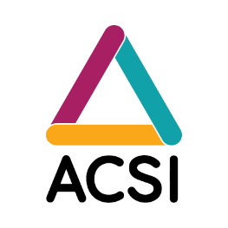

Acronyms and abbreviations
ACSI | Australian Council of Superannuation Investors
AICD | Australian Institute of Company Directors
APRA | Australian Prudential Regulation Authority
APRA Inquiry | APRA’s Inquiry into the Commonwealth Bank of Australia
ASX Principles | ASX Corporate Governance Principles
Banking Royal Commission | Royal Commission into Misconduct in the Banking, Superannuation and Financial Services Industry
The Commission | Australian Human Rights Commission
Deloitte Report | Deloitte Access Economics report: the economic costs of sexual harassment in the workplace
EMT | Executive Management Team or Executive Team
ESG | Environmental, social and corporate governance
Respect@Work or the  National Inquiry | National Inquiry into Sexual Harassment in Australian Workplaces

Contents
Acronyms and abbreviations 6
Foreword – Kate Jenkins 8
Foreword – Louise Davidson 10
Executive Summary 12
Key statistics 13
Recommendations 15
Section 1: Introduction 17
1.1 Project purpose 17
1.2 Methodology 18
Section 2: The current context 22
2.1 Respect@Work: Key findings and recommendations 22
2.2 ASX200 companies: Increasing transparency and accountability for workplace culture and sexual harassment 24
Section 3: Key findings – Understanding current approaches to collecting, reporting and using data on sexual harassment 27
3.1 Leadership and governance 27
3.2 Risk assessment and industry action 32
3.3 Culture 33
3.4 Knowledge 34
3.5 Reporting and supports 35
3.6 Measurement and accountability 37
3.7 Transparency 39
3.8 Gender diversity 42
Section 4: Recommendations 44
Appendix 1 56
Duty to collect sexual harassment data and report 56
Additional reporting obligations that might apply to sexual harassment incidents 58

Foreword – Kate Jenkins
There is global momentum demanding an end to violence against women, and in particular ensuring our workplaces are safe and free from sexual harassment, bullying and discrimination.
Motivated by the global #MeToo movement, the Australian Human Rights Commission (the Commission)’s National Inquiry into Sexual Harassment in Australian Workplaces (The National Inquiry or Respect@Work) report revealed the prevalence of and immense harm caused by sexual harassment in Australian workplaces. Deloitte Access Economics report: the economic costs of sexual harassment in the workplace (Deloitte Report) quantified the cost of sexual harassment to the Australian economy in 2018 as $3.8 billion, through lost productivity, staff turnover, absenteeism and other associated impacts. Most of these costs were borne by employers.
If there was any doubt, the last 12 months has reinforced that the conventional way of dealing with sexual harassment will no longer work. Workplace sexual harassment is a systemic and costly issue that is flourishing under the guise of confidentiality and secrecy. Workers, customers, investors, journalists and the community, especially women, have had enough.
Drawing upon calls for guidance from companies, this report aims to contribute to the reduction of workplace sexual harassment at large Australian companies by focusing on the actions required of the most senior leadership in the most significant Australian companies: ASX200 boards and executive management. It also facilitates improved understanding of the role investors can play in holding ASX200 companies accountable to effectively addressing sexual harassment.
The recommendations build on significant findings of Respect@Work, including that transparency is the solution rather than the problem for addressing sexual harassment, and that gender equality is the foundation of safe, respectful workplaces, for everyone. It builds upon decades worth of research and advocacy of workers, unions, women’s rights organisations and the courage of survivors who have come forward to tell their stories.
On behalf of the Commission, I express my appreciation to all ASX200 companies that generously shared their rich and considered perspectives during interviews and the survey. These insights served as a strong basis for the report’s recommendations.
I also pay tribute to our partner organisation in this research project, the Australian Council of Superannuation Investors (ACSI), for their valuable support and expertise.

Foreword – Louise Davidson
Ensuring sexual harassment is eliminated is a job for everyone, yet for many companies it is unclear who is accountable. This lack of clarity exposes a significant risk factor for owners assessing a company’s approach to safety and culture.
While at the forefront only a few decades ago, Australia now ranks well behind other countries in preventing and responding to sexual harassment. High profile cases have brought into sharp focus the role of the board, highlighting issues with organisational culture, and raising questions as to whether boards are receiving the information needed to appropriately respond to sexual harassment.
While companies are collecting data on these issues, how this information is analysed and used remains inconsistent across large companies. Shifting responses from reactive to preventative will be key to eliminating sexual harassment. With an increasing momentum to address prevalence of sexual harassment, now is the time for further focus to ensure companies meet the expectations of stakeholders in managing this material risk.
ACSI has worked with the Sex Discrimination Commissioner to undertake research to better understand how companies are addressing sexual harassment. Over half of ASX200 companies participated in this research, with the Commission asking them about sexual harassment: how it is reported, managed, and ultimately prevented in their business.
The data indicates that the majority of boards discuss sexual harassment on a reactive basis, rather than proactively seeking assurance on prevention. It is clear there is more work to be done to structurally respond to sexual harassment. The eight recommendations in this report provide tangible steps for companies and their leaders to improve their approach. Directors must prioritise and embed good company culture within their organisations, and act immediately where there are instances of misconduct or unethical behaviour.
The research also provides recommendations for investors, acknowledging that prevention of sexual harassment is a shared goal, given the significant cost of poor practice.
Corporate culture has a profound impact on a company’s performance, governance and reputation. At the heart of many – if not all – of the high-profile governance failures over the past decade have been examples of poor company culture or subcultures.

Executive Summary
This report presents research into the collection and reporting of workplace data relevant to sexual harassment by ASX200 companies. The research, led by the Sex Discrimination Commissioner, Kate Jenkins, on behalf of ACSI, is based on a comprehensive survey of 118 ASX200 companies, as well as in-depth interviews with representatives of 16 ASX200 companies. The report provides insights into how companies currently collect and use data relating to sexual harassment, and based on those insights, makes recommendations about the role the boards of large Australian companies can and should play in preventing and responding to workplace sexual harassment. Additionally, the report highlights actions investors can take to manage financial risks associated with workplace sexual harassment within investee companies.
Clearly, collection of information alone is not enough to prevent and address sexual harassment. The report finds a range of maturity across the ASX200 companies when it comes to using the information to manage this material risk. Information must be analysed, shared and acted upon for it to be useful. If information is not appropriately escalated within an organisation, risk cannot be effectively and proactively managed by those responsible.
The report recommends that boards focus on oversight of prevention of as well as response to sexual harassment. Boards should take primary responsibility and accountability for ensuring the company has in place a governance framework for sexual harassment, and for monitoring performance against this framework across the organisation. The board should also clearly identify the information it expects to receive in monitoring performance, including information to assess how effective the organisation’s systems are in preventing, as well as responding to, sexual harassment.
Key statistics and recommendations are set out below.

Key statistics
Leadership and governance
It can be unclear who holds primary responsibility and accountability for the prevention of and response to sexual harassment.
19% of survey respondents recognised that the board had primary responsibility and accountability for the prevention and response to sexual harassment, including the oversight of policies and frameworks that support the gathering and use of data. Instead, in most companies, primary responsibility sits with senior executives (Head of Human Resources or the CEO). For many companies, the responsibility is shared and can be unclear.
Fewer than half of respondents indicated that sexual harassment was a regular board agenda item (43%). We heard that external events often served as a prompt for board discussion, suggesting that the majority of boards have been taking a reactive, rather than proactive or preventative, approach to addressing sexual harassment.
Risk assessment
64% of respondents had developed a mechanism that identified and mitigated risk factors for sexual harassment.
Gender diversity and expertise
Gender diverse boards and access to relevant expertise is correlated with stronger governance and oversight of matters regarding sexual harassment.
62% of respondents had set a target to increase representation of women on their board.
Gender equality was a priority for the majority of respondents (94%) who indicated they have policies and strategies in place to support gender equality in recruitment.

Culture
The majority of respondents indicated that they tied the EMT’s remuneration and performance incentives with culture and conduct standards. 27% reported that they tied incentive payments, at least partially, to preventing sexual harassment.
Knowledge building
Directors and EMT would benefit from additional skills and expertise on good governance and sexual harassment.
19% of respondents reported that board directors undergo training on good governance and sexual harassment.
Three out of five respondents (60%) indicated that the EMT was required to undergo training on good governance and sexual harassment.
Reporting and supports
The majority of respondents had a range of complaint options available, however practices in respect of follow up and monitoring varied.
While the majority of companies had a range of avenues available to report sexual harassment, there is an opportunity to strengthen systems to evaluate the effectiveness of complaints procedures, provide supports to involved parties, and follow up with involved parties to a complaint.
Measurement and accountability
Respondents collected a broad range of information regarding corporate culture, including the prevalence of sexual harassment, but that there is opportunity to improve the way data is used and reported, especially on an industry basis.
Transparency
There is inconsistency in respect of information sharing internally. In addition, less than one third publicly reported information relevant to sexual harassment as recommended by the ASX Corporate Governance Principles and 14% of respondents did not report externally at all.

Recommendations
Recommendation 1: Leadership
Demonstrate visible leadership and appropriate oversight and governance over culture, sexual harassment and gender equality. The board has primary responsibility and accountability for ensuring that the entity has in place a governance framework for the prevention of and response to sexual harassment, and for monitoring performance across the entity.
Recommendation 2: Skills and experience
Ensure the entity has the skills and experience to effectively prevent and respond to workplace sexual harassment.
Recommendation 3: Culture
Make gender equality a priority and set gender diversity targets.
Recommendation 4: Systems and frameworks
Ensure systems and frameworks are in place to collect, analyse and use data to effectively manage the risks related to sexual harassment.
Recommendation 5: Executive alignment
Align appointment, expertise and performance management of the CEO and EMT with the entity’s values to ensure that EMT demonstrates and displays visible leadership on culture, sexual harassment and gender equality.

Recommendation 6: Use transparency to drive outcomes
Report internally and externally to measure and track the effectiveness of systems and frameworks to prevent and manage sexual harassment.
Investors
It is important to acknowledge that institutional investors are also a workplace and the recommendations set out above will equally apply to their entities. In addition, investors have an ongoing responsibility to protect and enhance investment value. To that end, the Commission makes the following further recommendations for investors:
Recommendation 7: Seek information on investee entities systems and processes to prevent and address sexual harassment
Recommendation 8: Advocate for improved transparency and public disclosure on sexual harassment
Investors should encourage their investee entities to disclose their approach to prevent and respond to sexual harassment.

- Introduction

Project purpose
The Commission released Respect@Work in March 2020. The report highlighted the high prevalence, systemic nature and significant cost of sexual harassment in Australian workplaces. Respect@Work identified 55 recommendations in five key areas designed to improve both prevention and response to workplace sexual harassment:
- Data and research
- Primary prevention
- Legal and regulatory framework
- Workplace prevention and response
- Support, advice and advocacy.
Respect@Work identified the benefits of data collection, use and reporting to assess effectiveness of current action, tailor improved practice, measure progress and enable better oversight by boards and stakeholders. One of the key recommendations was to further explore best practice approaches for corporate boards to prevent and respond to sexual harassment in the workplace.
ACSI understands that sexual harassment is a financially material risk for companies, as it has the potential to adversely impact productivity, profitability, culture, reputation and the ability of a company to attract and retain talent.
Drawing upon feedback that there was a lack of information on better practice for companies to prevent and respond to sexual harassment, the Commission and ACSI partnered to conduct a joint research project to:
- identify what workplace data relevant to sexual harassment is currently collected by ASX200 companies
- identify what workplace data relevant to sexual harassment is currently internally reported by ASX200 companies, and to which level of governance
- form an expert view on what data relevant to sexual harassment should be collected and reported to the board level.
The report seeks to facilitate improved understanding of the role boards can, and should, play in preventing and responding to workplace sexual harassment, as well as provide information on the appropriate reporting of data related to sexual harassment. This report intends to assist investors to understand the questions they can ask to satisfy themselves that their investee companies do not have an unacceptable risk of sexual harassment.

Methodology
Data collection was undertaken between 3 March and 1 April 2021. The research involved two elements:

Quantitative data
A bespoke questionnaire was distributed to ASX200 companies to understand the way workplace sexual harassment data is collected, reported and used, both internally and externally. Company Secretaries or Investor Relations leads from each ASX200 listed company were invited to complete the survey between 3 and 31 March 2021. 118 companies participated in the survey, resulting in a 59% response rate. Completion of the questionnaire was voluntary, and all responses have been treated as confidential and de-identified.

Qualitative data
To complement the questionnaire data, the Sex Discrimination Commissioner conducted interviews with representatives of 16 ASX200 companies between 10 March and 1 April 2021. Each company elected their own representative to participate in the interview and these included Company Secretaries, Investor Relations leads, and Executive Directors of Human Resources. The interviews collected information, observations and perspectives in relation to:
- what workplace data relevant to sexual harassment is currently collected by the company
- what workplace data relevant to sexual harassment is currently internally reported by the company, and to which level of governance
- the reasons behind the company’s decisions on what data is collected and reported
- the baseline understanding of respondents on the potential uses for such data to prevent and respond to sexual harassment.
The selection of companies interviewed reflected the diversity of ASX200 companies, including the range of:
- industries and workforce types
- sizes
- gender-based board composition.
The details of companies participating in interviews for this project remains anonymous and confidential to encourage frank and honest discussion.

Desktop review
This research report and its recommendations are underpinned by existing legal and regulatory frameworks, including:
- ASX Listing Rules
- ASX Corporate Governance Council’s Corporate Governance Principles and Recommendations (4th Edition)
- Banking Executive Accountability Regime
- Corporations Act 2001 (Cth)
- Crimes Act 1900 (NSW)
- Workplace Gender Equality Act 2012 (Cth).

Further information about the legal and regulatory frameworks is detailed in Appendix 1.
The research also built upon evidence gathered and key findings from the Respect@Work report, including:
- submissions by individuals, companies, unions, and others
- Everyone’s Business: Fourth National Survey on Sexual Harassment in Australian Workplaces
- academic literature.
This report identifies findings and recommendations that are informed by a statistical analysis of the questionnaire results, contributions shared through interviews and subject matter analysis.

Terminology
Under the Sex Discrimination Act 1984 (Cth), sexual harassment is:
- any unwelcome sexual advance
- unwelcome request for sexual favours
- other unwelcome conduct of a sexual nature in relation to the person harassed
in circumstances where the person receiving the conduct would be offended, humiliated and intimidated.
Sexual harassment may constitute one or more of the following behaviours:
- unwelcome touching, hugging, cornering or kissing
- inappropriate staring or leering that makes a person feel intimidated
- sexual gestures, indecent exposure or inappropriate display of the body
- sexually explicit pictures, posters or gifts that makes a person feel offended
- repeated or inappropriate invitations to go out on dates
- intrusive questions about your private life or physical appearance that makes a person feel offended
- sexually explicit comments made in emails, SMS messages or on social media
- inappropriate physical contact
- repeated or inappropriate advances on email, social networking websites or internet chat rooms
- being followed, watched or someone loitering nearby
- sexually suggestive comments or jokes that makes a person feel offended
- sharing or threatening to share intimate images or film of a person without their consent
- indecent phone calls, including someone leaving a sexually explicit message on voicemail or an answering machine
- requests or pressure for sex or other sexual acts
- actual or attempted rape or sexual assault
- any other unwelcome conduct of a sexual nature that occurred online or via some form of technology.

- The current context

Respect@Work: Key findings and recommendations
In 2018 and 2019, against the global realisation of the pervasiveness of sexual harassment spurred by the rise of the #MeToo, #TimesUp, #NotYourHabibti, #Teknisktfel, and other movements, the Sex Discrimination Commissioner led Respect@Work. The National Inquiry analysed findings from Everyone’s Business: Fourth survey on sexual harassment in Australian Workplaces with extensive research, consultations and submissions.
Respect@Work found that gender inequality is the key power disparity that drives sexual harassment, both in the workplace and more broadly in society. While sexual harassment is widespread and pervasive across Australian workplaces, fewer than one in five victims made a formal complaint. Throughout the Inquiry, the Commission heard of the need to shift from the current, reactive, complaints-based approach to one which requires positive actions from employers and a focus on prevention. This new approach must be led from the top.
Sexual harassment is a human rights issue. It also presents a cost to Australian employers through lost productivity, staff turnover, negative impact on workplace culture, resources associated with responding to complaints, and reputational damage.
Respect@Work found that current approaches by employers have not been effective in reducing sexual harassment and identified seven areas in which workplaces should focus their attention to prevent and better respond to workplace sexual harassment.

To prevent workplace sexual harassment, action is needed to:
- develop and display strong leadership that contributes to cultures that prevent workplace sexual harassment
- strengthen focus on risk assessment and transparency to mitigate the risk it can pose to businesses
- build culture based on trust and respect in order to minimise the risk of sexual harassment and ensure it is managed adequately
- generate knowledge through education and training.
To better respond to sexual harassment, further action is needed to:
- prioritise support of workers’ wellbeing before and after reporting
- increase reporting options available to workers and address barriers to reporting
- improve understanding of the nature, prevalence and impacts of sexual harassment through measuring and collecting data.
In addition to these seven areas of focus, Respect@Work made recommendations specifically relevant to ASX200 companies, including: the introduction of a positive duty to prevent sexual harassment under the Sex Discrimination Act; guidelines on responsible media reporting of sexual harassment; guidance on the use of non-disclosure agreements; training for board members on governance of sexual harassment; specialist training for personnel in roles advising on sexual harassment; public reporting on sexual harassment to the Workplace Gender Equality Agency (WGEA) and under the ASX Corporate Governance Council’s Corporate Governance Principles and Recommendations; encouraging industry action to combat sexual harassment; creating a new council of workplace regulators to improve clarity and consistency in operation of the applicable laws; and establishing a new online platform to share resources and best practice approaches in addressing workplace sexual harassment.

ASX200 companies: Increasing transparency and accountability for workplace culture and sexual harassment
‘If we plotted on a chart the pace of change over the last 10 years within our company, there has been very slow change and then very significant change over the last two years’
Preventing and responding to sexual harassment and establishing a gender diverse workplace culture is a matter of equality and fairness. It also protects the company’s bottom line. Companies and investors are now recognising the value of diversity, as well as the cost of sexual harassment and a disrespectful workplace culture. Workers, contractors and customers expect safe and respectful workplaces. Regulators, investors, and the public at large are increasingly demanding more transparency around the measures companies are adopting to address sexual harassment and improve gender diversity at the board and company level, and accountability where those measures fail.

Companies
A positive workplace culture results in low staff turnover, high employee satisfaction, higher standards of ethical behaviour, improved job satisfaction, and better performance. In turn, this improves profitability and stock price. Existing research suggests that positive corporate culture may account for 20–30% of differential corporate performance, and that companies with high employee satisfaction outperform companies with low ratings by nearly five percentage points per year.
Gender diverse and inclusive governance structures have a positive impact on company culture, performance and profits. WGEA’s study, Gender Equity Insights 2020: Delivering the Business Outcomes, finds a causal relationship between increasing the number of women in leadership and subsequent improvements to company performance, productivity and profitability. It finds that an increase of 10 percentage points or more in female representation on ASX listed boards leads to a 4.9% increase in company market value.
By comparison, poor workplace culture, sexual harassment and low gender diversity all come at a cost. The Deloitte Report gave a ‘conservative estimate’ that workplace sexual harassment cost the Australian economy $3.8 billion in 2018, with most of these costs falling on employers.

Workers, customers, clients, contractors and stakeholders
Workers, customers, clients, contractors and other stakeholders are increasingly expressing their disapproval of unethical conduct, including sexual harassment, and demanding change. Media reports of alleged sexual harassment incidents are also increasing, with a new focus on its systemic nature, spotlighting particular industries and the publication of data and personal experiences, which were previously confidential.

Investors
Corporate culture, sexual harassment and gender diversity are becoming increasingly critical considerations for investors. ACSI and Australian Institute of Company Directors (AICD)’s Governing Company Culture: Insights from Australian Directors found that culture is a priority for company directors and directors see a link between company culture and long-term performance. The research also identified that investors would value greater disclosure to discern a company’s cultural strengths and weaknesses.
According to the Harvard Business Review: How Sexual Harassment Affects a Company’s Public Image, even one public scandal of workplace sexual harassment can have a profoundly negative impact on public perceptions of a company and its overall approach to gender equity. The study found that sexual harassment claims harm public opinion of a company more than financial misconduct or fraud.
A failure to manage environmental, social and/or governance (ESG) risks comes at a cost to investors. A Bank of America study that analysed 24 major issues among S&P 500 companies between 2014 and 2019 concluded that major ESG-related controversies, including those related to sexual harassment, were accompanied by peak-to-trough market capitalization losses of US$534 billion, against a backdrop in which the S&P 500 grew by an average of 7%.

Regulators
Regulatory frameworks are progressively reflecting recent changes to investor and community expectations. For example, the Fourth Edition of the ASX Corporate Governance Principles (ASX Principles) establishes an expectation of increased focus on corporate culture, requiring that companies ‘instil and continually reinforce a culture across the organisation of acting lawfully, ethically and responsibly’, achieve gender diversity in the composition of boards and have and disclose a whistleblower policy.

The need for more transparency and public disclosure
Despite a growing body of evidence that positive workplace culture drives performance and profits, there remains room to improve reporting of information related to workplace culture and sexual harassment. In ACSI and the AICD’s report, Governing Company Culture: Insights from Australian Directors, an analysis of information gathered through a series of interviews with ASX50 directors, identified widespread variance in public disclosure practices in relation to company culture. In relation to sexual harassment, Respect@Work made observations about the lack of mandatory, external reporting required of companies with respect to the measures adopted to prevent and respond to sexual harassment.
Internal and external reporting on sexual harassment and gender diversity in the workplace presents an opportunity for companies to improve and demonstrate their commitment to better practice. This may be particularly effective for companies that have already suffered reputational damage from sexual harassment scandals to rebuild trust within the company and throughout the community.

- Key findings – Understanding current approaches to collecting, reporting and using data on sexual harassment

Leadership and governance
‘It needs to start with the board if we’re going to shift the dial – otherwise change will never happen’.
The survey results indicated that it can be unclear who holds primary responsibility and accountability for the prevention of and response to sexual harassment:
- 19% of survey respondents reported that the board had primary responsibility and accountability for the prevention of and response to sexual harassment, including the oversight of policies and frameworks that support the gathering and use of data
- The majority of respondents reported that the Head of Human Resources or the CEO had the primary responsibility for preventing and responding to sexual harassment
- Other respondents reported that the primary responsibility rested with the Head of Legal (14%), or other part of the organisation (17%).
Survey results indicated that companies were collecting a broad range of information relevant to sexual harassment and corporate culture, but there were inconsistencies with respect to the way the information was used and reported across different levels of the organisation. Results suggested that information relevant to sexual harassment was more frequently shared with EMT and, as might be expected, the same information was less likely to be shared with the board or board sub-committee. Survey results also indicated that:
- with respect to workplace sexual harassment incidents, 63% of survey respondents reported to EMT, 49% of respondents reported to the board, and 47% reported to the board sub-committee
- information related to worker misconduct was most commonly reported to EMT (68%), while half of respondents reported to the board (50%), and just under half reported to the board sub-committee (47%)
- the exception to this trend was information regarding whistleblower events, where more respondents indicated that they reported information to the board (65%) and board sub-committee (56%), than to the EMT (54%).
Survey results also highlighted that:
- with respect to information regarding romantic relationships among staff at work, 30% of respondents reported to EMT, 7% of respondents reported to the board, and 9% to board sub-committee
- for information on mental health statistics, 52% of respondents reported information to EMT, 38% to the board, and 35% to the board sub-committee.

Survey results – Information reported to the EMT, board and relevant board sub-committee
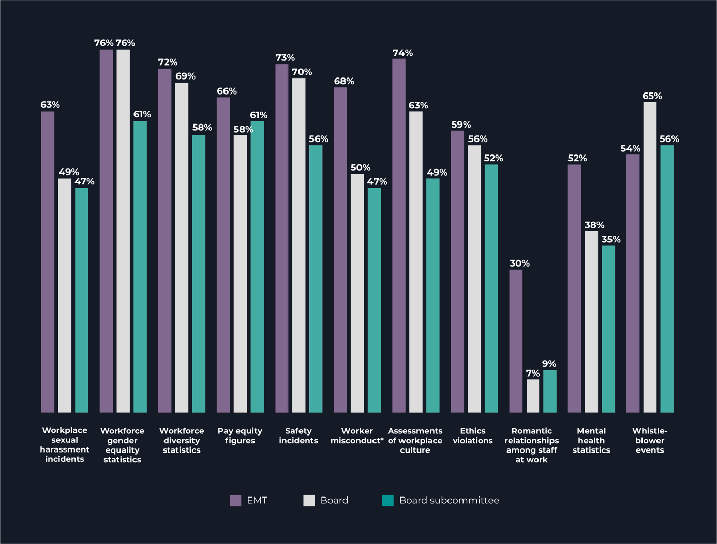
* Worker misconduct, including bullying and other forms of inappropriate conduct (n=118).
While it is generally expected that management will be provided with a greater degree of detail, the survey results raised the question of whether boards are getting the information they need to ensure systems and frameworks are in place and effectively working to appropriately manage the risks of sexual harassment.

According to survey findings, fewer than half of respondents indicated that sexual harassment was a regular agenda item (43%), and that external events served as a prompt for board discussion, suggesting boards have been taking a reactive approach to addressing sexual harassment. In addition:
- 31% of respondents indicated a discussion was prompted by concerns about an issue within the company
- Board discussion on sexual harassment was most often prompted by media reporting (29%), or an incident within the industry (25%), or a concern raised by a worker (24%)
- 16% of respondents indicated that the launch of Respect@Work prompted discussion on workplace sexual harassment
- less commonly, concerns raised by a shareholder (12%) or customer (9%) prompted discussion on sexual harassment.
‘Recent media reporting immediately prompted questions from our board about what information is being fed through to them; what is the role of the board and the executive team; and how do we improve how we do things’.

Survey results – What prompts the board, board sub-committee or EMT to consider workplace sexual harassment?
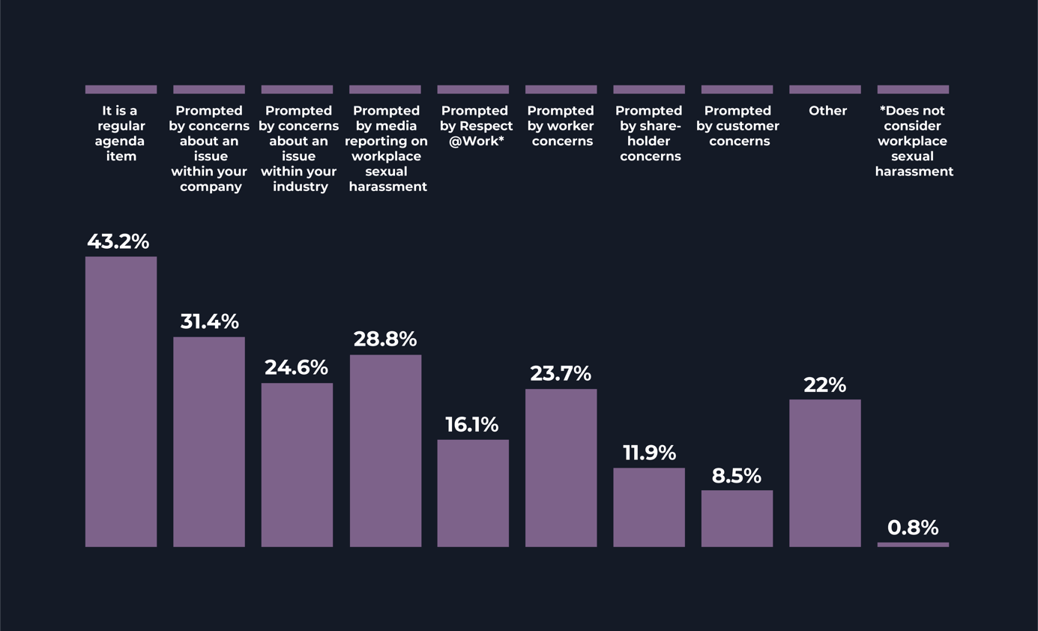
5. *The Australian Human Rights Commission’s National Inquiry into Sexual Harassment in Australian Workplaces.
10. *The EMT, Board or Board subcommittee (n=118).
Survey results indicated that the board expected to engage in a discussion on workplace sexual harassment where:
- it might have impacted the company’s reputation (73%), or related to the performance of the CEO (73%)
- it related to an ongoing legal case (65%), it was raised as a safety issue (64%), or impacted share price (61%)
- 41% of respondents indicated that a discussion on workplace sexual harassment was expected on a regular basis
- 30% of respondents indicated that workplace sexual harassment was considered where there was a risk it may impact productivity.
‘The approach has moved away from, ‘we only need to know, what we need to know’, and ‘what we don’t hear, we don’t have to worry about’, to ‘this is a serious issue and we need to be informed about it’.
The data indicated that the majority of boards discussed sexual harassment on a reactive basis, rather than regularly and proactively seeking assurance on prevention. Further, it is surprising that only 73% of boards expected to engage in a discussion on sexual harassment where it impacted the company’s reputation or related to the performance of the CEO, given the board’s role in overseeing the performance of the CEO.

Risk assessment and industry action
‘The question our board is asking is, if this was another safety issue, would it take you this long to respond to it?’
64% of respondents had developed a mechanism that identified and mitigated risk factors for sexual harassment.
Given that sexual harassment can be indicative of a systemic issue, rather than a matter of individual misconduct, a focus on identifying, assessing and mitigating risk is an important part of prevention.
Survey results indicated that the majority of companies had employed a risk-based approach to addressing sexual harassment:
- 64% of respondents had developed a mechanism that identified high risk factors for sexual harassment within their company: for example, male dominated workplaces, workplaces with overnight shift work, and workplaces that are in rural or remote areas, among others. Measures adopted to mitigate these risks included: conducting regular culture surveys, mandating leadership development training, aligning performance management of leaders with the company’s values and standards of conduct, and publicising relevant support services to staff.
- Of those respondents that did not already have a mechanism in place, 5% of respondents were not willing to develop a mechanism to identify systemic risk factors, and 18% indicated that they might be willing to establish a mechanism to identify systemic risk factors if circumstances required.
‘What if we treated safety in the same way as we treated sexual harassment? What if people were afraid to speak up when they identified a hazard; what if we didn’t talk about safety risks?’
Industry, profession, and sector-wide initiatives play an important role in addressing the specific drivers and responses to sexual harassment. These may include action plans, campaigns, programs, and codes of practice. Several respondents were actively collecting evidence and information to inform prevention initiatives and responses:
- 63% of respondents were part of an industry-based association
- Of those that were part of an industry-based association, respondents indicated that the industry led initiatives on gender equality (39%), safety (35%), and mental health (31%)
- 29% of respondents indicated that their industry-based association led initiatives specifically related to sexual harassment.

Culture
‘Compliance with professional standards of conduct is not enough. The CEO needs to put their weight behind this issue to actually drive the change we need to see’.
The majority of companies tied EMT’s remuneration and performance incentives to culture and conduct standards, with 27% reporting that they had non-financial performance metrics for EMT specifically relating to sexual harassment.
Several inquiries, including the Australian Prudential Regulation Authority (APRA)’s Inquiry into the Commonwealth Bank of Australia (APRA Inquiry), the Royal Commission into Misconduct in the Banking, Superannuation and Financial Services Industry (Banking Royal Commission), the Royal Commission into Institutional Responses to Child Sexual Abuse, among others, examined the critical role of organisational culture in enabling aberrant or harmful behaviour in the workplace. These inquiries recognised the marked impact that culture has on an organisation’s standing and reputation within the community, and highlighted the profound effect it has on the organisation’s long-term success or failure.
Survey results indicated that companies were adopting measures to ensure leaders were adhering to and modelling corporate culture standards, however there is further opportunity to support leaders to fulfil their responsibilities to prevent and respond to sexual harassment:
- 79% of respondents tied remuneration and performance incentives to culture and conduct for EMT to support adherence to company values
- 27% of respondents indicated that they tied incentive payments, at least partially, to preventing sexual harassment.

Knowledge
Survey and interview findings suggested that directors and EMT may benefit from additional skills and expertise on good governance and sexual harassment:
- 19% of respondents indicated that directors were required to undergo education on good governance and sexual harassment
- 60% of respondents indicated that EMT were required to undergo training on good governance and sexual harassment
- 69% of respondents indicated that staff were required to undergo training on sexual harassment
- Within the company, bespoke sexual harassment training that was tailored to build the skills of those with specialist roles and responsibilities was provided in some instances, specifically with Human Resources (34%), managers (27%) and health and safety officers (14%)
- For those that received sexual harassment training, programs covered a range of topics, most commonly, sexual harassment basics (81%), complaint procedures (77%), as well as the drivers and impacts of sexual harassment (58%). For a smaller portion of respondents, training covered strategies for bystanders (43%), building skills and capacity on how to respond to sexual harassment (43%), and building skills on how to prevent sexual harassment (36%)
- 11% of respondents indicated that training was trauma-informed and focused on victim-centric approaches to worker welfare
- The majority of respondents audited training attendance (92%) and maintained a record of training through a variety of methods (95%), including online Learning Management Systems, employee records, and electronic safety systems.

Reporting and supports
Survey results indicated that the majority of respondents had a range of complaint options available, however practices in respect of follow up and monitoring varied. While the majority of companies had a range of avenues available to report sexual harassment, survey results indicated that there is the opportunity to strengthen systems to evaluate the effectiveness of complaints procedures, provide supports to involved parties, and follow up with involved parties to a complaint.
- 85% of respondents had whistleblower reporting options, 81% had internal investigation options, 79% had manager interventions, and 78% had anonymous reporting mechanisms available
- 75% of respondents indicated that external investigation mechanisms were available, and 70% engaged in informal resolution.
Developing a system to monitor and follow up with parties to a sexual harassment complaint may facilitate improved understanding of the professional and personal impacts of sexual harassment on the individual, as well as the company. Routine follow-ups with involved parties may also facilitate evaluation and continuous improvement of reporting and management procedures and reduce victimisation. This is important given that Everyone’s Business: Fourth National Survey on Sexual Harassment in Australian Workplaces found that 43% of people who reported sexual harassment experienced negative consequences as a result.
Survey results indicated that follow-up processes can be improved:
- 31% of respondents monitored the outcome of workplace sexual harassment complaints by following up with the complainant six months following the conclusion of the matter, and in the same timeframe, only 16% of respondents followed up with the alleged perpetrator
- 31% of respondents indicated that no formal evaluation system existed within their company to facilitate continuous improvement of procedures to manage sexual harassment complaints.
The survey results pointed to a need to strengthen available supports for involved parties to a workplace sexual harassment complaint. For employees involved in a workplace sexual harassment complaint:
- 85% of respondents had employee assistance programs
- 43% externally referred employees for psycho-social support, and 32% had online support information or programs available
- These support mechanisms were most commonly publicised by Human Resources (82%), on the intranet (78%), and shared during induction (74%)
- 1% of respondents did not provide supports to employees involved in a workplace sexual harassment complaint.

Survey results indicated that fewer respondents made supports available to bystanders and alleged perpetrators during and after a workplace sexual harassment complaint:
- 81% of respondents offered employee assistance programs
- 36% of respondents externally referred for psycho-social support, 28% made online support programs available, and 12% made legal advice available
- 2% of respondents indicated that no support was provided to alleged perpetrators and bystanders.

Measurement and accountability
Survey findings indicated that respondents collected a broad range of information regarding corporate culture, including the prevalence of sexual harassment, but that there is the opportunity to improve the way data was used and reported.
Survey results indicated that the majority of respondents collected a wide range of data regarding workplace sexual harassment complaints:
- 78% of respondents collected information in relation to workplace sexual harassment complaints, and 70% collected data on anonymous, de-identified complaints
- 64% of respondents collected information related to legal cases, and 61% of respondents collected information about complaints that were dropped and/or finalised
- 51% of respondents collected information about settlements with current or former staff, and 44% collected information regarding trends
- 36% of respondents collected data on the length of time for a sexual harassment complaint to be finalised, and 35% collected data on other consequences of workplace sexual harassment complaints
- 19% of respondents collected information about the satisfaction of parties (victims and alleged perpetrators).

Survey results – Data collected regarding workplace sexual harassment complaints data in the company
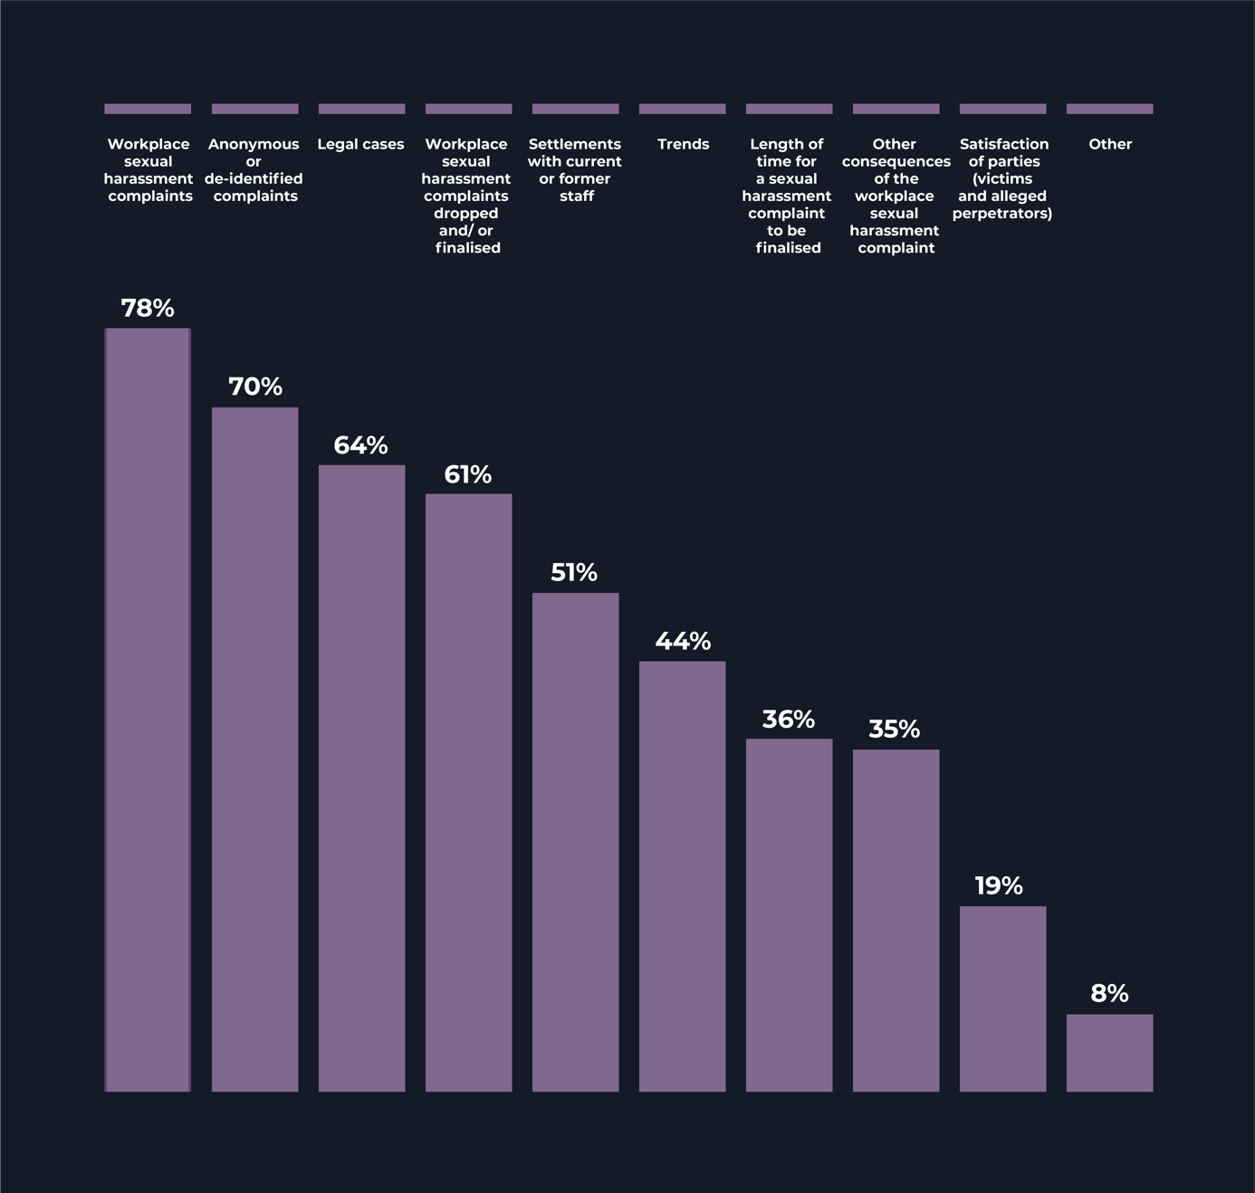
Beyond data specifically regarding workplace sexual harassment complaints, the survey results suggested that some companies were gathering a wide range of information to identify potential cultural issues and prevalence of sexual harassment:
- 79% of respondents collected data from employee satisfaction surveys, 78% on staff turnover, and 76% from exit interviews
- 70% of respondents collected data on diversity information, 69% on safety reports, and 64% on workers compensation claims
- 60% of respondents collected information on absenteeism, 57% on performance management, and 51% on training records
- 53% of respondents reported this information at the departmental level, 46% at the geographical level, and 25% of respondents indicated that they shared information at the demographic level
- 20% of respondents did not report at the departmental, geographical or demographic levels.

Transparency
Survey results indicated inconsistency in respect of information-sharing internally. In addition, less than one third publicly reported information relevant to sexual harassment as recommended by the ASX Corporate Governance Principles, and 14% of respondents did not report externally at all.
Historically, non-disclosure agreements and defamation laws have discouraged discussion about workplace sexual harassment. The benefits of sharing information internally were highlighted in the Banking Royal Commission, where Commissioner Hayne observed that sharing information with workers about incidents of misconduct, ‘sends a clear message to all staff about both accountability and what kinds of conduct the board regards as unacceptable’. Consequence management reporting on an aggregate and deidentified basis can also demonstrate to both internal and external audiences that the company takes the issues seriously. It is also important to enable information sharing on evidence-based improvements across the organisation.
Notwithstanding the benefits of internal transparency and information sharing, survey results indicated inconsistent levels of internal reporting with respect to sexual harassment data:
- 67% of respondents consulted with staff on issues relating to workplace sexual harassment through a variety of means including exit interviews, performance discussions, prevalence surveys on sexual harassment, and focus groups
- 68% of respondents provided information to staff regarding workplace sexual harassment as part of general discussions, and 64% provided information to staff about updated policies and procedures
- 11% of respondents provided updates about specific public cases on sexual harassment
- 8% of respondents indicated that de-identified, high-level information about complaints data was shared, and 13% of respondents did not discuss information about sexual harassment with staff at all.
External reporting can motivate employers to improve their approach to sexual harassment in their workplace, build trust among investors and the community, and present an opportunity for companies to promote evidence-based practices that address sexual harassment. Reporting increases scrutiny and incentivises employers to take more effective action to address sexual harassment, clarify progress and evaluate success of actions. This is particularly effective when comparative industry data is available.
‘The more companies that (externally report), the more people will understand that this is responsible behaviour, and there are lots of things to gain’.
Survey findings indicated widespread underreporting of information regarding sexual harassment externally:
- 66% of respondents indicated that they externally reported on sexual harassment through WGEA reporting
- 31% externally reported as recommended by the ASX Corporate Governance Principles, and 21% of respondents reported through insurers and AGM/shareholder engagement
- 14% of respondents indicated that they did not externally report information regarding workplace sexual harassment
- 9% of respondents indicated they delivered information as per government procurement requirements, 8% reported to their clients and customers, and 4% externally reported information to the general public.
‘[public disclosure] means holding ourselves accountable publicly, and gives an expression of confidence that we have the right culture and the right leadership. We should be comfortable with that’.
Voluntary external reporting presents an opportunity for companies to demonstrate their commitment to better practice. This may be particularly effective for companies that have already suffered reputational damage from sexual harassment scandals to rebuild trust within the company and throughout the community.

Survey results – What external reporting do companies deliver with respect to workplace sexual harassment?
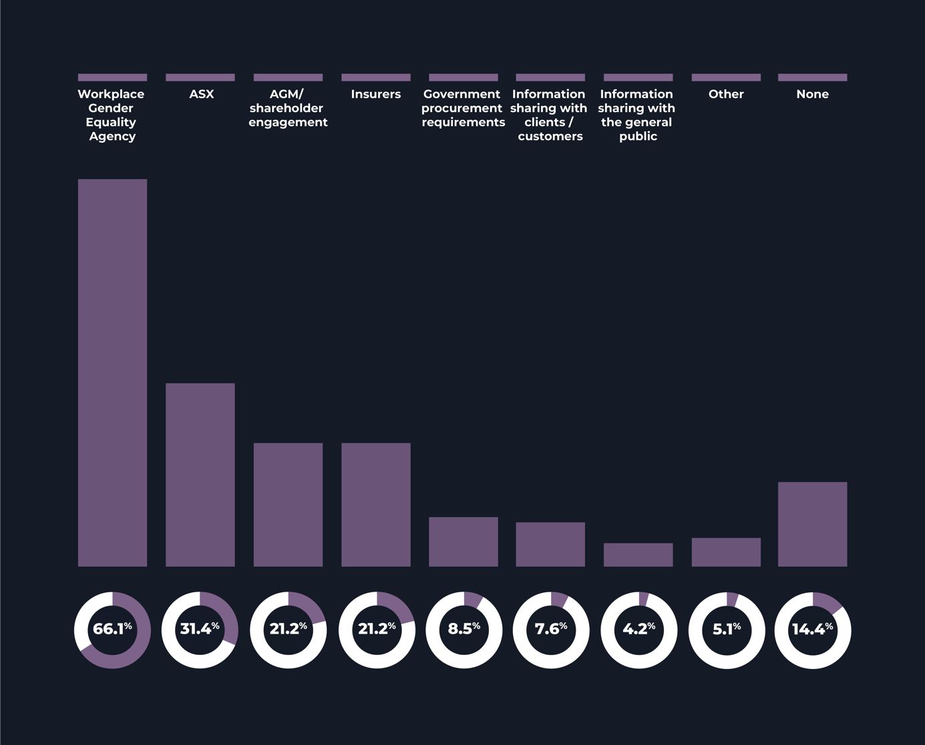
(n=118)

Gender diversity
During interviews, we heard that gender-diverse boards and access to relevant expertise was correlated with stronger governance and oversight of matters regarding sexual harassment.
62% of respondents had set a target to increase representation of women on their board.
Gender equality was a priority for the majority of respondents (94%), who indicated they had strategies to support gender equality in recruitment.
Consistently across interviews, the Commission heard that the gender diversity of the board made a ‘massive difference’ to the degree to which the board engaged on issues of sexual harassment. In some cases, it was suggested that even just one additional woman board member made a significant difference. Interviewees noted that women board members, ‘just ask different questions’, ‘advocate for issues on gender equality’, ‘push the agenda forward’, and had a higher level of interest in what the organisation was doing to improve culture.
‘Diversity on the board is really needed. There wouldn’t even be a conversation about sexual harassment otherwise.’
While women remain underrepresented on boards across the ASX200, survey results indicated some forward-looking progress for gender diversity on leadership structures:
- 62% of respondents had set a target to increase the representation of women on their board. Of the respondents that had not set such a target, the reasons provided were that the board was already gender-balanced (19%), or targets were under development (3%). Other companies indicated that board gender targets were not a corporate priority (3%)
- 56% of respondents had gender diversity targets in place at the EMT level.

Survey results indicated that gender equality was a priority for companies as they had developed formal policies and strategies to support gender equality in the following areas:
- 94% of respondents indicated that they had gender equality policies and strategies in recruitment, and 89% for gender equality overall
- 80% of respondents indicated gender equality policies and strategies were in place to support succession planning, and 79% for talent identification
- most respondents confirmed gender equality policies and strategies were in place regarding training and development (71%), retention (71%), and promotions (68%).

- Recommendations
Recommendation 1: Leadership
Demonstrate visible leadership and appropriate oversight and governance over culture, sexual harassment and gender equality. The board has primary responsibility and accountability for ensuring that the entity has in place a governance framework for the prevention of and response to sexual harassment, and for monitoring performance across the entity.
Board
Based on best practices shared by entities, the Commission recommends that the board make it clear that it has primary responsibility and accountability for ensuring that the entity has in place a governance framework for the prevention of and response to sexual harassment, and for monitoring performance against that framework. There should be alignment across the entity, including systems of risk identification, management and assurance. Appropriate oversight includes regular board assessment on whether the policies, systems and frameworks are appropriate and effective. The board should:
- ensure access to expertise at board level and within the entity (see recommendation 2)
- encourage a ‘speak up’ culture, including discussions on sexual harassment, both within the entity and at board level
- demonstrate and display visible leadership and commitment to preventing and addressing sexual harassment
- adopt a pro-active and risk-based approach to managing sexual harassment that includes establishing policies, systems and frameworks that are regularly evaluated and focus on prevention as well as response
- clearly define the data it expects to be collected and reported to assist in this evaluation (see recommendation 4)
- establish the frequency for full board discussion and evaluation, at least annually.

Throughout interviews, the Commission consistently heard that strong leadership from the board is critical for effectively addressing sexual harassment within the organisation.
The Commission recommends that board directors demonstrate and display visible leadership and commitment to promoting positive workplace culture, achieving gender equality and addressing sexual harassment. The board can display leadership and commitment by, for example, prioritising corporate culture in board discussions, setting gender equality related targets in strategic plans, and demonstrating zero tolerance to sexual harassment.
Board sub-committees
Building upon best practices shared by entities, board sub-committees can be an efficient and effective way to focus on the issues and manage the board’s responsibilities outlined above, while the board retains ultimate oversight and accountability. The accountabilities for sub-committee reporting to the full board, and information-sharing and coordination between board sub-committees should be clearly recorded in Terms of Reference or equivalent documents.
Useful resources:
- Australian Institute of Company Directors: A Director’s Guide to Preventing and Responding to Sexual Harassment at Work: Questions for Board Directors to examine workplace sexual harassment
Recommendation 2: Skills and experience
Ensure the entity has the skills and experience to effectively prevent and respond to sexual harassment.
All directors should have the requisite level of understanding of the prevention and management of sexual harassment to exercise sound judgment and decision making.
The Commission recommends that all directors ensure they are educated on the prevention and response to sexual harassment, and accompanying issues related to gender, safety and trauma. Education should be trauma-informed and victim-centric and should specifically aim to build skills on best practice governance to prevent and address workplace sexual harassment.
Throughout interviews, the Commission consistently heard that boards benefit from having a member who has sophisticated and specialist expertise on gender, culture and/or the effective prevention and management of sexual harassment. The Commission therefore recommends that boards deeply consider whether their skills and experience matrices appropriately address gender or workplace culture expertise.
EMT members should also be required to undergo education on good governance and understanding sexual harassment, gender, safety and trauma in order to develop the requisite understanding of how to provide adequate oversight on sexual harassment.
Some EMT members, including Human Resources executives, have specific roles and responsibilities in preventing and responding to sexual harassment. The Commission recommends that EMT members with specialist responsibilities undergo training that builds skills and knowledge on the nature, drivers and impacts of sexual harassment and steps to address it, in accordance with Respect@Work.
Beyond EMT members that have specialist responsibilities, all EMT members should have a foundational level of understanding on good governance and sexual harassment to exercise sound judgment and decision making with respect to matters regarding sexual harassment.
Useful resources:
- Respect@Work, community guide
- UN Women briefing paper, Stepping Up to the Challenge: Towards International Standards on Training to End Sexual Harassment
- UN Women briefing paper, What Will it Take? Promoting Cultural Change to End Sexual Harassment
Recommendation 3: Culture
Make gender equality a priority and set gender diversity targets.
According to the WGEA Gender Equity Insights Report 2021, there is a clear relationship between the increase in women’s representation in company and board leadership and gender equity policies. Board diversity promotes discussion about a range of important issues. Achieving gender balance on the board has proven to be an effective way of building transparency and improving engagement on sexual harassment issues.
Research supports that there is a correlation between gender diverse workforces and strong company financial performance. McKinsey and Company’s: Why Diversity Matters finds that companies in the top quartile for gender diversity are more likely to have financial returns above their national industry medians, whereas companies in the bottom quartile for gender diversity are statistically less likely to achieve above average returns.
The Commission recommends that boards set gender diversity targets (40:40:20) and a timeframe within which these targets will be achieved.
The Commission recommends that the board prioritise achieving gender equality across the organisation as a strategic goal. This might involve setting gender diversity targets at each level across the company, ensuring adequate policies and strategies exist to support women’s participation in the workforce, overseeing the implementation of gender equality policies and ensuring the CEO demonstrates leadership on advancing gender equality.
Recommendation 4: Systems and frameworks
Ensure systems and frameworks are in place to collect, analyse and use data to effectively manage the risks related to sexual harassment.
Based on best practices shared by entities, the Commission recommends that the entity have in place policies, systems and frameworks for the prevention of and response to sexual harassment. Systems should be in place to collect, analyse and use data to effectively manage the risks related to sexual harassment and include information to both prevent and address sexual harassment.
Information to prevent sexual harassment, and identify potential cultural issues could include:
- results of employee satisfaction surveys
- rates of staff turnover, absenteeism and performance management data
- insights shared in exit interviews
- workers compensation claims
- safety reports
- diversity information
- mental health records
- training records
- workforce gender equality statistics
- workforce diversity statistics
- comparative industry or national data
- pay equity figures
- worker misconduct
- assessments of workplace culture
- ethics violations
- romantic relationships at work
- whistleblower events
- worker and manager education.
Information should be appropriately de-identified and treated with appropriate respect and confidentiality.
Information to measure and address sexual harassment could include:
- workplace sexual harassment prevalence data
- workplace sexual harassment complaints
- anonymous or deidentified complaints
- data on the length of time for complaints to be finalised
- legal cases
- settlements
- satisfaction of involved parties during and after the complaints process.
Primary responsibility and accountability for data collection in relation to sexual harassment should be clearly allocated. Data should be collected and used to identify, measure and monitor systemic trends and patterns with respect to corporate culture, including sexual harassment. Of course, information should be appropriately de-identified and treated with appropriate respect and confidentiality.
EMT members responsible for collecting, using and reporting workplace sexual harassment data should report information to:
- the relevant board sub-committee to facilitate good governance
- EMT to improve management capabilities
- internal channels to strengthen information sharing and transparency
- external mechanisms to build trust within the community and with investors.
Recommendation 5: Executive alignment
Align appointment, expertise and performance management of the CEO and EMT with the entity’s values to ensure that EMT demonstrates and displays visible leadership on culture, sexual harassment, and gender equality.
Throughout interviews, the Commission consistently heard that strong leadership from the CEO is one of the main drivers for effectively addressing sexual harassment within the organisation. Entities reported positive changes in culture where the CEO had demonstrated an unequivocal commitment to creating a safe workspace and upheld zero tolerance to all forms of harassment. Entities reported favourably on public accountability programs and initiatives, including the Champions of Change Coalition, recognising that since their CEO had become involved, they had further advanced their understanding of the drivers, impacts and consequences of gender inequality and visibly strengthened their commitment to addressing abuses of power within the organisation. In practice, the CEO’s leadership has accelerated policy and procedure reform, set expectations on standards of professional behaviour, and had ‘trickle down’ effects on workplace culture.
The Commission recommends that the board’s strategic plan prioritises the advancement of gender equality, the promotion of positive corporate culture and effective approaches to addressing sexual harassment. The appointment and performance oversight of the CEO and EMT is an effective way to do this. To this end, the board may consider including demonstrated experience of inclusive leadership and gender equality as a key selection criterion for appointments.
Performance management tools should also reflect the organisation’s priorities in this respect. In practice, this can mean linking remuneration and performance incentives to culture, conduct, and ability to prevent and respond to sexual harassment and advance gender equality across the workplace. It might also mean incentivising efforts to improve transparency on matters regarding sexual harassment with workers and the public, and engaging with industry wide initiatives or public accountability platforms such as the Champions of Change Coalition or through industry bodies.

Recommendation 6: Use transparency to drive outcomes
Report internally and externally to measure and track the effectiveness of systems and frameworks to prevent and manage sexual harassment.
External reporting can motivate employers to improve their approach to and metrics on sexual harassment in their workplace, build trust among investors and the community, and present an opportunity to promote good practices on addressing sexual harassment. It can incentivise employers to take more effective action to address sexual harassment.

Report information through existing public disclosure mechanisms
Several reporting mechanisms, including the ASX Corporate Governance Principles, recommend that companies report on social risks, such as those related to corporate culture and diversity. Further information about these reporting mechanisms is in Appendix 1. The Commission recommends that companies report information regarding approaches to preventing and responding to sexual harassment through existing reporting mechanisms.

Industry-based reporting
Given the often systemic nature of sexual harassment, industry prevalence and trend reporting provides a useful vehicle for investors, workers and other stakeholders to assess and compare the cultural health of an organisation. The Commission recommends that entities engage in industry led initiatives and industry-based reporting on corporate culture and sexual harassment.

Recommended indicators for public reporting
The Commission heard of concerns related to the data and metrics that would be used for public reporting. For example, data on the number of sexual harassment complaints is likely to be misleading. A high number of complaints may be indicative of a workplace culture in which personnel feel empowered to speak up, and similarly, a low number of complaints may be indicative of a workplace culture in which people feel silenced.
The Commission recommends the following indicators be considered for disclosure:

Indicators for public disclosure
- board and board sub-committee discussions on the topic of sexual harassment
- gender balance on board, or target date for achieving gender balance
- director expertise, or access to expertise, in relation to gender, culture and/or the effective prevention and management of sexual harassment, including appropriate training
- gender balance at EMT, or target date for achieving gender balance
- EMT expertise, or access to expertise, in relation to gender, culture and/or the effective prevention and management of sexual harassment, including appropriate training
- systems and frameworks in place to support gender equality and prevent and address sexual harassment, including reporting channels and complaint resolution processes, availability and use of anonymous reporting channels, participation in industry initiatives in relation to sexual harassment and gender equality, use of trauma and gender informed expertise in complaint management
- effectiveness of systems and frameworks in place including:
- numbers of education interventions for staff in a year (on average) on sexual harassment, bullying, code of conduct, culture
- collection of data in relation to sexual harassment and workplace culture
- sexual harassment prevalence rates based on surveys
- complaint data and comparison to industry average rates of sexual harassment, and use of reporting channels (including anonymous reports)
- complaint resolution timeframes and satisfaction levels (after 0, 6, 12 months)
- complaint mechanisms for sexual harassment, including complaints by and about staff, board, senior leaders, contractors, and members of public
- numbers of relevant separations with confidentiality terms (or Non-Disclosure Agreements).

Internal reporting
The Commission recommends that entities improve internal information sharing practices with the view to building trust and transparency with workers. Internal sharing of information may include updated policies and procedures, discussions on workplace behaviour, systemic themes and trends and high-level information about complaints.
Internal information sharing may be targeted to:
- managers, to improve management skills and raise awareness of current management challenges
- parts of the organisation that have a relevant role, for example, for performance assessments, facilities management for security and access to sites, marketing area for social events, among others
- staff, for briefings and education
- staff, to provide feedback on staff satisfaction surveys with insights and intended actions, or staff involved in a complaints procedure.

Recommendations for Investors
It is important to acknowledge that institutional investors are also a workplace and the recommendations set out above will equally apply to their entities. Investors also have an ongoing responsibility to protect and enhance investment value.
To that end, the Commission makes the following further recommendations for investors:
Recommendation 7: Seek information on investee entities systems and processes to prevent and address sexual harassment
As described above, publicly disclosed information about sexual harassment can be deceptive. For example, a high number of sexual harassment complaints can be indicative of a healthy workplace culture in which workers feel empowered to speak up. On the other hand, a low number of sexual harassment complaints may be indicative of a poor workplace culture.
The Commission recommends that investors actively seek information from investee entities on its approach to addressing sexual harassment. Information about the entity’s approach to addressing sexual harassment may be publicly available across several platforms, including the company’s website, WGEA reporting, industry reporting, annual reports and Corporate Governance Statements, among others.
The Commission recommends that investors consider the data listed above in Figure 5.
Recommendation 8: Advocate for improved transparency and public disclosure on sexual harassment
Investors should encourage their investee entities to disclose their approach to prevent and respond to sexual harassment.
The Commission recommends that investors continue to advocate for improved transparency on sexual harassment. Investors should encourage their investee entities to disclose their approach to prevent and respond to sexual harassment.

In addition, the Commission recommends that investors advocate for stronger and more specific metrics on sexual harassment in existing reporting mechanisms, including annual reporting and WGEA reporting. For example, the ASX Corporate Governance Principles may benefit from amendments that specifically target the prevention of sexual harassment:
- When appointing or re-electing a director or senior executive, boards should undertake appropriate checks and consider all material information. The Commission recommends that appropriate reference checks into a person’s character should include seeking information about ethical and respectful conduct and commitment to gender equality initiatives (ASX Principles Recommendation 1.2).
- Recognise that information about measures taken to prevent and address sexual harassment should form part of listed entities’ approach to their diversity policy and measurable objectives to achieve gender diversity (ASX Principles Recommendation 1.5).
- As part of its requirement to introduce a program for new directors and ensure existing directors are undertaking continuous professional development, specifically recommend education and skill building on good governance on preventing and responding to sexual harassment (ASX Principles Recommendation 2.6).
- Specific mention of sexual harassment in guidance on company codes of conduct (ASX Principles Recommendation 3.2).

Appendix 1

Duty to collect sexual harassment data and report
Legislation/Framework | Comment
Workplace Gender Equality Agency (WGEA) reporting  Workplace Gender Equality Act 2012 (Cth) | WGEA’s mandatory compliance reporting program requires companies to meet minimum standards to prevent sex-based harassment and discrimination.  The annual compliance reporting for businesses requires companies to report to WGEA on formal polices and strategy on sex-based harassment, grievance processes for reporting sexual harassment and training on sex-based harassment for managers and employees. The disclosure obligations are limited to an entity’s policies and processes, and do not require disclosure of data relating to specific incidents.  Companies who do not meet the minimum standards are named and may not be eligible to tender for contracts under Commonwealth and some state procurement frameworks.
Crimes Act 1900 (NSW) | The general rule is that a corporation is not obliged to report a suspected criminal offence, with the exception of corporations within New South Wales. Under Section 316(1) of the Crimes Act 1900 (NSW) it is an offence to conceal a serious indictable offence without reasonable excuse. Some forms of sexual harassment could constitute a serious indictable offence for the purposes of the NSW Crimes Act and require reporting.  There is an argument that the NSW Crimes Act no longer applies to corporations, and therefore cannot require them to report criminal offences. Prior to 2018, the requirement to report applied to a ‘person’. In 2018 this was changed to an ‘adult’. This amendment was intended to remove the reporting obligation (and offence for failing to report) from children. However, arguably, it has limited the requirement to report to individual adult human beings (and therefore it no longer applies to ‘legal persons’, including corporations).  Given the intention of the legislation, and the fact that its provisions will apply to individual company directors that become aware of a serious indictable offence in any event, the better view is that corporations must still report serious criminal offences where the NSW Crimes Act applies.

Additional reporting obligations that might apply to sexual harassment incidents
Legislation/Framework | Comment
Whistleblowing  Part 9.4AAA of the Corporations Act 2001 (Cth) | The Australian whistleblowing laws do not require a corporation to report sexual harassment data. Rather, they may provide protection to persons who report sexual harassment claims. All public companies must have a whistleblower policy.  The Treasury Laws Amendment (Enhancing Whistleblower Protections) Act 2019 (Cth) introduced amendments to the Corporations Act intended to expand anonymity protections and increase the application of whistleblower protections to any disclosure of information where:  - the discloser is a current or former officer, employee, supplier, associate, or trustee of a regulated entity (or a relative or dependent of such a person)  - the disclosure is made to an officer, senior manager, or other eligible recipient of the regulated entity or to ASIC, APRA or another Commonwealth authority, and  - the discloser has reasonable grounds to suspect that the information concerns ‘misconduct or an improper state of affairs or circumstances’ in relation to the regulated entity or its related bodies corporate (‘disclosable matters’).  ‘Regulated entity’ is defined broadly and includes all companies incorporated under the Corporations Act 2001 (Cth).  The term ‘disclosable matters’ includes any offence against a Commonwealth law that is punishable by imprisonment for 12 months or more. It does not, however, include personal work-related grievances. A sexual harassment claim is likely to be treated as a ‘disclosable matter’ (i.e. ‘misconduct or an improper state of affairs or circumstances’ rather than a ‘personal work-related grievance’).
ASX Listing Rules  ASX Corporate Governance Council’s Corporate Governance Principles and Recommendations (4th Edition) (Principles) | Corporate Governance Statement  The ASX Corporate Governance Council’s Principles set out Recommendations for ASX listed entities. ASX Listing 4.10.3 requires ASX listed entities to publish an annual Corporate Governance Statement that sets out the extent to which the entity has followed the Recommendations during the previous financial year. If an ASX listed entity does not comply with one or more of the Recommendations, it must publicly state this fact and disclose ‘if not, why not’ in its Corporate Governance Statement.  Codes of conduct  Recommendation 3.2 states that a listed entity should have and disclose a code of conduct for its directors, senior executives and employees.  The board (or a committee of the board) should be informed of any material breaches of the code of conduct.  Commentary on Recommendation 3.2 (Box 3.2) suggests that a code of conduct should include a statement of the listed entity’s expectations in relation to certain matters, including that all directors, senior executives and employees ‘will treat fellow staff members with respect and not engage in bullying, harassment or discrimination’.  Therefore, assuming a listed entity’s code of conduct covers sexual harassment, if there is a material breach of that code the board of the listed entity would expect to be made aware of it.  Whistleblower Policies  Recommendation 3.3 states that a listed entity should have and disclose a whistleblower policy and ensure that the board (or a committee of the board) is informed of any material incidents reported under that policy.  Therefore, if a sexual harassment incident is reported under the whistleblowing policy (assuming the report is material and concerning ‘misconduct or an improper state of affairs or circumstances’, rather than ‘a personal work-related grievance’), the board of the listed entity would expect to be made aware of it. However, due to the strict anonymity requirements of the Corporations Act, the Board may need to be informed of the incident on an anonymous basis, to protect the identity of the whistleblower.
Financial Services  Banking Executive Accountability Regime | The Banking Act 1959 (Cth) includes the Banking Executive Accountability Regime (BEAR), which applies to authorised deposit-taking institutions (ADIs or Banks). Under the BEAR, a Bank must identify individuals who have actual or effective senior executive responsibility for management or control of the Bank, or a significant or substantial part or aspect of the operations of the Bank. These people are known as ‘accountable persons’.  The BEAR provisions require a Bank to notify the Australian Prudential Regulation Authority (APRA) if an accountable person breaches any of their accountability obligations. The accountability obligations include a duty to ‘conduct the responsibilities of his or her position as an accountable person by acting with honesty and integrity, and with due skill, care and diligence’. The BEAR is primarily aimed at protecting the prudential standing and reputation of the Bank, however it is possible that if an accountable person were found guilty of sexual harassment, the Bank might also report the incident to APRA as a breach of the accountable person’s duty to act with honesty and integrity, and with due skill, care and diligence.  The Commonwealth Government has stated that it intends to enact legislation that expands the regime more broadly across the financial services sector. The proposed Financial Services Executive Accountability Regime is colloquially known as FAR.

Herbert Smith Freehills
6 April 2021
Please note that Herbert Smith Freehills were not provided with research findings in the development of this summary.

Endnotes

Australian Human Rights Commission, Respect@Work: National Inquiry into Sexual Harassment in Australian Workplaces (Final Report, February 2020).
Australian Human Rights Commission, Respect@Work: National Inquiry into Sexual Harassment in Australian Workplaces (Final Report, February 2020) recommendations 13, 14, 17, 38, 41-48.
The quotes used throughout the report are taken from the interviews conducted with representatives of ASX200 companies. All quotes have been deidentified.
Australian Human Rights Commission, Respect@Work: National Inquiry into Sexual Harassment in Australian Workplaces (Final Report, February 2020); Australian Council of Superannuation Investors and Australian Institute of Company Directors, Governing Company Culture: Insights from Australian Directors (Report, 2020); Deloitte Access Economics, The Economic Costs of Sexual Harassment in the Workplace, (Final Report, 2019); Nilofer Merchant, ‘The Insidious Economic Impact of Sexual Harassment’, Harvard Business Review (online, 29 November 2017). <https://hbr.org/2017/11/the-insidious-economic-impact-of-sexual-harassment>.
Ibid.
James L. Heskett, The Culture Cycle: How to Shape the Unseen Force That Transforms Performance (Pearson Professional, 2012), quoted in John Coleman, ‘Six Components of a Great Corporate Culture’, Harvard Business Review (online, 6 May 2013) <https://hbr.org/2013/05/six-components-of-culture>.
Bank of America Merrill Lynch, ‘ESG Matters – US: 10 reasons you should care about ESG’ (Fact Sheet, 2019) <https://www.sec.gov/comments/s7-23-19/s72319-6660329-203852.pdf>.
Rebecca Cassells and Alan Duncan, Gender Equity Insights 2020: Delivering the Business Outcomes (Bankwest Curtin Economics Centre and Workplace Gender Equality Agency Gender Equity Series, Issue No 5, March 2020).
Rebecca Cassells and Alan Duncan, Gender Equity Insights 2020: Delivering the Business Outcomes (Bankwest Curtin Economics Centre and Workplace Gender Equality Agency Gender Equity Series, Issue No 5, March 2020).
Deloitte Access Economics, The Economic Costs of Sexual Harassment in the Workplace (Final Report, 2019) Chapter 4.
Serena Does, Seval Gundemir, and Margaret Shih, ‘How Sexual Harassment Affects a Company’s Public Image’, Harvard Business Review (online, 11 June 2018). <https://hbr.org/2018/06/research-how-sexual-harassment-affects-a-companys-public-image>.
Serena Does, Seval Gundemir, and Margaret Shih, ‘How Sexual Harassment Affects a Company’s Public Image’, Harvard Business Review (online, 11 June 2018). <https://hbr.org/2018/06/research-how-sexual-harassment-affects-a-companys-public-image>. See also Crystal Kim, Leslie P. Norton, and Lauren R. Rublin ‘Sexual Harassment is Becoming a Serious Investment Risk’, Barron’s (online, 4 November 2017).
Bank of America Merrill Lynch, ‘ESG Matters – US: 10 reasons you should care about ESG’ (Fact Sheet, 2019) <https://www.sec.gov/comments/s7-23-19/s72319-6660329-203852.pdf>.
ASX Corporate Governance Council, Corporate Governance Principles and Recommendations (4th edition, February 2019).
ASX Corporate Governance Council, Corporate Governance Principles and Recommendations (4th edition, February 2019) principle 3 and recommendations 1.5 and 3.3; Australian Human Rights Commission, Respect@Work: National Inquiry into Sexual Harassment in Australian Workplaces (Final Report, February 2020) recommendation 44.
Australian Council of Superannuation Investors and Australian Institute of Company Directors, ‘Governing Company Culture: Insights from Australian Directors’, (2020) accessible at https://acsi.org.au/wp-content/uploads/2020/12/Governing-Company-Culture-report.Dec20.pdf.
Australian Human Rights Commission, Respect@Work: National Inquiry into Sexual Harassment in Australian Workplaces (Final Report, February 2020) 637-638.
Serena Does, Seval Gundemir, and Margaret Shih, ‘How Sexual Harassment Affects a Company’s Public Image’, Harvard Business Review (online, 11 June 2018). <https://hbr.org/2018/06/research-how-sexual-harassment-affects-a-companys-public-image>.
Consensual romantic relationships are not sexual harassment, but evidence indicates that they can involve power disparities, be the product of or create an unwelcome sexualised workplace, cause a conflict of interest, send mixed messages to staff about tolerated conduct, and result in sexual harassment risk when a relationship ends.
Australian Prudential Regulation Inquiry, Prudential Inquiry into the Commonwealth Bank of Australia (Final Report, April 2018).
Royal Commission into Misconduct in the Banking, Superannuation and Financial Services Industry (Final Report, February 2019).
Royal Commission into Institutional Responses to Child Sexual Abuse (Final Report, December 2017).
Australian Human Rights Commission, Everyone’s Business: Fourth National Survey on Sexual Harassment in Australian Workplaces (Report, September 2018) 73.
Royal Commission into Misconduct in the Banking, Superannuation and Financial Services Industry (Final Report, February 2019) 366.
Serena Does, Seval Gundemir, and Margaret Shih, ‘How Sexual Harassment Affects a Company’s Public Image’, Harvard Business Review (online, 11 June 2018). <https://hbr.org/2018/06/research-how-sexual-harassment-affects-a-companys-public-image>.
Australian Institute of Company Directors, ‘Board Diversity Statistics’, (2021) accessible at <https://aicd.companydirectors.com.au/advocacy/board-diversity/statistics>.
Purna Sen, What Will It Take? Promoting Cultural Change to End Sexual Harassment (UN Women, Report, September 2019) 36. See also Liz Kelly, Stepping up to the Challenge: Towards International Standards on Training to End Sexual Harassment (UN Women, Report, February 2020).
Purna Sen, What Will It Take? Promoting Cultural Change to End Sexual Harassment (UN Women, Report, September 2019) 36.
Australian Human Rights Commission, Respect@Work: National Inquiry into Sexual Harassment in Australian Workplaces (Community Guide, February 2020).
Liz Kelly, Stepping up to the Challenge: Towards International Standards on Training to End Sexual Harassment (UN Women, Report, February 2020).
Purna Sen, What Will It Take? Promoting Cultural Change to End Sexual Harassment (UN Women, Report, September 2019).
Rebecca Cassells and Alan Duncan, Gender Equity Insights 2020: Delivering the Business Outcomes (Bankwest Curtin Economics Centre and Workplace Gender Equality Agency Gender Equity Series, Issue No 5, March 2020).
Vivian Hunt, Dennis Layton, and Sara Prince, ‘Why Diversity Matters’, McKinsey&Company (online, 1 January 2015) <https://www.mckinsey.com/business-functions/organization/our-insights/why-diversity-matters#>.
40:40:20 refers to a Board composition of 40% women, 40% men, 20% discretionary. See Australian Council Superannuation Investors, ‘ACSI Governance Guidelines: A Guide to Investor Expectations of Listed Australian Companies’ (October 2019) and Workplace Gender Equality Agency, ‘40:40 Vision – a new initiative to bolster gender equality in the ASX200’ (web page, 1 October 2020) <https://www.wgea.gov.au/newsroom/4040-vision-a-new-initiative-to-bolster-gender-equality-in-the-asx200>.

