Disability Rights: Accessibility and Liveability
A unit of work for the Australian Curriculum: Geography, Year 7
Almost 4 million Australians live with disabilities. If we add families, friends and colleagues, the number of people affected by disability is larger still.
These lessons fit within the Year 7 Geography Curriculum, Unit 2: ‘Place and liveability’. These lessons are based on the Australian Human Rights Commission’s 20 Years: 20 Stories film project, which celebrates 20 years of Australia’s Disability Discrimination Act 1992. The Act provides protection from discrimination for people with disabilities.

Focus
It was a simple attempt to cross the road to get a cup of coffee that sparked Mark Hopper’s passion for accessibility. Mark simply couldn’t get his wheelchair onto the road safely. He complained and won. In his Victorian hometown, Mark scrutinised every building, every footpath, every access point and tested it against the standards which had been in place since the Disability Discrimination Act’s introduction. Mark Hopper is a true action hero.
This unit uses stories like Mark’s to address the issues surrounding the liveability of places for people with disabilities. This includes urban planning for accessibility and liveability, community inclusion of people with disabilities, and strategies to improve the liveability and accessibility of places and services for people with disabilities.
Students will explore the following inquiry questions:
- What effect does the uneven distribution of resources and services have on the lives of people?
- What approaches can be used to improve the availability of resources and access to services?

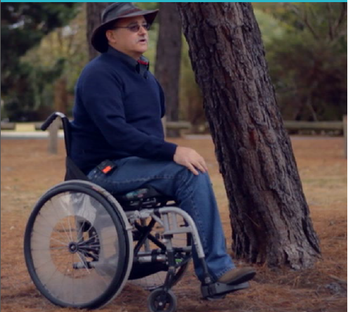
Image Caption: Mark Hopper, Ramped up, 20 Years: 20 Stories Film Project, Australian Human Rights Commission

Teaching and Learning Activities
These lessons can be taught as a unit or as individual lessons:
- What makes a community liveable for diverse groups of people?
- Assessing the liveability of your local suburb
- Disability rights and accessibility
- Assessing and improving the liveability of your school environment for people with disabilities
- Examine the role that transport plays in people’s ability to access services

Learning Outcomes
As a result of this unit students will:
- Investigate the concept of liveability and factors that affect the liveability of a place.
- Explore how the liveability of a place can be limited by its accessibility.
- Analyse how places have varying degrees of liveability and accessibility depending on a person’s perspective and situation; focusing specifically on how people with a range of disabilities may face difficulties with accessing places.

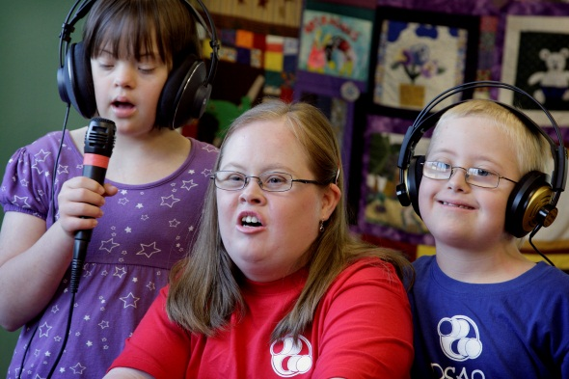
Image Caption: Photograph by Renate Hottmann –Schaefer, Australian Human Rights Commission Photography Competition

Contents
Disability Rights: Accessibility and Liveability 1
Australian Curriculum Links - Geography 5
Unit description: 6
Resources 7
Vocabulary 7
Lesson 1 What makes a community liveable for diverse groups of people? 8
Lesson 2 Assessing the liveability of your local suburb 10
Lesson 3 Disability rights and accessibility 12
Lesson 4 Assessing and improving the liveability of your school environment for people with disabilities 16
Lesson 5 Examine the importance of accessible transport 17
Activity and Resource Sheets 20

About this resource:
The Australian Human Rights Commission encourages the dissemination and exchange of information provided in this publication.
All material presented in this publication is provided under Creative Commons Attribution 3.0 Australia, with the exception of:
- the Australian Human Rights Commission Logo
- photographs and images
- any content or material provided by third parties.
The details of the relevant licence conditions are available on the Creative Commons website, as is the full legal code for the CC BY 3.0 AU licence
Attribution
Material obtained from this publication is to be attributed to the Australian Human Rights Commission with the following copyright notice:
© Australian Human Rights Commission 2014.
Electronic format
This publication can be found in electronic format on the website of the Australian Human Rights Commission: www.humanrights.gov.au/publications/index.html.
Contact details
For further information about the Australian Human Rights Commission, please visit www.humanrights.gov.au or email communications@humanrights.gov.au.
You can also write to:
Human Rights Education Team
Australian Human Rights Commission
GPO Box 5218
Sydney NSW 2001

Australian Curriculum Links - Geography
Content Description | Elaboration
Geographic Knowledge and Understanding, Unit 2: Place and Liveability
ACHGK043 The factors that influence the decisions people make about where to live and their perceptions of the liveability of places | - investigating students’ interpretations of the concept of liveability and choices about where to live, including considerations of a broad range of disabilities (physical, sensory, psychosocial and intellectual).  - comparing student access to and use of places and spaces in their local area and evaluating how this affects perceptions of liveability
ACHGK044 The influence of accessibility to services and facilities on the liveability of places | - examining the role transport plays in people’s ability to access services and participate in activities in the local area
ACHGK046The influence of social connectedness, community identity and perceptions of crime and safety on the liveability of places | - discussing the different types of places where people can feel included or excluded, and evaluating how this affects perceptions about the liveability of places.  - investigating the extent to which people in their place are socially connected or socially isolated and its effect on liveability
ACHGK047 The strategies used to enhance the liveability of places, especially for young people, including examples from Australia and Europe | - developing a specific proposal to improve an aspect of the liveability of their place, taking into account the needs of diverse groups in the community, including people with disabilities  - researching methods implemented in Australia to improve the liveability of a place, and evaluating their applicability to their own locality
Geographical Inquiry and Skills, Observing, Questioning and Planning
ACHGS047 Develop geographically significant questions and plan an inquiry, using appropriate geographical methodologies and concepts | - developing questions about liveability and accessibility of places and services for people with disabilities.
Geographical Inquiry and Skills, Collecting, recording, evaluating and representing
ACHGS048 Collect, select and record relevant geographical data and information, using ethical protocols, from appropriate primary and secondary sources | - gathering relevant data from a range of primary sources, for example, from observation and annotated field sketches, surveys and interviews, or photographs about the impacts of and responses to a hydrological hazard, or the factors influencing decisions people make about where to live  - collecting geographical information from secondary sources, for example, population pyramids, reports, census data and the media  - applying ethical research methods
Geographical Inquiry and Skills , Communicating
ACHGS053 Present findings, arguments and ideas in a range of communication forms selected to suit a particular audience and purpose; using geographical terminology and digital technologies as appropriate | - presenting a report, supported by graphic representations, to communicate a reasoned argument, for example, to propose actions to improve liveability of the school environment

General Capabilities
The general capabilities emphasised in this unit of work are Ethical Understanding, Personal and Social Capability, Literacy and Information and Communication Technology (ICT) Capability.

Disability Rights: Accessibility and Liveability

Unit description:
These lessons fit within the Year 7, Unit 2: ‘Place and liveability’. These lessons address the issues surrounding the liveability of places for people with disabilities. Issues discussed include urban planning for accessibility and liveability, community inclusion of people with disabilities, and strategies to improve the liveability and accessibility of places and services for people with disabilities.

Teaching and Learning Activities
These lessons can be taught as a unit. Alternatively, teachers can select particular lessons to teach at their discretion.
1: What makes a community liveable for diverse groups of people?
2: Assessing the liveability of your local suburb
3: Disability rights and accessibility
4: Assessing and improving the liveability of your school environment for people with disabilities
5: Examine the role importance of that accessible transport

Key inquiry questions:
- What effect does the uneven distribution and accessibility of resources and services have on the lives of people?
- What approaches can be used to improve the availability of resources and access to services?

Learning Outcomes
As a result of this unit students will:
- Investigate the concept of liveability and factors that affect the liveability of a place.
- Explore how the liveability of a place can be limited by its accessibility.
- Analyse how places have varying degrees of liveability and accessibility depending on a person’s perspective and situation; focusing specifically on how people with a range of disabilities may face difficulties accessing places.

Resources | Vocabulary
Videos  Ramped Up, Twenty Years: Twenty Stories (5mins 34secs) http://youtu.be/wzgoQDuioMY  Access for All, Twenty Years: Twenty Stories (4mins 57secs) http://youtu.be/HhFcwBBFvms  Room for Change, Twenty Years: Twenty Stories (5mins 49secs) http://youtu.be/D3ErxMvdDPo  Dee’s Place Twenty Years: Twenty Stories (5 mins 17 secs) http://www.youtube.com/watch?v=ezdSrX7MNBQ  Graeme Innes vs. Railcorp, Twenty Years: Twenty Stories (2mins 18secs) http://youtu.be/3svI4-cPpcc  Transcript and audio description are available at http://www.humanrights.gov.au/twentystories/videos.html  Activities  Activity Sheets: Picture Difference (Pictures A and Pictures B)  Activity Sheet: Defining Liveability  Activity Sheet: What makes a community liveable for different groups of people?  Activity Sheet: Disability Discrimination Act and Access to Premises  Activity Sheet: Ramped Up  Activity Sheet: Dee’s Place  Activity Sheet: Room for Change  Activity Sheet: Access for All  Activity Sheet: Checklist for assessing school’s accessibility based on Disability Access Standards  Activity Sheet: Proposal Template  Activity Sheet: Sydney Morning Herald Opinion Piece. Clear announcements cannot stay in RailCorp's too hard basket  Literacy Activity Sheet: Sydney Morning Herald Opinion Piece. Clear announcements cannot stay in RailCorp's too hard basket  Resource sheets:  Resource Sheet: Hypothetical discrimination scenarios  Resource Sheet: Disability Discrimination Act and Access to Premises  Resource Sheet: Sydney Morning Herald Opinion Piece. Clear announcements cannot stay in RailCorp's too hard basket  Resource Sheet: Glossary  Additional Resources  Access to buildings and services guidelines and information http://www.humanrights.gov.au/publications/access-guidelines-and-information  The good, bad and ugly design and construction access http://www.humanrights.gov.au/publications/good-bad-and-ugly-design-and-construction-access-0 | Accessibility  Disability  Discrimination  Infrastructure  Liveability  Social connectedness  Social inclusion

Lesson 1 What makes a community liveable for diverse groups of people?
Australian Curriculum links
ACHGK043 The factors that influence the decisions people make about where to live and their perceptions of the liveability of places
  - investigating students’ interpretations of the concept of liveability and choices about where to live, including considerations of a broad range of disabilities (physical, sensory, psychosocial and intellectual)
ACHGK046 The influence of social connectedness, community identity and perceptions of crime and safety on the liveability of places
  - discussing the different types of places where people can feel included or excluded, and evaluating how this affects perceptions about the liveability of places.
Integrated Teaching Learning and Assessment | Resources
Pre-viewing/Scaffolding Activities  - Conduct a picture difference activity to introduce the unit to students. Divide students into pairs. Provide one student with pictures labeled A (which shows buildings/services that are not accessible) whilst the other student has pictures labeled B (which contain accessible buildings/services). Students need to communicate with each other to figure out what is different about the ‘A’ pictures compared to the ‘B’ pictures. There are in total three pictures each for A & B.  - Difference between pictures 1A and 1B: Unlike in picture 1A, there is an accessible toilet and the word ‘toilet’ is written in braille in picture 1B.  - Difference between pictures 2A and 2B: The pictures show the services provided in train stations. The train station in picture 2B, unlike the train station in picture 2A, has a lift, ramp, and an accessible toilet, payphone and carspace.  - Difference between pictures 3A and 3B: The pictures show the access to a café in Federation Square, Melbourne. Picture 3B shows the café in the square can be accessed via both a ramp and stairs, whereas picture 3A shows the café can only be accessed via stairs.  - Draw the students’ attention back to the uncropped image of Federation Square in Melbourne, shown in picture 3B. Discuss with students how this public space has been designed to be accessible to all people. For example, the square uses both stairways and gentle slopes for ease of access; features accessible bathrooms and parking; and provides hearing loops in the main areas. Federation Square has also developed a Disability Action Plan to contribute to the ongoing improvement of its facilities and services. You can read about the Plan and the accessible services at the Federation Square website.  - Students construct a definition of ‘liveability’ by considering the various facets of ‘liveability’ such as:  - the ability of all individuals to have a political voice in the community;  - employment opportunities for all residents  - everyone’s access to built infrastructure (e.g. hospitals, schools, leisure facilities, telecommunications and transport networks)  - ability of all residents to access social infrastructure (e.g. community organisations or clubs)  - sustainable environmental practices  - Access to technology.  Students are provided with the Activity sheet: Defining liveability. As a class, construct word circles for each of the included terms, and discuss the terms in the context of liveability (i.e. provide examples). Students could also create diagrams/graphics to represent each of the terms.  - Students identify that the liveability of a community differs for different groups of people in the community based on their different needs.  - Break the class into small groups. Assign each group a different demographic group such as older people, young people, families, people with disabilities and people without cars. Encourage students to identify specific features of liveability for their group and how this can increase social inclusion.  - Conduct a jigsaw classroom activity to ensure all students identify the common and specific aspects of liveability for different groups. (For more information about the jigsaw activity view the Jigsaw Classroom website)  Provide students with the Activity sheet: What makes a community liveable for different groups of people? The activity sheet will help structure the jigsaw activity. Discuss the importance of the community catering for the needs of diverse groups of people.  Alternatively, create a class mind map on http://mindmeister.com/ to identify common and specific aspects of liveability for different groups. | Activity sheets: Picture difference (Pictures A and Pictures B)  Activity sheet: Defining liveability  Activity sheet: What makes a community liveable for different people?
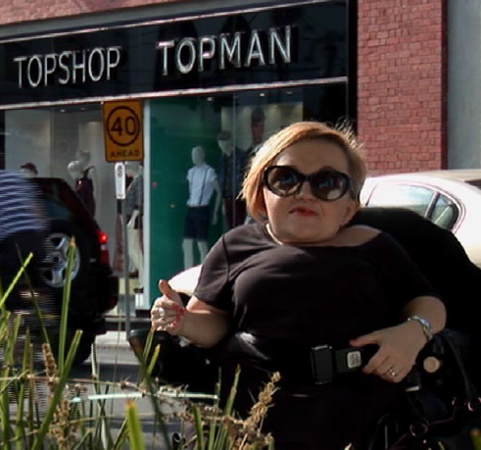
Image Caption: Stella Young, Room for change,, 20 Year: 20 Stories

Lesson 2 Assessing the liveability of your local suburb
Australian Curriculum links
ACHGK043 The factors that influence the decisions people make about where to live and their perceptions of the liveability of places
- comparing student access to and use of places and spaces in their local area and evaluating how this affects perceptions of liveability
ACHGK046 The influence of social connectedness, community identity and perceptions of crime and safety on the liveability of places
- discussing the different types of places where people can feel included or excluded, and evaluating how this affects perceptions about the liveability of places.
Integrated Teaching Learning and Assessment | Resources
- Divide students into groups. Assign each group a different demographic, such as people with disabilities, people without cars, young people, older people and families.  Students are shown a map of the suburb their school is located in. Each group is asked to identify the features and factors that make it a ‘liveable’ space for their particular demographic. Students need to consider proximity to public transport, fire station, access to roads, amenities etc. This could be done using Google Maps in Satellite and Street View modes. Students should also research the accessibility of social infrastructure in the suburb.  - Students write a description or annotate a map of the suburb, providing details about access to public transport, amenities and services. Students assess how ‘liveable’ they think the area is for their assigned demographic by referring to accessibility and proximity of important services and features.  Each group reports their assessment of the liveability of the area to the class.  Extension: Students could produce a short PowerPoint presentation about the liveability of the suburb for their demographic, and provide suggestions on how to enhance the liveability of the community. | Google Maps or a physical map of local area  Extension: PowerPoint presentation
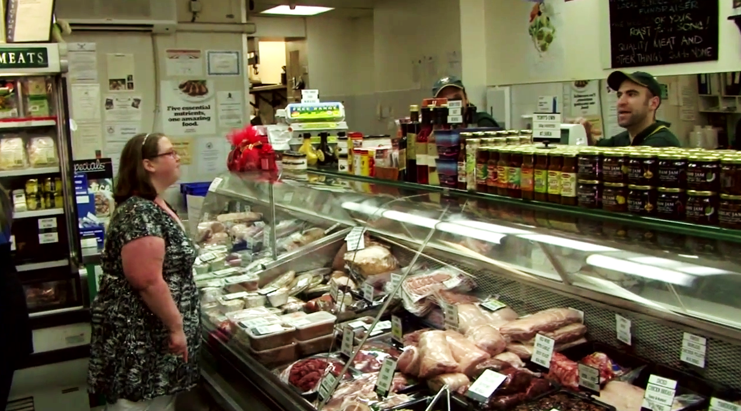
Image Caption: Dee at the deli. Dee’s Place, 20 Year: 20 Stories

Lesson 3 Disability rights and accessibility
Australian Curriculum links
ACHGK043 The factors that influence the decisions people make about where to live and their perceptions of the liveability of places
  - investigating students’ interpretations of the concept of liveability and choices about where to live, including considerations of a broad range of disabilities (physical, sensory, psychosocial and intellectual)
ACHGK046 The influence of social connectedness, community identity and perceptions of crime and safety on the liveability of places
  - investigating the extent to which people in their place are socially connected or socially isolated and its effect on liveability
  - discussing the different types of places where people can feel included or excluded, and evaluating how this affects perceptions about the liveability of places.
Integrated Teaching Learning and Assessment | Resources
- Explain to students that in this lesson and upcoming lessons, the focus will be on the human rights of people with disabilities and their inclusion and social connectedness.  - As a class, discuss the term ‘disability’ and briefly discuss different types of disabilities e.g. physical, intellectual, sensory and physcosocial.  Introduce the concept of disability rights. As a class, students brainstorm the rights of people with disabilities. Ensure students understand that people with disabilities have the same rights as people without disabilities.  - Explain that the Disability Discrimination Act is a law that makes it illegal to discriminate against people with disabilities. This can improve the lives of people with disabilities so that their communities are more liveable and they feel more socially connected and less socially isolated.  The term ‘discrimination’ needs to be discussed. In small groups, students can brainstorm examples of discrimination against people with disabilities. Groups can then report their examples to the class.  Alternatively, the teacher can use hypothetical scenarios to ask students whether any of the characters are experiencing discrimination. For the activity, students could be provided with red and blue cards to express their views. If the students believe discrimination is occurring in the scenario, they hold up red cards; otherwise students hold up blue cards. Students will need to provide explanations for their answers.  Extension: Discuss and differentiate between the terms ‘direct discrimination’ and ‘indirect discrimination'.  - In pairs or as a class, students complete the Activity sheet: Disability Discrimination and Access to Premises. Ensure students understand the right to have access to premises used by the public.  - Brainstorm what it means to feel socially connected – this can be done in small groups or as a class.  - Introduce the concept that people with disabilities may face barriers to social connectedness, which can then affect the liveability of communities for people with disabilities. In small groups or as a class, students brainstorm examples of barriers that people with disabilities may face.  To stimulate discussion, ask students to think about different groups of people living with disabilities: children with disabilities, women with disabilities, men with disabilities, older people with disabilities, people with disabilities living in rural and remote areas, Aboriginal and Torres Strait Islander people with disabilities, people with disabilities from culturally and linguistically diverse background and people with disabilities from minority groups.  - Also ask students to think about different types of disabilities and how people with those disabilities may experience a variety of barriers to inclusion and participation in community life.  - There are three videos (Ramped up, Room for change and Dee’s Place), which address liveability and social inclusion for people with disabilities.  Teachers can choose which video to show the class. Alternatively, students can be divided into groups. Each group chooses one video to view and complete related activities.  - Ramped up – Explores Mark’s fight to improve liveability, and accessibility of shops, footpaths and services for people with disabilities.  - Room for change – Explores Stella’s experience clothes shopping and her online advocacy for clothes shops to be accessible to people with disabilities. It also explores Madeleine’s advocacy to make fitting rooms more accessible for people with disabilities.  - Dee’s Place – Explores Dee’s experience living independently in shared accommodation rather than in a group home. It also explores issues of inclusion and community.  Ramped up  Viewing activities  - Introduce the video Ramped up and explain that it is about changing streets and shops to become more accessible for people with disabilities. Watch the Ramped up video. Students complete the questions on the Activity sheet: Ramped up after they view the video a second time.  - Literacy activity: The language in this video is highly colloquial and may need scaffolding. For instance, at first, students watch the whole video to obtain a general idea of the context. Afterwards, the teacher can replay the video to focus more intensely on literacy. When a colloquial term is mentioned in the video, the teacher can pause it and provide students with the opportunity to predict the meaning of the term based on its context. Students, as a class or in small groups, can then develop word circles for each colloquial term.  Examples of colloquial terms that may require explaining include ‘bug bears’, ‘fallen on my feet’, ‘fighting tooth and nail’ and the play on words in the title of the video.  Post-viewing activities  - Using the viewing questions as a scaffold, facilitate a class or small group discussion about the liveability issues raised. Focus on:  - the difficulties faced by people with disabilities in terms of accessibility and mobility  - the impact this would have on people’s quality of life and sense of social connectedness  - how limitations to accessibility might affect the decisions of people with disabilities about where to live and how to spend their time.  Room for change  Viewing activities  - Introduce the video Room for change. Explain how it is about Stella’s experience of having trouble physically accessing fashion shops to buy clothes and the action she took through social media to change the situation. The video also explores Madeleine’s advocacy to make fitting rooms more accessible for people with disabilities.  - Students answer the viewing questions on the Activity sheet: Room for change after viewing the video for a second time.  Post-viewing activities  - Using the viewing questions as a scaffold, facilitate a class or small group discussion about the liveability issues raised. Focus on:  - the difficulties faced by people with disabilities in terms of accessibility and mobility  - the impact this would have on people’s quality of life and sense of social connectedness  - how limitations to accessibility might affect the decisions of people with disabilities about where to live and how to spend their time.  Dee’s Place  Viewing activities  - Introduce the video Dee’s Place. Explain that it is about a woman with intellectual disabilities learning to live independently. Watch Dee’s Place.  - Students answer the viewing questions on the Activity sheet: Dee’s Place after viewing the video for a second time.  Post-viewing activities  - Using the viewing questions as a scaffold, facilitate a class or small group discussion about the liveability issues raised.  Focus on:  - the difficulties faced by people with disabilities in terms of living independently and living a full and inclusive life as part of a community  - the impact this would have on people’s quality of life and sense of social connectedness  - how a lack of accessible housing restricts or limits the choices and freedoms of people with disabilities. | Resource sheet: Hypothetical discrimination scenarios  Resource sheet/Activity sheet: Disability Discrimination Act and Access to Premises  Ramped up video  http://youtu.be/wzgoQDuioMY  Activity sheet: Ramped up  Room for change video  http://youtu.be/D3ErxMvdDPo  Activity sheet: Room for change
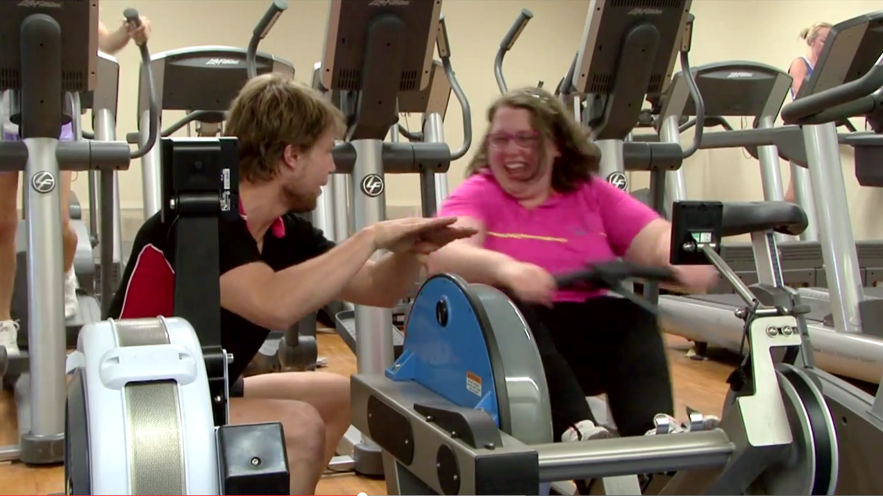
Image Caption: Dee working hard at the gym. Dee’s Place, 20 Year: 20 Stories

Lesson 4 Assessing and improving the liveability of your school environment for people with disabilities
Australian Curriculum links
ACHGS047 The strategies used to enhance the liveability of places, especially for young people, including examples from Australia and Europe
- developing a specific proposal to improve an aspect of the liveability of their place, taking into account the needs of diverse groups in the community, including people with disabilities
- researching methods implemented in Australia to improve the liveability of a place, and evaluating their applicability to their own locality
ACHGS053 Present findings, arguments and ideas in a range of communication forms selected to suit a particular audience and purpose; using geographical terminology and digital technologies as appropriate
- presenting a report, supported by graphic representations, to communicate a reasoned argument, for example, to propose actions to improve liveability of the school environment
Integrated Teaching Learning and Assessment | Resources
- Review key concepts, such as liveability, social connectedness and accessibility for people with a disability, raised in previous lessons. Briefly revise what makes a place liveable for students with disabilities.  - Refer to the Resource sheet: Disability Discrimination Act and Access to Premises in the context of your own school environment.  - In small groups or as a class, students discuss the Access to buildings and services guidelines and information.  Students can be shown photographs from The good, bad and ugly: Design and construction access website for visual representations of the access guidelines. Provide students with blue cards (representing correct application of the building standards) and red cards (representing incorrect application of the building standards). Show students a photograph, and using the cards, students need to express whether the buildings/parts of a building in the photograph correctly apply the building standards to enhance accessibility for people with disabilities.  Alternatively, divide students into groups. Provide each group a red and a blue card. Show students a photograph. In groups, students discuss whether the photograph illustrates the correct or incorrect design of buildings/parts. Using the coloured cards, groups report their decision to the class.  - In pairs or small groups, students can complete the accessibility audit on the Activity sheet: How accessible is your school? Assess the school building/s’ accessibility for people with disabilities. Get students to consider people with a range of disabilities (e.g. physical, sensory, psychosocial, intellectual) who may have difficulty with accessing buildings, reading signs and navigating. Students research strategies that can be used to enhance the accessibility of the building/s and make recommendations on how to make your school more accessible.  - In pairs or small groups, students develop a specific proposal of how to improve the liveability of the school environment for people with disabilities. Provide students with the Activity sheet: Proposal template to structure the task.  Alternatively, provide students with a map or blueprint of the school. In pairs or small groups, students re-design the school to make it more accessible.  Consider inviting the Principal, or representatives of the P&C, to come and listen to students’ suggestions in order to provide an authentic audience to motivate students.  Extension activity  - Students choose a well-known landmark or building in their city or town, and assess its accessibility for people with disabilities. Students can write a letter/petition making recommendations for improvements. Students can support their argument using: general human rights principles, Access Guidelines, Disability (Access to Premises-Buildings) Standards (2010), Disability Discrimination Act and/or the Convention on the Rights of Persons with Disabilities.  The teacher could invite a community member with disabilities to come to the class and provide advice on the students’ suggestions and recommendations. The letter/petition could then be submitted to the local council. | Disability Access to Premises-Buildings Standards (2010), Disability Discrimination Act  Access to buildings and services guidelines and information  http://www.humanrights.gov.au/publications/access-guidelines-and-information  The good, bad and ugly: Design and construction access  http://www.humanrights.gov.au/publications/good-bad-and-ugly-design-and-construction-access-0  Activity sheet: How accessible is your school?  Activity sheet: Proposal template  Map or blueprint of school

Lesson 5 Examine the importance of accessible transport
Australian Curriculum links
ACHGK043 The factors that influence the decisions people make about where to live and their perceptions of the liveability of places
  - investigating students’ interpretations of the concept of liveability and choices about where to live, including considerations of a broad range of disabilities (physical, sensory, psychosocial and intellectual)
ACHGK044 The influence of accessibility to services and facilities on the liveability of places
- examining the role transport plays in people’s ability to access services and participate in the local area
Integrated Teaching Learning and Assessment | Resources
Explore different issues around transport accessibility.  Buses  Access for All  Viewing activities  Introduce the video Access for all. Explain how it is about making public transport accessible for people with disabilities. Watch the video Access for All. Students answer the questions in the Activity sheet: access for all after viewing the video for a second time.  Post-viewing activities  Using the viewing questions as a scaffold, facilitate a class or small group discussion about the liveability issues raised. Focus on:  - the difficulties faced by people with disabilities in terms of accessibility to public transport  - the impact this would have on people’s quality of life and sense of social connectedness  - how limitations to accessibility might affect the decisions of people with disabilities about where to live and how to spend their time.  Trains  Graeme Innes vs. Railcorp  Pre-viewing activities  - In small groups, students brainstorm the difficulties of travelling on trains for people with disabilities. Get students to consider people with a variety of disabilities e.g. sensory, physical, intellectual and physcosocial.  Viewing activities  - Students view the video Graeme Innes vs. Railcorp. Prior to viewing, explain to students that it is about the importance of having train announcements for people who are blind or have print disabilities.  - Ask students to consider the benefits of better design to the wider community (e.g. train announcement may benefit those who can’t read or don’t read English well, those with certain intellectual disabilities, older people, or those who have fallen asleep.  Post-viewing activities  - In small groups or as a class, students read the Sydney Morning Herald opinion piece Clear announcements cannot stay in RailCorp's too hard basket. Students then complete the Activity sheet: Clear announcements cannot stay in Railcorp’s too hard basket.  - Literacy activity: The newspaper article is quite dense, and some students may have difficulty understanding some of the vocabulary and comprehending the text. In this case, the teacher should conduct a detailed reading of the newspaper article and provide students with the Literacy activity sheet to scaffold the reading experience.  The Literacy activity sheet requires students to predict the meaning of the bold words as they read the article. Students need to record synonyms/definitions of the bold words in the accompanying brackets. Students also need to predict the meaning of cultural expressions depending upon the context, and subsequently answer the margin questions. If necessary, the teacher can show images of various words, such as ‘Railcorp’, ‘eisteddfod’, ‘Tigers (rugby league team)’, ‘white cane’, ‘PA equipment’ etc. This will help trigger students’ prior knowledge and/or provide visual representations of the text.  The teacher should frequently paraphrase sentences/paragraphs. Alternatively, students in small groups or pairs paraphrase paragraphs to obtain a greater understanding of the text.  - Using the Activity sheet: Clear announcements cannot stay in Railcorp’s too hard basket as a scaffold, facilitate a class or small group discussion about the liveability issues raised.  - Focus on:  - the difficulties faced by people with disabilities in terms of accessibility to public transport  - the impact this would have on people’s quality of life and sense of social connectedness  - how limitations in accessibility would affect the decisions of people with disabilities about where to live and how to spend their time. | Access for all video  http://youtu.be/HhFcwBBFvms  Activity sheet: Access for all  Graeme Innes vs. Railcorp video  http://youtu.be/3svI4-cPpcc  Resource sheet: Sydney Morning Herald opinion piece Clear announcements cannot stay in RailCorp's too hard basket  Activity sheet: Clear announcements cannot stay in Railcorp’s too hard basket.  Literacy activity sheet: Clear announcements cannot stay in Railcorp’s too hard basket.

Activity and Resource Sheets

Rights Ed Activity Sheet: Picture Difference
Pictures A
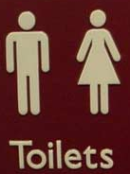
Picture 1A
Source: http://www.humanrights.gov.au/publications/good-bad-and-ugly-design-and-construction-access-0

Picture 2A
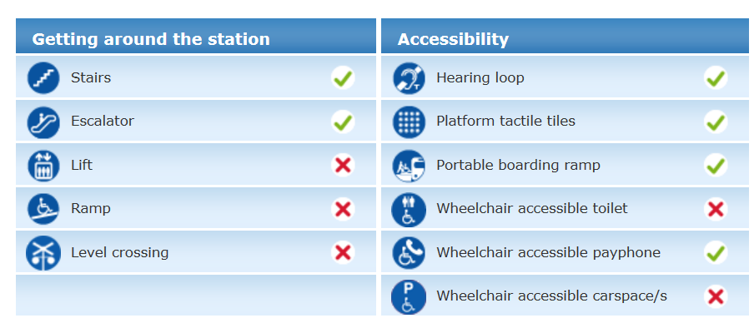
Source: http://www.sydneytrains.info/stations/station_details.htm

Picture 3A
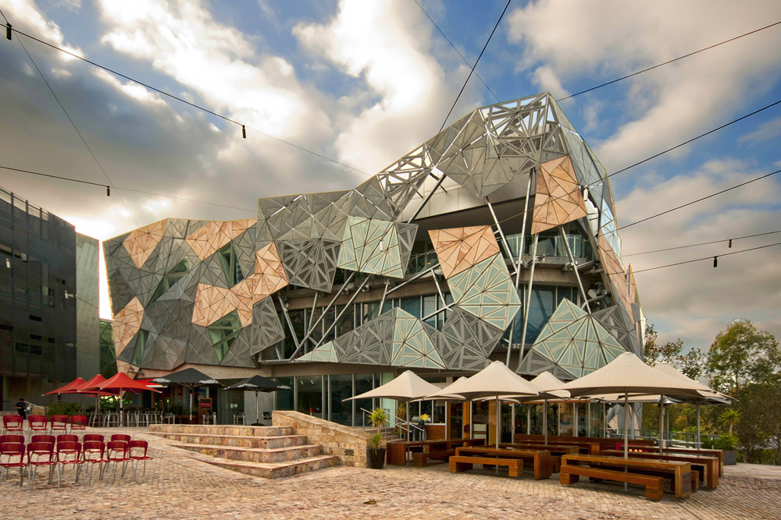
Source: Photograph taken by Wotjek Gurak on Flikr

Rights Ed Activity Sheet: Picture Difference
Pictures B
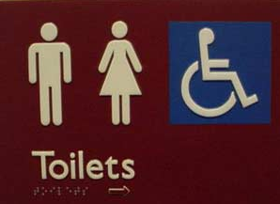
Picture 2B
Source: http://www.humanrights.gov.au/publications/good-bad-and-ugly-design-and-construction-access-0

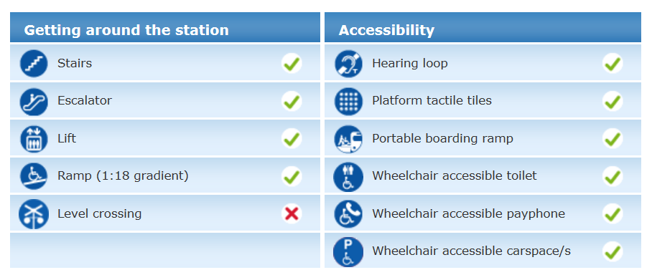
Picture 2B
Source: http://www.sydneytrains.info/stations/station_details.htm

Picture 3B
Source: Photograph taken by Wotjek Gurak on Flikr

Rights Ed Activity Sheet: Defining Liveability
Employment opportunities
Education
Political voice
Inclusion
Sustainable use of environment
Access to…

Built infrastructure
Social infrastructure
access means…

Rights Ed Activity Sheet: What makes a community liveable for different groups people?
PART A
What features of a community will make that community liveable for each of the following groups of people? Think about access to services, employment, education etc.
PART B
Older People
Which features are shared between multiple groups?

People with disabilities
Young People
People without a car

Families

What features of a community will make that community liveable for each of the following groups of people with disabilities?
Why is it important that a community provides for the needs of different groups of people?

People with intellectual disabilities
People with psychosocial disabilities
People with sensory disabilities
People with physical disabilities
Rights Ed Resource Sheet: Hypothetical discrimination scenarios
- A restaurant refuses Lizzy entry because she has a guide dog.

- The local library can only be accessed via a set of steps. Jack can’t enter the library because he uses a wheelchair.

- Leonard’s teacher will not let him go on an overnight school camp because he has epilepsy and needs medication at night.

- Rachel, who has a hearing impairment, said she was unable to enjoy performances at their local cinema because the venue does not have adjustments to accommodate the needs of people with hearing impairments.

- Joe is not allowed to attend professional training at work because he has autism.

- A store requires Lana, who is vision impaired, to produce a driver’s licence as identification before it will accept her cheque to pay for goods. Lana is not eligible to have a licence because of her vision impairment. The store will not accept other forms of official identification that Lana offers.

- A clothes shop does not have wheelchair accessible changing rooms.

(Scenarios have been obtained from the following websites: http://www.humanrightscommission.vic.gov.au/index.php/types-of-discrimination/disability and http://www.humanrights.gov.au/know-your-rights-disability-discrimination)

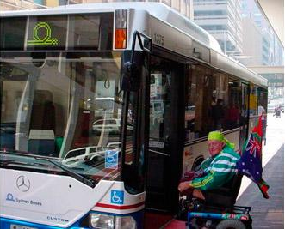
Rights Ed Resource Sheet: Disability Discrimination Act and Access to Premises
What is the Disability Discrimination Act (DDA)?
The Disability Discrimination Act is a national law that aims to eliminate discrimination against people with disabilities, and promote community awareness that people with disabilities have the same rights as all members of the community.
- In which areas of life are people with disabilities protected from discrimination?
Area | Example
Employment | trying to get a job, a promotion or equal pay
Education | enrolling in a school, TAFE, university or other college
Access to premises used by the public | using libraries, places of worship, government offices, hospitals, restaurants, shops, or other premises used by the public
Goods, services and facilities | ability to get goods or services from shops, pubs, places of entertainment, cafes, video shops, banks, lawyers, government departments, doctors and hospitals.
Accommodation | renting or trying to rent a room in a boarding house, unit or house
Buying land | buying a house, a place for a group of people, or a drop-in centre
Activities of clubs and associations | wanting to enter or join a registered club (such as a sports club, RSL or fitness centre), or when a person is already a member
Sport | wanting to play, or when playing a sport
Commonwealth Government laws and programs | seeking information on government entitlements like Centrelink, trying to access government programs, wanting to use voting facilities.
- The Disability Discrimination Act and the right to have access to premises used by the public
The right to have access to premises used by the public means that public buildings and other public places need to be accessible to people with disabilities.
This includes:

- Public footpaths and walkways (including Tactile Ground Surface Indicators for people with vision disabilities)
- Educational institutions
- Shops
  - Banks and other financial institutions
- Parks
- Public swimming pools
- Cafes, restaurants and pubs
- Government service offices
- Public transport facilities
- Hospitals and other medical facilities
- Cinemas and sports venues
- Libraries and other information and advice centres
- Doctors, lawyers and other professional offices
- Other premises the public or a part of the public is entitled or allowed to enter or use
- Lift including accessible signage(e.g. including Braille)

Improving building access improves liveability and gives more people more opportunity to access employment, education and services, and to connect with the broader community.
Rights Ed Activity Sheet: Disability Discrimination Act and Access to Premises
What is the Disability Discrimination Act (DDA)?
The Disability Discrimination Act is a national law that aims to eliminate discrimination against people with disabilities, and promote community awareness that people with disabilities have the same rights as all members of the community.
- In which areas of life are people with disabilities protected from discrimination?
Instructions: Match each area with the correct example
Area | Example
Employment |  | using libraries, places of worship, government offices, hospitals, restaurants, shops, or other premises used by the public
Education |  | wanting to enter or join a registered club (such as a sports club, RSL or fitness centre), or when a person is already a member
Access to premises used by the public |  | trying to get a job, a promotion or equal pay
Goods, services and facilities |  | renting or trying to rent a room in a boarding house, a flat, unit or house
Accommodation |  | wanting to play, or when playing a sport
Buying land |  | enrolling in a school, TAFE, university or other college
Activities of clubs and associations |  | seeking information on government entitlements like Centrelink, trying to access government programs, wanting to use voting facilities
Sport |  | buying a house, a place for a group of people, or a drop-in centre
Commonwealth Government laws and programs |  | ability to get goods or services from shops, pubs, places of entertainment, cafes, video shops, banks, lawyers, government departments, doctors and hospitals
- The Disability Discrimination Act and the right to have access to premises used by the public
The right to have access to premises used by the public means that public buildings and other public places need to be accessible to people with disabilities.
This includes: public footpaths and walkways, educational institutions, ....................................
………………………………………………………………………………………………………………………………………………………………………………………………………………………………………………………………………………………………………………………………………………………………………………………………………………………………………………………………………………………………………………………………………………………...............
Improving building access improves liveability and gives more people more opportunity to access employment, education and services, and to connect with the broader community.

Rights Ed Activity Sheet: Ramped up
Watch the Ramped up video http://youtu.be/wzgoQDuioMY
Question | Answer
Why, until recently, were many buildings difficult for Mark to access?

What is the ‘DDA’?

What difficulties did Mark face when trying to cross the road?

What kind of building features can make access difficult for a person using a wheelchair?

What happened in 2010? What was the significance of this change?

In what ways have changes in building access rules improved liveability?

What are some practical ways that Mark’s community has become more liveable for him?
How has Mark contributed to improving the liveability of his community?
Do you think Mark initially felt socially isolated? Why or why not?

Do you think Mark feels more socially connected now? Why or why not?

Rights Ed Activity Sheet: Room for change
Watch the Room for change video http://youtu.be/D3ErxMvdDPo
Question | Answer
What difficulties did Stella experience in accessing the shop?

How did this experience make Stella feel?
How did Stella respond to the limited accessibility of the shop for people with disabilities?

How did the shop improve accessibility for people with disabilities
?

How effective are the changes?

What was the issue faced by Madeleine?

How did Madeleine respond to this difficulty?

How did Madeleine’s retailer fix this situation?

Do you think the solution makes Madeleine feel more socially connected now?

Rights Ed Activity Sheet: Dee’s Place
Watch the Dee’s Place video http://www.youtube.com/watch?v=ezdSrX7MNBQ#t=12

Question | Answer
What accommodation options did Dee face when deciding how and where to live?

What sorts of support and services did Dee require in order to achieve independent living?

How did Dee’s parents respond to her quest for independence?

How does Dee interact with and contribute to her local community?

How does her independent living contribute to her social connectedness?

Identify the mutual benefits for Dee and her flatmate arising from their shared living arrangements

What are the benefits of having a diverse and inclusive community, as demonstrated by Dee’s story?

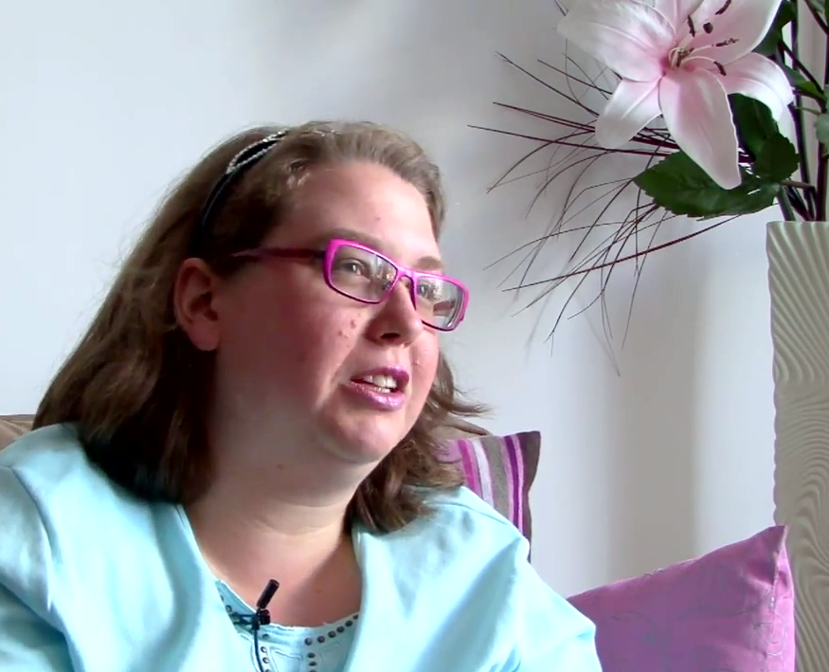

Image Caption: Dee at home, talking about how much she values her independence. Dee’s Place, 20 Year: 20 Stories

Rights Ed Activity Sheet – How accessible is your school?
Instructions
Accessibility Rating System
Excellent Fully accessible
Very Good Most of facility is accessible
Good Partial accessibility
Limited Poor accessibility

You are a geographer; your job is to find out how liveable your school or another local area is for people with disabilities.

Complete the accessibility audit below and provide feedback to the class.

Physical feature | Rating | Comments/issues | What can be done to improve accessibility?
Footpaths e.g. are there ramps? Are they wide and free of obstructions? Are there steps or other barriers that make it difficult to cross roads? Are there Tactile Ground Surface Indicators on the footpaths to indicate direction? Are there Audio Tactile Pedestrian devices to assist in crossing the road?

Corridors and doorways e.g. are they wide enough for a wheelchair? Are they free of obstructions?

Classrooms e.g. are there gaps between tables? Are desks and benches accessible?

School canteen e.g. can someone using a wheelchair purchase something easily? Are there steps or other barriers?

Toilets e.g. are there accessible toilets? Do doors meet Australian standards regarding weight? Is there a sink that is accessible?

Car parking e.g. is it accessible for someone using a wheelchair? Are there steps or other barriers?

Public Transport e.g. do local buses/train stations take into account people using wheelchairs or who can’t walk up steps?
Rights Ed Activity Sheet: Proposal to improve liveability of the school environment template
Proposed Strategy:
Description
Monitoring and Evaluation: How is the effectiveness of the strategy going to be assessed?
Justification of strategy: How will the strategy improve the liveability of the school for students with disabilities? Why is it important to implement this strategy?
Implementation: How will the strategy be implemented?
Description of Strategy: How does the strategy work?
Rights Ed Activity Sheet: Access for all
Watch the Access for All video http://youtu.be/HhFcwBBFvms or http://www.humanrights.gov.au/twentystories/video-access-for-all.html
Question | Answer
Why couldn’t a person using a wheelchair get on a bus before 1994?

How did Maurice feel about being excluded from public transport because of his disabilities?
What did Maurice do about it?
What changes were necessary to make public transport accessible ?
Why did Maurice hate travelling in the back of a taxi van?
Maurice says he wants to be able to go with his neighbours down to the bus stop and travel to work. Why is it important for him to be able to do this?
Maurice talks about how history tells us that if you keep people separate it really adds to the attitudinal issues. What does he mean by this?
Maurice says that diversity adds to the richness of a community. What does he mean by this?
The former Disability Discrimination Commissioner Graeme Innes says that removal of discrimination is as much about inclusion in community activities as removing the physical barrier. What do you think this means?
Are buses now accessible for people with disabilities? From what year will all public transport be accessible?

Rights Ed Resource Sheet: Sydney Morning Herald Opinion Piece
Clear announcements cannot stay in RailCorp's too hard basket
February 4, 2013
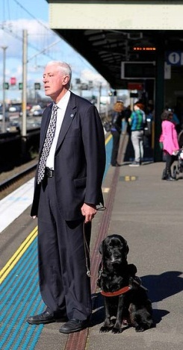
"Independence can come at a high price" ... Graeme Innes. Photo: Janie Barrett
1. One of the many clever things that my teachers at the North Rocks School for Blind Children did was to invent a game called railway fun. It used a large sheet of plywood, with little cups glued onto it to represent each of the Sydney railway stations. They were all labelled in braille. Using this game, we entertained ourselves while learning the railway system, an incredibly useful piece of knowledge for blind students.

2. I've spent much of my life on trains. Mum didn't drive, so we used them a lot to get around as children. I went to eisteddfods on trains. I went to watch NSW play at the SCG on trains. We visited friends on trains, and went to Newcastle to visit my aunt on trains.

3. As I grew up, I went to barrack for the Magpies - now the Tigers - with my brother on trains. And when I started using a white cane and travelling alone, I visited friends, went to social events, to university and work on trains. They are an integral part of my life.

4. In fact, I refuse to live more than walking distance from a railway station. I've used trains in Sydney, in Perth, in London and in New York - places where I have lived and worked.

5. Being able to use trains has been a key part of my independence. I can find my way to the station. I can find the right platform. I can get onto the train, and find a seat. But how do I know where I am?

6. My knowledge of the train system, and the announcements on our stations, mean I can usually catch the right train. But, once I'm on board, it becomes harder. Sometimes the stations are announced, but not always. Where the announcements are automatic, they are pretty reliable. But where the announcements are done manually, on the older trains where the PA equipment is not as good, the reliability drops.

7. What option does that leave me? I can try to listen to the sounds outside - the sounds of tunnels and bridges - but that's hard through closed doors and sealed windows. I can count stations, but it's easy to lose count. As a last resort, I ask other passengers. This always is the last resort because - in empty trains - they are hard to find, and you often don't get the right information when you do find them.
8. These methods often don't work. My family calls it train tennis - going past my station, coming back, and (on one famous occasion) missing it for the second time. Like the tennis ball crossing the net but not landing on it.

9. Journeys without announcements are far less relaxing for me - I can't read, think or sleep. They cause me tension and headaches, and my normally sunny personality takes a turn towards the dark side.

10. And why should I not have the information, just because I happen not to be able to see? All I asked RailCorp [the NSW rail corporation] to do, as it does for passengers who can see, is tell me where I am.

11. I, and others who are blind, asked when the NSW Anti-Discrimination Act was changed in 1981 to cover the ground of disability. I, and others who are blind, asked again when the federal Disability Discrimination Act was passed in 1992. And we asked again in 2007 when announcements were required by the Disability Standards for Accessible Public Transport passed under the Disability Discrimination Act.

12. RailCorp's response has always been: ''We understand the problem. It's on our list of things to fix - in our own sweet time.'' So while blind people in most other cities in the world know where they are on a train, those in Sydney have to wait.

13. I got tired of waiting. So, after due warning, I began to lodge discrimination complaints every time I rode on a train and was not told where I was. But RailCorp intransigence continued. Not prepared to accept my many offers of settlement, it fought me all the way to the Federal Court. After much soul-searching and prayer with my wife, I ran a case in which - if I had been unsuccessful and had costs awarded against me - we could have lost our house.

14. Independence can come at a high price. But hopefully RailCorp will now accept the umpire's decision, and tell me where I am.

Graeme Innes is Australia's former Disability Discrimination Commissioner

Activity Sheet: Clear announcements cannot stay in Railcorp’s too hard basket
Paragraph 1
Why did Graeme’s teachers invent the game railway fun?
Paragraph 2-5
Why do you think trains were so important to Graeme as he started using a white cane and travelling alone?
Paragraph 6-7
Why does it become more difficult for Graeme to know where he is, when he is on the train?
Paragraph 8
Why does Graeme’s family call it train tennis?
Paragraph 10
What was Graeme asking Railcorp to do?
Paragraph 11
How long have Graeme and other people who are blind been asking for train announcements?
Paragraph 12
What was Railcorp’s response?
Paragraph 13
What did Graeme do because he was tired of waiting?
Paragraph 14
Graeme won his court case, what does he hope Railcorp will do now?

Rights Ed Literacy Activity Sheet: Sydney Morning Herald Opinion Piece

Instructions: In the brackets, write the synonym of the bolded word. Answer the margin questions.
Clear announcements cannot stay in RailCorp's too hard basket
February 4, 2013
What is Railcorp?
"Independence can come at a high price" ... Graeme Innes. Photo: Janie Barrett  What is an eisteddfod?  1. One of the many clever things that my teachers at the North Rocks School for Blind Children did was to invent a game called railway fun. It used a large sheet of plywood, with little cups glued onto it to represent each of the Sydney railway stations. They were all labelled in braille. Using this game, we entertained ourselves while learning the railway system, an incredibly useful piece of knowledge for blind students.  Who are the Tigers?  2. I've spent much of my life on trains. Mum didn't drive, so we used them a lot to get around as children. I went to eisteddfods on trains. I went to watch NSW play at the SCG on trains. We visited friends on trains, and went to Newcastle to visit my aunt on trains.  3. As I grew up, I went to barrack (__________________) for the Magpies - now the Tigers - with my brother on trains. And when I started using a white cane and travelling alone, I visited friends, went to social events, to university and work on trains. They are an integral (__________________) part of my life.  4. In fact, I refuse to live more than walking distance from a railway station. I've used trains in Sydney, in Perth, in London and in New York - places where I have lived and worked.  5. Being able to use trains has been a key part of my independence (__________________). I can find my way to the station. I can find the right platform. I can get onto the train, and find a seat. But how do I know where I am?  6. My knowledge of the train system, and the announcements on our stations, mean I can usually catch the right train. But, once I'm on board, it becomes harder. Sometimes the stations are announced, but not always. Where the announcements are automatic, they are pretty reliable. But where the announcements are done manually (______________________________), on the older trains where the PA equipment is not as good, the reliability drops.  7. What option does that leave me? I can try to listen to the sounds outside - the sounds of tunnels and bridges - but that's hard through closed doors and sealed windows. I can count stations, but it's easy to lose count. As a last resort, I ask other passengers. This always is the last resort because - in empty trains - they are hard to find, and you often don't get the right in formation when you do find them.  What is the difference between a manual and an automatic announcement?  What is PA equipment?  8. These methods often don't work. My family calls it train tennis - going past my station, coming back, and (on one famous occasion) missing it for the second time. Like the tennis ball crossing the net but not landing on it.  What does the phrase ‘train tennis’ mean?  9. Journeys without announcements are far less relaxing for me - I can't read, think or sleep. They cause me tension and headaches, and my normally sunny personality takes a turn towards the dark side.  10. And why should I not have the information, just because I happen not to be able to see? All I asked RailCorp to do, as it does for passengers who can see, is tell me where I am.  11. I, and others who are blind, asked when the NSW Anti-Discrimination Act was changed in 1981 to cover the ground of disability. I, and others who are blind, asked again when the federal Disability Discrimination Act was passed in 1992. And we asked again in 2007 when announcements were required by the Disability Standards for Accessible Public Transport passed under the Disability Discrimination Act.  What does this phrase mean?  12. RailCorp's response has always been: ''We understand the problem. It's on our list of things to fix - in our own sweet time.'' So while blind people in most other cities in the world know where they are on a train, those in Sydney have to wait.  13. I got tired of waiting. So, after due warning, I began to lodge discrimination complaints every time I rode on a train and was not told where I was. But RailCorp intransigence (_____________________) continued. Not prepared to accept my many offers of settlement, it fought me all the way to the Federal Court. After much soul-searching and prayer with my wife, I ran a case in which - if I had been unsuccessful and had costs awarded against me - we could have lost our house.  14. Independence can come at a high price. But hopefully RailCorp will now accept the umpire's decision, and tell me where I am.  What does this phrase mean?  What does soul-searching mean?  Graeme Innes is Australia's former Disability Discrimination Commissioner  Who was the umpire in this case?  What was the outcome of the case? | What is a white cane used for?

Rights Ed Resource Sheet: Glossary
Word | Meaning
Accessibility | Accessibility is the degree to which a product, device, service, or environment is available to as many people as possible.
Convention on the Rights of Persons with Disabilities (CRPD) | The United Nations Convention on the Rights of Persons with Disabilities (CRPD) is an international human rights treaty. The purpose of the Convention is to promote, protect and ensure the full and equal enjoyment of all human rights and fundamental freedoms for all people with disability, and to promote respect for their inherent dignity.  It came into force in 2008 and was ratified by Australia in July of that year.
Disability | The CRPD describes disability as an evolving concept and that disability results from the interaction between persons with impairments and attitudinal and environmental barriers that hinders their full and effective participation in society on an equal basis with others.  Persons with disabilities include those who have long-term physical, mental, intellectual or sensory impairments.
Disability discrimination | The CRPD describes disability discrimination as any distinction, exclusion or restriction on the basis of disability which has the purpose or effect of impairing or nullifying the recognition, enjoyment or exercise, on an equal basis with others, of all human rights and fundamental freedoms in the political, economic, social, cultural, civil or any other field.
Infrastructure | Facilities or services needed for the functioning of a community or society  Built infrastructure – physically built facilities/amenities needed for the functioning of a community e.g. roads, bridges, shops, post offices, power lines, transport networks  Social infrastructure – facilities that are needed for the provision of social services e.g. education facilities, health facilities, community clubs or organisations
Liveability | Based on the ability of all individuals to participate actively and politically in the community, have access to equal employment opportunities, and built and social infrastructure. Liveability also depends upon the sustainable environmental practices that are implemented in a community.
Social connectedness | Refers to the relationships people have with others and the benefits these relationships can bring to the individual and society. It includes relationships with family, friends, colleagues, neighbours, as well as connections people make through paid work, sport, community service and other leisure activities.  Source: http://socialreport.msd.govt.nz/social-connectedness/
Social inclusion | All people feel valued, their differences are respected and basic needs are met. There is opportunity for all individuals to have freedom of speech; participate in society through employment and access to services; and to connect with family, friends and the local community.  Sources: http://www.health.vic.gov.au/agedcare/maintaining/countusin/inclusion.htm  http://www.aifs.gov.au/cafca/pubs/sheets/rs/rs3.html

