Colours of Australia
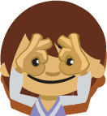  I spy with my little eye  Blue and brown and green. | 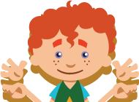  Open, blinking, wide and winking,  The brightest eyes I’ve ever seen. | 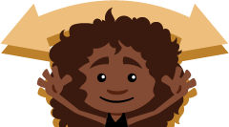  I see colours, colours everywhere!  The colours of Australia,  The beauty we all share. | 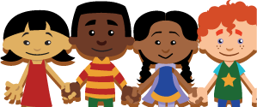  I see colours, colours everywhere!  So let’s hold hands and show we care.
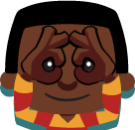  I spy with my little eye  Blond and black and red. | 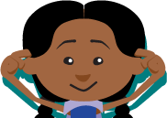  Straight and long,  Curly and strong,  Different hair on different heads. | 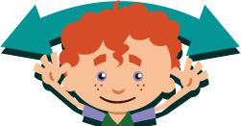  I see colours, colours everywhere!  The colours of Australia,  The beauty we all share. | 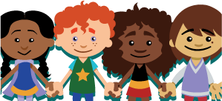  I see colours, colours everywhere!  So let’s hold hands and show we care.
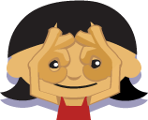  I spy with my little eye  White and tan and brown. | 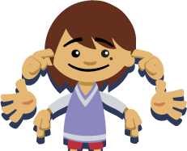  Cheeks and noses,  Fingers and toes,  Healthy skin is all around. | 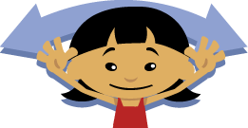  I see colours, colours everywhere!  The colours of Australia,  The beauty we all share. | 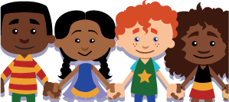  I see colours, colours everywhere!  So let’s hold hands and show we care.
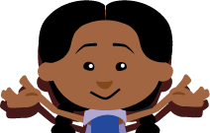  We’re lucky to live in a colourful world,  With lots of boys and lots of girls. | 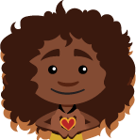  We all look different but on the inside,  We have the same heart,  And we wear it with pride! | 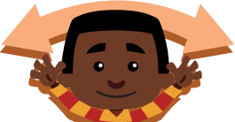  I see colours, colours everywhere!  The colours of Australia,  The beauty we all share. | 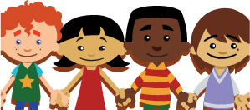  I see colours, colours everywhere!  So let’s hold hands and show we care.

