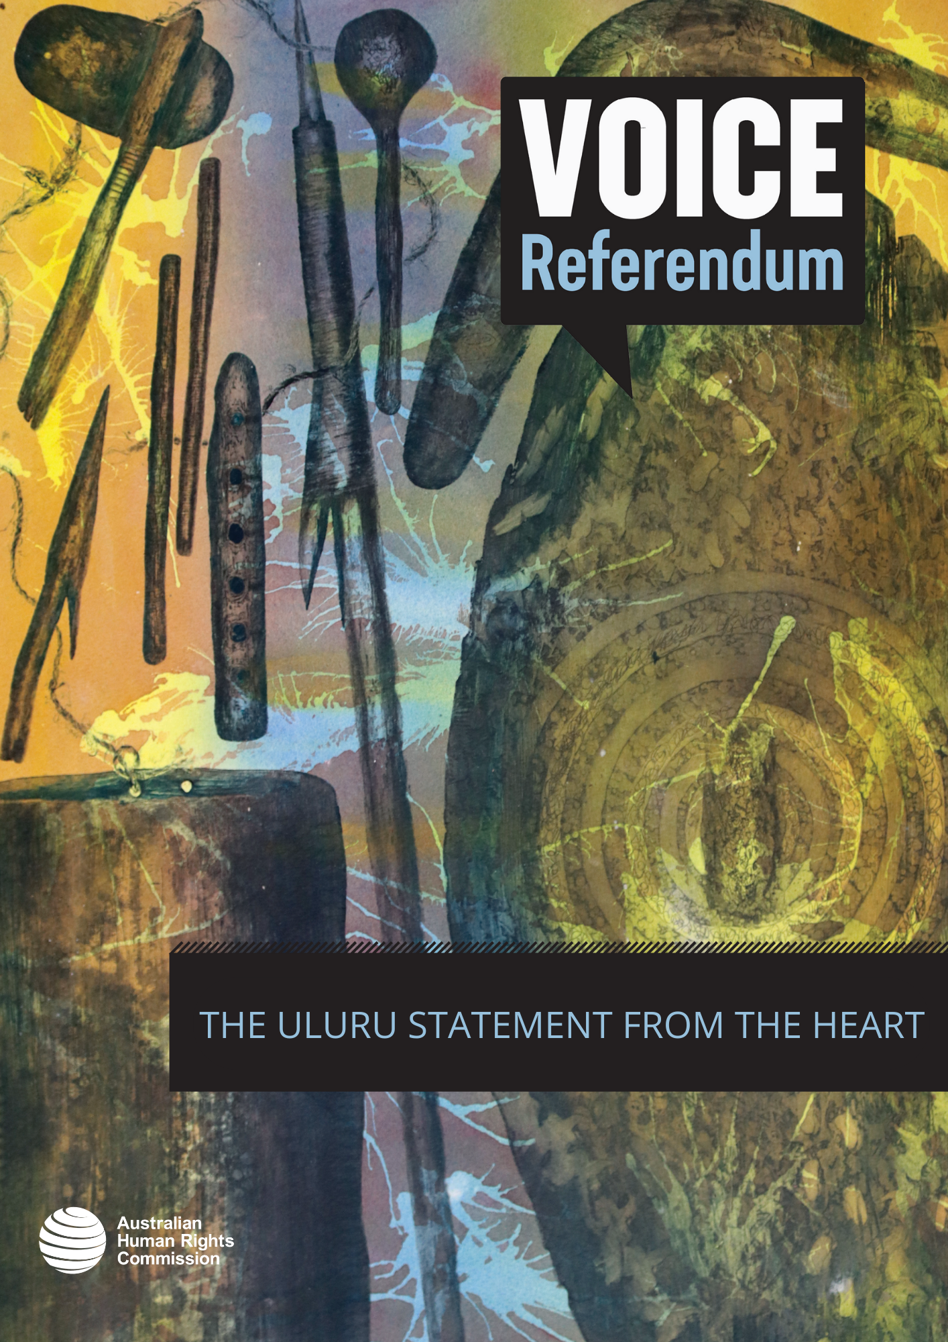

THE ULURU STATEMENT FROM THE HEART

The Uluru Statement from the Heart (the Statement) is an invitation from a group of First Nations people to non-Indigenous Australians. Shared in 2017, the Statement calls for substantive reform to help realise Indigenous rights, through the establishment of an Indigenous Voice to Parliament and a Makarrata Commission. ‘Makarrata’ is a multi-layered Yolŋu word understood as the coming together after a struggle. The Statement specifies that the Makarrata Commission would undertake processes of agreement-making (treaty) and truth-telling.
The three key pillars of substantive reform called for in the Statement are:
- Voice – a constitutionally enshrined representative mechanism to provide expert advice to Parliament about laws and policies that affect Aboriginal and Torres Strait Islander peoples.
- Treaty – a process of agreement-making between governments and First Nations peoples that acknowledges the historical and contemporary cultural rights and interests of First Peoples by formally recognising sovereignty, and that land was never ceded.
- Truth – a comprehensive process to expose the full extent of injustices experienced by Aboriginal and Torres Strait Islander peoples, to enable shared understanding of Australia’s colonial history and its contemporary impacts.
The Uluru Statement comes after decades of research, reports and calls for genuine substantive reform to recognise and protect the rights of Aboriginal and Torres Strait Islander peoples as the First Peoples of these lands and waters.
The Australian Government announced on 23 March 2023 that it would hold a referendum in 2023, to ask the Australian people whether they agree to recognising the First Peoples of Australia in the Constitution by establishing an Indigenous Voice to Parliament. Learn more about this in the ‘referendums and constitutional change’ section of the resource kit.
The Australian Human Rights Commission affirmed its support for the Uluru Statement from the Heart in March 2023.

About the Australian Human Rights Commission
The Australian Human Rights Commission (Commission) is an independent organisation, established by an Act of the Australian Parliament. The Commission is responsible for promoting awareness of human rights, educating the Australian community about such rights, and providing expert guidance on Australia’s human rights obligations, both internationally and domestically.
The Commission’s contribution to the 2023 referendum is independent and non-partisan, appropriate to its role as a National Human Rights Institution (NHRI). We encourage and support the Australian public to consider the Voice proposal and associated referendum through a human rights lens.

