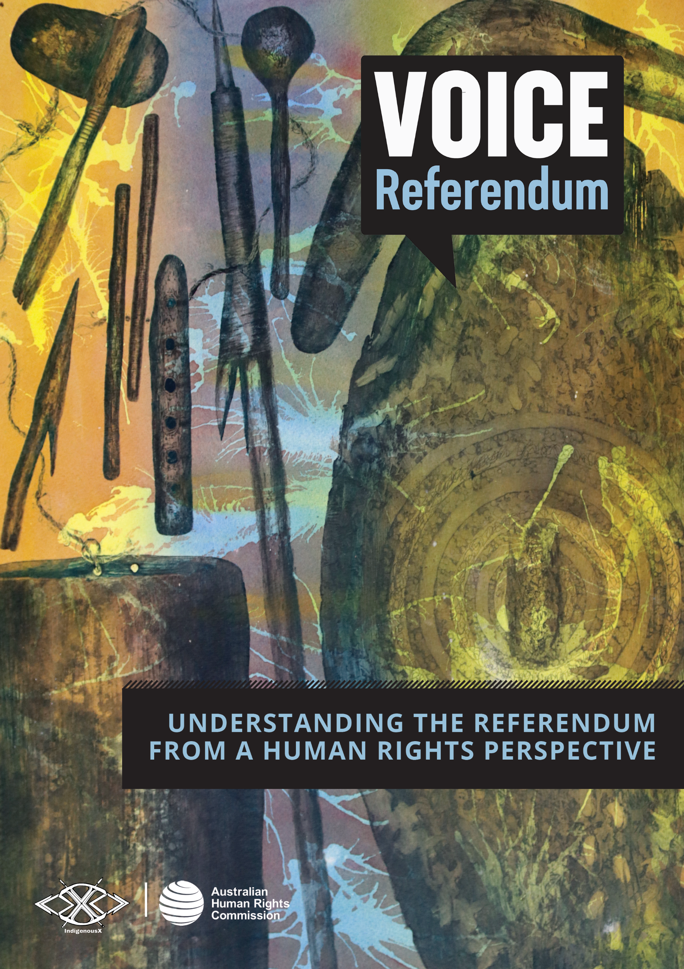

© Australian Human Rights Commission 2023.
The Australian Human Rights Commission encourages the dissemination and exchange of information presented in this publication. All material presented in this publication is licensed under the Creative Commons Attribution 4.0 International Licence, with the exception of:
- artwork, photographs and images
- the Commission’s logo, any branding or trademarks
- where otherwise indicated.
The details of the relevant licence conditions are available on the Creative Commons website, as is the full legal code for the CC BY 3.0 AU licence.
Attribution: Material obtained from this publication is to be attributed to the Australian Human Rights Commission with the following copyright notice: © Australian Human Rights Commission 2023.
Voice Referendum: Understanding the referendum from a human rights perspective
ISBN 978-1-925917-84-0
This publication can be found in electronic format on the Australian Human Rights Commission’s website at https://humanrights.gov.au/our-work/aboriginal-and-torres-strait-islander-social-justice/voice-referendum-understanding
Acknowledgements:
The Australian Human Rights Commission extends its sincere thanks to IndigenousX, a 100% Indigenous owned and operated media, consultancy and training organisation, for their generous guidance and expertise. Their insights into the nature of race and racism in Australia along with their dedication to ensuring careful consideration of and respect for Indigenous rights, knowledges, and experiences proved invaluable to the development of these resources.
The Commission also extends its sincere thanks to Saltwater People, an Indigenous-owned, full-service creative agency that delivers strategic design communications and cross-cultural engagement. Throughout the development of this resource kit, they generously provided expertise in best practice cross-cultural engagement, Indigenous Cultural and Intellectual Property (ICIP) and visual communication.
For further information about the Australian Human Rights Commission or copyright in this publication, please contact:
Australian Human Rights Commission
GPO Box 5218 SYDNEY NSW 2001
Telephone: (02) 9284 9600
Email: communications@humanrights.gov.au
Cover design and artwork credit © Paul Bong in collaboration with Saltwater People.
Warning: Aboriginal and Torres Strait Islander peoples should be aware that the Voice referendum resource suite contains names of people who are deceased.

CONTENTS

The Uluru Statement from the Heart……………….5
Minimising harm in conversations about the referendum……………………………………………………..8
Indigenous rights and the Voice…………………….14
The history of Aboriginal and Torres Strait Islander peoples advocating for the right to be heard……………………………………………………………..22
Symbolic change or substantive reform…………31
Self-determination and Indigenous peoples….33
The Voice and human rights………………………….38
Referendums and constitutional change……....42
Support Services……………………………………………46
Appendix……………………………………………………….51

ACKNOWLEDGEMENT

The Australian Human Rights Commission acknowledges the Aboriginal and Torres Strait Islander traditional custodians of land, sea, waterways and sky throughout Australia and pays respect to First Nations Elders past and present.
The Commission recognises First Nations peoples continuing connection to their traditional land and waters - a connection that has existed since time immemorial - and acknowledges the impacts of colonisation, which continue to obstruct First Nations peoples full enjoyment of individual and collective rights.
The Commission also acknowledges the ongoing work of Aboriginal and Torres Strait Islander peoples in anti-racism since colonisation.

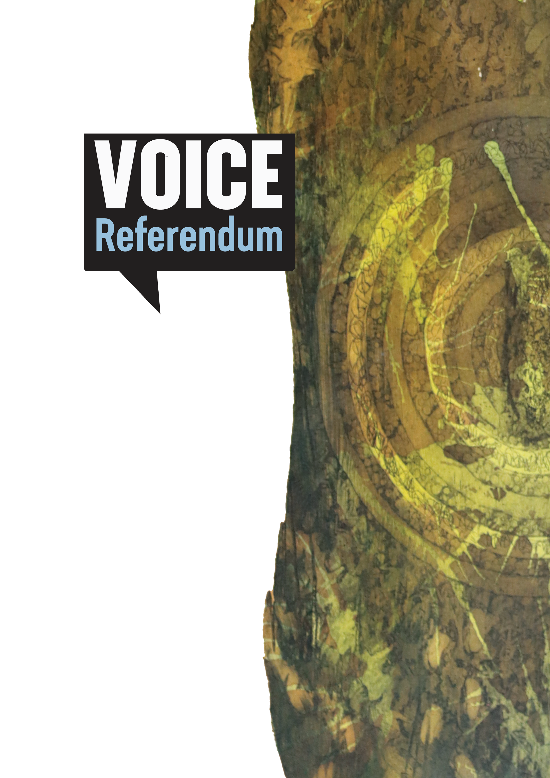

This resource kit is designed to promote greater awareness and understanding of human rights principles as they relate to the Uluru Statement, specifically the upcoming referendum and the proposed Indigenous Voice to Parliament. Within this document, you will find information intended to help you consider whether the Voice could help to support the realisation of Indigenous rights.

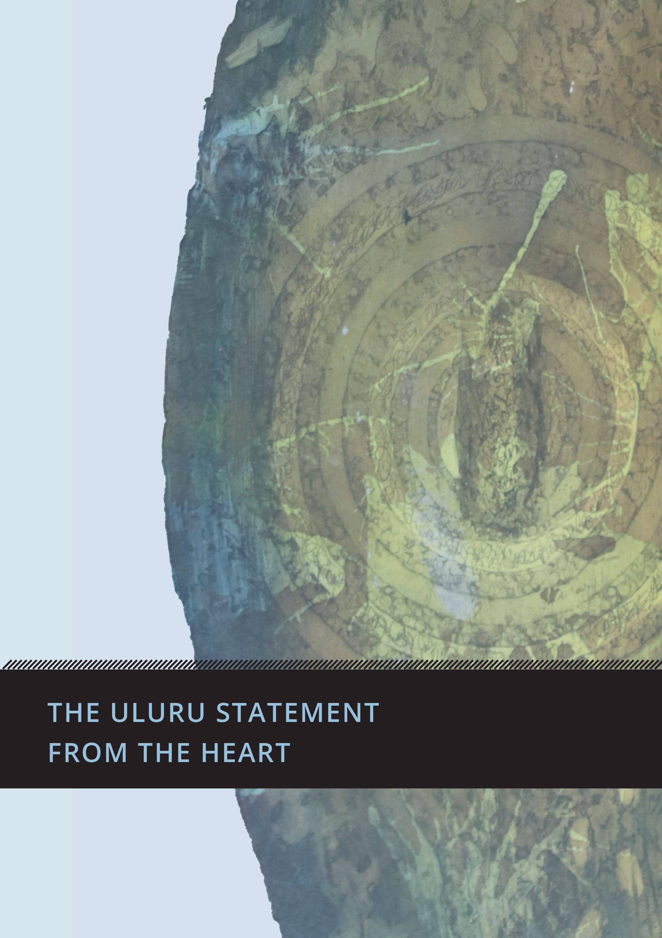

THE ULURU STATEMENT
FROM THE HEART

THE ULURU STATEMENT FROM THE HEART

The Uluru Statement from the Heart

The Uluru Statement from the Heart (the Statement) is an invitation from a group of First Nations people to non-Indigenous Australians. Shared in 2017, the Statement calls for substantive reform to help realise Indigenous rights, through the establishment of an Indigenous Voice to Parliament and a Makarrata Commission. ‘Makarrata’ is a multi-layered Yolŋu word understood as the coming together after a struggle. The Statement specifies that the Makarrata Commission would undertake processes of agreement-making (treaty) and truth-telling.
The three key pillars of substantive reform called for in the Statement are:
- Voice – a constitutionally enshrined representative mechanism to provide expert advice to Parliament about laws and policies that affect Aboriginal and Torres Strait Islander peoples.
- Treaty – a process of agreement-making between governments and First Nations peoples that acknowledges the historical and contemporary cultural rights and interests of First Peoples by formally recognising sovereignty, and that land was never ceded.
- Truth – a comprehensive process to expose the full extent of injustices experienced by Aboriginal and Torres Strait Islander peoples, to enable shared understanding of Australia’s colonial history and its contemporary impacts.
The Uluru Statement comes after decades of research, reports and calls for genuine substantive reform to recognise and protect the rights of Aboriginal and Torres Strait Islander peoples as the First Peoples of these lands and waters.
The Australian Government announced on 23 March 2023 that it would hold a referendum in 2023, to ask the Australian people whether they agree to recognising the First Peoples of Australia in the Constitution by establishing an Indigenous Voice to Parliament. Learn more about this in the ‘referendums and constitutional change’ section of the document.
The Australian Human Rights Commission affirmed its support for the Uluru Statement from the Heart in March 2023.

About the Australian Human Rights Commission
The Australian Human Rights Commission (Commission) is an independent organisation, established by an Act of the Australian Parliament. The Commission is responsible for promoting awareness of human rights, educating the Australian community about such rights, and providing expert guidance on Australia’s human rights obligations, both internationally and domestically.
The Commission’s contribution to the 2023 referendum is independent and non-partisan, appropriate to its role as a National Human Rights Institution (NHRI). We encourage and support the Australian public to consider the Voice proposal and associated referendum through a human rights lens.
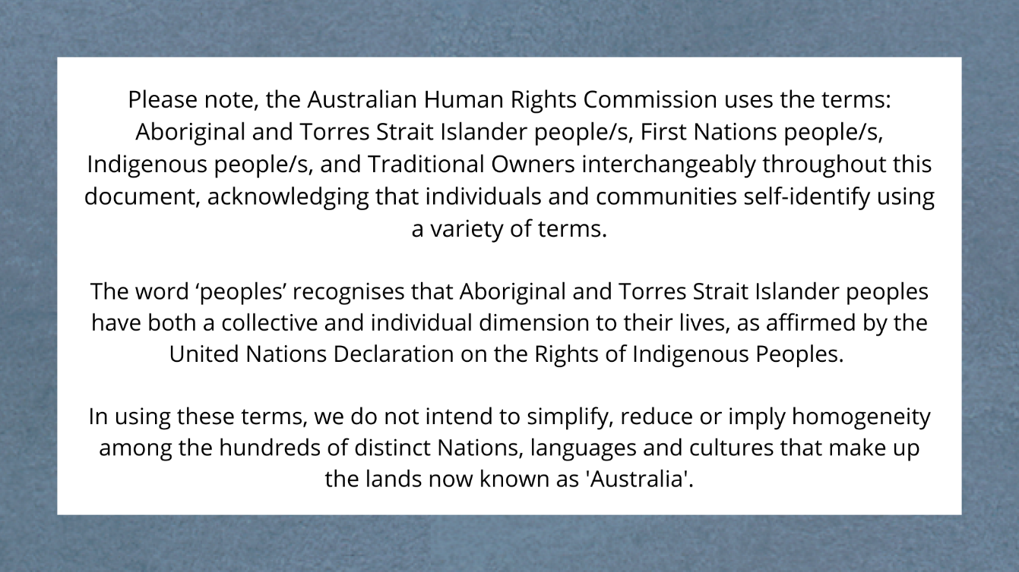

MINIMISING HARM IN CONVERSATIONS ABOUT THE REFERENDUM

Minimising harm in conversations about the referendum

MINIMISING HARM IN CONVERSATIONS ABOUT THE REFERENDUM

Too often, Indigenous peoples are the subject of national debates that cause direct and indirect harm.
In a democracy, it’s important that people can express their opinions on key issues, especially those of great national importance. However, it is crucial that these conversations are approached in a way that is factual, is not based on racial stereotypes, does not involve racially denigrating language, and does not cause harm to Indigenous peoples. This is particularly important when discussing issues that disproportionately affect certain individuals and communities, such as the referendum for an Indigenous Voice to Parliament.
This section of the document provides information and practical tips to engage in conversations about the referendum in ways that minimise harm, including:
- Practise cultural humility
- Centre Indigenous knowledges, voices, and perspectives
- Remember, there is no one true ‘Indigenous perspective’
- Avoid deficit discourse
- Call out and actively combat fear tactics

Practise cultural humility
Acknowledging the potential for harm and working to minimise it, while still being able to express personal views and opinions takes a certain level of thoughtfulness, respect and cultural humility.
Cultural humility is a lifelong process that requires each of us to examine our own views about race and racism, and how racism has influenced our experiences, our opportunities, and our relationships. Aunty Dulcie Flower OAM, an Elder of the Erub nation and the first Torres Strait Islander nurse involved in the formation of the Redfern Aboriginal Medical Service, describes cultural humility as “something that you learn; you’re not born with this, it’s a whole learning process”.
Cultural humility necessitates a willingness for self-evaluation, learning, and self-reflection. It is a commitment to fix power imbalances that occur within social interactions, institutions and society itself. It requires a transparent commitment to institutional accountability for often systemically racist and harmful policies and practices, as part of developing and maintaining reciprocal relationships with Indigenous peoples based on trust and respect.
Within a framework of cultural humility, the goal is not to become an ‘expert’ on Indigenous people and cultures, but instead it is about having a respectful and realistic framework. Such a framework seeks to understand, while not expecting all Indigenous people to be teachers or to fit into any preconceptions of what Indigenous people should think or do.
Commit to practising cultural humility.
Talk to your organisation about cultural safety and cultural humility training. Some Indigenous organisations offering this service include: Jumbunna Institute for Indigenous Education and Research, IndigenousX, Indigenous Psychological Services (IPS), Centre for Cultural Competence Australia, and Aboriginal Insights.
Watch an animated video that introduces the concepts of cultural safety, humility, and awareness, produced by the Indigenous Health Team of Northern Health, Canada.

Centre Indigenous knowledges, voices and perspectives
Indigenous peoples have long been excluded from decision making. Often, Indigenous peoples are treated as an object of debate – a problem to be solved by non-Indigenous people who believe they know what is best for Indigenous people. This is dehumanising.
It can play out whenever Indigenous topics are being discussed by non-Indigenous people in the media, politics, online, in workplaces or in schools, without any Indigenous representation and perspectives.
Indigenous peoples have rights to representation and participation in matters that affect them, as well as rights to be consulted and have their voices heard. Learn more about this in the ‘Indigenous rights and the Voice’ section of the document.
When witnessing or engaging in discussions about Indigenous people, issues and communities, consider the extent to which Indigenous knowledge, voices and perspectives are centred.
It’s appropriate and important to seek a range of perspectives from First Nations peoples and to reflect and draw on these in a way that is fair, appropriate and accurately portrays the intent of the original speaker or author.
Organising a community or workplace event? Ensure that First Nations people and perspectives are considered, consulted and included.
For media made by, for and about Aboriginal and Torres Strait Islander people, check out organisations like: National Indigenous Television (NITV), National Indigenous Radio Service (NIRS), Koori Mail, and IndigenousX.

Remember, there is no one true ‘Indigenous perspective’
The desire to have Indigenous individuals speak on behalf of all Indigenous people stems from the commonly held misconception that Indigenous people are a homogenous group with the same views on social, political and cultural issues. This can lead some non-Indigenous people to become confused or angry when confronted with a diversity of opinion amongst Indigenous peoples.
There are over 250 unique Indigenous nations and hundreds of thousands of individuals, with a wide range of views. Some non-Indigenous people struggle with this, leading them to label views outside of the one they deem to be ‘authentic’ as ‘less Indigenous’. When used by non-Indigenous people, terms like ‘sell out’, ‘fake’, ‘urban’, ‘elite’ and other words designed to belittle the identity and perspective of Indigenous people are harmful and unhelpful.
It’s unrealistic to expect consensus amongst Indigenous people, just as it would be to expect this from any other group in Australia.
Listen to a range of Indigenous voices and consider which ideas resonate. That is the natural and inevitable outcome of respectfully listening to a diverse range of views on any topic.
It’s ok to disagree, to fact check, and to have strongly held beliefs. But showing cultural humility means understanding that the desire for a single ‘authentic’ Indigenous voice is unreasonable and unrealistic, and every single Indigenous person is entitled to their beliefs and views, just as every other Australian is. Every human being is deserving of dignity and respect.

Avoid deficit discourse
Deficit discourse is when we talk about Indigenous people and issues as though there is an innate deficit or deviance with being Aboriginal and/or Torres Strait Islander.
“'Deficit discourse' refers to disempowering patterns of thought, language and practice that represent people in terms of deficiencies and failures.” – Lowitja Institute Summary Report.
It commonly attempts to blame Indigenous people for challenges and circumstances, often ignoring the larger social, economic, political and historical factors which are major contributors.
Taking a strengths-based approach is necessary to combatting deficit discourse. This approach seeks ‘to move away from the traditional problem-based paradigm and offer a different language for thinking about and discussing issues’. It involves emphasising strengths, culture, country, rights and partnership, in the context of First Nations people.
Refuting deficit discourse means challenging racial stereotypes and ensuring that conversations about Indigenous people and issues are conducted in a way that upholds the respect and dignity of individuals, communities and cultures.

For more information on deficit discourse, see the Summary Report from the Lowitja Institute.

Call out and actively combat fear tactics
From the earliest days of colonisation, fear campaigns attempting to paint Indigenous people as an innate risk have been common.
From fears about Indigenous people stealing cattle to wanting ‘free handouts’, these messages evoke harmful racist stereotypes that pose a threat to the health and safety of Indigenous people. They have the potential to affect Aboriginal and Torres Strait Islander people’s experiences, limit life opportunities, and influence funding and policy decisions from governments and other organisations.
Reactions like ‘Aboriginal people are going to steal your backyard’ in the wake of the Mabo decision, is an example of a fear tactic. This method, used historically and in contemporary debates, generates fear and animosity towards Indigenous people. This is then used to undermine Indigenous rights and justify taking systemically racist and harmful approaches, policies and practices to Indigenous affairs, that would otherwise be considered unacceptable.
In conversations about the referendum, take a stand against divisive and racist discourse. Call out harmful fear tactics when observed, and work to minimise harm.
Keen to learn more about practical conversations and messaging that works? Passing the Message Stick is a multi-year, First Nations research project that lays out the messaging needed to build public support for self-determination and justice, paving the way for long term change.

INDIGENOUS RIGHTS AND
THE VOICE

Indigenous Rights & the Voice

INDIGENOUS RIGHTS AND THE VOICE

What are Indigenous rights?
Indigenous peoples around the world have unique rights as the Traditional Owners and original Custodians of lands that have been colonised.
These individual and collective Indigenous rights are set out in the United Nations Declaration on the Rights of Indigenous Peoples (UNDRIP). UNDRIP establishes a universal framework of minimum standards for the survival, dignity and well-being of Indigenous peoples around the world.
UNDRIP sets out how universal human rights and fundamental freedoms apply to the distinct experiences of Indigenous peoples across the world. It includes the rights of Indigenous peoples to:
- Self-determination: the right to shape their own lives, including their economic, social, cultural, and political futures (Article 3). This is a central right of UNDRIP, and all other Indigenous rights in the Declaration help to achieve self-determination. Learn more about this in the ‘self-determination and Indigenous peoples’ section of this document.
- Autonomy and self-government: the right to decide how to develop politically, economically, and socially (Article 4).
- Indigenous decision-making institutions: the right to maintain and strengthen their distinct political, legal, economic, social, and cultural institutions (Article 5).
- Culture: the right to practise and revitalise their cultural traditions and customs, including to maintain, protect and develop the past, present and future manifestations of their cultures (Article 11).
- Language: the right to establish and control their educational systems and institutions providing education in their own languages, in a manner appropriate to their cultural methods of teaching and learning (Article 14).
- Participation and representation: the right to participate in decision-making in matters that affect their rights, and through representatives they choose (Article 18).
- Consultation with government: the right to be consulted through their own representative institutions in order to obtain their free, prior and informed consent before adopting and implementing legislative or administrative measures that may affect them (Article 19).
- Determining future priorities: the right to be actively involved in developing and determining health, housing and other economic and social programs affecting them (Article 23).
- Land: the right to legal recognition and protection of the lands, territories, waters, coastal seas, and resources that they have traditionally owned or occupied (Article 26).
UNDRIP specifically requires that Governments around the world ‘in consultation and cooperation with Indigenous peoples, shall take the appropriate measures, including legislative measures, to achieve the ends of this Declaration’. Australia endorsed UNDRIP in 2009.

While Australia has long acknowledged the importance of Indigenous rights both in Australia and in international processes, our national government has not yet put in place legal protections for all of the Indigenous rights referred to in the UNDRIP and has therefore not yet fully implemented the requirements of the Declaration.

The 2023 referendum is asking the Australian people whether they agree to establishing an Indigenous Voice to Parliament as a potential way to make these rights a reality.

Please see the Commission’s community guide to UNDRIP.

How are Indigenous rights different from human rights for everyone?

Everyone is entitled to the full realisation and protection of human rights as set out in international human rights treaties. This applies to Indigenous peoples and non-Indigenous people alike. Foundational among these human rights principles, and captured in Article 7 of the Universal Declaration of Human Rights, is the right to be treated equally before the law and to non-discrimination.

While this may sound simple, ensuring that people are treated equally has proven a challenge the world over.

For this reason, many governments in the world have also agreed to human rights treaties for particular groups of people that set out how universal human rights standards apply to them. This is to ensure that everyone can fully enjoy their human rights – as women, as children, on the basis of their race, as persons with disability and as Indigenous peoples, for example.

Human rights principles that relate to Indigenous peoples (or Indigenous rights) set out minimum standards to ensure that Indigenous peoples can equally enjoy human rights alongside everyone else.

History shows that Indigenous peoples around the world have not equally enjoyed human rights. The UNDRIP acknowledges that recognising the distinct cultural characteristics of Indigenous peoples and the impact of their historical treatment is critical if we are to achieve equal enjoyment of human rights between Indigenous and non-Indigenous peoples.

Indigenous rights are not additional or special rights for Indigenous peoples. Instead, they show what factors should be recognised so that universal human rights standards can be fully realised for Indigenous peoples. As an example, UNDRIP sets out the importance of recognising Indigenous cultures and languages so that Indigenous peoples can equally enjoy the right to education.

What is the Indigenous Voice to Parliament?
The Indigenous Voice to Parliament is a proposal within the Uluru Statement from the Heart, an invitation shared with the Australian people in 2017. The Statement calls for three key pillars of significant substantive reform to help realise Indigenous rights: Voice, Treaty, and Truth.
The Statement’s first call to action is for a constitutionally enshrined Indigenous Voice to Parliament, to give Aboriginal and Torres Strait Islander peoples a say on laws and policies that affect them. Learn about the significance of constitutional change in the ‘referendums and constitutional recognition’ section of this document.
The Voice referendum is seeking substantive reform by guaranteeing First Nations recognition in the Constitution, through a mechanism for participation. If the referendum is successful, the Voice will be able to make representations and provide advice to Parliament and the Executive on matters that affect Aboriginal and Torres Strait Islander peoples. As a representative structure, the Voice could also enable informed decision-making through the lived experience and expertise of Indigenous peoples across Australia.
Read the Uluru Statement from the Heart in full.

How could the Voice to Parliament support the realisation of Indigenous rights?
Central to the achievement of all human rights for Indigenous peoples is the right to participate in decisions that affect them, and to be represented by their own freely chosen representatives (Article 18 UNDRIP).
Through UNDRIP, governments have committed to consult and cooperate in good faith with Indigenous peoples through their own representative institutions before adopting laws or decisions that affect them (Article 19 UNDRIP).
The Voice proposes a mechanism that addresses both of these elements – a process for Indigenous peoples’ participation in decision making, and a mechanism for governments to consult with Indigenous peoples.
Enshrining the Voice in the Australian Constitution makes the Voice an ongoing mechanism for this participation and consultation.
Some opposition to the Voice proposal has related to its inclusion in the Constitution, and a view that an Indigenous representative mechanism does not need to be constitutionally enshrined.
Those who support the Uluru Statement have stated that including a Voice in the Constitution would prevent this Indigenous representative structure from being disbanded by government, as has occurred in the past.
The Voice could also promote the realisation of other human rights for Indigenous peoples, including to ensure the full realisation of rights to health, education, housing and the protection of Indigenous cultures.

How do other countries acknowledge Indigenous rights?
Other countries that have been colonised use First Nations representative mechanisms to support the realisation of Indigenous rights, as defined by UNDRIP.
Constitutional recognition of Indigenous peoples internationally occurs in a variety of ways, including the protection and promotion of Indigenous cultures, land titles and political representation. For example:
- In Aotearoa/New Zealand, Te Tiriti o Waitangi (the Treaty of Waitangi) recognises Māori sovereignty, and was signed by Māori Chiefs and the British Crown in 1840. While the Treaty itself is not enshrined in legislation, its principles have been given legal recognition through a series of court cases and legislative measures, such as the 1975 Treaty of Waitangi Act, which established the Waitangi Tribunal. The 1867 Māori Representation Act guaranteed Māori seats in Parliament that are separate from the general electoral system and are reserved exclusively for Māori representation. Representatives are elected by Māori voters to sit alongside other MPs in the New Zealand Parliament. Further, the 2002 Local Government Act requires councils to consult with Māori on issues that may affect their rights and interests. This consultation process allows for meaningful participation and input from Māori in policy and decision-making, particularly regarding resource management, cultural heritage, and land rights.

- In Norway, the Sámi Parliament was established through a 1987 amendment to the Constitution – the Sámi Act – as a representative body to enable Indigenous Sámi people to actively participate in political decision-making. The Sámi Parliament has 39 members who are elected every four years by Sámi voters in Norway. The Sámi Parliament has the power to make recommendations on issues affecting the Sámi people, including cultural preservation, land rights, and natural resource management. Norway has also implemented co-management arrangements which ensure Sámi perspectives and traditional knowledge are considered in decision-making related to natural resources and protected areas.

- Bolivia was the first country in the world to incorporate UNDRIP into domestic law and later, its Constitution. The Constitution, adopted in 2009, goes further than any previous legislation in Bolivia in securing rights and freedoms for the nation’s Indigenous peoples. Article 30 of the Constitution establishes the right to participation and prior consultation for Indigenous peoples in decisions that may affect their territories, natural resources, or cultural heritage. The Bolivian Plurinational Legislative Assembly, established in 2009, includes seven reserved seats for Indigenous people, who are elected by Indigenous customary law (usos y constumbres). This mechanism ensures that Indigenous peoples have a direct say in the country’s political decision-making processes.
The referendum question wording states that the Voice ‘may make representations’ to the Parliament and Executive Government. Since there is no legal requirement that the government must listen to, or act on, what it is advised by the Voice, the proposal is more limited in scope when compared to international examples of Indigenous participation in decision-making.
The principles of the Voice include that its members will be ’selected by Aboriginal and Torres Strait Islander communities, not appointed by the Executive Government’. This is similar to examples of Indigenous representation in Aotearoa/New Zealand, Norway and Bolivia, where Indigenous peoples elect their own representatives.
In contrast to international examples, the proposal for the Indigenous Voice to Parliament is not seeking a separate, parallel Indigenous parliament or representation in the Australian Parliament. Rather, it is a proposal for a representative mechanism that can provide recommendations to Parliament on issues that affect Indigenous peoples and communities.

Learn more about international examples of Indigenous representation
Examples detailed in the section above are included for reference, not as an endorsement of any particular model, including that which is currently proposed in Australia.
If you are interested to learn more about the international examples, and associated issues, we encourage you to explore the further reading list in the appendix at the end of this document.

The history of Aboriginal and Torres Strait Islander peoples advocating for the right to be heard

THE HISTORY OF ABORIGINAL AND TORRES STRAIT ISLANDER PEOPLES ADVOCATING FOR THE RIGHT TO BE HEARD

THE HISTORY OF ABORIGINAL AND TORRES STRAIT ISLANDER PEOPLES ADVOCATING FOR THE RIGHT TO BE HEARD

There is a long history of First Nations people advocating for the right to representation and participation in decisions that affect them. Although colonisation has significantly disrupted First Nations Law, structures and culture, Aboriginal and Torres Strait Islander peoples have persevered, demonstrating remarkable strength, resilience and tenacity when engaging with the Australian nation state to have their rights recognised.

First Nations peoples have resisted state-sanctioned injustice since colonisation began, well before the events listed below. Early examples include mass protests against the inhumane treatment and living conditions imposed upon residents of Aboriginal reservations, such as the Cummeragunja walk-off. The swell of support for change sparked by the Indigenous protest movement in Australia has led to changes to the Constitution in the past, as with the 1967 referendum. Much like the referendum taking place this year, the 1967 referendum was not initiated by a single event, but rather decades of growing national and international advocacy and support for change.

The events listed below are a selection of moments in history when Aboriginal and Torres Strait Islander peoples have taken action to call for large-scale change by Australian governments to realise their Indigenous rights.

WARNING: Aboriginal and Torres Strait Islander readers are warned that the following timeline contains names of deceased persons.

Please note, the following section uses culturally inappropriate terms of reference that have contributed to the historical erasure of hundreds of distinct Nations, languages and cultures that make up the lands now known as 'Australia'. Terminology can change over time, and it is best practice to find out what the preferred term is from the respective Aboriginal and/or Torres Strait Islander group or individual you are referring to.

Date | Historic Event
1933-8 | William Cooper Petition  In 1933 Yorta Yorta man William Cooper established the Australian Aborigines’ League (AAL) in Melbourne together with Margaret Tucker, Eric Onus, Anna and Caleb Morgan, and Shadrach James. Cooper was the founding secretary of the League which lobbied to improve the lives and rights of First Nations peoples, on behalf of their communities. From 1933–1938 Cooper gathered nearly 2000 signatures from First Nations people, on behalf of the AAL, for a petition to the King, calling for First Nations representation in the federal parliament.  The Government refused to present the petition to King George VI.  In December 1938, William Cooper and the AAL made history when they marched on the German Embassy in Melbourne to protest against the treatment of the Jewish community in Germany following the events known as Kristallnacht. It was the first protest in support of the Jewish community anywhere in the world.
1936 | Torres Strait Maritime Strike  In January 1936, Torres Strait Islanders united against the substandard working conditions of pearl divers. At the time, Torres Strait Islander communities made up a significant proportion of the labour workforce, as was the case with many First Nations groups in northern Australia, meaning that industrial action became a particularly effective tool for advancing change. Through the Maritime Strike, Islanders advocated for the right to choose how they spent their wages and to have control over their own affairs, in other words the right to self-determination. The Strike lasted 9 months and led to the repeal of highly restrictive legislation and the introduction of the Torres Strait Islanders Act in 1939. Although restrictive, this legislation recognised Torres Strait Islanders as a separate First Nations group with the right to vote and elect their own chairmen and councillors to local government.  The Torres Strait Maritime Strike not only paved the way for future reform towards self-government in the region but is also one of the first recorded strikes by First Nations peoples across the continent, initiating the Indigenous workers’ rights movement in Australia and leading to pivotal events, such as the Wave Hill Walk-Off in 1966.
1938 | Day of Mourning  150 years after colonisation began, celebrations were planned across the lands now known as Australia for the 26th of January 1938. In response to this, the Australian Aborigines’ League and the newly established Aboriginal Progressive Association, declared a Day of Mourning. They held a conference in Sydney, a landmark gathering of First Nations peoples, to draw attention to the violence, dispossession and inhumane conditions imposed upon Aboriginal communities, and to request full citizenship status and rights. This was one of many First Nations protests against injustice, denial of land and protectionist policies, and is considered by many to be the start of the Indigenous political movement in Australia.  A few days later, members of the Australian Aborigines’ League and the Aborigines Progressive Association led a delegation to the Prime Minister, Joseph Lyons, with a proposed national policy for Aboriginal people. Their requests were rejected by the Government.
1963 | Yirrkala Bark Petitions  In August 1963, two bark petitions were presented to the Australian House of Representatives, one in Yolŋu Matha and the other in English, with differing and distinct paintings framing the text. The paintings represent the two Yolŋu moieties, Dhuwa and Yirritja. This was the Yolŋu’s first formal proposal to have their land rights recognised. The 1963 petitions still hang in Parliament House, Canberra.  The petitions were the first documents to have incorporated First Nations ways of representing relationships to land that were formally acknowledged by the Commonwealth Parliament. Four additional petitions were made and presented in 1968, 1988 (see ‘The Barunga Statement’ below), 1998 and 2008. To this day, these petitions have not been effectively responded to by the Government.
1965 | The Freedom Ride  In February 1965, Charles Perkins and other students from the University of Sydney’s Student Action For Aborigines group led a 15-day bus journey across Northern NSW ‘to shine a light on the marginalisation of Aboriginal people in regional New South Wales’, known as the Freedom Ride. Ensuring that the protest was covered by the media, the students drew national and international attention to racial segregation and discrimination in public places such as swimming pools, picture theatres, hotels and RSL clubs, refusal of service in shops, and the inhumane conditions under which First Nations people were forced to live.  The Racial Discrimination Act 1975 (Cth) – introduced by the Government to implement Australia’s obligations under the International Convention on the Elimination of All Forms of Racial Discrimination (CERD) – makes it unlawful to discriminate against a person because of their race, descent, national or ethnic origin.  The Freedom Rides were also a way to campaign for the dismantling of racism facing Aboriginal and Torres Strait Islander communities in accessing health, education and housing services, barriers which still exist today.
1972 | Aboriginal Tent Embassy  On 26 January 1972, Michael Anderson, Billy Craigie, Bertie Williams and Tony Coorey set up a beach umbrella outside Parliament House in Canberra and named it the Aboriginal Embassy, protesting the Government’s stated opposition to Indigenous land rights. In response to persistent forced removal by police, the Aboriginal Tent Embassy operated in multiple locations before its permanent establishment on the lawns in front of Parliament House in 1992. The Embassy continues to operate today, advocating for First Nations land rights, sovereignty and self-determination.  The Aboriginal Tent Embassy is recognised as the longest continuous First Nations land rights protest in the world.
1988 | The Barunga Statement  Leader of the Gumatj clan of the Yolŋu, Galarrwuy Yunupingu, presented the Barunga Statement to the Prime Minister at the Barunga Sport and Cultural Festival. The Barunga Statement is an important part of the tradition of painted legal documents that have been presented to the Australian Government, beginning with the 1963 Yirrkala Bark Petitions. Fusing Yolŋu, Arrernte and Warlpiri symbolism with English text, the Statement calls for First Nations self-management and self-determination, a national system of land rights, compensation for loss of lands, respect for Aboriginal identity, an end to discrimination and the granting of full civil, economic, social and cultural rights for Indigenous peoples.  While the Statement has been permanently exhibited in Parliament House since 1991, many of the calls for action and recommendations within it have not yet been implemented by the Government.
1990 | Establishment of ATSIC  The Aboriginal and Torres Strait Islander Commission (ATSIC) was established to replace the National Aboriginal Conference as a national representative body for First Nations people in Australia. ATSIC consisted of elected regional councils and a board of commissioners to monitor and advise on service delivery and policy decisions directly affecting Indigenous communities.  ATSIC was abolished by the Government in 2005.
1988–92 | Mabo Decision  Mabo v Queensland (1988) and Mabo v Queensland [No. 2] (1992) delivered landmark rulings from the High Court of Australia on the land rights of First Nations people across the country. The High Court recognised and acknowledged the Meriam people’s traditional ownership of their land and waters (including Mer Island), overturning the fiction of terra nullius (‘land belonging to no-one’) that did not recognise Indigenous occupation and custodianship of land and waters. The Mabo [No. 2] decision recognised Aboriginal and Torres Strait Islander peoples’ continuing connection and rights to land and waters through native title in the Australian legal system and led to the passing of the Native Title Act 1993 (Cth).  In the years that followed, amendments were made to the Act that significantly weakened Aboriginal and Torres Strait Islander peoples’ procedural rights to native title claims, effectively diminishing the rights initially recognised through the Mabo decisions.
1994 | Establishment of Torres Strait Regional Authority  The Torres Strait Regional Authority (TSRA) was established as a self-governing body consisting of 20 elected representatives to administer the Torres Strait Islands, aiming to strengthen the region’s economic, cultural, and social development. TSRA, previously the Torres Strait ATSIC regional body, was separated from ATSIC between 1994 and 1997. It survived the abolition of ATSIC in 2005 and continues today, providing local and government services as well as a political representative structure for Torres Strait Islanders.  However, Torres Strait Islander communities have identified further progress towards greater autonomy and the establishment of a self-governing territory as key priorities.
1998 | National Sorry Day  The first National Sorry Day event was held one year after the tabling of the Commission’s report of the National Inquiry into the Separation of Aboriginal and Torres Strait Islander Children from their Families, the Bringing Them Home report. The inquiry and report examined the forcible removal of Aboriginal and Torres Strait Islander children from their families and communities and paid tribute to the strength of First Nations people who shared their stories. Many of the report’s recommendations have still not been implemented by the Government.  Today, First Nations children are removed from their families at rates higher than that of the Stolen Generations, disrupting their connection to Country, community and culture. Sorry Day continues to serve as an ongoing call to implement the recommendations of the Bringing Them Home report, and an opportunity to acknowledge the systemic failures that contribute to the disproportionate rates of child removals.
2007 | UNDRIP Adopted by the United Nations General Assembly  First Nations people in Australia played a key and significant role in the development of the United Nations Declaration on the Rights of Indigenous Peoples (UNDRIP). However, Australia was one of four nation states to vote against the Declaration in 2007, alongside Canada, New Zealand and the United States.  Following considerable international and domestic pressure, Australia reversed its position and formally endorsed the UNDRIP in 2009. Canada, New Zealand and the USA also reversed their opposition around this time. However, Australia has not yet put in place sufficient mechanisms for realising Indigenous rights on a national level and has therefore not effectively incorporated the UNDRIP into domestic law.
2009 | Establishment of National Congress of Australia’s First Peoples  In 2009, then Aboriginal and Torres Strait Islander Social Justice Commissioner, Tom Calma AO, led a national consultation for a new First Nations representative body, culminating in the creation of the National Congress of Australia’s First Peoples (NCAFP). The body was established in 2009, comprising three representative chambers: representatives from existing First Nations peak bodies, community representatives and individuals with expertise in different fields. It had a 50/50 gender parity policy for delegates and an ethics council with oversight of elections and organisational operations.  In 2013, the government withdrew the NCAFP’s funding and in 2019, it was forced out of operation and went into voluntary administration.
2016–17 | The Redfern Statement  In June 2016, national Aboriginal and Torres Strait Islander peak organisations and representative bodies came together to develop and announce the Redfern Statement. The Statement was an urgent call for an end to budget cuts and the restoration of funding to the Indigenous Affairs Portfolio. It laid out six key priority areas and recommendations, and covered issues ranging from engagement, health, justice, violence prevention, disability, children and families and calls for a new dialogue with the Government to address some of the major challenges facing Aboriginal and Torres Strait Islander peoples. In February 2017 the Statement was formally presented to the Prime Minister in Parliament House.
2017 | The Uluru Statement from the Heart  On 26 May 2017, at the National Constitutional Convention in Yulara on the lands of the Aṉangu people, the Uluru Statement from the Heart was presented to the Australian public by a group of First Nations people. Regional dialogues prior to the convention were hosted in 13 locations across Australia. 250 delegates were invited to attend the convention and many were in support of the Statement. For those delegates, it was an expression of desires for substantive constitutional reform and proposed a First Nations Voice to Parliament, and a Makarrata Commission that would undertake agreement-making (treaty) and truth-telling.

SYMBOLIC CHANGE OR
SUBSTANTIVE REFORM

Symbolic change or substantive reform

SYMBOLIC CHANGE OR SUBSTANTIVE REFORM

What is symbolic change?
A symbolic change to the Australian Constitution is a change that does not affect any existing duties, powers or legal relationships.
For example, some people support the idea of constitutional recognition in the form of an introduction or ‘preamble’ to the Constitution. Such a preamble would recognise that Indigenous peoples are the original inhabitants of the lands and waters now known as Australia. However, that recognition would not have any direct legal consequence.
The Australian Constitution does not currently have a preamble.

What is substantive reform?
The proposed Indigenous Voice to Parliament is an example of substantive legal reform. This is because it would provide for a new constitutionally entrenched legal entity with the function of making representations to the Parliament and the Australian Government on matters relating to Aboriginal and Torres Strait Islander peoples.
The proposed amendment to the Constitution would also give the Parliament a new power to make laws about the composition, functions, powers and procedures of the Voice.
Whether or not the substantive reform being offered is appropriate and/or adequate is something individuals must ask themselves when considering whether they will write yes or no in the upcoming referendum. Take the time to learn more about the proposed changes as well as the long history of Indigenous advocacy, starting with the information available in the ‘history of Aboriginal and Torres Strait Islander peoples advocating for the right to be heard’ section of this document.

SELF-DETERMINATION AND
INDIGENOUS PEOPLES

Self-determination and Indigenous peoples

SELF-DETERMINATION AND
INDIGENOUS PEOPLES

What is self-determination?
Self-determination is an ongoing process of ensuring that peoples are able to make decisions about matters that affect their lives. Essential to the exercise of self-determination is choice, participation and control.

It is the right of peoples to freely determine their political status and economic, social and cultural development. The outcomes of self-determining processes must correspond to the free and voluntary choice of the people concerned.

The right to self-determination is enshrined in international law under Article 1 of the International Covenant on Civil and Political Rights as well as the International Covenant on Economic, Social and Cultural Rights.

While many traditional human rights are concerned with individual members of a society, self-determination is a collective right exercised by ‘peoples’.

Articles 3 and 4 of the United Nations Declaration on the Rights of Indigenous Peoples (UNDRIP) confirms that Indigenous peoples have the right to self-determination under international law.

This means Australia is obliged to ensure that Indigenous peoples have a say about their social, political, cultural, and economic needs. It requires official recognition of Indigenous nations’ and peoples’ representatives and institutions.

The right of Indigenous peoples to self-determination recognises long-held traditions of ‘independent decision-making, self-government, and institutional self-reliance’. This includes Aboriginal and Torres Strait Islander peoples, who practised self-determination and self-government for tens of thousands of years before colonisation began.

Does self-determination of Indigenous peoples undermine the existence of nation states?

No. Indigenous self-determination does not undermine the existence of nation states. Article 46 of UNDRIP states that nothing in the Declaration should impair the ‘territorial integrity or political unity’ of countries – Australia included.

Would the Indigenous Voice to Parliament enable self-determination?
The proposed Indigenous Voice to Parliament would create a dedicated mechanism for the First Peoples of Australia to have a say in policy and legislation that affects their daily lives. It could provide a means for exercising the right to self-determination. In order for the Voice to be consistent with the right to self-determination, it would need to be truly representative and accepted as such by Indigenous peoples.

Why is self-determination important for Aboriginal and Torres Strait Islander communities in Australia?

Self-determination is intrinsically linked to all other Indigenous rights. Australia cannot meet the minimum standards for the survival, dignity and well-being of Indigenous peoples without enabling the right to self-determination.

Indigenous peoples’ ability to exercise the right to self-determination has been significantly limited in countries around the world. This is due to colonisation and the deliberate and targeted exclusion from decision-making processes since colonisation. This has resulted in long-lasting and detrimental social, political, cultural and economic impacts.

For too long, Aboriginal and Torres Strait Islander peoples have been subjected to reactive and punitive policies, often impeding communities’ capacity to drive long-term change, and causing further harm.

For example, the Northern Territory Emergency Response (NTER), also known as the Northern Territory Intervention, and later, Stronger Futures, took place despite widespread community opposition and no consultation. It ultimately allowed the Federal Government to assume control of the day to day lives of members of more than 70 remote communities in the Northern Territory for 15 years.

The imposition of culturally inappropriate and punitive policy, coupled with a complete loss of autonomy, continues to negatively impact First Nations communities in the Northern Territory today. The NTER demonstrates that restricting the right of Indigenous peoples to self-determination can have detrimental and ongoing adverse outcomes.

Case Study: Self-determination in action
Aboriginal Community Controlled Health Organisations (ACCHOs)
Mainstream health services have consistently failed to effectively engage Aboriginal people and communities. In response to experiences of racism in primary health care and an unmet need for culturally safe and accessible services, the Redfern Aboriginal Medical Service was established in 1971 as the first Aboriginal Community Controlled Health Organisation in Australia. Since then, over 145 Aboriginal Community Controlled Health Organisations (ACCHOs) have been established to deliver holistic, comprehensive, and culturally safe primary healthcare services for Aboriginal and Torres Strait Islander peoples. The sector focuses on prevention, early intervention, comprehensive care and wrap-around supports, and has proven effective in improving both access and results, in comparison with mainstream health services.
ACCHOs have long adopted a holistic definition of health:
‘”Aboriginal health” means not just the physical well-being of an individual but refers to the social, emotional and cultural well-being of the whole Community in which each individual is able to achieve their full potential … thereby bringing about the total well-being of their Community. It is a whole of life view and includes the cyclical concept of life-death-life.’

Each ACCHO is autonomous and independent both of one another and of government, meaning care is tailored specifically to the needs of the local community, and of each individual patient. Furthermore, the ACCHO model acknowledges the diversity within Aboriginal and Torres Strait Islander communities, and that one-size-fits-all approaches are not appropriate in meeting the distinct needs of each First Nations community.

ACCHOs provide flexible and responsive services to address the socio-economic determinants of health that are specific to their region. In turn, ACCHOs support the social, emotional, physical and cultural wellbeing of Aboriginal and Torres Strait Islander peoples, families and communities, far beyond the mainstream definition of ‘health’.

The expansion and success of ACCHOs demonstrates that community-control over services, activities and programs is essential to realising self-determination and addressing inequality.

THE VOICE AND HUMAN RIGHTS

The Voice and human rights

THE VOICE AND HUMAN RIGHTS

Is the Voice compatible with human rights?
All bills and legislative instruments that are introduced into the Australian Parliament must be accompanied by a Statement of Compatibility with human rights.
A Statement of Compatibility is an assessment of whether the bill or legislative instrument is compatible with rights and freedoms recognised in the seven international human rights treaties to which Australia is a signatory. These treaties are:
- the International Covenant on Civil and Political Rights (ICCPR)
- the International Covenant on Economic, Social and Cultural Rights (ICESCR)
- the International Convention on the Elimination of All Forms of Racial Discrimination (CERD)
- the Convention on the Elimination of All Forms of Discrimination against Women (CEDAW)
- the Convention against Torture and Other Cruel, Inhuman or Degrading Treatment or Punishment (CAT)
- the Convention on the Rights of the Child (CRC)
- the Convention on the Rights of Persons with Disabilities (CRPD).

A Statement of Compatibility accompanied the Constitution Alteration (Aboriginal and Torres Strait Islander Voice) 2023. The Statement of Compatibility confirms that “this Bill is compatible with the human rights and freedoms recognised or declared in the international instruments” to which Australia is a signatory (listed in the dot points above). It states that the Constitution Alteration Bill engages the following rights:
a. The right to self-determination in Article 1 of the ICCPR and Article 1 of ICESCR, as well as the principle in Article 3 of the United Nations Declaration on the Rights of Indigenous Peoples (UNDRIP);
b. The rights to equality and non-discrimination in Articles 2 and 26 of the ICCPR, Article 2(2) of ICESCR, and Article 5 of CERD, as well as the principle in Article 2 of the UNDRIP; and
c. The right to take part in public affairs and elections in Article 25 of the ICCPR.

The Statement of Compatibility confirms that:
- The Bill is consistent with the realisation of Aboriginal and Torres Strait Islander peoples’ right to self-determination.
- This Bill is consistent with the right to equality and non-discrimination.
- This Bill promotes the right to take part in public affairs.

Importantly, in relation to the right to self-determination, the Statement of Compatibility noted that the intention of the Voice proposal is that its members would be selected by Aboriginal and Torres Strait Islander people based on the wishes of local communities, and will improve the participation of members of those communities in decisions, policies and laws that affect their rights and interests.
In relation to the right to equality and non-discrimination, the Statement of Compatibility noted that the design of the Voice acknowledges the continuing disadvantage and historical exclusion of Aboriginal and Torres Strait Islander peoples from decision-making processes, and seeks to address this inequality through a mechanism that enables them to express their views to the Parliament and the Australian Government. Further, the exercise of this mechanism is designed to ensure that laws and policies are better attuned to addressing disadvantage faced by Aboriginal and Torres Strait Islander peoples and to improving outcomes for them.
In relation to the right to take part in public affairs, the Statement of Compatibility noted that the Voice would allow Aboriginal and Torres Strait Islander peoples to contribute their views on the decisions, policies and laws that affect them at a national level through an enduring representative body.
The Joint Parliamentary Committee on Human Rights assesses all bills (and their Statements of Compatibility) and is required to identify situations where a bill is not consistent with human rights. The Committee’s analysis of the Constitution Alteration (Aboriginal and Torres Strait Islander Voice) 2023 concluded that the contents of the Bill (i.e. the proposed Indigenous Voice to Parliament) is compatible with human rights, and accepted as accurate the reasoning in the Statement of Compatibility accompanying the bill.

Do international human rights instruments support the Voice?
The United Nations human rights treaty bodies are committees of independent experts that monitor the progress of nation states – including Australia – in meeting their obligations under international human rights treaties (listed in dot points above).
A range of these treaty bodies have commented on the Uluru Statement from the Heart, and the constitutional recognition of Aboriginal and Torres Strait Islander peoples. This includes the Committee on the Elimination of Racial Discrimination (2017), the Human Rights Committee (2017), and the Committee on Economic, Social and Cultural Rights (2017).
The United Nations Special Rapporteur on the rights of Indigenous peoples has also indicated support for the Uluru Statement. The most recent report of the Rapporteur on a visit to Australia, recommends that the Government “[p]lace full political weight behind and act on the proposals put forth by the Referendum Council, including the establishment of a ‘First Nations Voice’ in the Constitution and of a commission for treaty negotiation and truth-telling. Such measures would carry momentous significance to resetting the relationship with the First Peoples of Australia.”

REFERENDUMS AND CONSTITUTIONAL CHANGE

Referendums and constitutional change

REFERENDUMS AND CONSTITUTIONAL CHANGE

Why is Australia holding a referendum in 2023?
The Australian Electoral Commission (AEC) will hold a referendum in late 2023. The referendum will ask Australians whether the Constitution should be changed to include a recognition of the First Peoples of Australia by establishing an Aboriginal and Torres Strait Islander Voice.
Calls for the Voice were primarily shared with the Australian people via the Uluru Statement from the Heart. The Statement seeks substantive reform through a constitutionally enshrined First Nations Voice to Parliament, and a Makarrata Commission to oversee the process of treaty-making and truth-telling. The Statement was released in 2017.

What will the referendum ask us?
When voting in the referendum, you will be asked to write ‘yes’ or ‘no’ to the following question:
A Proposed Law: to alter the Constitution to recognise the First Peoples of Australia by establishing an Aboriginal and Torres Strait Islander Voice. Do you approve of this proposed alteration?

The referendum proposes to add a new ‘Chapter IX – Recognition of Aboriginal and Torres Strait Islander Peoples’ to the end of the Constitution. The proposed wording of the amendment is:
In recognition of Aboriginal and Torres Strait Islander peoples as the First Peoples of Australia:
- there shall be a body, to be called the Aboriginal and Torres Strait Islander Voice;
- the Aboriginal and Torres Strait Islander Voice may make representations to the Parliament and the Executive Government of the Commonwealth on matters relating to Aboriginal and Torres Strait Islander peoples;
- the Parliament shall, subject to this Constitution, have power to make laws with respect to matters relating to the Aboriginal and Torres Strait Islander Voice, including its composition, functions, powers and procedures.

What is the Constitution and why is it important?
The Australian Constitution is a legal document that establishes the key institutions of government and sets out how Australia is governed. The unique status of the Constitution means that it can’t be changed by the Parliament of the day. While it enables Parliament to make laws (legislation), the Constitution itself can only be changed through a vote of the people – a referendum.
To become law, the proposed change to the Constitution must be approved by a ‘double majority’ of electors voting for the changes. This means a national majority of voters (more than 50%) from all states and territories, as well as a majority of voters (more than 50%) in a majority of states (at least four of the six states). The Australian Electoral Commission’s double majority fact sheet has more information.

Have we ever had a referendum before?
Yes, Australia has had a total of 44 nation-wide referendums since 1901, some of which have been held at the same time with a number of different questions being asked. Eight of these have been successful.
Example of previous successful referendums are listed on the Australian Electoral Commission’s website.

What is the significance of constitutional change?
The Uluru Statement from the Heart calls for the Voice to be constitutionally enshrined. To do so requires a referendum.
There is a key difference between a Voice that is constitutionally enshrined and one that is not. If enshrined in the Constitution, the Voice could not be abolished by government without holding another referendum to ask whether this is what the Australian people want. By contrast, if the Voice was established by legislation, it could be disbanded by repealing that legislation. For many, this is an important distinction, given the significant number of national Indigenous representative bodies that have been disbanded by previous governments.
Changing the Australian Constitution also has profound symbolic value. In the words of Aboriginal and Torres Strait Islander Social Justice Commissioner June Oscar AO, ‘the Constitution has maintained Australia’s greatest foundation myth, that our First Nations occupation of these lands pre-colonisation meant nothing and our existence had no bearing or consequence on the formulation of the Commonwealth’. The referendum provides an opportunity to formally recognise Aboriginal and Torres Strait Islander peoples as the First Peoples of these lands, through substantive reform to the Constitution.

What is my role in the referendum?
All Australian citizens aged 18 years and over are required by law to vote in the referendum. The Australian Human Rights Commission encourages voters to learn more about and reflect on human rights principles as they relate to the referendum and the proposed Voice to Parliament. More information about this is available in the following resources: Indigenous rights and the Voice, self-determination and Indigenous peoples, and the Voice and human rights.

Where can I find out more?
Information from the Australian Electoral Commission regarding the referendum.
Disinformation awareness fact sheet from the Australian Electoral Commission.

SUPPORT SERVICES

Support services

SUPPORT SERVICES

Racism directed towards Aboriginal and Torres Strait Islander people is likely to continue increasing in the lead up to the referendum. This is already being witnessed in online platforms, media outlets, political commentary, and everyday conversations.
Experiencing racism can be distressing and traumatic. If you experience racism, you may want to seek support. Support may come from family, friends or people within your community. However, formal support services are also available:
- eSafety Commission: A suite of resources for First Nations digital wellbeing, including practical actions to protect yourself online, and ways to report harmful content on the internet, are available via the Office of the eSafety Commissioner. Explore the full suite of eSafety First Nations resources.
- 13YARN: For culturally safe First Nations crisis support, you can give 13YARN a call on 13 92 76. They offer a free, confidential one-on-one yarning opportunity with an Aboriginal and/or Torres Strait Islander Crisis Supporter, 24 hours a day, 7 days a week.
- Wellmob: Online social, emotional and cultural resources, developed by and for First Nations people, are available through Wellmob. This includes websites, apps, podcasts, videos, social media, and online counselling with a focus on social and emotional wellbeing. Explore the WellMob resources.
- AIMhi-Y: A mobile app to support the wellbeing of First Nations young people, aged 12-25, called AIMhi-Y. The app is a strengths-based, digital wellbeing tool that integrates education and brief intervention, embedding guidance from Elders, and building connection with culture, Country and language. The AIMhi-Y app is available for download on mobile devices via the App Store (Apple) or Google Play (Android).

The true extent of racism in Australia is not well understood. If you experience racism, you may also want to report it. Doing so can inform evidence-based research that enables reporting on racism and its impacts, and strengthens anti-racism action.
- Call It Out is a secure, online register to report racism and discrimination experienced by First Nations people. Its purpose is to collect information on racism, including how it is experienced, how often it is occurring and the impact it is having on people. This data is hoped to progressively impact public policy into the future. Visit Call It Out to report an incident of racism.
- The Australian Human Rights Commission is an independent body that investigates complaints about human rights breaches, including discrimination on the basis of race, national or ethnic origin. It doesn’t cost anything to ask questions through the inquiry line or make a complaint, no matter where you live in Australia. The elements of the process, including how to make a complaint, are outlined on the Commission’s website.
- You may also be able to make a complaint to your state or territory-based anti-discrimination commission. What is unlawful can vary depending on where you live, more information about the reporting process can be found at the below websites.
  - Anti-Discrimination NSW: https://antidiscrimination.nsw.gov.au/anti-discrimination-nsw/complaints/how-to-make-a-complaint.html
  - Queensland Human Rights Commission: https://www.qhrc.qld.gov.au/complaints/making-a-complaint
  - Victorian Equal Opportunity and Human Rights Commission: https://www.humanrights.vic.gov.au/dispute-resolution/what-happens-when-you-make-a-complaint/
  - South Australia Equal Opportunity Commission: https://www.eoc.sa.gov.au/complaints/making-a-complaint
  - Northern Territory Anti-Discrimination Commission: https://adc.nt.gov.au/complaints
  - Western Australia Equal Opportunity Commission: https://www.wa.gov.au/service/community-services/social-justice-and-equity/make-discrimination-and-harassment-complaint
  - Equal Opportunity Tasmania: https://equalopportunity.tas.gov.au/complaints
  - ACT Human Rights Commission: https://hrc.act.gov.au/complaints/

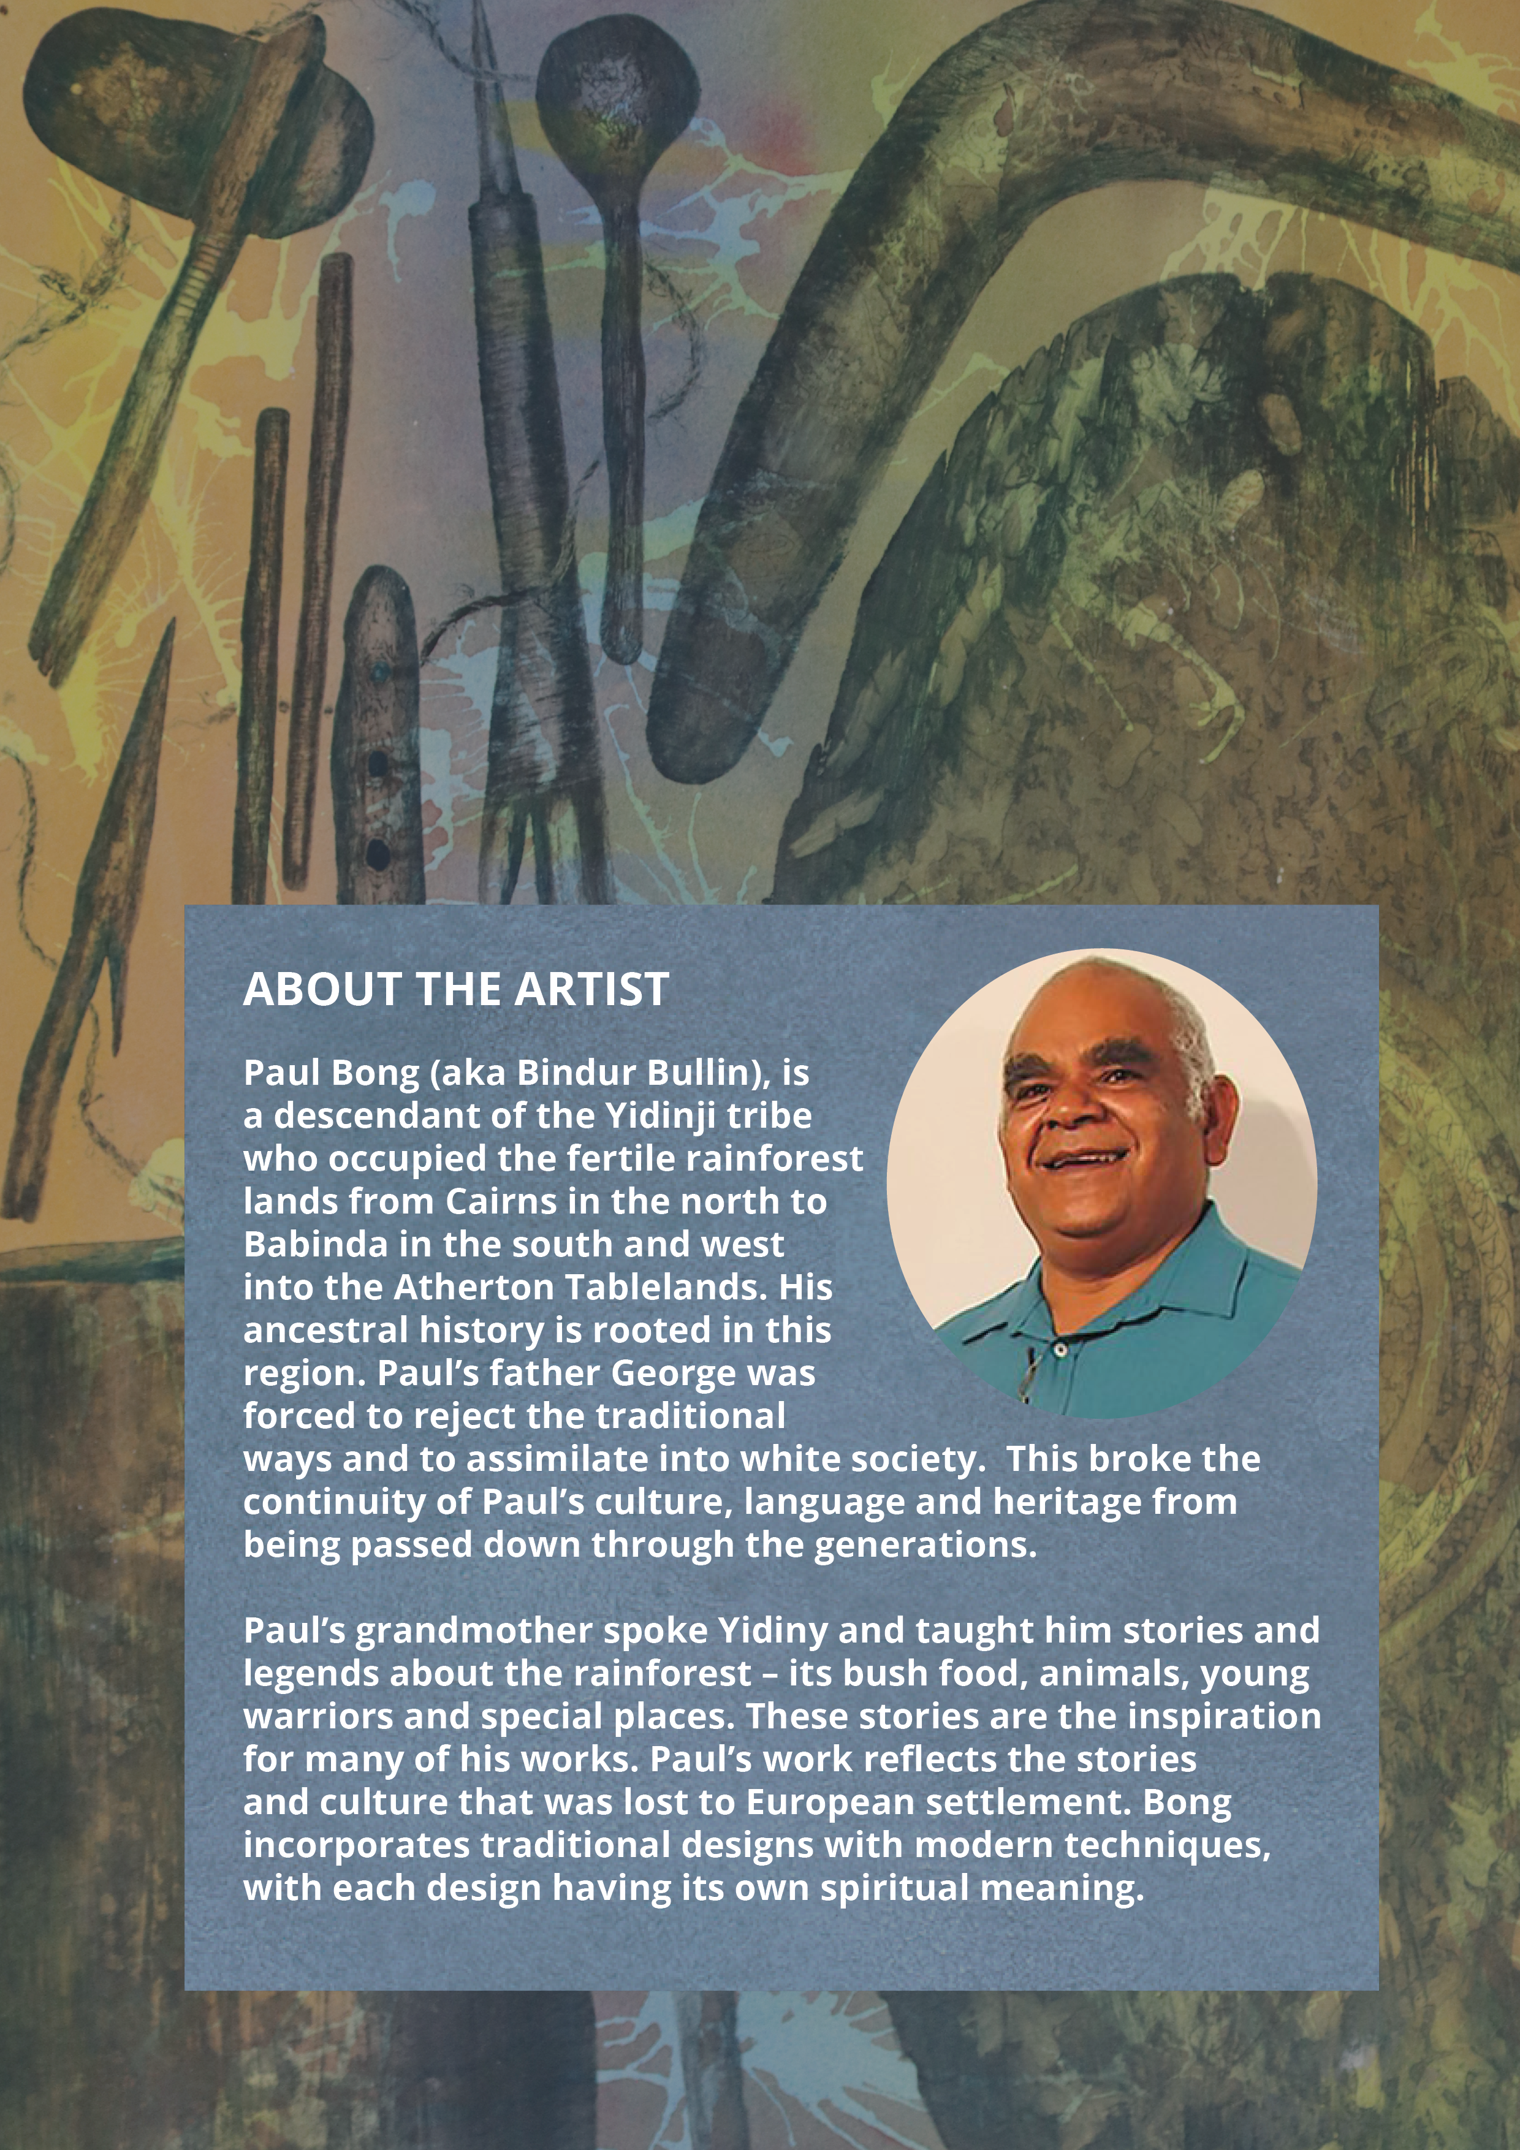

Appendix

International examples detailed in the ‘Indigenous rights and the Voice’ section of this document are not without issue or controversy. To learn more, please visit:
- Treaties, agreements and other constructive arrangements, including peace accords and reconciliation initiatives, and their constitutional recognition - Study of the United Nations Expert Mechanism on the Rights of Indigenous Peoples (2022)
- Effect of Māori seats: Uneven representation, official neglect and racial segregation, Ngā māngai, Te Ara – the Encyclopedia of New Zealand (2016)
- Differences between English and Māori texts of the Treaty of Waitangi – Nga korero a ipurangi o Aotearoa [New Zealand History] (2021)
- Co-management of protected areas to alleviate conservation conflicts: experiences in Norway, Gunn Elin Fedreheim and Esther Blanco, International Journal of the Commons, Vol.11, No. 2 (2017) pp. 754-773
- The promises and challenges of indigenous self-determination: The Sami case, Else Grete Broderstad, International Journal Vol. 66, No. 4 (2011) pp. 893-907
- Procedures for Consultations between State Authorities and The Sami Parliament [Norway], Ministry of Local Government and Regional Development Norway (2018)
- UNDRIP and the 2009 Bolivian Constitution: Lessons for Canada Roberta Rice, Centre for International Governance Innovation (2014)
- A comparative analysis of constitutional recognition of Aboriginal peoples – Dr Ben Gussen, Melbourne University Law Review Vol 40, No. 4 (2017) pp. 867-904

Please note, the Commission has used both in-text hyperlinks and endnotes when referencing sources throughout this document, to promote accessibility and further research, whilst acknowledging the original authors. We encourage readers to further explore the resources listed below:

Australian Human Rights Commission, ‘Support for Uluru Statement from the Heart’ (Web Page 15/03/2023).
Aunty Dulcie Flower OAM, ‘A pathway to wellbeing through Cultural Safety and Cultural Humility’, Croakey Health Media (Web Page, 2022).
The Lowitja Institute, ‘Deficit Discourse and Aboriginal and Torres Strait Islander Health Policy Summary Report’, (May 2018) 3.
Robert Gottliebsen, ‘Backyard native title is no joke’ The Australian Financial Review (5 May 1997).
United Nations Declaration on the Rights of Indigenous Peoples, GA Res 61/295, UN GAOR, 61st sess, 107th plen mtg, Agenda Item 68, Supp No 49, UN Doc A/RES/61/295 (2 October 2007).
José Martínez Cobo, ‘Study of the Problem of Discrimination Against Indigenous Populations’ (1981) (Web Page 2023).
The New Zealand Wars, ‘The Treaty of Waitangi’ (Web Page 2023).
Waitangi Tribunal, ‘About the Waitangi Tribunal’ (Web Page 2023).
New Zealand History, ‘Māori and the vote’ (Web Page 2023).
New Zealand Legislation, ‘Local Government Act 2002’, (Web Page 2023).
Government of Norway/Regjeringen, ‘The Sámi Act’ (Web Page 2023).
Sámediggi, ‘About the Sámi Parliament’ (Web Page 2023).
Gunn Elin Fedreheim and Esther Blanco, ‘Co-management of protected areas to alleviate conservation conflicts: experiences in Norway’ (2017) 11(2) International Journal of the Commons 754 (Web Page 2023).
Roberta Rice, UNDRIP and the 2009 Bolivian Constitution: Lessons for Canada (The Internationalization of Indigenous rights: UNDRIP in the Canadian Context, Centre for International Governance Innovation, January 2014) 59-64 (Web Page 2023).
Constitución Política del Estado [Constitution] (Bolivia) 2009 [tr Constitute Project] (Web Page 2023).
Rachael Knowles, ’What was the Cummeragunja Walk-Off?’, NITV (4 February 2022).
National Museum of Australia, William Cooper Protests (Web Page 2023).
National Archives of Australia, William Cooper Petition (Cabinet Paper) 1938 (Web Page 2023).
National Museum Australia, William Cooper protests (Web Page 2023).
Torres Strait Islander Act of 1939 (Qld), as repealed by Aborigines' and Torres Strait Islanders' Affairs Act 1965 (Qld) (Web Page 2023).
National Archives of Australia, William Cooper ’Day of Mourning’ Letter 1938 (Web Page 2023).
National Museum Australia, Defining Moments: Day of Mourning (Web Page 2023).
National Museum Australia, Defining Moments: Yirrkala Bark Petitions (Web Page 2023).
AIATSIS, 1965 Freedom Ride (Web Page 2023); Charles Perkins, A Bastard Like Me (URE Sydney, 1975).
Professor Bronwyn Carlson and Lynda-June Coe, A Short History of the Aboriginal Embassy - An Indelible Reminder of Unceded Sovereignty (24 March 2022) The Museum of Australian Democracy at Old Parliament House; National Museum of Australia, Defining Moments: Aboriginal Tent Embassy.
Ibid.
National Archives of Australia, Aboriginal Land Rights Protest (Web Page 2023).
AIATSIS, The Barunga Statement (Web Page 2023).
Dani Larkin et al, Aboriginal and Torres Strait Islander Peoples, Law Reform and the Return on the States (11 May 2022) Indigenous Constitutional Law; Kinglsey Palmer, ‘ATSIC: Origins and Issues for the Future. A Critical Review of Public Domain Research and Other Materials’ (Research Discussion Paper No 12/2004, Australian Institute of Aboriginal and Torres Strait Islander Studies, 2004).
Larissa Behrendt, ‘The abolition of ATSIC – Implications for democracy’, Democratic Audit of Australia – November 2005, 1 (Web Page, 2023).
John Hannaford, Jackie Huggins, and Bob Collins, ‘In the Hands of the Regions - A New ATSIC Report of the Review of the Aboriginal and Torres Strait Islander Commission’, Australian Indigenous Law Reporter, Vol. 8 No. 3 pp. 105-112 (November 2003).
Mabo v Queensland (1988) 166 CLR 186; Mabo v Queensland [No. 2] (1992) 175 CLR 1.
Torres Strait Regional Authority, Section Two: About the TSRA.
Australian Human Rights Commission, Wiyi Yani U Thangani (Women’s Voices): Securing Our Rights, Securing Our Future Report (Report, 2020) 86.
Australian Human Rights Commission, Bringing them Home: Report of the National Inquiry into the Separation of Aboriginal and Torres Strait Islander Children from their Families (Report, April 1997).
SNAICC – National Voice for our Children, the Family Matters Campaign, Monash University and the University of Technology Sydney, The Family Matters Report 2022 (Report, 2022).
Bronwyn Carlson, 'National Sorry Day is a day to commemorate those taken. But ‘sorry’ is not enough – we need action', The Conversation (online, 26 May 2022).
United Nations Declaration on the Rights of Indigenous Peoples, GA Res 61/295, UN GAOR, 61st sess, 107th plen mtg, Agenda Item 68, Supp No 49, UN Doc A/RES/61/295 (2 October 2007).
ANTAR, UNDRIP in Australia (16 December 2022).
James Haughton, Former Aboriginal and Torres Strait Islander Australian Government representative and advisory bodies: a quick guide (16 June 2023) Parliament of Australia.
Commonwealth, Parliamentary Debates, Senate, 15 February 2017, 18 Indigenous Australians – Redfern Statement (James McGrath, Assistant Minister to the Prime Minister).
‘Uluru Statement: a quick guide’, Parliament of Australia (Web Page 2023).
International Covenant on Civil and Political Rights, 999 UNTS 171, 16 December 1966 (entered into force 23 March 1976), Art. 1; International Covenant on Economic, Social and Cultural Rights, 993 UNTS 3, 16 December 1966 (entered into force 3 January 1976), Art. 1.
James Anaya, Indigenous Peoples in International Law (Oxford University Press, 1996) 77.
United Nations Declaration on the Rights of Indigenous Peoples, GA Res 61/295, UN GAOR, 61st sess, 107th plen mtg, Agenda Item 68, Supp No 49, UN Doc A/RES/61/295 (2 October 2007).
Asia Pacific Forum of National Human Rights Institutions and the Office of the United Nations High Commissioner for Human Rights, The United Declaration on the Rights of Indigenous Peoples: A Manual for Human Rights Institutions (August 2013) 19.
Australian Human Rights Commission, Social Justice Report 2002: Self-determination - the freedom to 'live well' (Report, December 2002).
United Nations Declaration on the Rights of Indigenous Peoples (n iii) art 46.
Nathan mudyi Sentance, ‘Genocide in Australia’, Australian Museum (Web Page 2022).
ABC News, What was the Northern Territory Emergency Response, better known in Indigenous Communities as The Intervention? (29 January 2023).
‘Our History and Future’, Aboriginal Medical Services Redfern (Web Page 2023).
Kathryn S Panaretto et al, 'Aboriginal community controlled health services: leading the way in primary health care' (2014) 200 (11) The Medical Journal of Australia, 649-652.
‘Aboriginal Community Controlled Health Organisations (ACCHOs)’, NACCHO (Web Page 2023).
Human Rights (Parliamentary Scrutiny) Act 2011 (Cth), s 7(a).
Parliamentary Joint Committee on Human Rights, Human rights scrutiny report, Report 5 of 2023 (9 May 2023) 11–19.
Committee on the Elimination of Racial Discrimination, Concluding observations on the eighteenth to twentieth periodic reports of Australia, 2597 mtg, CERD/C/AUS/18-20 (26 December 2017) pt C para 7.
Human Rights Committee, Concluding observations on the sixth periodic report of Australia, 3418-9th mtg, CCPR/C/AUS/CO/6 (1 December 2017) 15.
Committee on Economic, Social and Cultural Rights, Concluding observations on the fifth periodic report of Australia, 14-15th mtg, E/C.12/AUS/CO/5 (11 July 2017) 49.
Ibid [107](a).
‘The Uluru Statement from the Heart’, The Voice (Web Page, 2023).
‘Understanding the Constitution’, The Australian Electoral Commission (Web Page, 2023).
‘Voice: A History of Representation’, ANTAR, Background report (Web Page 2023).
June Oscar AO, ‘Sir Wallce Kyle Oration’ (Speech, 22 August 2022).

