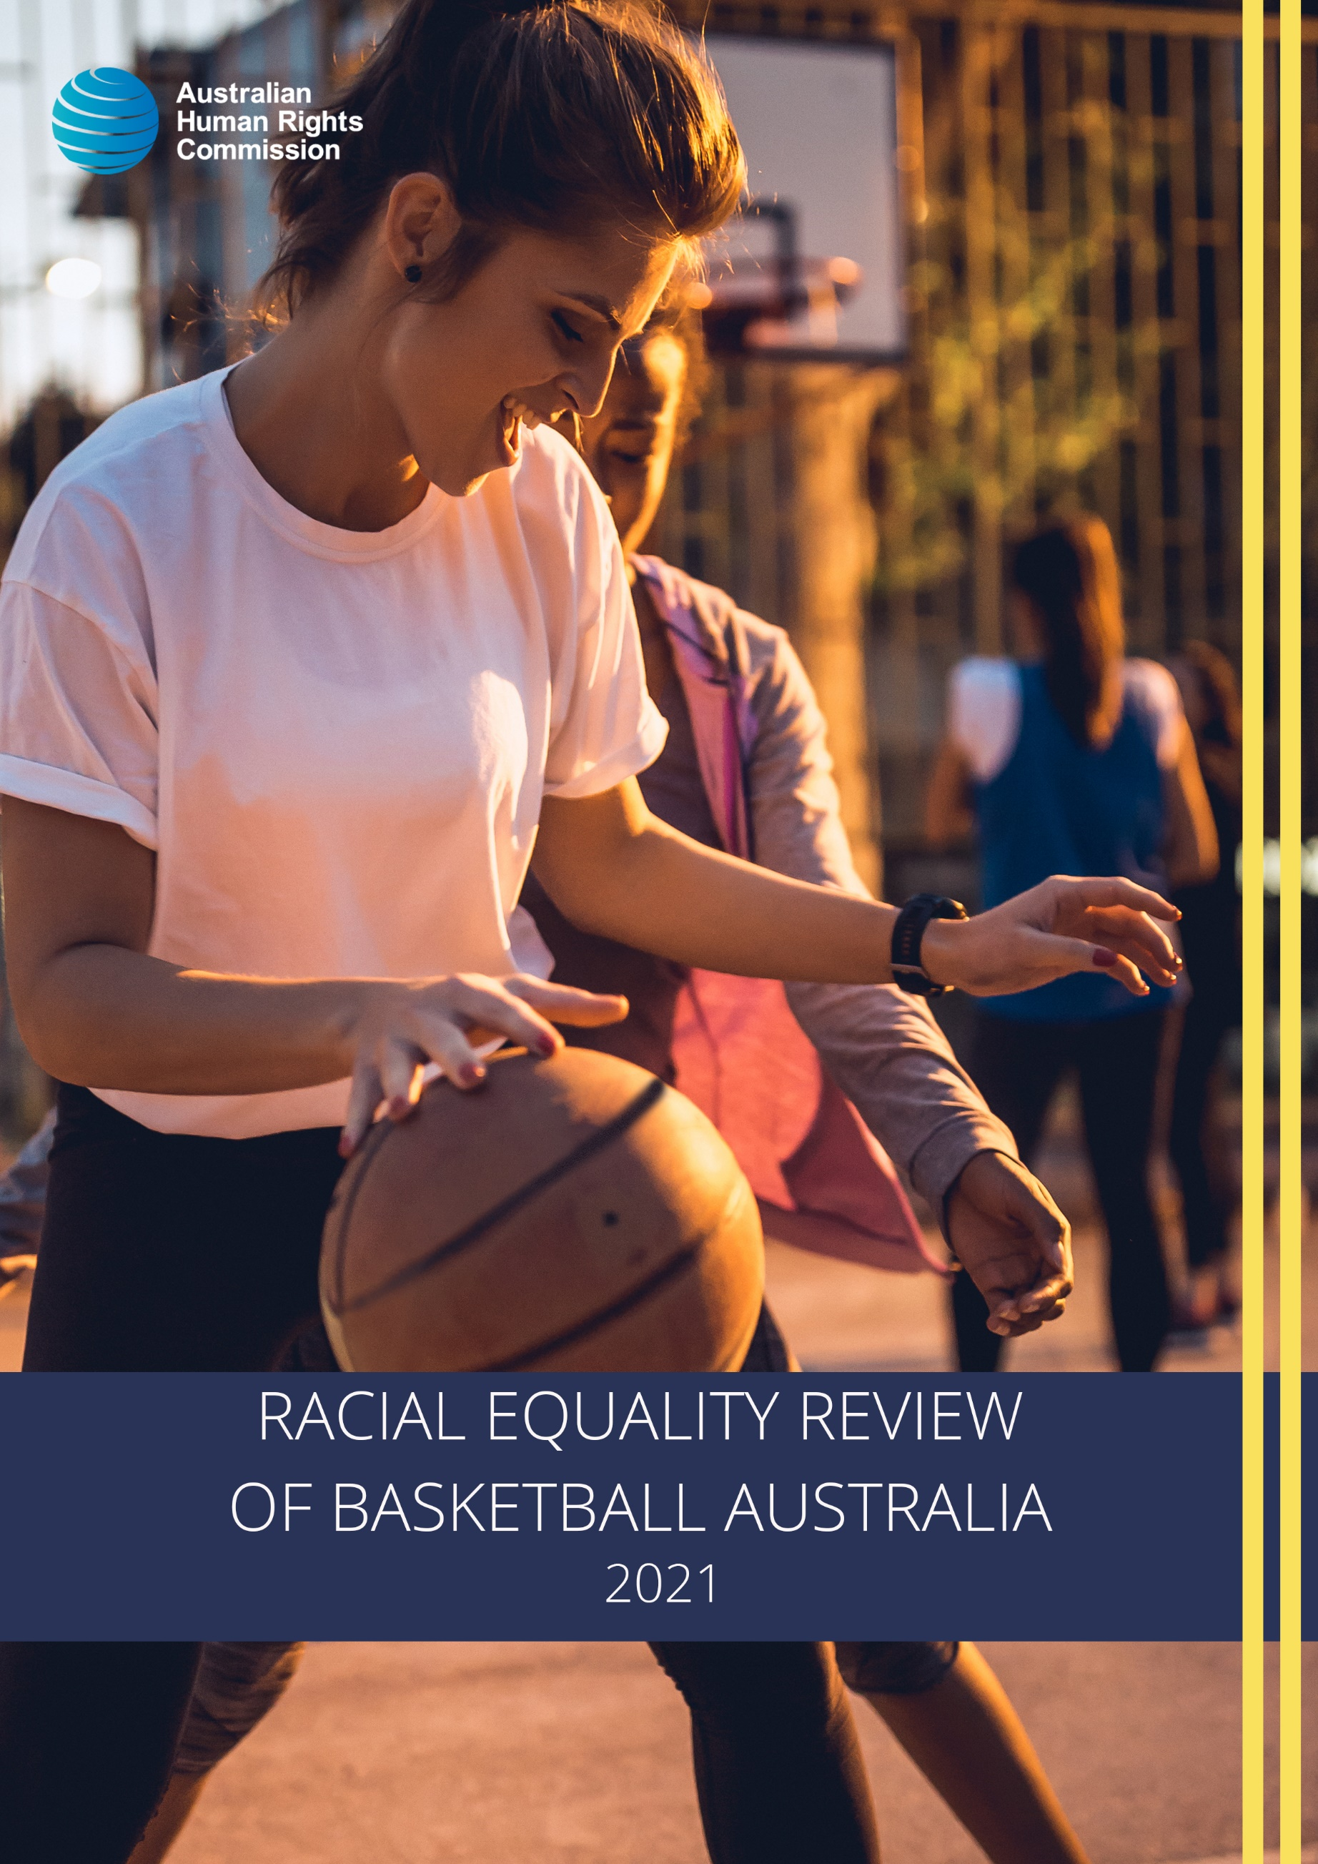
© Australian Human Rights Commission 2021.
The Australian Human Rights Commission encourages the dissemination and exchange of information presented in this publication and endorses the use of the Australian Governments Open Access and Licensing Framework (AusGOAL).
All material presented in this publication is licensed under the Creative Commons Attribution 4.0 International Licence, with the exception of:
- photographs and images
- the Commission’s logo, any branding or trademarks
- where otherwise indicated.
To view a copy of this licence, visit https://creativecommons.org/licenses/by/4.0/legalcode.
In essence, you are free to copy, communicate and adapt the publication, as long as you attribute the Australian Human Rights Commission and abide by the other licence terms.
Please give attribution to: © Australian Human Rights Commission 2021.
Racial Equality Review of Basketball Australia 2021
ISBN: 978-1-925917-29-1
Acknowledgements
Review Team: Nevo Rom, Olivia Aitken and Gabriela Sanchez.
Other Commission Staff: Maria Twomey, Natasha de Silva, Samantha Turner, Catherine Duff, Gillian Eshman, Leon Wild, Partha Bapari and Laura Tebb.
The Commission is grateful to all individuals that participated in the Commission’s consultations.
This publication can be found in electronic format on the Australian Human Rights Commission’s website at https://humanrights.gov.au/about/publications.
For further information about the Australian Human Rights Commission or copyright in this publication, please contact:
Australian Human Rights Commission
GPO Box 5218, SYDNEY NSW 2001
Telephone: (02) 9284 9600
Email: communications@humanrights.gov.au
Design and layout: Australian Human Rights Commission
Cover image: iStock
Internal photography: iStock

Racial Equality Review of Basketball Australia

Australian Human Rights Commission 2021

CONTENTS
Executive summary 7
Focus area one: Leadership and governance 7
Focus area two: Cultural safety and inclusion 8
Focus area three: Pathways for progression 8
Recommendations 9
Introduction 12
Review purpose 12
Methodology 12
Qualitative data 13
Limitations 14
Racial discrimination, equality and inclusion in sport 15
The power of sport and benefits of inclusion 16
Focus area one: Leadership and governance 17
A cultural snapshot 17
Inclusive leadership 18
Diversity in leadership 20
Recommendations 22
Focus area two: Cultural safety and inclusion 25
From everyday racism to everyday respect 25
Cultural awareness and sensitivity 27
Communication and consultation 28
Recommendations 29
Focus area three: Pathways for progression 33
Support, pathways and accessibility for national players 33
Diversity in supporting and professional roles 36
Recommendations 38
Recommendations 42
Further Information 48

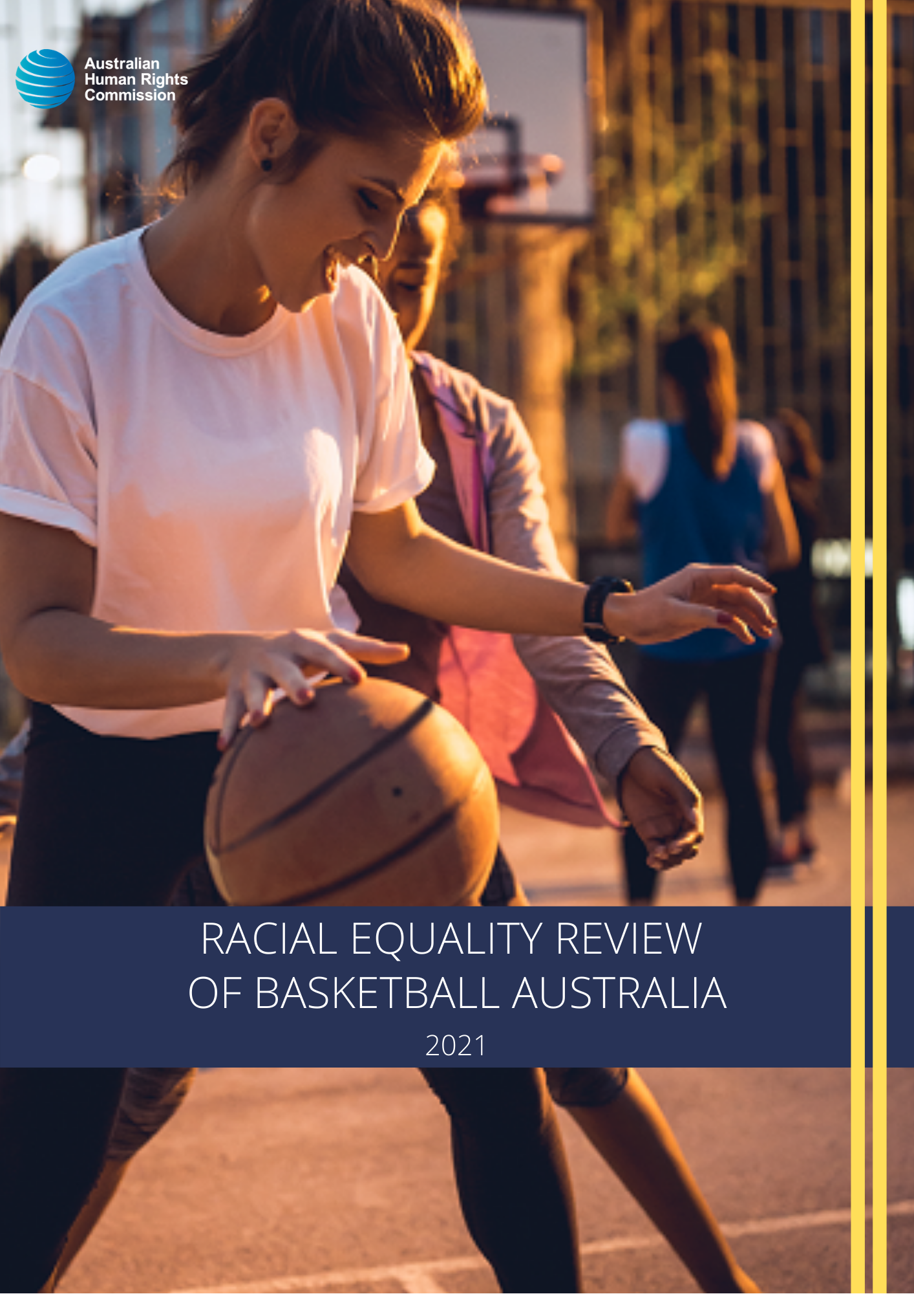
Executive summary
In August 2020, the Australian Human Rights Commission (the Commission) was engaged by Basketball Australia to undertake an independent Racial Equality Review (‘the Review’) of the sport at a national level.
The request for the Commission to conduct the Review was made against the backdrop of global protests and calls for racial justice through the Black Lives Matter movement. In response to these global events members of Australia’s basketball community reached out to Basketball Australia to examine its own position with respect to racial equality in the sport.
This Review builds on and draws upon the Commission’s extensive experience in conducting cultural reviews of various organisations, as well as the Commission’s work on human rights and sport.
In conducting the Review, the Commission sought to engage with current and former national players and their families, coaches, administrators, and Basketball Australia staff by way of interviews, focus groups and written submissions. The Commission also undertook a ‘desktop audit’ of Basketball Australia’s relevant policies and procedures. The purpose of this engagement and audit was to examine and report on:
- Existing structural barriers to achieving racial equality within organisational policies, pathways, programs, leagues, governance, and culture within Basketball Australia
- The experiences of current and former national players and their families, coaches, administrators, and Basketball Australia staff about the organisational culture at Basketball Australia, in particular as it relates to racial equality.
This report outlines the Commission’s key findings, highlights international and domestic examples of good practice, and makes 12 recommendations for action and reform under three focus areas.

Focus area one: Leadership and governance
The Commission commends the steps recently taken by Basketball Australia to improve the inclusivity of the sport and the organisation. However, the Commission heard from a number of participants that the culture at Basketball Australia can sometimes be exclusionary, and that progress can depend on ‘who you know’.
Basketball Australia has an opportunity to boost inclusive leadership capabilities to enable a culture where national players and staff from all ethnic and cultural backgrounds feel welcome and supported. This report recommends that Basketball Australia take proactive steps to enhance these capabilities including by developing individual action plans for all coaches and leaders.
The Commission also heard from participants that Basketball Australia could better represent Australia’s diversity across their leadership positions. This report recommends the review of current Board selection processes and the introduction of targets for Board composition to encourage greater representation of Aboriginal and/or Torres Strait Islander peoples and people from racial, ethnic, and/or ethno-religious minority groups.

Focus area two: Cultural safety and inclusion
Throughout the Review, the Commission heard about experiences of everyday racism, and a need to build a culture of everyday respect where racism, homophobia, sexism, and ableism are acknowledged, recognised, and not tolerated.
In addition to targeted training for leaders on fostering an inclusive culture, the Commission recommends Basketball Australia implement strategies to enable positive and inclusive interaction between all employees and national players from different backgrounds, as well as providing ongoing specific anti-racism and cultural awareness training to national players, coaches, and other staff across Basketball Australia. The Commission also recommends that all future policies, resources, programs, and training be developed in consultation with community, staff, and national players, and that there are safe and appropriate pathways for providing feedback.

Focus area three: Pathways for progression
While the cultural diversity of the national teams is increasing, some participants noted that Aboriginal and/or Torres Strait Islander national players and national players from racial, ethnic, and/or ethno-religious minority groups do not always receive the support necessary to thrive in the sport or to progress their careers at the national level beyond playing basketball. The Commission also heard that some Aboriginal and/or Torres Strait Islander national players and national players from racial, ethnic, and/or ethno-religious minority groups did not feel welcomed or supported to take up on and off-court roles at Basketball Australia.
The Commission recommends that Basketball Australia introduce targeted scholarships for national players from underrepresented groups and work with communities to develop clearer pathways to ensure equitable access to advancement opportunities. The Commission also recommends that Basketball Australia take active steps to increase the diversity of the organisation, including by reviewing all recruitment and promotion policies to ensure they are free from bias.

Recommendations
The cultural challenges identified throughout this Review are not unique to Basketball Australia—many sporting codes, nationally and internationally, have much to improve to ensure their cultures are inclusive for all.
The findings and recommendations of this Review are a call to action for Basketball Australia to improve its culture and create an organisation where everyone—national players, coaches and all staff and other personnel can grow, develop, progress, and feel included. To support this work, the Commission has made 12 recommendations that provide a blueprint for inclusion that can be applied at all levels of the sport. The recommendations include:
- Establishment of targets to diversify Board membership and broader recruitment and selection
- Embedment of racial equality in all policies and education
- Delivery of regular anti-racism and cultural awareness training
- Ongoing consultation with community, staff, and national players, particularly Aboriginal and/or Torres Strait Islander peoples and people from racial, ethnic, and/or ethno-religious minority groups
- Opportunities and pathways for Aboriginal and/or Torres Strait Islander national players and national players from people from racial, ethnic, and/or ethno-religious minority groups to progress through the sport on and off the court.
It is recognised that there are a number of operational and organisational factors that must be considered by Basketball Australia in the implementation of the 12 recommendations. This includes delivering and driving consistent messaging and change within a federated model. These considerations are not explored in this report.
Finally, it should be noted that racial equality alone will not result in making basketball an inclusive sport and the recommendations should be considered and implemented in conjunction with broader diversity and inclusion efforts. This is critical, as the effects of exclusion can be compounded when race intersects with other characteristics such as gender, sexual orientation, disability, or socio-economic status.

Introduction

Review purpose
The purpose of the Review was to conduct an independent assessment of Basketball Australia’s current efforts to achieve racial equality within the organisation and the sport more broadly. The Review examined:
- Structural barriers to achieving racial equality within organisational policies, pathways, programs, leagues, governance, and culture within Basketball Australia
- The organisational culture of Basketball Australia, particularly regarding racial equality, by hearing from current and former national players and their families, coaches, administrators, and Basketball Australia staff about their experiences.
This report provides an overview of current experiences and practice and makes recommendations for change. It is intended to guide Basketball Australia in implementing both current and ongoing policy development and practice.
Individual allegations of racial discrimination or racial vilification were not investigated or reported on as part of the Review.

Methodology
The Review was undertaken between August and December 2020. The Review was conducted using qualitative research methods. All participation was voluntary, and all data was treated as confidential. The Review was exclusively promoted by Basketball Australia through their channels. Basketball Australia also identified relevant stakeholders and participants and contacted them directly to invite them to participate in the Review.
As the scope of the Review was limited to the national level, the Commission sought to engage with current and former national players and their families, coaches, administrators, and Basketball Australia staff. Chief Executive Officers from State and Territory Associations were also engaged to provide a more comprehensive understanding of the federated nature of the sport and to identify any ‘pipeline’ issues that may be preventing player and staff progression and selection at a national level.

Qualitative data
Submissions
The Commission invited written submissions via its website over a period of 12 weeks from August to October 2020. The online submission form included targeted questions relating to the culture of Basketball Australia and the national teams, as well as specific questions on diversity and inclusion, and relevant Basketball Australia policies. Supplementary information or a separate submission could also be attached. All questions were voluntary, and submissions could be made anonymously.
The Commission received 21 submissions from current and former national players, coaches, and family members of national players.
Interviews and focus group
In November 2020, the Commission facilitated five semi-structured interviews, and one focus group. Participants in the interviews and focus group included Basketball Australia staff and other relevant personnel and Chief Executive Officers from State and Territory Associations. Both the interviews and focus group examined individual experiences and views of team and organisational culture at Basketball Australia; attitudes towards diversity and inclusion, particularly racial equality; structural barriers; and existing relevant policies and procedures.
The interviews and focus group were conducted via video conference due to physical distancing requirements as a result of the COVID-19 pandemic and the varied locations of participants.
Desktop audit
The Commission completed a high-level review of corporate policies, protocols, and governance structures relating to racial equality and inclusion at the national level from 2015. This included:
- Policies, protocols, and procedures relating to athlete and staff experience
- Education strategies, programs, and resources
- Information and documentation relevant to reporting and complaints handling frameworks and processes
- Information and documentation on governance and accountability structures relevant to athlete and staff experience
- Final and interim reports from any past reviews undertaken into the culture of Basketball Australia at the national level, as it pertains to athlete experience.
The purpose of the audit was to identify any gaps in policies, and to gain an understanding of how and to what extent practical implementation of the policies occur.
The Commission also reviewed literature on racism and racial equality in sport; and diversity and inclusion frameworks and policies across sporting codes internationally to inform the analysis and recommendations.

Limitations
While the sample of participants in the Review was varied and included current and former national players and their families, coaches, Basketball Australia staff and other relevant personnel, the population group invited to take part in the Review was of a relatively limited size, and of that group, uptake in participation was relatively low. Accordingly, the small sample size means that the feedback drawn upon and reflected in this report cannot be considered representative of the experiences of any relevant cohort—national players, coaches, or staff. Further, given the focus on the national level, the Commission recognises that the report does not explore the potential systemic barriers to player progression to the national level from club and state levels in great detail.
While it is difficult to know the precise reasons for the limited engagement, the Commission considers that contributing factors may include: the impacts of the COVID-19 pandemic; a lack of external public promotion; a lack of interest in the topic by the basketball community or no concerns about racial equality in basketball; apprehension regarding privacy and/or anonymity due to the invitations to participate being facilitated through Basketball Australia; that many of the men’s national team members were located overseas during the period of the Review; and that many of the women’s national team members were engaged in competition during the period of the Review.

Racial discrimination, equality and inclusion in sport
Racism remains an ongoing problem in Australia and is not limited to sport, with approximately one in five Australians in 2018 reporting experiences of racism within the previous 12 months.
Racial discrimination and racism can take many forms and remain uncomfortable terms for some. At an interpersonal level, racism can manifest in jokes or comments that cause offence and hurt, name-calling or verbal abuse; harassment or intimidation; and acts of physical abuse and violence.
Racism and racial discrimination can also occur at a systemic level, and directly or indirectly exclude people from accessing services or participating in employment, education, and sport as a result of policies, conditions or practices that disadvantage certain groups and perpetuate inequalities in access to power, resources and opportunities. In some cases, treating everyone in the same way may further benefit or disadvantage particular groups.
Australia has federal laws that protect people from racial discrimination in many areas of public life, including in sport, employment and when accessing public places. The Racial Discrimination Act 1975 (Cth) (RDA) exists to ensure all people are treated equally, regardless of their race, colour, descent, national origin or ethnic origin, or immigrant status. The RDA also makes racial hatred unlawful. Further legislation exists in every state and territory and often provides additional protections.
Sporting organisations have a responsibility to respect fundamental human rights and legal obligations to take active steps to protect employees, athletes, and other members of the sporting community from discrimination and racial abuse and the harm that they cause.
For the purposes of this Review, racial equality within such a sporting context means actively valuing diversity and ensuring everyone, including athletes, coaches and officials, and other administration staff have equal opportunities and equal access to participate, regardless of race, the country in which they were born, their ethnic origin or their skin colour. All members of an organisation should be expected to contribute to an inclusive, non-discriminatory culture. Diversity policies and practices should be used as a tool to foster inclusion, rather than merely as a way to demonstrate inclusive culture.
An inclusive culture grounded in everyday respect will open opportunities for more people to participate and progress in basketball. It is essential for attracting and retaining talented national players, staff and other personnel and it can enable greater community engagement; increased sponsorship opportunities; better governance and risk management; increased public support and volunteer base; and better and more engaged national players.

The power of sport and benefits of inclusion
‘Basketball Australia can help make change because sport is a great vehicle where you can be inclusive and change lives very quickly.’
Sport is an integral part of Australian culture and can play an influential role in furthering the promotion and protection of human rights.
As an accessible and relatable vehicle for cultural change, sport can effectively contextualise rights and responsibilities for the broader public. Addressing racial inequality and prejudice in basketball, and in sporting codes more broadly, has the potential to influence the inclusivity of our society as a whole.
On an individual level, the benefits of an inclusive sporting culture can also be powerful. Many of the physical benefits of sport are uncontested. When these benefits are coupled with an inclusive environment, members of the sporting community can develop an increased understanding and appreciation of diversity and be better prepared for life in a more inclusive society.
In addition, for some, sport can also provide a pathway to improving the social and economic wellbeing of both the individual and their community.

Focus area one: Leadership and governance
This section of the report sets out the Review’s findings in relation to inclusive leadership and diversity in leadership and makes recommendations to improve the inclusivity of Basketball Australia from a leadership perspective.

A cultural snapshot
‘Basketball is a game for everyone and anyone’
Participants to the Review had differing views about the inclusiveness of the sport and of Basketball Australia as an organisation. Many spoke of a ‘strong’, ‘open’, ‘welcoming’, and ‘inclusive’ culture at the national level of the sport.
A number of participants who are or have been involved with the Women’s National Team, the Australian Opals, referred to the culture of their team as ‘inclusive’, ‘supportive’, ‘nurturing’, and referenced the contribution that the coaches had made in helping to foster this positive environment.
‘I believe our culture as the Australian Opals team is great, we are inclusive and supportive in as many ways as we can. But we can always be doing more to spread awareness’
Some participants also shared that the culture had improved over time, acknowledging the importance and impact of strong leadership.
‘[The culture of the sport] certainly has improved and all of my experiences have been positive.’
‘I think the current leaders in our sport have done a better job of including all cultures in our sport.’
However, a number of participants asserted that the culture of basketball at the national level and Basketball Australia ‘could and should be more inclusive’. The Commission heard that the organisational culture of Basketball Australia needs to improve and become more inclusive of people from all backgrounds, and that the organisation’s leadership should be representative of the players in the sport.
Building an inclusive culture requires commitment from all members of an organisation but particularly from those at the top. Leaders must demonstrate that cultural diversity and inclusion is a top priority and that they are willing to take strong and sustained action to make progress. Successful leaders in this area understand that there are both moral and strategic reasons for increasing inclusion and cultural diversity within their organisations and use both motivations to drive action.
A key challenge in enhancing organisational culture is that a lack of diversity amongst visible leaders can be both a symptom and a cause of a less inclusive organisation—and it can create a mutually reinforcing environment. It can be difficult to attract and retain talent from racial, ethnic, and/or ethno-religious minority groups if an organisation has not shown that it embraces diversity. Similarly, it is difficult for an organisation to demonstrate its inclusivity if it does not already have diversity amongst its leaders.

Inclusive leadership
To create meaningful and sustainable change, leaders at Basketball Australia must be dedicated to transforming good intention into good practice with an openness to acknowledging and better understanding some of the existing cultural issues. Participants noted that many of those involved with Basketball Australia, including senior leaders, have positive intentions to create an inclusive culture in the sport. There is a strong desire to learn and do better which is evidenced by the initiatives already underway such as the Diversity and Inclusion Framework.
‘I think [Basketball Australia] want to build a stronger culture to benefit everyone involved in basketball in this country. They are willing to listen to members of the national team for constructive criticism but I think support could be better for all individuals.’
Of note, participants shared that the sport and Basketball Australia often felt like a ‘white boys club’, a ‘mates club’ or a ‘basketball fraternity’ where Aboriginal and/or Torres Strait Islander people and members of racial, ethnic, and/or ethno-religious minority groups, and particularly women from these groups, did not see themselves represented or feel actively included.
‘I feel like it’s very white, male and … like an ‘old boys/girls’ club. Obviously a severe lack of diversity throughout different appointments whether it be at an administration level or coaching.’
‘I felt because of my race and not in the ‘basketball fraternity’ there was no need to investigate opportunities as I had seen evidence from the boys club that gave me no confidence to explore further.’
‘The culture of BA has always been one that has been very focused on ‘white boys club’ ties without much opportunity for others.’
Organisations that enable a ‘boys club’ to flourish normalise a culture of exclusion. Progression often depends on who you know and an affinity with those already in leadership. There is also the potential for judgements about leadership, including what type of person makes a good leader, to be informed by looking around at the existing people in senior positions. When one group or type of leadership style is over-represented, conclusions may be drawn that those types of people or a certain leadership style is what is needed to be successful. The criteria for filling leadership positions is often highly subjective and can be influenced by bias.
Further, those who are not part of ‘the club’ often do not feel that they fully belong or that they are ‘a valued part of’ the organisation. As O’Reilly and Banki (2016) note:
‘Social arenas that exclude certain employees because of their gender or race deny these employees important networking and career advancement opportunities and can detrimentally impact their perceived acceptance and value in their organization.’
While the focus of this Review is on racial equality, it is important to note that the effects of exclusion can be compounded when race intersects with other characteristics such as gender, sexual orientation, disability, and socio-economic status.
To respond to these challenges, leaders across the entire organisation must be seen to champion and demonstrate the imperative for change. This requires them to actively model the values and behaviours that ensure a healthy, safe and inclusive culture and to take authentic action to champion diversity within the organisation. Authentic leadership, and a willingness to approach problems with humility, is often critical to progress in this area.
“Basketball in Australia also cannot continue to exploit athletes by ignoring the communities they’ve come from. This seems short-sighted at the very least. It also can’t be on the shoulders of its’ superstars of colour … to lead the changes required.’
‘Let people in the basketball community know what the national teams stand for and also what [Basketball Australia] stands for.’
It is also essential that in any place where decisions are being made on behalf of or regarding a particular group, for example in the process to design programs to support Aboriginal and/or Torres Strait Islander players, there must be mechanisms to include and amplify the voices of members of that group in those processes, on top of any representation that might already exist within the decision-making structure.
‘You can’t have a boardroom full of old white men making decisions and thinking [they] know best for the Indigenous community.

Diversity in leadership
There is growing evidence that decision-making capabilities and results are improved by increasing diversity in leadership roles. Having diverse leadership also sends a powerful message to more junior members of an organisation, including players, that they belong.
Many Australian organisations across a range of sectors, however, do not reflect Australia’s diversity in their senior leadership ranks. Men, and especially women, from Aboriginal and Torres Strait Islander and non-Anglo communities have also been underrepresented in leadership and management positions throughout a range of sporting codes across Australia.
Some participants spoke to the Commission about the significant lack of diversity across the coaching, administrative and Board leadership roles within Basketball Australia.
‘Board, coaching, and Administrator roles are majority white, so if you are a young boy or girl [of colour] in Australia and want a career in Basketball that is not on the court as a player—there is no pathway for you to make this happen.’
‘From what I am aware, there is no cultural diversity on the board. This does not represent the Australian population. There are a number of [people of colour] in the men’s and women’s national team and obviously the board does not reflect this either!’’
‘The basketball community [should be] reflected in executive positions.’
Some participants raised concerns that the processes for appointing people to these roles was not always transparent and that there has not been a conscious effort to include, encourage or support Aboriginal and/or Torres Strait Islander people and members of racial, ethnic, and/or ethno-religious minorities to take up senior leadership roles.
‘it is not enough to have people Aboriginal and Torres Strait Islander or people of colour only in consulting roles when decisions are being made about their communities and participation, they must be in a position to make the decision and lead outcomes.’
International example: The Institute for Diversity and Ethics in Sport – Racial and Gender Report Card
Diversity and inclusion are key to the continued growth of sport around the world. Having an independent research body monitor and analyse practices holds sporting organisations accountable and responsible for their diversity initiatives and programs.
The Institute for Diversity and Ethics in Sport, at the University of Central Florida, undertakes an annual comprehensive analysis of the racial and gender hiring practices in most of the leading professional sporting organisations in the United States, including the National Basketball Association and the Women’s National Basketball Association. The report considers the composition—assessed by racial and gender make up—of players, coaches and front office/athletic department employees, indicating areas of improvement, stagnation, and regression.
The grading scale is updated to reflect America’s changing demographics and overall patterns in society. To get an A for race, the organisation needs to have 30 percent people of colour and to get an A for gender, 45 percent is needed.
Source: Richard E. Lapchick, ‘2019 Racial and Gender Report Card’ (2019) The Institute for Diversity and Ethics in Sport
It is crucial that the cultural diversity of the sport, and the broader Australian community, including Aboriginal and/or Torres Strait Islander peoples and racial, ethnic, and/or ethno-religious minority groups is represented at leadership and executive levels of Basketball Australia. As the Australian Sports Commission’s Sport Governance Principles highlight ‘the priority in board composition is building the best board, not assembling a group of the best individuals’. This will allow Basketball Australia to make informed decisions that speak to diverse communities and that consider different options, risks, and implications, as well as the complexities of racial inequality in Australia.
It will also enable Basketball Australia to create a more systematic approach that integrates cultural competence, particularly Aboriginal and Torres Strait Islander cultural competence, into policies and practices. This will ensure a coordinated approach to address issues, such as the lack of representation of Aboriginal and/or Torres Strait Islander peoples and people from racial, ethnic, and/or ethno-religious minority groups across Basketball Australia.
Increased diversity at the leadership level can also improve the ability to attract and retain talented athletes and staff (including administrative staff and across coaching and other on-court roles) at more junior levels. When members of an organisation see themselves reflected in the leadership ranks, this can improve their sense of ‘belonging’ to that organisation. Conversely, and as reflected at Basketball Australia, when cultural diversity is absent from leadership or the public face of the organisation, it can make members and potential members feel like it is not a space ‘for them’.

Recommendations
Senior leadership buy-in and visible continuous commitment is vital. Inclusive culture starts “at the top” and while inclusive behaviour should be expected from every individual involved at Basketball Australia, it must be led and modelled by the senior members of the organisation.
The leadership capability across all levels of Basketball Australia needs to be strengthened. Good leadership is required at all levels. This means that leaders model inclusive behaviours, including vulnerability, to encourage individuals to speak up; people from across Basketball Australia are empowered and enabled to provide ideas and solutions; and there is swift and visible accountability for inappropriate and disrespectful behaviour.

Recommendation 1: Enhance and accelerate inclusive leadership capability to ensure leaders understand and can appropriately respond to issues such as everyday racism, sexism, accessibility, disability, homophobia, and inclusive culture. This can be achieved through:
  - The development of individual development and action plans for every coach and leader
  - The provision of a holistic inclusive leadership curriculum for all management, leaders, coaches, and national players.
Recommendation 2: Introduce targets for Board composition and implement actions to include greater representation and retention of Aboriginal and/or Torres Strait Islander peoples and people from racial, ethnic, and/or ethno-religious minority groups, as articulated in the draft Diversity and Inclusion Framework. The first step should be reviewing the existing board selection process and inviting diverse Board Directors in 2021.

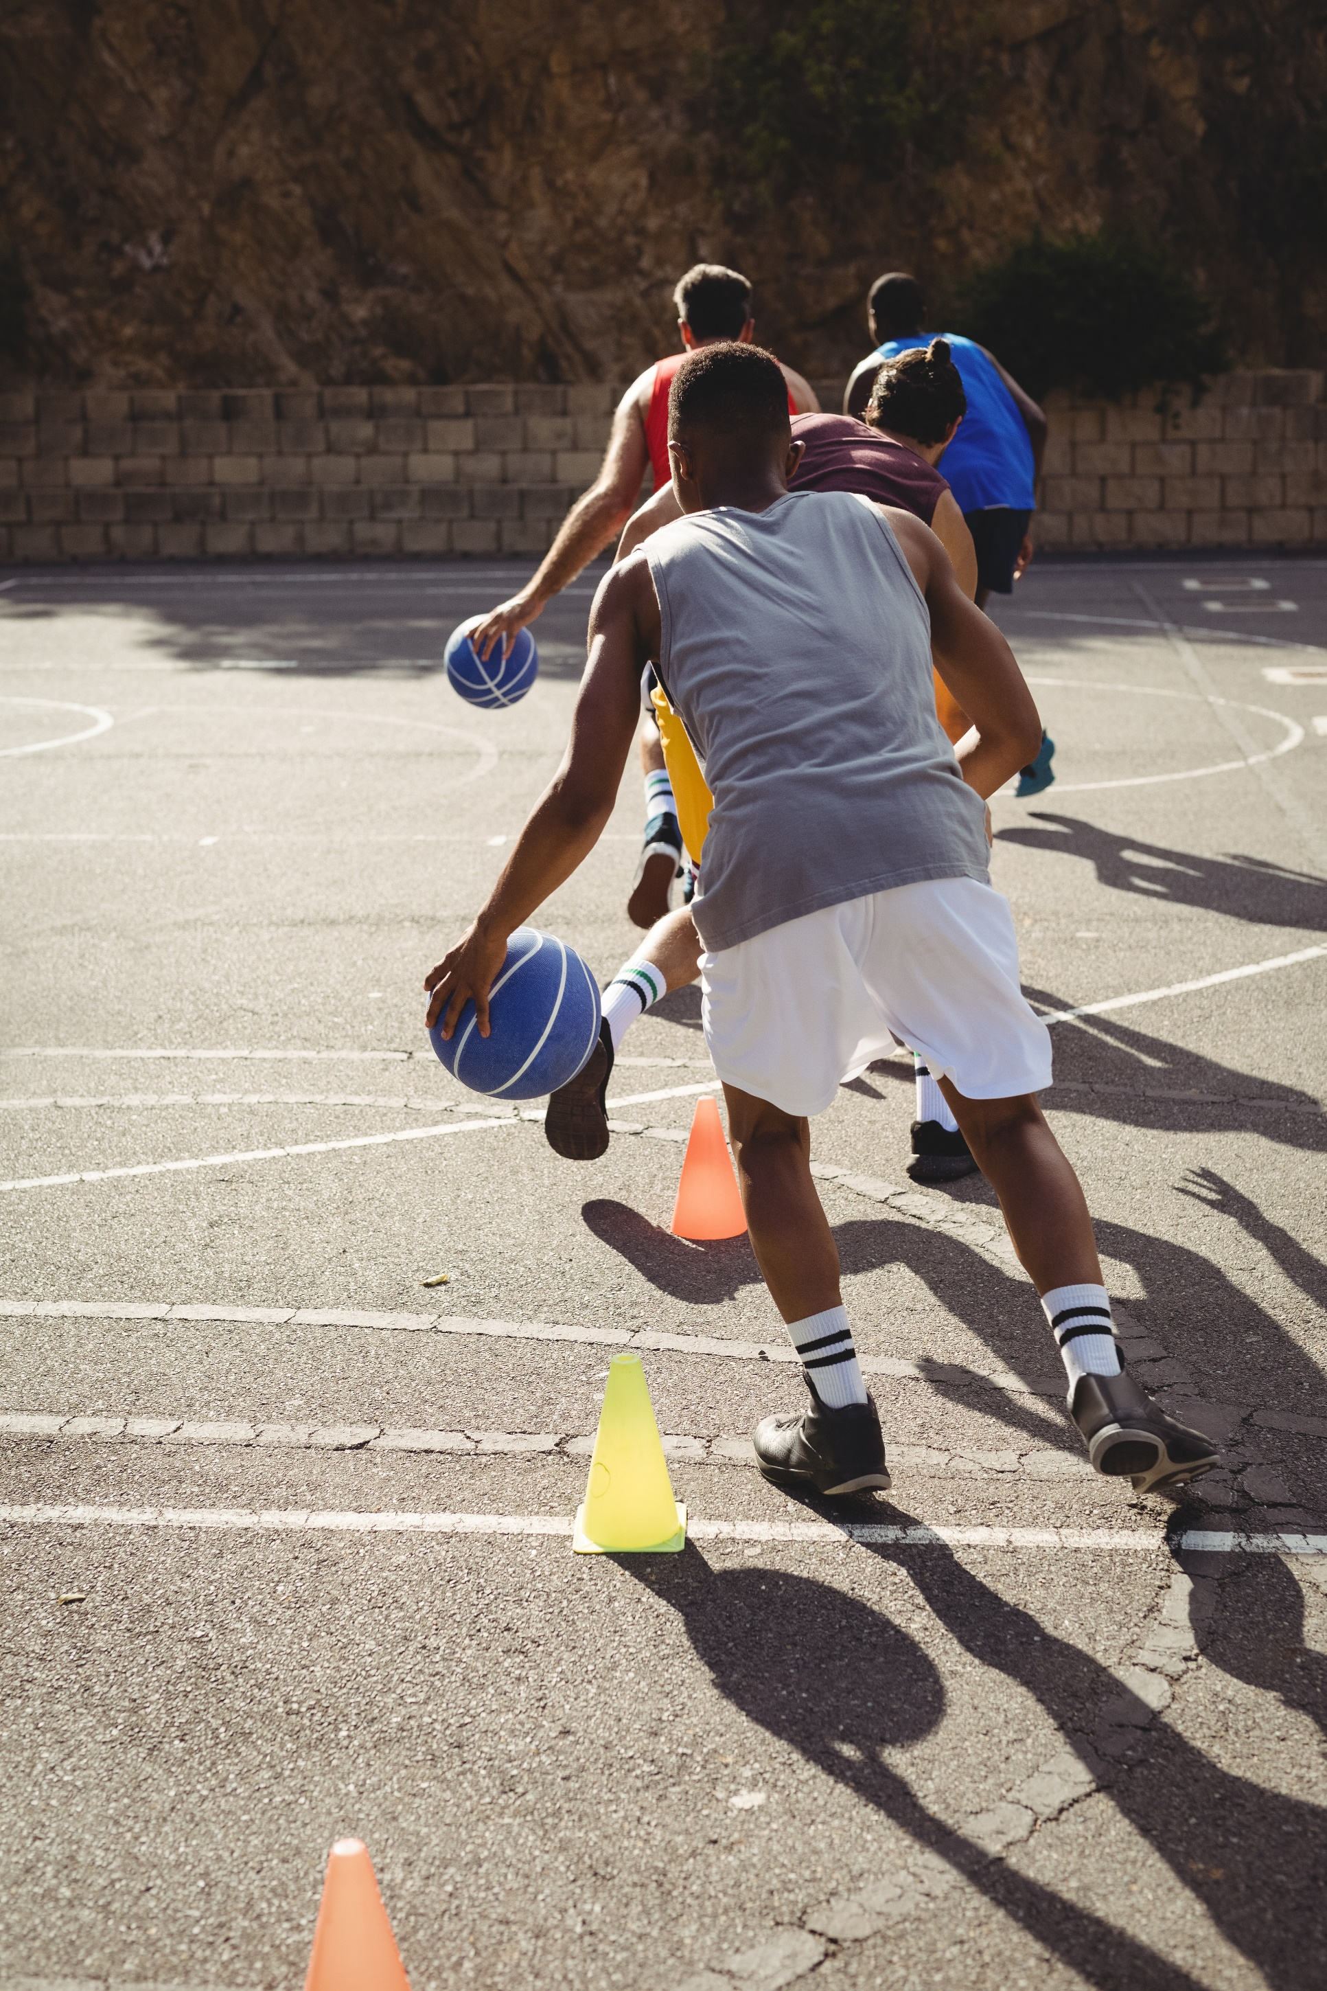

Focus area two: Cultural safety and inclusion
This section of the report sets out the Review’s findings in relation to cultural safety and inclusion and makes recommendations to improve the inclusivity of Basketball Australia.

From everyday racism to everyday respect
‘Because of my familiarity with the players, having competed against them for many years, the racism aspect had come and gone because, in my opinion, I had gained their respect. Should I have to had to gain that type of respect is another question.’
Some participants spoke of instances of everyday racism within the sport. Sometimes known as ‘casual racism’, everyday racism refers to the subtle forms of racist behaviour that may go unnoticed in everyday interactions. Everyday racism is commonly seen in daily conversations, through off-hand jokes and stereotypes or through gestures and expressions. While Basketball Australia’s Code of Conduct refers to the need to ‘refrain from any form of abuse, harassment or discrimination’, there is an opportunity to expand on what respectful behaviour is, and what is expected of everyone throughout the organisation.
Everyday racism can have serious impacts on people, including anxiety, depression, and low self-esteem. It can fuel further prejudice and discrimination, and it can lead others to form unfavourable impressions of those who make offensive jokes or comments. Participants spoke to the Commission about experiences of everyday racism on and off the court, including ‘microaggressions’ like mocking and racially insensitive comments.
‘[people would start] a derogatory comment with, "I know I shouldn't say this, but I am pissed off with those ________.’
Some participants linked these incidents to a broader culture where everyday respect could be improved—including specifically in relation to racism, homophobia, sexism, and ableism. Unless Basketball Australia builds a culture of everyday respect, policies, and initiatives to achieve diversity and inclusion will not deliver the progress required.
The Commission also heard that cultural awareness capacity could be improved across Basketball Australia and among all members of the national basketball community.
Some participants from racial, ethnic, and/or ethno-religious minority groups spoke of a general culture of exclusion, or of not being inherently accepted as part of the sport’s perceived culture of ‘mateship’ and needing to work harder than their peers to be respected.
International example: US Lacrosse
US Lacrosse has developed a framework to encourage and support club level organisations in becoming, not just culturally inclusive, but inclusive to all.
‘The goal for each program, chapter or league should be to become an organisation where diversity and inclusion are a fundamental part of the values and culture of the program. Bringing together varied life experiences and perspectives adds significant value to your community and reinforces the concept of inclusivity.’
The organisation has developed resources, practical guidance, toolkits and best practice strategies to assist organisations with ways to integrate inclusivity, accessibility, and cultural competency into programs.
In addition, the sporting organisation established the Native American Advisory Council in 2018 to better understand how it can best support sport growth and sustainability efforts in Native American communities.
Source: US Lacrosse, Diversity & Inclusion: <https://www.uslacrosse.org/diversity-inclusion>.

Everyone in Basketball Australia—coaches, national players, and staff—have a role to play in setting a tone of respect across the sport. This includes taking proactive steps to create a welcoming and supportive environment and having the knowledge, skills, and confidence to intervene when they see, hear of, or are made aware of racism, or other types of exclusion occurring. This type of intervention is often known as bystander or ‘upstander’ anti-racist action.

Cultural awareness and sensitivity
The Commission heard from participants that one of the barriers to the full inclusion of Aboriginal and/or Torres Strait Islander peoples and members of racial, ethnic, and/or ethno-religious minority groups is a lack of awareness and understanding amongst the national basketball community about racism, and how to respect the lived experiences of people from different racial and cultural backgrounds.
‘They are not bad people, rather, they are ignorant and stuck in their privilege...’
‘I still believe there is some level of unconscious bias in a lot of ways that we do have ingrained in our Australian culture, that we may or may not consider…as something that is racial.’
Basketball Australia does have some limited training offerings on cultural diversity awareness and ‘cultural safety’ within induction programs for national players across a number of specific high-performance environments, including the Australian Development Camps and National Training Camps and within the Australian Institute of Sport. There is also training provided to coaches, including in partnership with Timmy Duggan, Chief Executive Officer of Australian Aboriginal Basketball. The Commission considers that these could be consolidated and enhanced to provide consistency of message, more in-depth knowledge, and awareness of how to further develop inclusive environments and how to behave and call-out inappropriate behaviour and language.
One participant reflected on the importance of gaining awareness on racism and racial inequality within the sport and wider society.
‘I think there is so much work still to do. To be honest it wasn’t something I thought a lot about. It’s only recently I have realised the ongoing battles people face every day to feel included.’
Many called for increased acknowledgement amongst members of the national basketball community of the challenges to full inclusion within the sport and recommended cultural awareness training or education at all levels, including for national players, coaches, referees, administrators and leaders. Participants suggested that members of the basketball community hear ‘firsthand what people from different minorities go through everyday’ and learn more about:
- how to support Aboriginal and/or Torres Strait Islander peoples and members of racial, ethnic, and/or ethno-religious minority groups who are involved with the sport
- recognising and acknowledging biases, including issues associated with a ‘colour-blind’ approach
- racial injustice and racism.
‘Education, awareness, diversity, inclusion, and equity are key to making Basketball Australia more inclusive but WE have to stop thinking we are doing everything right and are not part of the problem.’
Providing training, in collaboration with Aboriginal and Torres Strait Islander peoples and people from racial, ethnic, and/or ethno-religious minority groups, to increase cultural awareness and improve communication on issues related to culture and race is a key strategy to progress towards an inclusive culture. Safe, welcoming and culturally appropriate sporting environments are fundamental to engaging people from racial, ethnic, and/or ethno-religious minority groups.

Communication and consultation
Clear communication and accessible avenues for consultation are also essential for building an inclusive culture. Genuine consultation empowers members of a community to contribute in a meaningful way to decisions, including the design of programs and policies. It enables them to have ownership of decisions that are made and can enhance their sense of belonging to an organisation. Where athletes do not feel they have a voice in decisions that are made, there is a risk that they do not feel they have opportunities to raise concerns about the sporting culture or issues that arise.
Basketball Australia appears to have few pathways and mechanisms for national players to provide input, feedback or to be consulted on organisational decisions.
‘Some of the leaders in the organisation seem to be really negative and also never inclusive of players in any decision making.’
‘The communication is not great and the administration is not held accountable which creates a bad culture that impacts players.’
Comments also indicated a broad lack of awareness of specific diversity and inclusion programs.
‘[S]ome of the Opals, I don’t even think they knew what programs Basketball Australia had. And if they didn’t know it means that they weren’t consulted. So why do we come up with policies and procedures for a group without having [consulted them].’
There is an opportunity to enhance engagement and communication across Basketball Australia to foster greater inclusion, awareness of programs and opportunities, and a sense of belonging for all. The NSW/ACT Australian Football League, for example, has developed a Multicultural Program, with the objective of creating stronger relationships with diverse communities, removing barriers to participation and developing new ways for people to engage with the game. The Program centres around awareness and training, engagement, participation and advocacy.

Recommendations
Creating a respectful, consultative environment that enhances and values two-way communication, will increase national player and staff engagement and buy-in to programs, policy, initiatives and overall cultural change.
Cultural awareness and inclusivity training and education needs to be embedded throughout all training consistently. Basketball Australia should consider strategies to encourage positive and inclusive interaction between employees and national players from different backgrounds, as well as providing ongoing specific anti-racism and cultural awareness training. The current training offerings can be adapted and enhanced to provide more in-depth knowledge and awareness of how to be a more inclusive leader, appropriate bystander action, and how to create safe environments for everyone to thrive.
The Commission endorses the Actions and Deliverables outlined in the Innovate RAP, including Acknowledgement of Country at all games, using Aboriginal and Torres Strait Islander artwork for jersey design, cultural learning opportunities, and improving supplier diversity. However, while these actions contribute to bringing about greater awareness and community engagement, there is an opportunity to further enhance and embed some of the Innovate RAP actions, to achieve meaningful and long-term change. This includes, comprehensive cultural education, with the currently proposed one-off workshop for new national players and staff not sufficient for driving lasting positive cultural change for Basketball Australia.
Further, while a number of policies exist relating to code of conduct, scouting and recruiting, and selection, Basketball Australia should ensure principles of racial equality are embedded in all to aid in their diversity and inclusion goals. Similarly, while there is significant emphasis on Aboriginal and/or Torres Strait Islander peoples throughout the Diversity and Inclusion Framework, it is also recommended that this be expanded to include those from racial, ethnic, and/or ethno-religious minority groups. Finally, resources for staff and national players, including a guidebook on building a positive culture should be developed.

Recommendation 3: Embed principles of racial equality into all policies and national player and staff education.
Recommendation 4: Enhance the current “Code of Conduct and Ethics” to be more inclusive and specifically call out exclusionary behaviour, racism, sexism, ableism, and homophobia.
Recommendation 5: Ensure the regular delivery of training and education to national players and employees on:
  - Anti-racism, including ‘bystander and upstander education to support employees to call out inappropriate behaviour
  - Cultural awareness
  - Bullying and harassment (especially as part of induction programs).
Recommendation 6: Ensure all future policies, resources, programs, training, and education are developed in consultation with community, staff and national players, particularly Aboriginal and/or Torres Strait Islander peoples and people from racial, ethnic, and/or ethno-religious minority groups with appropriate and safe pathways for feedback provided. The establishment of permanent governance structures to facilitate ongoing consultation with Aboriginal and/or Torres Strait Islander peoples and people from racial, ethnic, and/or ethno-religious minority groups should be considered.
Recommendation 7: Create a staff/national player guidebook that is clear and accessible and includes contextual support and assistance in relation to the creation of a positive culture.

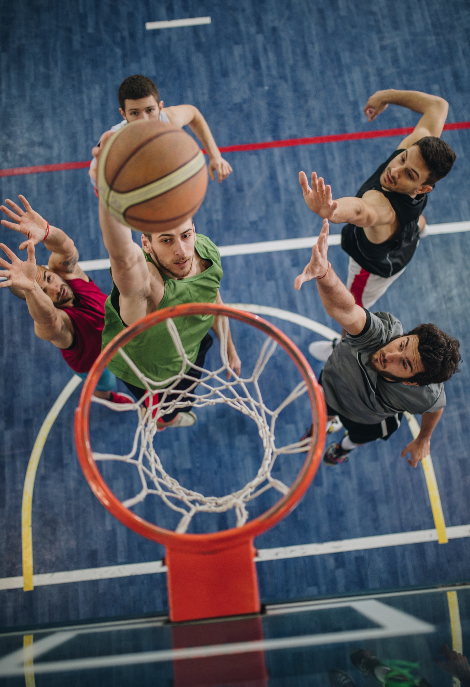

Focus area three: Pathways for progression
This section of the report sets out the Review’s findings in relation to pathways for progressions through the sport, both on and off the court, and makes recommendations in relation to addressing barriers to participation and progression for Aboriginal and/or Torres Strait Islander peoples, or people from racial, ethnic, and/or ethno-religious minority groups, and increasing opportunities for national players.

Support, pathways and accessibility for national players
Barriers to participation in sport for Aboriginal and/or Torres Strait Islander peoples or people from racial, ethnic, and/or ethno-religious minority groups are multi-faceted. Some participants noted that while the cultural diversity of the national teams has increased and will likely continue to increase, Aboriginal and/or Torres Strait Islander national players and national players from racial, ethnic, and/or ethno-religious minority groups do not always receive the appropriate support necessary for them to thrive at the national level of the sport.
‘Because they were Indigenous they weren’t provided the same or equitable opportunities and support to help make their participation and development possible.’
Participants identified the need for Basketball Australia to better respond to the cultural needs of their athletes, to celebrate cultural heritage and acknowledge lived experiences. Celebrating diversity through the public support of athletes’ cultural heritage can be an effective way to foster cultural diversity and inclusion.
‘We could represent our culture and diversity within our uniform. Within our public statements as a team.’
‘Celebrating black people, Indigenous people, Torres Strait Islander people more often.’
Examples of this practice exist across sporting codes. For example, the National Rugby League (NRL) has established a diverse range of events and awards to celebrate Aboriginal and Torres Strait Islander and multicultural participation in rugby league, including the NRL Indigenous Round and Harmony Day events as part of their Inclusion Framework. These types of events not only celebrate participation but also provide opportunities for education and awareness for players at all levels.
However, participants noted that symbolic gestures and public demonstrations of Basketball Australia’s commitment to cultural inclusion must be accompanied by practical action to support national players in the sport. Genuine change requires more than cultural celebration.
'The work without the storytelling is largely invisible and [symbolic] gestures without the work reek of inauthenticity …—very performative.’
Some participants raised the lack of coaching and support staff who are Aboriginal and/or Torres Strait Islander or members of racial, ethnic, and/or ethno-religious minority groups, as another barrier to athletes feeling truly understood. Athletes discussed needing access to support staff who are able to relate to their experiences in and outside the sport and understand culturally how they like to engage. One participant gave the example of a coach not knowing or understanding what it might feel like to be the only member of your team to be of your racial or cultural background.
‘Bring on a coaching and support team that can coach at a national level and create an environment where they understand culture and lived experiences of the players, particularly the young Australian basketball talent, of which many coming through are young men of colour.’
Participants also spoke about the need for increased communication and consultation between Basketball Australia and athletes about programs and processes designed to support them. Basketball Australia should consult with national players and their communities to understand how cultural supports could be improved.
‘well you need to invest, you need to get to know the person and work together and work with community and understand what some of these kids are coming through. And making that a welcoming—a culturally safe welcoming environment...’

Domestic example: The Australian Rugby League Indigenous Council and Australian Rugby League’s Reconciliation Action Plan (RAP)
Rugby League in Australia continues to ensure that the sport remains inclusive of all, irrespective of race and ethnicity, and one that values reconciliation.
Established as a key objective of their 2008-09 Reconciliation Action Plan, the Australian Rugby League Indigenous Council (ARLIC) represents the views and ideas of Aboriginal and/or Torres Strait Islander peoples and acts as a sounding board for the Australian Rugby League Commission, and the game more broadly, in the development and revision of policies, procedures and programs. The ALRIC ensures views of Aboriginal and/or Torres Strait Islander peoples are incorporated across the game.
The sporting organisation has also developed their fourth RAP 2018-2022, becoming the first National Sporting Organisation to develop a RAP at the Elevate level. The Plan incorporates reconciliation into core business practices and high-level decision-making, demonstrating an ongoing commitment to the promotion and inclusion of Aboriginal and Torres Strait Islander cultures in the workplace, while ensuring a safe and inclusive sporting environment that is free of racism.
Source: Australian Rugby League Commission, Elevate Reconciliation Action Plan <https://www.nrl.com/siteassets/community/nrl-official-reconciliation-action-plan.pdf>.

Regional and remote athletes were mentioned as having less access to participate in the sport competitively, highlighting a gap in development and training opportunities for athletes who live outside major cities, that could be addressed by developing better connections with smaller and more remote basketball associations and grassroots communities.
‘build a relationship with remote associations to develop pathways for more indigenous athletes.’
‘[Basketball Australia] could start by getting out into the communities and…giving them the opportunities to participate and experience basketball in ways they may not have previously had access to.’
Change requires a ‘whole of ecosystem’ commitment. To be effective, such pathways and outreach programs need to target junior level teams, to ensure the results flow upward and into the pipeline for the national level. This includes taking action to increase the inclusiveness, access, and diversity of camps and other relevant events where tryouts are held for competitive teams.
‘[Basketball Australia] would have to start at the lower levels if you want to make it more inclusive. Especially for it to then filter through to national teams with diversity and a wider range of people participating in the game.’
The economic impact and cost of participating in the sport at a competitive and national level was another barrier discussed by participants in the Review. Some suggested that pathways to encourage progress through the sport would need to be accompanied by scholarships or financial support to ensure everyone has access to those opportunities.
‘Promote, nurture and foster talent all over Australia. Not just for those people who are in a fortunate position to have the means to travel to a city to play it.’
‘[Basketball is] a pretty expensive sport when it comes to participation. Especially since it’s [a] user pays model when it comes to all the club teams and high performance programs. So, I would say that … may be a barrier to entry.’

Diversity in supporting and professional roles
Some participants told the Commission that cultural diversity is not only underrepresented in leadership positions within Basketball Australia, but also across all roles including coaching, administrative and other support staff.
‘when they were asking questions about how many Indigenous staff do you employ…and they said, “None.” And I thought, well …’
This is not limited to basketball, no Australian professional sporting league currently employs a permanent, full-time Aboriginal and/or Torres Strait Islander head coach for their team as at 2017, despite the overrepresentation of Aboriginal and/or Torres Strait Islander players within many sporting codes.
The Commission also heard of experiences that spoke to the existence of a ‘cultural ceiling’, an invisible organisational barrier that inhibits individuals from culturally diverse backgrounds from accessing higher level opportunities. Participants in the Review spoke about how the ‘white boys club’ culture of the sport dissuaded them from pursuing opportunities in basketball at a national level and contributed to a perception that opportunities in the sport were not available to all, and that this ‘mates club’ could not be ‘infiltrated’.
Participants said that it was important that Basketball Australia show that inclusion is a priority ‘both on and off the court’. This means demonstrating a conscious effort to include and actively make spaces and environments comfortable for Aboriginal and/or Torres Strait Islander people and members of racial, ethnic, and/or ethno-religious minority groups to work and participate in. More must also be done specifically for people in these groups to highlight available opportunities, and to encourage and support them to be involved.
‘I have never felt like there were opportunities for people of colour to have any position within Basketball Australia other than as players.’
‘[Basketball Australia] have also not done or made a conscious effort to include people of colour in jobs.’
‘[T}here was never any encouragement to apply for positions in coaching or in other areas.’
Some participants raised concerns that roles at Basketball Australia were not always advertised transparently or openly, and that biases within the system create barriers to a greater diversity of candidates.
‘It’s about trying to have more opportunities and being more transparent when there is [sic] jobs going and promoting those more.’
‘A wider/broader selection process [is needed]. Especially with staff and administration. It’s definitely a ‘who you know’ process.’
‘I have heard about people not applying for state coaching roles because of the process and bias in those processes. There is no diversity on the selection panels.’
Many participants told the Commission that they thought there should be better outreach and pathway programs for Aboriginal and/or Torres Strait Islander people and members of racial, ethnic, and/or ethno-religious minority groups who are involved with the sport to encourage them to take up roles as coaches, referees and administrators.
‘Why aren’t those jobs advertised? Why isn’t there a pathway … for coaches, score bench people, referees?’
‘[There should be] coaching pathways for people of colour.’
‘Perhaps have an indigenous scholarship/trainee position for coaching/admin roles.’
‘And I thought maybe in the future that maybe they could do some mentoring to get indigenous people who are very well qualified, into those positions at Basketball Australia.’
The Commission notes, however, that any designated programs must extend beyond entry-level or trainee positions and include training and skill development components to create meaningful pathways to long-term coaching or administrative careers within the sport, including ultimately in the most senior roles. Professional development is also an important part of developing an inclusive culture. This means equipping those of culturally diverse backgrounds with the right skills to ensure they have access to the same opportunities.

Recommendations
Basketball Australia has the opportunity to accelerate positive and sustainable cultural change so all national players feel safe, included and respected, and where they can see pathways for development and advancement within the organisation. This includes consultation on the nature and availability of support; open and transparent recruitment; and the celebration and improved visibility of national players from under-represented groups, especially Aboriginal and/or Torres Strait Islander peoples.
It is imperative that Basketball Australia enhance opportunities for greater representation specifically for Aboriginal and/or Torres Strait Islander peoples and people from racial, ethnic, and/or ethno-religious minority groups into coaching and other on and off-court roles within the organisation. Many national players reported concerns that they were not considered or encouraged to take up roles at Basketball Australia, limited pathways for career advancement and a lack of visibly diverse role models. Similarly, a more open and transparent recruitment process for all roles will help facilitate a greater number of applications from diverse candidates, and also help to foster greater awareness of available opportunities.
The Commission recommends that Basketball Australia amend its National Team Officials Selection policy, and Scouting and Recruiting policy, to make specific reference to diversity within the recruitment of coaches or management, and amongst national players. For example, the National Team Officials Selection policy mentions guidelines about advertising and details the Selection Committee and panel makeup, but without reference to diversity. These policies could be more inclusive by specifying outreach requirements for diverse candidates and a selection committee with mixed backgrounds and genders.
Creating a more consultative environment that enhances, and values, two-way communication will increase national player and staff engagement and buy-in to programs, policy, initiatives and overall cultural change. Programs such as bystander and upstander training, as well as developing inclusive leadership capability would be beneficial to creating a more inclusive national player experience at the national level and in Basketball Australia.

Recommendation 8: Commission an in-depth independent review of all recruitment and promotion processes, including those in the National Teams Officials Selection Policy, to ensure they are free from bias and are open and transparent.
Recommendation 9: Consider introducing inclusion guidelines, targets and key performance indicators for diversity across the recruitment processes for national players, coaches, and management roles.
Recommendation 10: Introduce scholarships for underrepresented groups to encourage greater national player representation.
Recommendation 11: Broaden partnerships with communities to increase pathways for Aboriginal and/or Torres Strait Islander peoples and people from racial, ethnic, and/or ethno-religious minority groups to progress through the sport in on and off-court roles.
Recommendation 12: Create opportunities for specific development such as mentoring and sponsorship for national players from underrepresented groups who aspire to become coaches.

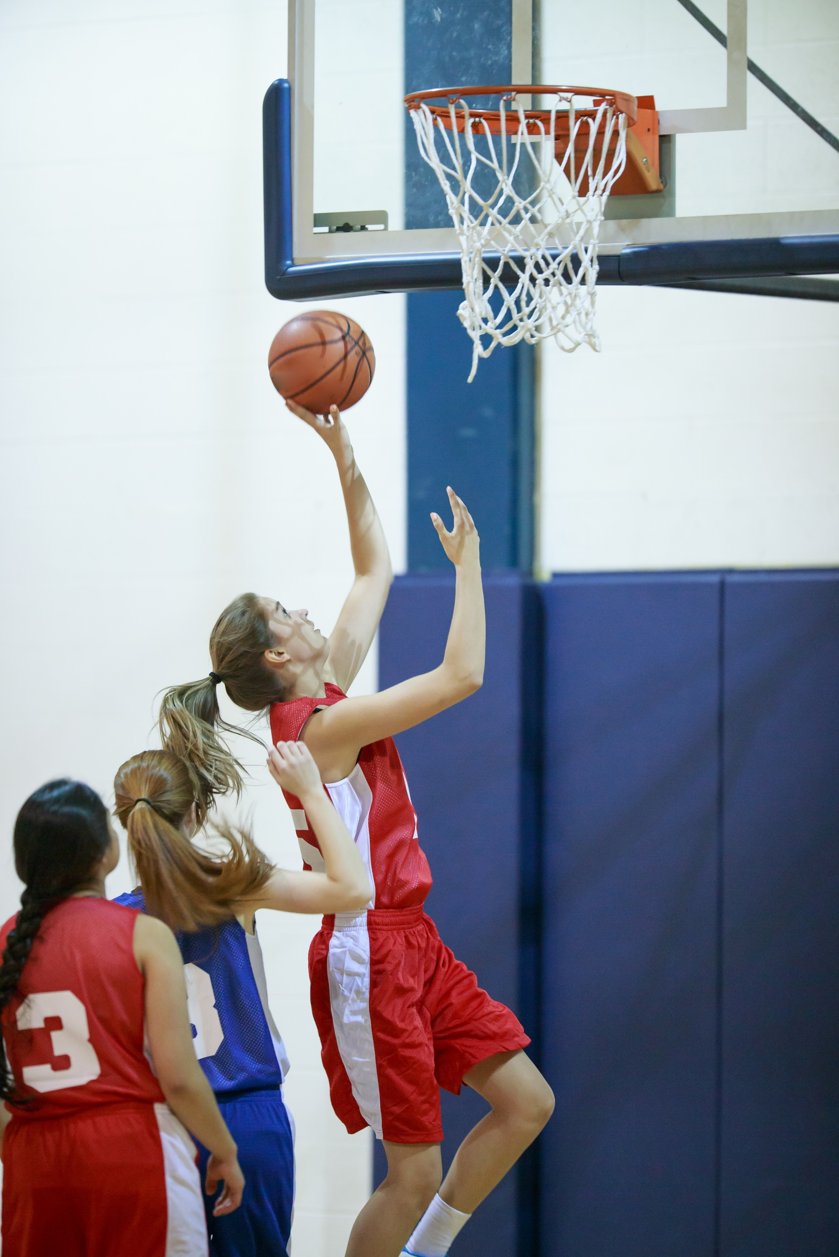

Recommendations
The following recommendations build on insights from the Commission’s consultation with the national basketball community and the desktop audit of Basketball Australia’s policies and procedures. They are intended to provide a blueprint for Basketball Australia to enhance and accelerate its existing and emerging strategies to strengthen the culture across the sport and the organisation. The recommendations are not intended to replace existing efforts being made by Basketball Australia but to enhance and guide the implementation of existing or future policy and practice, including the in-draft Diversity and Inclusion Framework 2020–2025, and the current Innovate Reconciliation Action Plan (RAP).
Further, it is expected that the recommendations be used to support the implementation of the Diversity and Inclusion Framework and the Innovate RAP, supported by a strong monitoring and evaluation framework to ensure programs and changes are implemented and overseen and to enable any areas of concern or slow progress to be addressed. Key indicators of progress should be tracked and reported to the Board on a quarterly basis and include engagement with staff and national players.

Focus area | Recommendations
Leadership and governance | - Enhance and accelerate inclusive leadership capability to ensure leaders understand and can appropriately respond to issues such as everyday racism, sexism, accessibility, disability, homophobia, and inclusive culture. This can be achieved through:  - The development of individual development and action plans for every coach and leader  - The provision of a holistic inclusive leadership curriculum for all management, leaders, coaches, and national players.  - Introduce targets for Board composition and implement actions to include greater representation and retention of Aboriginal and/or Torres Strait Islander peoples and people from racial, ethnic, and/or ethno-religious minority groups, as articulated in the draft Diversity and Inclusion Framework. The first step should be reviewing the existing board selection process and inviting diverse Board Directors in 2021.
Cultural safety and inclusion | - Embed principles of racial equality into all policies and national player and staff education.  - Enhance the current “Code of Conduct and Ethics” to be more inclusive and specifically call out exclusionary behaviour, racism, sexism, ableism, and homophobia.  - Ensure the regular delivery of training and education to national players and employees on:  - Anti-racism, including ‘bystander and upstander education to support employees to call out inappropriate behaviour  - Cultural awareness  - Bullying and harassment (especially as part of induction programs).  - Ensure all future policies, resources, programs, training, and education are developed in consultation with community, staff and national players, particularly Aboriginal and/or Torres Strait Islander peoples and people from racial, ethnic, and/or ethno-religious minority groups with appropriate and safe pathways for feedback provided. The establishment of permanent governance structures to facilitate ongoing consultation with Aboriginal and/or Torres Strait Islander peoples and people from racial, ethnic, and/or ethno-religious minority groups should be considered.  - Create a staff/national player guidebook that is clear and accessible and includes contextual support and assistance in relation to the creation of a positive culture.
Pathways for progression | - Commission an in-depth independent review of all recruitment and promotion processes, including those in the National Teams Officials Selection Policy, to ensure they are free from bias and are open and transparent.  - Consider introducing inclusion guidelines, targets and key performance indicators for diversity across the recruitment processes for national players, coaches, and management roles.  - Introduce scholarships for underrepresented groups to encourage greater national player representation.  - Broaden partnerships with communities to increase pathways for Aboriginal and/or Torres Strait Islander peoples and people from racial, ethnic, and/or ethno-religious minority groups to progress through the sport in on and off-court roles.  - Create opportunities for specific development such as mentoring and sponsorship for national players from underrepresented groups who aspire to become coaches.

Further Information

Australian Human Rights Commission
Level 3, 175 Pitt Street
SYDNEY NSW 2000
GPO Box 5218
SYDNEY NSW 2001
Telephone: (02) 9284 9600
Complaints Infoline: 1300 656 419
General enquiries and publications: 1300 369 711 TTY: 1800 620 241
Fax: (02) 9284 9611
Website: www.humanrights.gov.au
For detailed and up to date information about the Australian Human Rights Commission visit our website at: www.humanrights.gov.au.

In July 2020, Basketball Australia and the Australian Opals launched RISE UP, a campaign asking all Australians to stand with Aboriginal and Torres Strait Islander peoples and members of racial, ethnic, and/or ethno-religious minority groups to take action to eliminate racism and discrimination. Basketball Australia has also developed their first Innovate Reconciliation Action Plan (Innovate RAP) and a Diversity and Inclusion Framework (2020-2025).
Andrew Markus, Mapping Social Cohesion: The Scanlon Foundation Surveys 2018 (National Report, 978-0-9945960-7-9, 2018) 67.
Australian Human Rights Commission, Let’s talk race: a guide on how to conduct a conversation about racism (Report, 978-1-925917-10-9, June 2019).
Australian Human Rights Commission, National Anti-Racism Strategy (Report, 978-1-921449-30-7, July 2012) 3.
Australian Human Rights Commission, National Anti-Racism Strategy (Report, 978-1-921449-30-7, July 2012) 3.
Thabo Msibi, ‘Managing Diversity: toward a globally inclusive workplace’ (Review, 2011) 77 Transformation, 170.
Play by the Rules, Inclusion and diversity – what is it? (Webpage, 2020) <https://www.playbytherules.net.au/got-an-issue/inclusion-and-diversity/inclusion-and-diversity-what-is-it>.
Individual, Interview 1, Racial Equality Review of Basketball Australia.
Paul Oliver, ‘Sport and the Law, Racism and cultural diversity in Australian sport’ (2007) 32(2) Alternative Law Journal, 117.
Ohio University, Implementing and Maintaining Inclusive Sports Programs (Online Article) <https://onlinemasters.ohio.edu/blog/implementing-and-maintaining-inclusive-sports-programs/>.
Paul Oliver, Human Rights and Equal Opportunity Commission, What’s the score? A survey of cultural diversity and racism in sport (Report, 0 642 27001 5, 2016).
Individual, Submission 15, Racial Equality Review of Basketball Australia.
Individual, Submission 8, Racial Equality Review of Basketball Australia.
Individual, Interview 4, Racial Equality Review of Basketball Australia.
Individual, Submission 7, Racial Equality Review of Basketball Australia; Individual, Interview 4, Racial Equality Review of Basketball Australia.
Individual, Submission 6; Individual, Submission 12; Individual, Submission 25, Racial Equality Review of Basketball Australia.
Individual Submission 14; Individual Submission 6, Racial Equality Review of Basketball Australia.
Individual, Submission 14, Racial Equality Review of Basketball Australia.
Individual, Submission 15, Racial Equality Review of Basketball Australia.
Individual, Submission 24; Individual, Submission 15; Individual, Submission 16, Racial Equality Review of Basketball Australia.
Individual, Submission 14, Racial Equality Review of Basketball Australia.
Tim Soutphommasane, ‘Cultural Diversity in Leadership: What Does It Say About Australian Multiculturalism? (2017) 41(3) Journal of Australian Studies, 293.
Individual, Submission 1, Racial Equality Review of Basketball Australia.
Individual, Submission 6, Racial Equality Review of Basketball Australia.
Individual, Submission 5, Racial Equality Review of Basketball Australia.
Boris Groysberg and Katherine Connolly, ‘Great leaders who make the mix work’, Harvard Business Review, September 2013, <https://hbr.org/2013/09/greatleaders-who-make-the-mix-work>.
Individual, Submission 8, Racial Equality Review of Basketball Australia.
Individual, Submission 10, Racial Equality Review of Basketball Australia.
Individual, Submission 26, Racial Equality Review of Basketball Australia.
Individual, Submission 30, Racial Equality Review of Basketball Australia.
Jane O’Reilly & Sara Banki, ‘Research in work and organizational psychology: Social exclusion in the workplace’ (2016), in Paola Riva & Jennifer Eck, Social Exclusion (Springer International Publishing, Switzerland) 134.
Kenna Cottrill, Patricia Denise Lopez and Calvin Hoffman, ‘How authentic leadership and inclusion benefit organizations’ (2014) 33(3) Equality, Diversity and Inclusion: An International Journal, 275-292
Individual, Submission 30, Racial Equality Review of Basketball Australia.
Individual, Submission 8, Racial Equality Review of Basketball Australia.
Individual, Interview 1, Racial Equality Review of Basketball Australia.
Tim Soutphommasane, ‘Cultural Diversity in Leadership: What Does It Say About Australian Multiculturalism?’ (2017) 41(3) Journal of Australian Studies, 293.
Australian Human Rights Commission, Leading for Change: A blueprint for cultural diversity and inclusive leadership revisited (2018) <https://humanrights.gov.au/sites/default/files/document/publication/Leading%20for%20Change_Blueprint2018_FINAL_Web.pdf>.
Chris Hallinan, ‘Assessing the sociology of sport: On indigeneity, politics of identity and Australian sports’ (2015) 50(4-5) International Review for the Sociology of Sport, 451.
Individual, Submission 30, Racial Equality Review of Basketball Australia.
Individual, Submission 15, Racial Equality Review of Basketball Australia.
Individual, Submission 11, Racial Equality Review of Basketball Australia.
Individual, Submission 30, Racial Equality Review of Basketball Australia.
Australian Sports Commission, Sport Governance Principles (March 2020) 14.
Australian Sports Commission, Sport Governance Principles (March 2020) 14.
Michael Tynan and Paul Briggs, ‘How Culturally Competent is the Australian Football League (AFL)?’ (2013) 3(3) International Journal of Sport & Society, 200.
Individual, Submission 26, Racial Equality Review of Basketball Australia.
Australian Human Rights Commission, Everyday Racism (Webpage, 2020) <https://itstopswithme.humanrights.gov.au/everyday-racism>.
Australian Human Rights Commission, Everyday Racism (Webpage, 2020) <https://itstopswithme.humanrights.gov.au/everyday-racism>.
Individual, Submission 4, Racial Equality Review of Basketball Australia.
Individual, Submission 4, Racial Equality Review of Basketball Australia.
Individual, Focus Group 1, Racial Equality Review of Basketball Australia.
Individual, Submission 3, Racial Equality Review of Basketball Australia.
Individual, Submission 4; Individual, Submission 26; Individual, Submission 30; Individual, Submission7; Individual, Submission 16, Racial Equality Review of Basketball Australia.
Individual, Submission 7, Racial Equality Review of Basketball Australia.
Individual, Submission 26, Racial Equality Review of Basketball Australia.
Individual, Submission 4, Racial Equality Review of Basketball Australia.
Individual, Submission 16, Racial Equality Review of Basketball Australia.
Individual, Submission 4, Racial Equality Review of Basketball Australia.
Ramon Spaaij, ‘Cultural diversity in community sport: An ethnographic inquiry of Somali Australians’ experiences’, (2013) 16(1) Sport management review, 31.
Individual, Submission 12, Racial Equality Review of Basketball Australia.
Individual, Submission 11, Racial Equality Review of Basketball Australia.
Individual, Interview 3, Racial Equality Review of Basketball Australia.
NSW/ACT AFL, Multicultural (Webpage) <https://aflnswact.com.au/community-programs/multicultural/>.
Bystander and upstander anti-racism training is training designed to give individuals the knowledge, tools and confidence to take action when they witness incidents of racism, including ‘everyday racism’ such as offensive comments or jokes, in different settings. Research has shown that bystander intervention can have benefits to the target of racism, the bystander themselves and the broader culture of an organisation. See Jacqueline Nelson, Kevin Dunn and Yin Paradies, ‘ Bystander Anti-Racism: A Review of the Literature’ (2011) 11(1) Analyses of Social Issues and Public Policy, 267-269.
Ramon Spaaij, ‘Cultural diversity in community sport: An ethnographic inquiry of Somali Australians’ experiences’, (2013) 16(1) Sport management review, 33.
Individual, Submission 5, Racial Equality Review of Basketball Australia.
Individual, Submission 14, Racial Equality Review of Basketball Australia.
Individual, Submission 3, Racial Equality Review of Basketball Australia.
National Rugby League, Inclusion Framework (Webpage, 2017) <https://www.nrl.com/community/inclusion/inclusion-framework/>.
Tim Soutphommasane, ‘Cultural Diversity in Leadership: What Does It Say About Australian Multiculturalism? (2017) 41(3) Journal of Australian Studies, 295.
Individual, Submission 30, Racial Equality Review of Basketball Australia.
Individual, Submission 30, Racial Equality Review of Basketball Australia.
Individual, Interview 1, Racial Equality Review of Basketball Australia.
Individual, Submission 1, Racial Equality Review of Basketball Australia.
Individual, Submission 13, Racial Equality Review of Basketball Australia.
Individual, Submission 10, Racial Equality Review of Basketball Australia.
Individual, Submission 15, Racial Equality Review of Basketball Australia.
Individual, Interview 5, Racial Equality Review of Basketball Australia.
Individual, Interview 1, Racial Equality Review of Basketball Australia.
Nicholas Apoifis, Andrew Bennie and Demelza Marlin, ‘Noble athlete, savage coach: how racialised representations of aboriginal athletes impede professional sport coaching opportunities for aboriginal Australians’ (2017) International review for the sociology of sport.
Andrew Bennie, Nicholas Apoifis, Demelza Marlin & Jeffrey G. Caron, ‘Cultural connections and cultural ceilings: exploring the experiences of Aboriginal Australian sport coaches’ (2019) 11(3) Qualitative Research in Sport, Exercise and Health, 308.
Individual, Submission 26, Racial Equality Review of Basketball Australia.
Individual, Submission 8, Racial Equality Review of Basketball Australia.
Individual, Submission 26, Racial Equality Review of Basketball Australia.
Individual, Submission 13, Racial Equality Review of Basketball Australia.
Individual, Submission 30, Racial Equality Review of Basketball Australia.
Individual, Interview 4, Racial Equality Review of Basketball Australia.
Individual, Submission 10, Racial Equality Review of Basketball Australia.
Individual, Submission 30, Racial Equality Review of Basketball Australia.
Individual, Interview 1, Racial Equality Review of Basketball Australia.
Individual, Submission 11, Racial Equality Review of Basketball Australia.
Individual, Submission 12, Racial Equality Review of Basketball Australia.
Individual, Interview 2, Racial Equality Review of Basketball Australia.
Tim Soutphommasane, ‘Cultural Diversity in Leadership: What Does It Say About Australian Multiculturalism? (2017) 41(3) Journal of Australian Studies, 294.
Bystander and upstander anti-racism training is training designed to give individuals the knowledge, tools and confidence to take action when they witness incidents of racism, including ‘everyday racism’ such as offensive comments or jokes, in different settings. Research has shown that bystander intervention can have benefits to the target of racism, the bystander themselves and the broader culture of an organisation. See Jacqueline Nelson, Kevin Dunn and Yin Paradies, ‘Bystander Anti-Racism: A Review of the Literature’ (2011) 11(1) Analyses of Social Issues and Public Policy, 267-269.

